FFA T-Shirt Design Brainstorm
Use this template to sketch design ideas for a custom National FFA Week shirt for your chapter! Be sure the shirt has been approved by the chapter advisor and school administration before sending to production.
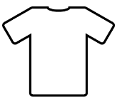
Front

Back

