FFA T-Shirt Design
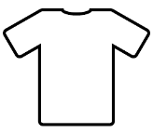
Directions: Use this template to sketch out design ideas for a custom shirt based on your National FFA Convention & Expo experience!

FRONT
BACK

