FFA Values Lesson Series Journal
Created: 05/2023 by the National FFA Organization
Use this journal to reflect on your learning and record thoughts and questions you may have to engage in meaningful conversations.

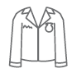
Activity 1: Introduction — FFA Value Statements Reinforce Ag Ed for All

- I heard this …

- I am reflecting …

- What I learned about myself …

- My action will be …


Activity 2: Values
- I heard this …

- I am reflecting …

- What I learned about myself …

- My action will be …


Activity 3: Working With Each Other (Emotions)
- I heard this …

- I am reflecting …

- What I learned about myself …

- My action will be …


Activity 4: Responding Respectfully
- I heard this …

- I am reflecting …

- What I learned about myself …

- My action will be …


Activity 5: Perspective
- I heard this …

- I am reflecting …

- What I learned about myself …

- My action will be …


Activity 6: Who Decides at the Local Level
- I heard this …

- I am reflecting …

- What I learned about myself …

- My action will be …


Activity 7: Communication Is Key
- I heard this …

- I am reflecting …

- What I learned about myself …

- My action will be …

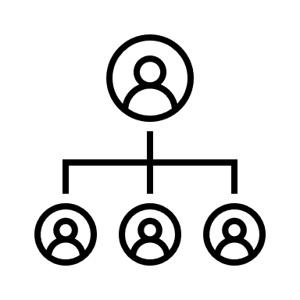
Activity 8: Backgrounds
- I heard this …

- I am reflecting …

- What I learned about myself …

- My action will be …

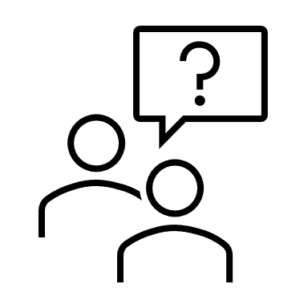
Activity 9: What to Ask
- I heard this …

- I am reflecting …

- What I learned about myself …

- My action will be …


Activity 10: Contributions for Advancement
- I heard this …

- I am reflecting …

- What I learned about myself …

- My action will be …


Activity 11: It Is All About Partnerships and Relationships
- I heard this …

- I am reflecting …

- What I learned about myself …

- My action will be …


Activity 12: How Everyone Contributes
- I heard this …

- I am reflecting …

- What I learned about myself …

- My action will be …


Activity 13: Gaining a Global Perspective
- I heard this …

- I am reflecting …

- What I learned about myself …

- My action will be …


Activity 14: Company Influence in Agriculture
- I heard this …

- I am reflecting …

- What I learned about myself …

- My action will be …


Activity 15: Conclusion — Put Thoughts to Words, Words to Action

- I heard this …

- I am reflecting …

- What I learned about myself …

- My action will be …

Final Reflection

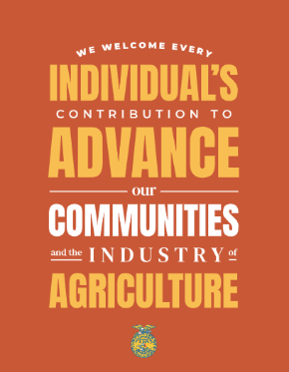
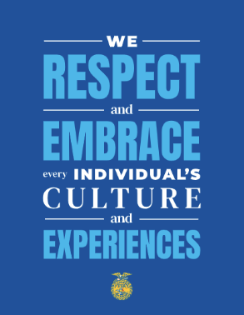
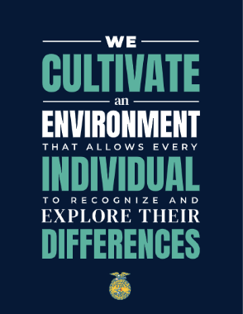
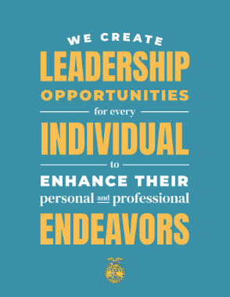
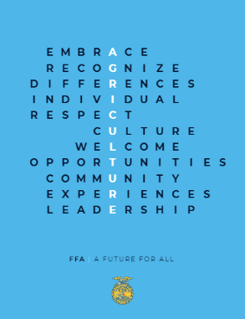
National FFA has created several posters to be shared in classrooms all over the country (see images below). Based on what you have learned, develop two additional posters to accompany the set. The posters should have a cohesive look and feel. Use the space below to plan and create your posters. Feel free to make your thoughts come to life just like a graphic designer and use a digital platform such as canva.com.
