FFA Values Lesson Series
Created: 05/2023 by the National FFA Organization
Description of Lesson: This lesson series is designed to guide students to become better leaders through personal growth in working with others. Lessons can be used in order or on their own.

Suggested Grade Level:
Grades 9 and 10 (This lesson is written so instructors can scale up or down based on class needs.)

Reflection Journal
The reflection journal is a separate resource that can be used as an accompaniment to this implementation guide. The reflection journal will allow students to reflect as they work through each lesson with a final reflection activity at the end. This is intended to be used if the entire lesson series is being completed.

Reflection is an important step in any learning process. Use the following guided questions to have students think about why reflection is important and what role reflection can have in learning. Have a class conversation to discuss responses.
- How often do you sit and reflect?
- Why do you spend so much time and/or little time on reflection?
- How do you feel when you take time to reflect upon your learning or something that has happened in your life?
- How do you think reflection could assist you with a learning process and/or specific situation?

Spanish Translated Versions
Full Lesson Series: https://ffa.box.com/s/agwigj69qlt7ctqf568xghaanx73z0fb
Student Journal: https://ffa.box.com/s/jhgvb09cqanac8y7in8frtey82l17ji1

These Activities Are Aligned to the Following Standards:

AFNR Performance Element
- CS.01: Analyze how issues, trends, technologies and public policies impact systems in the Agriculture, Food & Natural Resources Career Cluster.
- CS.02: Evaluate the nature and scope of the Agriculture, Food & Natural Resources Career Cluster and the role of agriculture, food and natural resources (AFNR) in society and the economy.
- CS.04: Demonstrate stewardship of natural resources in AFNR activities.
- CS.06: Analyze the interaction among AFNR systems in the production, processing and management of food, fiber and fuel and the sustainable use of natural resources.
FFA Precept
- FFA.PL-A.Action: Assume responsibility and take the necessary steps to achieve the desired results, no matter what the goal or task at hand.
- FFA.PL-C.Vision: Visualize the future and how to get there.
- FFA.PL-D.Character: Conduct oneself appropriately in relation to others regardless of the situation.
- FFA.PL-E.Awareness: Understand personal vision, mission and goals.
- FFA.PL-F.Continuous Improvement: Accept responsibility for learning and personal growth.
- FFA.PG-H.Social Growth: Successfully interact with others and adapt to various social situations.
- FFA.PG-I.Professional Growth: Assume responsibility for attaining and improving upon the skills needed for career success. 2
- FFA.PG-J.Mental Growth: Embrace cognitive and intellectual development relative to reasoning, thinking and coping.
- FFA.CS-M.Communication: Effectively interact with others in personal and professional settings.
- FFA.CS-N.Decision Making: Analyze a situation and execute an appropriate course of action.
- FFA.CS-O.Flexibility/Adaptability: Be flexible in various situations and adapt to change.
Common Career Technical Core
- AG1: Analyze how issues, trends, technologies and public policies impact systems in the Agriculture, Food & Natural Resources Career Cluster.
- AG2: Evaluate the nature and scope of the Agriculture, Food & Natural Resources Career Cluster and the role of agriculture, food and natural resources (AFNR) in society and the economy.
- AG4: Demonstrate stewardship of natural resources in AFNR activities.
- AG6: Analyze the interaction among AFNR systems in the production, processing and management of food, fiber and fuel and the sustainable use of natural resources.
NASDCTEc
- AGC10.3: Compare and contrast issues affecting the AFNR industry including biotechnology, employment, safety, environmental and animal welfare to demonstrate an understanding of the trends and issues important to careers in this industry.
- AGC10.04: Envision emerging technology and globalization and project its influence on widespread markets to demonstrate an understanding of technologies and trends that will impact the AFNR industry.
Common Core – Reading: Informational Text
- CCSS.ELA-Literacy.RI.9-10.1: Cite strong and thorough textual evidence to support analysis of what the text says explicitly as well as inferences drawn from the text.
- CCSS.ELA-Literacy.RI.9-10.2: Determine a central idea of a text and analyze its development over the course of the text, including how it emerges and is shaped and refined by specific details; provide an objective summary of the text.
- CCSS.ELA-Literacy.RI.9-10.3: Analyze how the author unfolds an analysis or series of ideas or events, including the order in which the points are made, how they are introduced and developed, and the connections that are drawn between them.
- CCSS.ELA-Literacy.RI.9-10.4: Determine the meaning of words and phrases as they are used in a text, including figurative, connotative, and technical meanings; analyze the cumulative impact of specific word choices on meaning and tone (e.g., how the language of a court opinion differs from that of a newspaper).
- CCSS.ELA-Literacy.RI.9-10.8: Delineate and evaluate the argument and specific claims in a text, assessing whether the reasoning is valid and the evidence is relevant and sufficient; identify false statements and fallacious reasoning.
Common Core – Writing
- CCSS.ELA-LITERACY.W.9-10.4: Produce clear and coherent writing in which the development, organization, and style are appropriate to task, purpose, and audience.
Common Core – Speaking and Listening
- CCSS.ELA-Literacy.SL.9-10.1: Initiate and participate effectively in a range of collaborative discussions (one-onone, in groups, and teacher-led) with diverse partners on grades 9-10 topics, texts, and issues, building on others' ideas and expressing their own clearly and persuasively.
- CCSS.ELA-Literacy.SL.9-10.2: Integrate multiple sources of information presented in diverse media or formats (e.g., visually, quantitatively, orally) evaluating the credibility and accuracy of each source.
- CCSS.ELA-Literacy.SL.9-10.4: Present information, findings, and supporting evidence clearly, concisely, and logically such that listeners can follow the line of reasoning and the organization, development, substance, and style are appropriate to purpose, audience, and task.
Common Core – Science & Technical Subjects
- CCSS.ELA-Literacy.RST.9-10.1: Cite specific textual evidence to support analysis of science and technical texts, attending to the precise details of explanations or descriptions.
- CCSS.ELA-Literacy.RST.9-10.8: Assess the extent to which the reasoning and evidence in a text support the author’s claim or a recommendation for solving a scientific or technical problem.
- CCSS.ELA-Literacy.RST.9-10.9: Compare and contrast findings presented in a text to those from other sources (including their own experiments), noting when the findings support or contradict previous explanations or accounts.

AFNR Career Ready Practices
- CRP.02. Apply appropriate academic and technical skills. Career-ready individuals readily access and use the knowledge and skills acquired through experience and education to be more productive.
- CRP.04. Communicate clearly, effectively, and with reason. Career-ready individuals communicate thoughts, ideas and action plans with clarity, whether using written, verbal and/or visual methods.
- CRP.05: Consider the environmental, social and economic impact of decisions. Career-ready individuals understand the interrelated nature of their actions and regularly make decisions that positively impact and/or mitigate negative impact on other people, organizations and the environment.
- CRP.06: Demonstrate creativity and innovation. Career-ready individuals regularly think of ideas that solve problems in new and different ways, and they contribute those ideas in a useful and productive manner to improve their organization.
- CRP.07: Employ valid and reliable research strategies. Career-ready individuals are discerning in accepting and using new information to make decisions, change practices or inform strategies.
- CRP.08: Utilize critical thinking to make sense of problems and persevere in solving them. Career-ready individuals readily recognize problems in the workplace, understand the nature of the problem, and devise effective plans to solve the problem.
- CRP.11: Use technology to enhance productivity. Career-ready individuals find and maximize the productive value of existing and new technology to accomplish workplace tasks and solve workplace problems.
Partnership for 21st Century Skills
- Communication
- Critical Thinking and Problem Solving
- Flexibility and Adaptability
- Global Awareness
- Information, Communications, and Technology Literacy
- Initiative and Self-direction
- Leadership and Responsibility
- Think Creatively

Table of Contents
Activity 1: Introduction — FFA Value Statements Reinforce Ag Ed for All
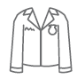
- The FFA Value Statements create a foundation for FFA to ensure it can develop opportunities and platforms that open doors and remove barriers for every individual in agricultural education to experience premier leadership, personal growth and career success through FFA. The National FFA Value Statements were ratified by the delegates at the 94th National FFA Convention.

Activity 2: Values

- Values play an important role in our everyday lives. In this lesson, students will define values and reflect on their own values. Students will also explore how values can guide behavior from others.

Activity 3: Working With Each Other (Emotions)

- Emotion plays a large role in how we respond in different situations. In this lesson, students will dive into how to manage emotions and how others manage emotions as well as how to respond to their own and others’ emotions.

Activity 4: Responding Respectfully

- Some of the instances when emotions can flare the most are when discussing topics with people with opposing views from our own. Students will learn to create counter claims to be better able to discuss topics that can have varying points of view.

Activity 5: Perspective

- Recognizing commonalities and differences is important to becoming more inclusive and can lead to greater connections.

Activity 6: Who Decides at the Local Level?

- Students will use critical thinking and collaborative discussion to answer an essential question for the agriculture industry. This engagement activity puts students into the role of individuals from different segments of a local community and government to gain a 360-degree view of the issues in agriculture and the solutions needed to meet the demands of a growing population.
Activity 7: Communication Is Key

- Communication is important to any interaction to build trusting relationships. In this lesson, students will learn about communication and persuasive communication to be able to discuss agriculture topics.

Activity 8: Backgrounds
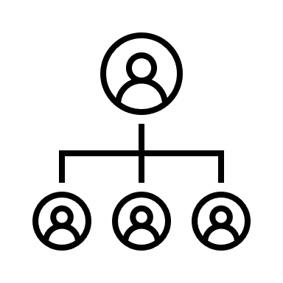
- Everyone comes from a different background and has a different viewpoint to bring to the table. Through this activity, students will discover how famous scientists’ backgrounds led them to make an impact throughout the industry.

Activity 9: What to Ask

- Surveys play a large role in helping to make decisions about questions and topics that exist. In this lesson, students will learn about developing surveys and how those surveys help to inform information on a topic.

Activity 10: Contributions for Advancement

- When working to understand a topic, it is important to look at different viewpoints to develop an opinion or statement. In this lesson, students will watch and/or conduct interviews with various individuals on an agriculture topic to gain a better understanding of the many facets of a topic.

Activity 11: It Is All About Partnerships and Relationships

- Developing partnerships and relationships that are respectful are important to success in everyday tasks and activities. In this lesson, students will process through various scenarios to dive into how to develop effective communication skills.

Activity 12: How Everyone Contributes

- People come from many different experiences and perspectives and each experience and perspective can lend itself to a well-rounded agriculture industry. Discover how individuals contribute to the industry in their everyday lives.

Activity 13: Gaining a Global Perspective

- Students will use critical thinking and collaborative discussion to answer an essential question for the agriculture industry. This engagement activity puts students into the role of individuals from different segments of a community and the government from a different country perspectives to gain a 360-degree view of the issues in agriculture and the solutions needed to meet the demands of a growing population.

Activity 14: Company Influence in Agriculture

- Being inclusive is important throughout life, including when entering the business world. In this lesson, students will look at what major agricultural companies are doing to address inclusivity.

Activity 15: Conclusion — Put Thoughts to Words, Words to Action

- Students have been taken on a journey to learn how to be more inclusive. Through this concluding activity, students will put what they have learned into action by planning an event from start to finish, keeping in mind inclusive considerations.

Activity Plans:
- Activity 1: Introduction — FFA Value Statements Reinforce Ag Ed for All
  - Description: The FFA Value Statements create a foundation for FFA to ensure it can develop opportunities and platforms that open doors and remove barriers for every individual in agricultural education to experience premier leadership, personal growth and career success through FFA. The National FFA Value Statements were ratified by the delegates at the 94th National FFA Convention.
  - Objectives:
    - Analyze the FFA Value Statements.
    - Compare the FFA Value Statements with another organization’s statements.
    - Develop a values statement for their current grade in school.
  - FFA Values Statement Alignment:
    - We respect and embrace every individual’s culture and experiences.
    - We welcome every individual’s contribution to advance our communities and the industry of agriculture.
    - We cultivate an environment that allows every individual to recognize and explore their differences.
    - We create leadership opportunities for every individual to enhance their personal and professional endeavors.
  - Suggested Time: 120 minutes (*Time requirements may vary based upon student understanding and class schedule.)
  - Student Activity Sheets:
Direct access to student activity sheets without lesson plan or answer key for easy upload to a learning management system or printing for classwork.
    - https://ffa.box.com/s/uf8zw45jddpjqodm7j5d6vveobaoflxt (Word)
    - https://ffa.box.com/s/4brtx0lv9yx9qgkdo942hu8j2cqvn0g0 (PDF)
    - https://ffa.box.com/s/41aiwsqy19plooq1i1ceecxse71s58gv (Non-Designed)
    - https://docs.google.com/document/d/1_HvYFVtIVaOXH_Yv3DbWrFuzPN1hrSk9Q6bHFHRFnVQ/copy (Google)
  - Resources/References:
    - Article: “FFA Value Statements Affirm Wide Welcome,” FFA.org/the-feed/ffa-value-statements-affirm-wide-welcome/
  - Equipment and Supplies Needed:
    - A copy of the “FFA Value Statements Reinforce Ag Ed for All” worksheet for each student
    - For virtual learners, a copy of the “Virtual Wall Activity Sheet” worksheet for each student
    - Internet access
    - Notecards
    - Colored pencils or markers
    - Tape
    - Paper
  - Lesson Plan:
      - Bell Ringer: Instruct students to quickly stand up on the count of three and have them point toward due north. Do it quickly enough so they don’t have time to converse with other students. Ask them how many agree with the people who pointed a specific way. Ask for agreement in several directions before revealing what direction is true north.

Consider any difficulties you had determining true north. When I say “north” turn to your neighbor and discuss what made this difficult and what might help us determine true north every time. Allow students time to discuss in pairs, then ask students to share their discussions with the group.

Who heard a good observation of why this is difficult? What else? What might help us determine true north every time? Points to bring out during questioning: hard to determine true north because school walls sometimes get us turned around and confused; didn’t have time to complete what the correct direction was; building doesn’t face directly north-south or east-west. What would help us determine true north every time? A compass (there is even an app for that).

Most of what confuses us in finding true north from where we sit in this classroom is external—the walls, our location, time or the building layout. By using a compass, we would be able to determine the right direction 100 percent of the time, despite these external factors.

      - Introduction: Quietly consider this: Each of us has a compass, but it’s not external. (Have students consider the following: What is a compass? How and why do people use them?) It is an internal compass that, if we follow its direction, will point us to the correct path to walk through life, despite all of life’s confusions. Today, we are going to explore three questions as they relate to the directions that organizations take. The skills you learn today are put into practice by the world’s largest companies and will help you increase your ability to think strategically and critically.
      - Activity: Each student needs a copy of the worksheet “FFA Value Statements Reinforce Ag Ed for All.” If a student is participating virtually, have them use the following worksheet for this part: “Virtual Wall Activity Sheet.”
        - Part 1: To facilitate the next activity, have students work together as a class to label the walls or areas of the classroom that closely represent their respective compass direction — north wall, south wall, east wall and west wall.

In a moment, when I say the word, “compass,” you will have one minute to work together as a class to label the classroom walls with their correct compass direction using the tape, paper and markers provided. When you are done, return to your seats. What questions do you have? How long do you have to complete the labeling? Compass!

For the next activity, you will need to prepare one notecard for each wall: north, south, east, west. You will be providing students with a list of options that correspond with each wall they labeled. Note: You can alter any of the prompts or examples to fit your class. With each option, students will stand by the wall that corresponds with the option that best reflects who they are. After each round of options, you will blindly draw a note card which will eliminate a wall from the competition. Students who are standing by that wall will sit down. Be sure to return the notecard to the stack. You will continue to have students pick a wall and eliminate a wall until you have only one or two students left standing.

I am about to ask you to make choices between some options to reflect your preferences. Each wall you have labeled will be associated with a choice. When I say the words, “up against the wall,” move to the wall associated with the option that best suits you. You must choose a wall. No fence-sitting. Only move when you hear the words. What questions do you have?

West wall — brown hair
East wall — blonde hair
North wall — red hair
South wall — black hair (and any other hair color, purple, pink, blue, etc.)

Up against the wall! Once students are in their respective corners, explain that one wall will be eliminated after every round. You, the teacher, will determine which wall is eliminated, based on your own preferences, but it should not be based on any specific criteria. If you want to speed up the activity, eliminate a large group gathered at a wall. Encourage students to make a chant to say after a wall is eliminated. For example, Bu-bye now! When students have been eliminated, have them return to their seats.

West wall — Don’t drink soda or other
East wall — Diet Coke
North wall — Dr. Pepper
South wall — Mountain Dew

Eliminate another wall and proceed with a chant. Continue until you have a winner, or you have a few people you will declare winners, depending on time available or class size. Make up categories as you choose. Possible categories include favorite breakfast cereal, favorite sport, favorite vehicle, favorite TV show or values like loyalty, friendliness, compassion and creativity. As participants become fewer and fewer, have them choose between three or even two walls. For increased competition and engagement, have students who are sitting down clap for the wall they do not want eliminated. Bring everyone back to their chairs and proceed to process their decision-making strategies. Students will record thoughts on their worksheet.

Once you have declared a winner, have all students return to their seats and answer the first four questions on their worksheets. Once students have had time to reflect and answer the four questions, have students share their thoughts on each question with a neighbor and then the class. Points to bring out in discussion: Share your observations of how students made their decisions. Some will hear one option and know their choice immediately. Others wait to hear all options and carefully weigh the decisions. Some wait to see where the most people agree and go from there. Some wait to see where their friends go and go to the same wall. Regardless of what you choose, there was the fear of being eliminated because of your choice. It’s not entirely fair because someone else’s preferences, or values, determined their outcome. We should make choices we believe in. Our decisions should be based on what is most important to us. Our decisions should be based on our values.
        - Part 2: Have students read the definition of the word “value” on their worksheets and answer the two questions. Have students share their responses. We communicate values by what we do and what we say: our actions and our language.
        - Part 3: Have students read the article “FFA Value Statements Reinforce Ag Ed for All,” found at FFA.org/the-feed/ffa-value-statements-affirm-wide-welcome/. Students will then analyze the four value statements from National FFA and determine what they mean. They will then create an action item that they can do for each statement to live out this value during the school year. Lastly, students will describe why value statements are important. Have students share thoughts from this activity.
Tip: Attached are the four Values Statement Posters.
        - Part 4: Students have now learned that values are very important. Students should select a company or group that they have a personal interest in. Examples: Nike, Cover Girl Cosmetics, John Deere, Adidas, Lululemon, Culver’s, McDonalds, NFL, MLB, NCAA, etc. Students will then use the internet to research the values of that company or group. Next, students will compare the values of the company they selected with the values from FFA. Students will finish by creating a personal values statement they can live by.
      - Follow-up: Have students do a check in with themselves to see if they are living out their personal values statement. If not, what can they do to better live out the value?
      - Optional – Extended Learning Opportunities (Not factored into time requirement): Have students write their personal values statement on a notecard and decorate the card. Students should then staple, glue or tape their notecards into their planners/notebooks or on the inside of their lockers so that they can be reminded of their values statement each day.
      - Exit Ticket: What would you say to someone who questions why a company or organization has value statements?
        - Note: If you are using the reflection journal, have students process what they have learned and record their thoughts and ideas following the exit ticket.

- Activity 2: Values
  - Description: Values play an important role in our everyday lives. In this lesson, students will define values and reflect on their own values. Students will also explore how values can guide behavior.
  - Objectives:
    - Define personal values and beliefs as they relate to equity, diversity and inclusion.
    - Define values.
    - Identify personal values.
    - Identify the benefits of living by personal values.
  - FFA Values Statement Alignment:
    - We cultivate an environment that allows every individual to recognize and explore their differences.
  - Suggested Time: 60 minutes (*Time requirements may vary based upon student understanding and class schedule.)
  - Student Activity Sheets:
Direct access to student activity sheets without lesson plan or answer key for easy upload to a learning management system or printing for classwork.
    - https://ffa.box.com/s/mw5535nv4jfnlxh324lzxwkh8b72v27t (Word)
    - https://ffa.box.com/s/9xqrtkg2d9hw42nuxsowabms72ydzt1o (PDF)
    - https://ffa.box.com/s/ei02p3n2wwwb633mf1ks3jhc9m1i9flk (Non-Designed)
    - https://docs.google.com/document/d/1GudwmFWfLHTgx57ZgDvEtygX8EU8BHYb4ekiibFHE0k/copy (Google)
  - Resources/References:
    - Video: “Values | Ethics Defined” from Texas McCombs, https://youtu.be/SCjYaatMJuY
    - Quiz: Personal Values Assessment, https://personalvalu.es/
  - Equipment and Supplies Needed:
    - A copy of the “Activity 2: Values” worksheet for each student
    - Markers
    - Calculators
    - Ruler
    - One paper plate for each student
  - Lesson Plan:
      - Bell Ringer: What are personal values? Give an example.
        - Example responses: time with family, honesty, loyalty, etc.
      - Introduction: Everyone has values. This lesson will focus on values and the role that they play in our lives.
      - Activity:
        - Part 1: Hand out the “Activity 2: Values” worksheet to each student. Students will imagine the circle as one week. They will divide the circle to represent the amount of time they would like to spend on different activities. They can divide the circle however they would like if it is representative of the time they would like to spend on the selected activity. These activities can be anything that they do during the week: school, sleep, work, homework, religious time, music, friends, video games, athletics, clubs/organizations, family time, etc. Just remember that everything should equal 168 hours (one week). Each activity should have a different color and contain a label for the activity and time used (Example: FFA practice three hours). Students may use calculators if needed to ensure the time equals 168. Give students about 25 minutes to complete their circles and the questions following the circle. Once this time is over, have students share their circles with two different people. Have students share what they learned about themselves through this activity.
          - Tip: Assign students homework the night before this lesson to begin brainstorming how they use their time. This could help set them up for this first activity.
Hand out a paper plate to each student. Instruct each student to now divide their paper plate into the time they actually spend on different activities. These activities can be anything that they do during the week: school, sleep, work, homework, religious time, music, friends, video games, athletics, clubs/organizations, family time, etc. Just remember that everything should equal 168 hours (one week). Each activity should have a different color and contain a label for the activity and time used. Students may use calculators if needed to ensure the time equals 168. Give students about 25 minutes to complete their circles and the questions following the circle. Once this time is over, have students share their circles with two different people. Have students share what they learned about themselves through this activity. Once everyone is finished, have student compare the two wheels they have developed and explain to a neighbor why they think there is such a difference. Consider hanging up each student’s paper plate wheel in the classroom. Have a conversation with students to discuss the differences between their wheels and further discuss things like time spent on their phones/social media to really start to look at are they really spending their time with the things they value most.
        - Part 2: Have students watch the video “Values | Ethics Defined” from Texas McCombs, https://youtu.be/SCjYaatMJuY. Students will answer questions as they watch. Discuss the answers once all students have completed their questions. Next, students will complete six statements: (1) I would prefer to keep to myself that … (2) I will share only with my friends that … (3) I would quietly take a position in favor of … (4) I would argue strongly in favor of … (5) I would be willing to physically fight for … and (6) I would be willing to die for …

Using these statements, students will boil them down to three main values. Students will then create a visual of their three most important values. Hang these up in the room so students can learn more about their classmates and create a stronger class community. Consider having students take this test to help determine values: https://personalvalu.es/.
        - Part 3: Students will read the FFA Creed and then highlight the values that exist in the creed. Based on student values identified in the previous activity, students will create a shield that represents their personal creed.
        - Part 4: Students will now write three scenarios and then identify how they respond based upon their values and how a classmate may respond based on their values. (Examples provided on student worksheet.) Students should use the values that were hung in class.
      - Exit Ticket: On the worksheet, students will answer the 3-2-1 question. What are values? What are two ways values impact our understanding of others? What are three ways values play a role in our day-to-day lives?
        - Note: If you are using the reflection journal, have students process what they have learned and record their thoughts and ideas following the exit ticket.

- Activity 3: Working With Each Other (Emotions)
  - Description: Emotion plays a large role in how we respond in different situations. In this lesson, we will dive into how to manage emotions and how others manage emotions as well as how to respond to your own and others’ emotions.
  - Objectives:
    - Recognize and evaluate emotions and behaviors when challenged with differing perspectives.
    - Define the terms “emotion” and “range of emotions.”
    - Identify various human emotions.
    - Identify situations that require emotional coping.
  - FFA Values Statement Alignment:
    - We cultivate an environment that allows every individual to recognize and explore their differences.
  - Suggested Time: 60 minutes (*Time requirements may vary based upon student understanding and class schedule.)
  - Student Activity Sheets:
Direct access to student activity sheets without lesson plan or answer key for easy upload to a learning management system or printing for classwork.
    - https://ffa.box.com/s/tgt614w1wh8xdp66xngc23bg6zmq7ym6 (Word)
    - https://ffa.box.com/s/klhaynw72ehzdndglinr3ds1u60somw0 (PDF)
    - https://ffa.box.com/s/uqwu09bxn929wz3ky952h751vyr3oeuj (Non-Designed)
    - https://docs.google.com/document/d/1bHs593NxDDBcqiBjRqP6R0SaY4NrQX0_mTbozm8WuDI/copy (Google)
  - Resources/References:
    - Video: “Meet Riley's Emotions,” https://youtu.be/1S0RKRRyqhQ
    - Article: “Dealing With Difficult Emotions,” https://kidshealth.org/en/teens/stressful-feelings.html
  - Equipment and Supplies Needed:
    - A copy of the “Activity 3: Working With Each Other (Emotions)” worksheet for each student
    - Purple and red writing utensils (markers, crayons, pens, etc.)
    - A copy of, or access to, the story “Goldilocks and the Three Bears,” https://www.dltk-teach.com/rhymes/goldilocks_story.htm
    - Sticky notes
    - Internet access
  - Lesson Plan:
      - Bell Ringer: Watch the video “Meet Riley's Emotions,” (https://youtu.be/1S0RKRRyqhQ) and identify the different emotions that you see. How do emotions impact you each day? Create a list of the emotions you have experienced today.
      - Introduction: Emotions are experienced every day. Today, we are going to explore the range of emotions we experience each day, how they can look for different people and how to work through those emotions.
      - Activity:
        - Part 1: Hand out the “Activity 3: Working With Each Other (Emotions)” worksheet to each student. Select three students to participate in the story and have them sit in three chairs staged in front of the class. Assign a role to each student: Mama Bear, Papa Bear and Baby Bear. Read the story “Goldilocks and the Three Bears”; when the assigned character shows an emotion, the student should act out the emotion. While the story is being read and the students are acting out the emotions, students in the audience should begin to fill in their charts. Once students have completed their charts, have students share their thoughts and observations. Next, students will determine the missing letters to the word that fits the description: EMOTION.

Share the following definition of “emotion” for students to record in the next box:
A short-term reaction to an event happening in an individual’s life that is felt internally and is displayed externally through a person’s outward behavior. It is a feeling or state of mind.

Next share the definition for a range of emotions and have students record the definition:
The full extent of feelings that can be expressed in response to an event or happening in an individual’s life. This range, or variety, of emotions can run the gamut from happy to sad and hopeful to despairing; that is, positive and pleasurable or negative and painful.

Once all students have written down the definitions, they should consider both terms and record their thoughts to the final question on the page. Have students share their thoughts.

        - Part 2: There are many human emotions. Students will think about the daily encounters they have had lately. Students will record, in their Situations Chart, seven situations they have experienced and the emotions that resulted. After students have completed their Situations Chart, have them complete the last two questions. Once students are finished, they should put their pencils down, turn over their tablets or close their laptop lids avoiding shut down. Once all students are finished, have students share with three other students and discuss their situations. Then have the class come together and share major thoughts and create a list on the board.

After the list has been created, students should complete the Emotion Resonation Chart based on the seven emotions identified by themselves and the class that most resonate. Students should have included emotions that they did not personally list previously. After listing the emotion, they will draw an emoji for the emotion, describe how this emotion could look for a peer and describe a specific scenario in which this emotion could occur.

While students are working, pass out a sticky note to each person (the prompt will be described below, just make sure they all have a sticky note given to them while they are working).

Once students are done with their Emotion Resonation Chart, have students share their images with their neighbors. Have students describe why their images may look different for the same emotion.

Once all students are finished with their Emotion Resonation Chart and questions, have students write on the sticky note the reason emotions look different for everyone. Have students place their sticky notes on the door.

Students will now turn to the next page where they will find a list of emotions that have been discussed. Students will read each emotion, circle in purple the emotions that make them feel good and strike through in red the emotions that they associate with feeling bad. While students are working, pass out two sticky notes to each student. Divide your whiteboard/chalkboard in half with a line and label one side “feel good” and one side “feel bad”. Once students are done circling, they are going to draw an image and label the image with on “feel good” emotion and one “feel bad” emotion. Have students walk up and place their sticky notes on the appropriate side of the board. Have a class conversation about why certain emotions are “feel good” and why some are “feel bad”. Are their similarities or differences amongst the class? Why or why not?
        - Part 3: When faced with positive and negative emotions, it is important to know how to handle them. Using this resource, https://kidshealth.org/en/teens/stressful-feelings.html, students will complete the questions that follow. Students will complete an activity where they will identify a scenario from this past week that evoked negative emotions. They will describe how they were feeling, what they could have done differently and how they can take action. Have students share with their neighbors. Students are now going to read two scenarios and identify the steps that should be taken to help with the negative emotions occurring. Once they have completed both scenario student will answer the following question “How can learning to work through negative emotions have a positive impact on you, those around you and your future?” Have students share their responses.
          - To get students up and moving, consider splitting students into two groups and having students act out the scenarios and then respond to what they see during the skit.
      - Exit Ticket: Hand out a second sticky note, have students record their answer to the final question prompt and hang it next to their first sticky note. Question: How can learning to work through negative emotions have a positive impact on you, those around you and your future?
        - Note: If you are using the reflection journal, have students process what they have learned and record their thoughts and ideas following the exit ticket.

- Activity 4: Responding Respectfully
  - Description: Emotions can flare the most when discussing topics with people with opposing views from our own. Students will learn to create counterclaims to be able to better discuss topics that can have varying points of view.
  - Objectives:
    - Manage emotion and behaviors when challenged with differing perspectives.
    - Write counterclaims for a conversation.
    - Practice conducting a respectful conversation when you may not agree.
  - FFA Values Statement Alignment:
    - We cultivate an environment that allows every individual to recognize and explore their differences.
  - Suggested Time: 60 minutes (*Time requirements may vary based upon student understanding and class schedule.)
  - Student Activity Sheets:
Direct access to student activity sheets without lesson plan or answer key for easy upload to a learning management system or printing for classwork.
    - https://ffa.box.com/s/62814958n0pt6modf3rhat3ledv40yo5 (Word)
    - https://ffa.box.com/s/g3i1ex07xfbvezz0b9kqfj5zign5hd6x (PDF)
    - https://ffa.box.com/s/t63i4tmtid3weskbblja9lt9tvsd15se (Non-Designed)
    - https://docs.google.com/document/d/1ebGlrIukuGDruBn3fASCAFvWPQaGi9XhU5rlFaPghHY/copy (Google)
  - Equipment and Supplies Needed:
    - A copy of the worksheet “Activity 4: Responding Respectfully” for each student
    - Internet access to complete research on a topic
  - Lesson Plan:
      - Bell Ringer: What happens when we speak out of emotion on a controversial topic instead of thinking through a topic and considering the situation, timing and people involved and nearby?
      - Introduction: Emotions can flare the most when discussing topics with people with opposing views from our own. Today, we will learn to create counterclaims to be able to better discuss topics that can have varying points of view.
      - Activity: Begin by handing out the “Activity 4: Responding Respectfully” worksheet to each student.
        - Students will work with a partner to complete the left side of the chart with the topic assigned by you. This can be something impacting your school/community locally or something you have been discussing in class.
          - Here are two examples: “All students in high school should be required to take a career and technical education (CTE) course before they graduate” or “Cell phones should not be allowed in classrooms during normal school hours.”
Students will work with their partners to determine how to discuss the topic respectfully with the prompts provided in the chart.
        - Next, students will select a topic of their choice that could be misunderstood and complete the counterclaim sentence starters. Counterclaims are an argument offered in opposition to another argument.
          - Example: After a bank sues a customer for an unpaid debt, the customer counterclaims (sues back) against the bank for fraud in obtaining the debt.
        - Have students share the counterclaims with another peer to practice conducting respectful conversations. Once students have completed their counterclaims, have them share with a group that selected a different topic. Host conversations with the class about why it is important to always think through responses, especially on topics that can be more controversial.
      - Exit Ticket: How can having respectful conversations with difficult topics impact you, those around you and your future?
        - Note: If you are using the reflection journal, have students process what they have learned and record their thoughts and ideas following the exit ticket.

- Activity 5: Perspective
  - Description: Recognizing commonalities and differences is important to becoming more inclusive and can lead to greater connections.
  - Objectives:
    - Discover multiple perspectives to identify shared needs and commonalities.
    - Discover why accommodations are important.
  - FFA Values Statement Alignment:
    - We cultivate an environment that allows every individual to recognize and explore their differences.
  - Suggested Time: 60 minutes (*Time requirements may vary based upon student understanding and class schedule.)
  - Student Activity Sheets:
Direct access to student activity sheets without lesson plan or answer key for easy upload to a learning management system or printing for classwork.
    - https://ffa.box.com/s/ovr2az9euh4sxfxtt012lq14y3yune42 (Word)
    - https://ffa.box.com/s/x3ttafs2tbwjlu0bn3n40qdzexx8ls0x (PDF)
    - https://docs.google.com/document/d/1u9Ugy3tw7d_Uhw_aLQfjWo2WldWM4Mc-IrFrsX33MP8/copy (Google)
  - Resources/References:
    - Video: “Ohio State vs #3 Purdue Basketball Game Highlights (2-19-2023),” https://youtu.be/g0Kz6BrOltM
  - Equipment and Supplies Needed:
    - A copy of the “Activity 5: Perspective” worksheet for each student
    - Printed copy of directions for each station
    - Technology for one station activity
    - Masking tape/painter’s tape
    - Lemonade drink mix
    - Water
    - Measuring spoons
    - Measuring cups
    - Three blindfolds
    - Plastic cups — enough for each student
    - Paper towel for spills
    - Three containers big enough to make a drink mix
    - Three mixing spoons
    - Internet access to watch the bell ringer video or embed it in a PowerPoint in advance (https://youtu.be/g0Kz6BrOltM)
  - Lesson Plan:
      - Bell Ringer: Have students watch the first four minutes of the following clip from the video “Ohio State vs #3 Purdue Basketball Game Highlights (2-19-2023),” https://youtu.be/g0Kz6BrOltM.
        - Develop a list of four strengths you see in the teams you are watching.
        - Do all these strengths come from the same person?
        - Are all of these individuals built the same in stature, speed and background?
        - How do these differences help each team to be successful?
      - Introduction: Today, we are going to learn about how recognizing differences helps us to think more critically and become more accepting and inclusive.
      - Activity:
        - Part 1: Hand out the “Activity 5: Perspective” worksheet to each student. Within the class, students are going to take the bingo board and find someone who matches a box on the bingo board provided. Have students get a signature from another student who matches the description. They should have multiple signatures from other students at the end. The first person to get “Bingo!” and call it out, wins! Once there is a winner, and they have been recognized, have students return to their seats and complete the 3-2-1 questions that are listed underneath the bingo board. Once students are done reflecting, have students share their thoughts. Continue discussions about inclusivity and the role it plays.
        - Part 2: Students will now turn to Part 2 on the worksheet. Students will select and highlight two questions from each column. Next, students will answer each question within the box on the worksheet. When you say “Go!” students will get up and find six different classmates and share one question they selected and their answer. They will then listen respectfully to the question and answer of their classmate. As they rotate, students will use the chart to write the question, summary of answer and person’s name with whom they talked. Students should share all six questions to complete the task, meaning they should see and talk with six different students and share each question and answer once. Once students are finished, have them return to their seats and complete the reflection question listed underneath the bingo board. Once students are done reflecting, have students share their thoughts.
        - Part 3: Prior to beginning this portion of the lesson, set up each of the three stations for students to rotate through:
          - Station 1: At this station, students will be taping their thumbs down and need to perform a series of tasks. The station location should have the directions for the station as well as masking tape/painter’s tape.
          - Station 2: At this station, one student will wear a blindfold and the other partner will verbally guide them through the room to another table/desk where the student will need to add 1.5 cups of water into a larger container. Students will change roles and the student that previously was guiding will now be blindfolded and be verbally guided to third table/desk. At this stop, the blindfolded student will need to add two tablespoons of drink mix to the previously measured water. The student will then use the mixing spoon to stir and then pour samples for each student to see if they completed the task. You need to have three separate locations set up with the same set of instructions at each table and the appropriate supplies. Highlight the section of the instructions students are to perform at the determined location.
          - Station 3: Print out and place the Station 3 directions. At this station, students will each need access to some kind of technology to be able to open the assigned website. When students open the site, they will need to write a sentence on blank lined paper.
Students should be divided into pairs. Students will use their reflection worksheet to record all thoughts as they move through each of the three stations. Students are to use the included directions at each station. Once students have completed all stations, have students change partners and share their experiences. Once students are done sharing, host a class conversation. To finish, students should answer the final question on the reflection worksheet: Why are accommodations important to consider and have? Once all students have had time to answer the question and reflect, have students share their thoughts and have a class discussion about the importance of inclusion.
      - Exit Ticket: Commonalities and differences exist for everyone. How does knowing this make you think about inclusivity?
        - Note: If you are using the reflection journal, have students process what they have learned and record their thoughts and ideas following the exit ticket.

- Activity 6: Who Decides at the Local Level?
  - Description: Students will use critical thinking and collaborative discussion to answer an essential question for the agriculture industry. This engagement activity puts students into the role of individuals from different segments of a local community and the government to gain a 360-degree view of the issues in agriculture and the solutions needed to meet the demands of a growing population.
    - Note: Ensure that you have a respectful class culture prior to delving into this lesson.
  - Objectives:
    - Critically think about global issues from a local viewpoint.
    - Engage in real-world challenges.
    - Examine the role that all people play in the agriculture industry.
    - Develop skills working with students from different backgrounds/perspectives to reach a common goal.
  - FFA Values Statement Alignment:
    - We create leadership opportunities for every individual to enhance their personal and professional endeavors.
  - Suggested Time: 120 minutes (*Time requirements may vary based upon student understanding and class schedule.)
  - Student Activity Sheets:
Direct access to student activity sheets without lesson plan or answer key for easy upload to a learning management system or printing for classwork.
    - https://ffa.box.com/s/r97mqx29deerkl1jfs12a3sieqqd9y9q (Word)
    - https://ffa.box.com/s/fam0w391mxf5lqoi1t85vy5gx2qlqz8u (PDF)
    - https://ffa.box.com/s/tqgcz4hjxogh2dky5ragivq9ajj745wn (Non-Designed)
    - https://docs.google.com/document/d/190u7jpVQogGUetgqOSRbwxyLoh1Y6lwzCa-wpwb5vho/copy (Google)
  - Equipment and Supplies Needed:
    - A copy of the “Who Decides at the Local Level? Profile Sheet” handout for each student
    - A copy of the “Activity 6: Who Decides at the Local Level?” worksheet for each student
    - A copy of the stakeholder profile for each group
    - A copy of the “Where Do We Go from Here?” worksheet for each student
    - Internet access to complete research
    - Blue and green markers/colored pencils
    - Sticky notes
  - Lesson Plan:
      - Bell Ringer: Who should be able to direct the future of the agriculture industry?
      - Introduction: Agriculture is a crucial component of everyday life; however, many different opinions exist about how agricultural products should be produced, marketed and sold. Additionally, the agriculture industry has the added strain of feeding a population that is growing at an alarming rate with less available land. With so many depending on agriculture, and so many concepts on how to feed the growing and changing population, whose ideas should guide the agriculture industry?
      - Activity:
        - Part 1: Begin by handing out the “Who Decides at the Local Level? Profile Sheet” and the “Activity 6: Who Decides at the Local Level?” worksheet. Students will utilize the worksheets to guide their research, record their findings and prepare for the “community forum meeting.”
  - Teacher Note: Assign each group a consumer or producer profile and hand out the profile sheet. Try to decide groups in a way that allows a student to engage in the discussion from another viewpoint. For example, if a student is from an urban home, then place that student in a producer role to challenge the student to learn about all sides of the topic. Tip: There is a grading rubric included for this activity.
Teacher Narrative: Today, each of you will assume the role of a community stakeholder for our town hall community discussion. The opinions shared and decisions made will be sent to the governor for discussion before heading to the national and global level. When you assume the role of the stakeholder, you will be responsible for sharing that stakeholder’s views and beliefs concerning the essential question. You and your classmates with the same profile will need to conduct research so you are prepared to present your “side,” defend your opinion and ask questions of other stakeholders. At the conclusion of our meeting, there will be reflection and discussion.
        - Part 2: Once the community forum has concluded, hand out the “Where Do We Go from Here?” worksheet to each student. Have students complete the worksheet and wait quietly for their classmates to also finish. Once everyone has completed the worksheet, have a group discussion about each question on the worksheet and discuss what the answer to the essential question should be. Students should eventually conclude that every voice is important and there is no one opinion/stakeholder that should be solely responsible.
      - Exit Ticket: On a sticky note, have students develop one final concluding/overarching thought about the essential question. As students leave, have them hang their sticky notes on the door for you to review.
        - Note: If you are using the reflection journal, have students process what they have learned and record their thoughts and ideas following the exit ticket.

- Activity 7: Communication Is Key
  - Description: Communication is important to any interaction to build trusting relationships. In this lesson, students will learn about communication and persuasion in discussions about agricultural topics.
  - Objectives:
    - Develop a leadership style that drives social change in agriculture.
    - Define persuasive communication.
    - Explain how persuasive communication can influence people.
    - Create a podcast about a common misconception in agriculture.
  - FFA Values Statement Alignment:
    - We create leadership opportunities for every individual to enhance their personal and professional endeavors.
  - Suggested Time: 120 minutes (*Time requirements may vary based upon student understanding and class schedule.)
  - Student Activity Sheets:
Direct access to student activity sheets without lesson plan or answer key for easy upload to a learning management system or printing for classwork.
    - https://ffa.box.com/s/46od9gi7wmchnzjgtkz3ecn0xf5sshvn (Word)
    - https://ffa.box.com/s/u5f3mlu6fmwthxdlexcbgzbfhww6shrq (PDF)
    - https://ffa.box.com/s/1j0que0giwojqbup3iydcrbe032udrsq (Non-Designed)
    - https://docs.google.com/document/d/1T9CWooOV7nT3E4qxfwfus3bxdUw8GgXLxMRrtFaCi9s/copy (Google)
  - Resources/References:
    - Website: “Concept Maps,” https://learningcenter.unc.edu/tips-and-tools/using-concept-maps/
  - Equipment and Supplies Needed:
    - A copy of the “Activity 7: Communication Is Key” worksheet for each student
    - Electronic device to record a podcast
    - Colored paper cut into small squares (See Pre-Lesson Prep for more details.)
    - Tape
    - Whiteboard
  - Lesson Plan:
      - Pre-Lesson Prep: Prior to students arriving, write the following words on separate small pieces of paper: “Communication is needed to influence others.” Each word should be on its own piece of paper. Tape these slips of paper around the room for a scavenger hunt. Be mindful of class size, if you have a large class consider having two sets of words hidden. Do not hide any words in cabinets or behind your desk.
      - Bell Ringer: Why is communication important?
      - Introduction: Communication is important for connecting with others and describing personal experiences that lead us to understanding a person. Without quality communication, misunderstandings and strife can occur. Today, we are going to look at influence and the pieces of quality communication.
      - Activity:
        - Part 1: Hand out the worksheet “Activity 7: Communication Is Key” to each student. In the box provided, students should use each of the letters in the word “influence” and identify for each letter one word that comes to mind when they hear the phrase “to influence others, you must …” Have students use the image provided as an example. Have students share what they wrote down highlighting those responses that tie to communication. Consider writing key words on the board.

Now, we are going to go on a scavenger hunt. When I say “go” move through the room trying to find the slips of paper that have been hidden with words to create a phrase. There are not any words hidden in anything or behind my desk. Once you have found all seven words as a class, combine them to determine the secret phrase without talking. What questions are there? GO!

Once students have unscrambled the words, without talking, have them say them in unison: Communication is needed to influence others!

Students will reflect on what the word “influence” has to do with communication. Next, have students reflect on their week to determine their influence and record their thoughts in the box. Have students think-pair-share with a neighbor. Have groups share if there was a really great example.

Next, students will define communication and the four types of influential communication by unscrambling the four words in the “Scrambled Term” column. Once they have finished, have each student show a thumbs up. Once all students have shown a thumbs up, go through the answers to ensure each student unscrambled the word correctly: (1) Communication, (2) Beliefs, (3) Attitudes, (4) Intentions and (5) Actions.
Share the following information with students to record in their charts. Students should be encouraged to write their own examples after seeing/hearing the ones that you provide. It is recommended that you write content on the board.
          - Influence (beliefs) — what they (think)
            - “to persuade my audience that the world is round” —Columbus
            - “to persuade my audience that TV violence is TV violence”
          - Influence (attitudes) — what they (feel)
            - “to persuade my audience that all men and women are equal” —Martin Luther King Jr.
            - “to persuade my audience that today’s teenagers are responsible and respectful”
          - Influence (intentions) — what they (hope to do)
            - “to persuade my audience to not build a military installation in Cuba” —John F. Kennedy
            - “to persuade my audience that they should go to college or a trade school”
          - Influence (actions) — what they (are doing)
            - “to persuade my audience to help the poor and disabled”
—Mother Teresa
            - “to persuade my audience that they should stop procrastinating”
Have students share the examples that they developed and discuss any questions that may have arose. Next, have students flip their papers over and do an oral quiz of terminology with the class.

Now that students know how they can persuade others, let’s look at the techniques that can be used both in formal settings, such as a speech, or informally with daily conversations that will help students to be more persuasive. Let’s look at three of them. Have students try to match the term with the definition. Students should put down their pencils when they are done matching. Go through each term to ensure every student has the correct answer:
              - Logic/Logos: These statements are supported by evidence such as facts, testimonials and expert opinion.
              - Emotion/Pathos: These statements bring about strong feelings through personal reference.
              - Credibility/Ethos: These statements establish the communicator as believable and trustworthy through competence and sincerity.

Then, to the left of the term, have students draw an image to help them remember the term.

Using the three pieces of persuasive communication (logic/logos, emotion/pathos, credibility/ethos), students will now identify which method of influencing is being described in each scenario provided.

Using the space provided, students will apply knowledge and understanding by creating a concept map to depict the relationship among the terms used in the lesson today. Note: There are two examples of what a concept map looks like if students need a reference. There is also a resource from the University of North Carolina with more information about concept maps. Have students swap concept maps with two other students in class.
  - Part 2: Using the space and outline provided, students will plan a two- to 4-minute podcast about a misconception that exists in the agriculture industry. They may pick any misconception that they feel strongly about, or you can assign one to students based upon what you have been learning in class. (Example topics: drone usage in agriculture, rBST use in dairy cattle, CRISPR technology in plants, robot use in agricultural production, etc.) Students must be sure to include statements that utilize logic, emotion and credibility while keeping in mind the way in which communication can influence others when developing their podcasts. Lastly, students should be sure their podcasts are organized in a manner that flows and has a beginning, middle and end to the topic to ensure clarity and understanding from their listeners. Once all podcasts are complete, listen to them in class for a further learning opportunity.
    - Tip: There is a grading rubric included for this activity.
      - Exit Ticket: Why is how we communicate so important when interacting with others?
        - Note: If you are using the reflection journal, have students process what they have learned and record their thoughts and ideas following the exit ticket.

- Activity 8: Backgrounds
  - Description: Everyone comes from a different background and has a different viewpoint to bring to the table. Through this activity, students will discover how famous scientists’ backgrounds led them to make an impact throughout the industry.
  - Objectives:
    - Explore diversity in individual backgrounds and perspectives to enhance productivity and innovation.
    - Research well known agriculture scientists.
    - Create a profile for a well-known agriculture scientist.
  - FFA Values Statement Alignment:
    - We respect and embrace every individual’s culture and experiences.
  - Suggested Time: 60 minutes (*Time requirements may vary based upon student understanding and class schedule.)
  - Student Activity Sheets:
Direct access to student activity sheets without lesson plan or answer key for easy upload to a learning management system or printing for classwork.
    - https://ffa.box.com/s/qn7f6pnizb1nl6arl0j7ooxayad5fxd2 (Word)
    - https://ffa.box.com/s/ze0fi5jlodpzhafi09j4ynxrm7n37mg0 (PDF)
    - https://ffa.box.com/s/12snvmkiuthmy67c34ix66uda2wpwpa3 (Non-Designed)
    - https://docs.google.com/document/d/1Rbu9EG9RxfyDTfN66XkqdnGxVzz425irIFKfY1l-DLc/copy (Google)
  - Equipment and Supplies Needed:
    - A copy of the worksheet “Activity 8: Backgrounds” for each student
    - Colored pencils, crayons or markers
    - Tape to hang images
  - Lesson Plan:
      - Bell Ringer: How does your background and personal experiences impact the decisions you make and how you work with others?
      - Introduction: Just like each of us come from a variety of backgrounds, there is a lot of diversity that exists in the agriculture industry. It is important to understand what individuals have contributed, but what are their backgrounds? What was their motivation? Today, we are going to have the opportunity to learn more about some amazing agriculturists.
      - Activity: Hand out the worksheet “Activity 8: Backgrounds” to each student. Students will follow the steps provided to research a well-known agriculture scientist and create a LinkedIn profile. Once students have completed their profiles, have them hang them around the room. Students will then complete a gallery walk. Once they have viewed all the profiles, students will complete the questions provided on the worksheet. Lastly, students will use the space provided to develop a collage that depicts how different backgrounds come together to impact an industry that society relies on. Hang all the collages together to develop a larger image for all to see.
      - Exit ticket: What role do people’s backgrounds play in their beliefs and interactions with others?
        - Note: If you are using the reflection journal, have students process what they have learned and record their thoughts and ideas following the exit ticket.

- Activity 9: What to Ask
  - Description: Surveys are a process that play a large role in helping to make decisions about questions/topics that exist. In this lesson, students will learn about developing survey questions and how those surveys help to inform information on a topic.
  - Objectives:
    - Identify well-written survey questions.
    - Identify common mistakes made when developing survey questions.
    - Weigh multiple points of view and experiences when seeking to address agricultural challenges.
    - Develop survey questions.
  - FFA Values Statement Alignment:
    - We respect and embrace every individual’s culture and experiences.
    - We welcome every individual’s contribution to advance our communities and the industry of agriculture.
  - Suggested Time: 90 minutes (*Time requirements may vary based upon student understanding and class schedule.)
  - Student Activity Sheets:
Direct access to student activity sheets without lesson plan or answer key for easy upload to a learning management system or printing for classwork.
    - https://ffa.box.com/s/cpe1ey809t3581jlcsmh2om411kozg1g (Word)
    - https://ffa.box.com/s/dngpronclcg2rfc9sxqd3lmaynxxrww8 (PDF)
    - https://ffa.box.com/s/usrlxsb3nh2mcxgkffox46ivwczryy6x (Non-Designed)
    - https://docs.google.com/document/d/1kxAQyNHIOgtmk4zenfAbi5PyYY_2bNPJJ9bdDlesMIc/copy (Google)
  - Resources/References:
    - Article: “Survey Questions 101: Do You Make These 7 Mistakes?” https://medium.com/@Qualtrics/survey-questions-101-do-you-make-these-7-mistakes-290f6b07ce43
  - Equipment and Supplies Needed:
    - A copy of the “Activity 9: What to Ask” worksheet for each student
    - Internet access or article printed in advance
    - Red, green and purple writing utensils (crayons, markers or pencils)
  - Lesson Plan:
      - Bell Ringer: What is a survey? Where have you seen a survey? Have you ever taken a survey?
      - Introduction: It is always important to look at all information before making a decision. Reviewing and gathering several viewpoints on a topic can make for more informed decisions. But how do we ask the right questions in the right way to gain the information we need? Today, we are going to learn how to properly write survey questions and then try writing our own.
      - Activity: Hand out the worksheet “Activity 9: What to Ask” to each student.
        - Part 1: Using the resource “Survey Questions 101: Do You Make These 7 Mistakes?” (https://medium.com/@Qualtrics/survey-questions-101-do-you-make-these-7-mistakes-290f6b07ce43) students will begin by identifying the seven common mistakes made when developing a survey. Next, students will use what they just read to examine the questions provided. They will identify the survey questions that have been written correctly by circling them in green and will draw a red circle around those questions that are written incorrectly. Once they have identified the correctly and incorrectly written questions, students will use purple to correct the questions they identified as poorly written. Have students share why they identified some as well written and others as poorly written.
          - Teacher Note: A survey is a process that pulls together information through relevant questions. A list of questions is also called a questionnaire and is a tool used by researchers during a survey process. The term “questionnaire” can be used interchangeably with “survey” or “survey questions”.
        - Part 2: Now that students understand how to write survey questions, students will try to develop questions of their own. Students will follow the steps provided to develop their surveys. Once students have developed their questions, they should trade with a peer and receive feedback. Based on the feedback received, students should make changes to their questions. Use the “popcorn” method to have students each share a question that they developed.
        - Part 3: Have students implement their surveys by distributing them to their identified audience (on paper or electronically, such as using SurveyMonkey). Students need to be sure to give a deadline for answers to be returned. Students will then analyze their data. Using the provided questions on their worksheet, have students share out items that surprised then about their results.
          - Note: If you do not have time, or do not want to have students implement the surveys they created, use the included information/data for this part of the lesson. This information was compiled from a National FFA Agriscience Fair project.
      - Exit Ticket: What role do/can surveys play in helping to make decisions or draw a conclusion about a topic?
        - Note: If you are using the reflection journal, have students process what they have learned and record their thoughts and ideas following the exit ticket.

- Activity 10: Contributions for Advancement
  - Description: When working to understand a topic, it is important to look at different viewpoints to develop an opinion or statement. In this lesson, students will watch and/or conduct interviews with various individuals about an agriculture topic to gain a better understanding of the many facets of a topic.
  - Objectives:
    - Explore your role in creating an equitable and inclusive world through an agricultural context.
    - Create a reel/video to showcase what has been learned.
    - Develop skills in interviewing others about themselves.
  - FFA Values Statement Alignment:
    - We welcome every individual’s contribution to advance our communities and the industry of agriculture.
  - Suggested Time: 90 minutes (*Time requirements may vary based upon student understanding and class schedule.)
  - Student Activity Sheets:
Direct access to student activity sheets without lesson plan or answer key for easy upload to a learning management system or printing for classwork.
    - https://ffa.box.com/s/z3ltzexj7j28vp9torz666decqjsrxxp (Word)
    - https://ffa.box.com/s/gnijdlut5da84zt6ws0blo1v7tutggju (PDF)
    - https://ffa.box.com/s/73tcddo8xk4pcxq3ps9limuf4qzwtxv5 (Non-Designed)
    - https://docs.google.com/document/d/1U4cAfIhZsQ2SMpnwPX9hyByrNjREp08Tymw6BMoJbss/copy (Google)
  - Equipment and Supplies Needed:
    - A copy of the “Activity 10: Contributions for Advancement” worksheet for each student
    - Technology to record a reel/video
    - Internet access to view the interview videos
  - Lesson Plan:
- Bell Ringer: What is the purpose of an interview? What are different types of interviews?
- Introduction: Including multiple perspectives when formulating an opinion on a topic can play a crucial role in understanding all viewpoints of a topic, allowing for more informed thought. Today, we are going to look at interviewing different individuals to gain multiple perspectives on an agriculturally based topic.
- Activity: Hand out a copy of the worksheet “Activity 10: Contributions for Advancement” to each student. Look through and discuss each of the interview questions on the worksheet prior to students conducting their own interview(s).
  - Lesson Option 1: On a blank sheet of paper, have students record information from everyone being interviewed. Tip: Show all four videos or just one—gauge this on the needs of your class. Videos: https://ffa.box.com/s/wl50uic0qhxji0slq0fyxf2ygtzo1aew
    - Host conversations about what was just heard after each video is shown.
    - Once students understand how to conduct an interview, have students select a topic they have interest in pursuing through interviews. (You can either assign a topic, or allow students to select their own.) Students should either circle their topic or record their topic in the first box on the worksheet.
    - Students will now identify who they would like to interview. There should be one individual from each of the following categories:
      - One adult from school (administrator, custodian, non-agriculture teacher, etc.),
      - One community member,
      - One member of their family, one classmate.
        - Note: Students should be encouraged to select individuals that span different age ranges for richer content.
        - TIP: Prior to students conducting interviews, be sure to review and discuss the interview tips/tricks included on their worksheets. Students should take good notes to prepare them for the next part of the activity.
    - Once students have conducted all interviews, they should sit down to draw conclusions. Students will then develop a 90-second reel/video about what they have learned on the topic. Points for students to include are listed on their worksheets.
    - Share the videos in class and host conversations about what was learned.
  - Lesson Option 2: On a blank sheet of paper, have students record information from everyone being interviewed. Have students record notes for each interview that they see. Host conversations about what was just heard after each video is shown. Once students have watched all four interviews, they should sit down to draw conclusions. Students will then develop a 90-second reel/video about what they have learned on the topic. Points for students to include are listed on their worksheets. Share the videos in class and host conversations about what was learned. Tip: There is a rubric for this activity.
- Exit Ticket: What can you gain from learning from different people when trying to study a topic?
  - Note: If you are using the reflection journal, have students process what they have learned and record their thoughts and ideas following the exit ticket.

- Activity 11: It Is All About Partnerships and Relationships
  - Description: Developing partnerships and relationships that are respectful are important to success in everyday tasks and activities. In this lesson, students will examine various scenarios to dive into how to develop effective communication skills.
  - Objectives:
    - Describe Equity, Diversity and Inclusion (EDI) as a key competency in leadership for the industry of agriculture.
    - Determine how to navigate different situations.
    - Work through scenarios to build relationships through critical thinking.
    - Plan respectful responses.
    - Construct respectful responses to build partnerships and relationships.
  - FFA Values Statement Alignment:
    - We welcome every individual’s contribution to advance our communities and the industry of agriculture.
  - Suggested Time: 30 (*Time requirements may vary based upon student understanding and class schedule.)
  - Student Activity Sheets:
Direct access to student activity sheets without lesson plan or answer key for easy upload to a learning management system or printing for classwork.
    - https://ffa.box.com/s/m041b6gl5y1ijf1n01zqjxwm4853czj9 (Word)
    - https://ffa.box.com/s/pmb88c98190kji99htlhhbm7j27u8i7x (PDF)
    - https://ffa.box.com/s/rmypxlp7lltzcgr728fol8k6b2f7mslk (Non-Designed)
    - https://docs.google.com/document/d/1VBRf6AWA_XKlXsYZuTvDnrnonT0qbkMvc7JfQiyiXwQ/copy (Google)
  - Equipment and Supplies Needed:
    - A copy of the “Activity 11: It Is All About Partnerships and Relationships” worksheet for each student
  - Lesson Plan:
      - Bell Ringer: How can thinking before responding to a situation help to build relationships?
      - Introduction: Thinking through a situation and responding respectfully can help to further build partnerships and relationships. Today, we are going to practice thinking through a situation by examining different scenarios.
      - Activity:
        - Part 1: Hand out the “Activity 11: It Is All About Partnerships and Relationships” worksheet to each student. Students are going to read three scenarios and work through the prompts to form a response that would help to build relationships and partnerships with those involved. Once students complete the three scenarios, have students think-pair-share their responses with three different classmates, including how they arrived at their final response. Have a class discussion about how they felt through the process and why it was helpful in formulating a response.
        - Part 2: Students will now develop their own scenarios (can be something they are experiencing in their life at the current time) and use the same prompts to formulate a response that is respectful and builds partnerships/relationships. Have students think-pair-share their scenarios and responses with a classmate they have not spoken to yet during this lesson.
      - Exit Ticket: How can being respectful develop partnerships and relationships?
        - Note: If you are using the reflection journal, have students process what they have learned and record their thoughts and ideas following the exit ticket.

- Activity 12: How Everyone Contributes
  - Description: People come from many different experiences and perspectives, and each experience and perspective can lend itself to a well-rounded agriculture industry. Discover how individuals contribute to the industry in their everyday lives.
  - Objectives:
    - Identify how inclusion in agriculture can improve local communities.
    - Describe how different backgrounds play an important role in the agriculture industry.
  - FFA Values Statement Alignment:
    - We welcome every individual’s contribution to advance our communities and the industry of agriculture.
  - Suggested Time: 30 minutes (*Time requirements may vary based upon student understanding and class schedule.)
  - Student Activity Sheets:
Direct access to student activity sheets without lesson plan or answer key for easy upload to a learning management system or printing for classwork.
    - https://ffa.box.com/s/pddgafs934kdc8oicyxjvpjgfy8td6z0 (Word)
    - https://ffa.box.com/s/zxxy572jtmtgkyomca7f3unasqlptc4l (PDF)
    - https://ffa.box.com/s/bubspyrs0gvwx7khmi1zo9a4ofniy8i4 (Non-Designed)
    - https://docs.google.com/document/d/1xoM1anD-qg2RJx2y9Yndm6FsOi4V-Ae8IEZh9wxXX3Q/copy (Google)
  - Resources/References:
    - Video: “Dairy Heifers SAE | Jonathan Jones,” https://vimeo.com/235413243
    - Article: “FFA Alumna Shares Her Mental Health Struggle,” FFA.org/the-feed/ffa-alumna-shares-her-mental-health-struggle/
    - Article: “Differently Abled, Similarly Involved,” FFA.org/diversity-inclusion/differently-abled-similarly-involved/
    - Article: “FFA Member Enjoys the Show,” FFA.org/the-feed/ffa-member-enjoys-the-show/
  - Equipment and Supplies Needed:
    - Internet access to view the video
    - Internet access to read the articles or one copy of each article printed per student
    - A copy of the “Activity 12: How Everyone Contributes” worksheet for each student
  - Lesson Plan:
    - Bell Ringer: How does a person’s life experience impact the agriculture industry?
    - Introduction: People come from many different experiences and perspectives, and each experience and perspective can lend itself to a more informed industry.
    - Activity: Hand out the “Activity 12: How Everyone Contributes” worksheet to each student. To gain insight into some of the different life experiences and perspectives individuals bring to the agriculture industry, have students read and watch the stories provided (see worksheet and Resources/Reference section for links). While watching the videos or reading the articles, students will complete the column labeled “Synthesis.” After students are done with the video or article, they will fill in the “Reflections and Thoughts” column to capture any thoughts they may have in relation to what they just read or watched. Once students have completed all four stories, they will use the table to answer the questions on the following page. Once students have completed their thoughts, have them share the final 3, 2, 1 question with a neighbor and then follow up with a class conversation.
    - Exit Ticket: How do different backgrounds and abilities impact the agriculture industry?
      - Note: If you are using the reflection journal, have students process what they have learned and record their thoughts and ideas following the exit ticket.

- Activity 13: Gaining a Global Perspective
  - Description: Students will use critical thinking and collaborative discussion to answer an essential question for the agriculture industry. This engagement activity puts students into the role of individuals from different segments of a community and the government from a different country to gain a 360-degree view of the issues in agriculture and the solutions needed to meet the demands of a growing population.
  - Objectives:
    - Critically think about global issues from a global viewpoint.
    - Engage in real-world challenges.
    - Examine the role that all individuals play in the agriculture industry.
    - Envision yourself and create a global mindset to be a part of the greater agricultural community.
  - FFA Values Statement Alignment:
    - We welcome every individual’s contribution to advance our communities and the industry of agriculture.
  - Suggested Time: 120 minutes (*Time requirements may vary based upon student understanding and class schedule.)
  - Student Activity Sheets:
Direct access to student activity sheets without lesson plan or answer key for easy upload to a learning management system or printing for classwork.
    - https://ffa.box.com/s/5bf7egw4ca2dan59gzsz6jtt55b553ff (Word)
    - https://ffa.box.com/s/jb6wj4ol58x2nc8w2yv56xe0kwdbgjlm (PDF)
    - https://ffa.box.com/s/6o6oyn1i375ylvfsnnwqq0eokamguegx (Non-Designed)
    - https://docs.google.com/document/d/1HBd0BFENPNtDH95gcTlyJ4KUoHzImpvPvZ8Lc95g1-s/copy (Google)
  - Materials:
    - A copy of the “Who Decides at the Global Level? Profile Sheet” handout for each student
    - A copy of the “Activity 13: Who Decides at the Global Level?” worksheet for each student
    - A copy of the stakeholder profile for each group
    - A copy of the “Where Do We Go from Here?” worksheet for each student
    - Internet access to complete research
    - Blue and green markers/colored pencils
    - Sticky notes
  - Lesson Plan:
      - Bell Ringer: Which country should be able to direct the future of the agriculture industry for our entire world?
      - Introduction: Agriculture is a crucial component of everyday life; however, many different opinions exist about how agricultural products should be produced, marketed and sold. Additionally, the agriculture industry has the added challenge of feeding a population that is growing at a quick rate with less available land. With so many depending on agriculture, and so many concepts on how to feed the growing and changing population, whose ideas should guide the agriculture industry?
        - Part 1: Begin by handing out the “Who Decides at the Global Level? Profile Sheet” and the “Activity 13: Gaining a Global Perspective” worksheet. Students will utilize the worksheets to guide their research, record their findings and prepare for the Global Leaders Summit.
          - Teacher Note: Hand out the “Who Decides at the Global Level? Profile Sheet.” Students will be able to select a specific country from those listed on the profile sheet. Try to divide groups in a way that allows a student to engage in the discussion from another viewpoint.

Teacher Narrative: Today, each of you will assume the role of a country in a different part of the world for our World Leaders Summit discussion. When you assume the role of the country, you will be responsible for sharing that country’s views and beliefs concerning the essential question. You and your classmates with the same profile will need to conduct research so you are prepared to present your “side,” defend your opinion and ask questions of other countries. At the conclusion of our meeting, there will be reflection and discussion.
Tip: There is a grading rubric included for this activity.
        - Part 2: Once the Global Leaders Summit has concluded, hand out the “Where Do We Go from Here?” worksheet to each student. Have students complete the worksheet and wait quietly for their classmates to also finish. Once everyone has completed the worksheet, have a group discussion about each question on the worksheet and discuss what the answer to the essential question should be. Students should eventually conclude that every voice is important and there is no one opinion or country that should be solely responsible.
      - Exit Ticket: On a sticky note, have students develop one final concluding or overarching thought about the essential question. As students leave, have them hang their sticky notes on the door for you to review.
        - Note: If you are using the reflection journal, have students process what they have learned and record their thoughts and ideas following the exit ticket.

- Activity 14: Company Influence in Agriculture
  - Description: Being inclusive is important throughout life, including when entering the business world. In this lesson, students will look at what major agricultural companies are doing to address inclusivity.
  - Objectives:
    - Describe how major agricultural companies are being inclusive.
    - Describe the role of equity, diversity and inclusion (EDI) in sustaining and reinforcing the global agriculture/food economy.
  - FFA Values Statement Alignment:
    - We welcome every individual’s contribution to advance our communities and the industry of agriculture.
  - Suggested Time: 60 minutes (*Time requirements may vary based upon student understanding and class schedule.)
  - Student Activity Sheets:
Direct access to student activity sheets without lesson plan or answer key for easy upload to a learning management system or printing for classwork.
    - https://ffa.box.com/s/1dqt77nok662gylnakjmxjhm5mnvms9r (Word)
    - https://ffa.box.com/s/gz16ev7dqkfkjeptj7qka9f8m0qk599k (PDF)
    - https://ffa.box.com/s/gz16ev7dqkfkjeptj7qka9f8m0qk599k (Non-Designed)
    - https://docs.google.com/document/d/1n8tIkZly8gI79yOOr0OCFAWA1ZA3n0k7ZKC49yFvs-s/copy (Google)
  - Resources/References:
    - CHS: https://jobs.chsinc.com/inclusion-diversity
    - John Deere: https://www.deere.com/en/our-company/john-deere-careers/benefits/diversity/
    - Tractor Supply Co.: https://corporate.tractorsupply.com/ESG/diversity-and-inclusion/default.aspx
    - Bayer: https://www.bayer.com/en/commitments/inclusion-diversity-at-bayer
  - Equipment and Supplies Needed:
    - A copy of the “Activity 14: Company Influence in Agriculture” worksheet for each student
    - Internet access
  - Lesson Plan:
      - Bell Ringer: Define “inclusivity” and explain why you think it is a priority for major agricultural companies.
      - Introduction: Inclusivity is important to ensure respect for all individuals and their unique backgrounds. By having individuals with varying backgrounds and experiences, we can continue to strengthen agriculture. Today, we are going to learn about what four major agricultural companies are doing.
      - Activity:
        - Part 1: Hand out the “Activity 14: Company Influence in Agriculture” worksheet to each student. To learn about the equity, diversity and inclusion efforts of business and industry, students will explore Tractor Supply Co., John Deere, Bayer and CHS to gain an understanding of the importance for these industry leaders when it comes to diversity and inclusivity. Students will begin by identifying the company through its logo, then exploring its website. Students will process what they have read and describe the importance to the company as well as how having an equitable and diverse culture plays a role in the company’s mission and goals.
          - Note: Consider splitting the companies up amongst students and have them then rotate and share the content they found.
        - Part 2: After students have explored the four major agricultural companies, they will select a company that they have personal interest in and answer the same directives. Lastly, students will process what they have learned. Encourage students to share thoughts with the class on what they can do to be more inclusive.
      - Exit Ticket: How does equity, diversity and inclusion impact what you do and how you prepare for your future career?
        - Note: If you are using the reflection journal, have students process what they have learned and record their thoughts and ideas following the exit ticket.

- Activity 15: Conclusion — Put Thoughts to Words, Put Words to Action
  - Description: Students have been taken on a journey to learn how to be more inclusive. Through this concluding activity, students will put what they have learned into action by planning an event from start to finish, keeping in mind inclusive considerations.
  - Objectives:
    - Plan an inclusive event.
    - Communicate effectively with those involved in planning an event.
    - Involve others that think differently from you.
    - Coordinate many individuals to make an event happen.
  - FFA Values Statement Alignment:
    - We respect and embrace every individual’s culture and experiences.
    - We welcome every individual’s contribution to advance our communities and the industry of agriculture.
    - We cultivate an environment that allows every individual to recognize and explore their differences.
    - We create leadership opportunities for every individual to enhance their personal and professional endeavors.
  - Suggested Time: Planning – 90 minutes, Execution – 2 weeks (*Time requirements may vary based upon student understanding and class schedule.)
  - Student Activity Sheets:
Direct access to student activity sheets without lesson plan or answer key for easy upload to a learning management system or printing for classwork.
    - https://ffa.box.com/s/u6iopz4o9s7gs2pb5n64i6getixemq8y (Word)
    - https://ffa.box.com/s/xcs0tquunb1kk0w6enwltx26lflg69ly (PDF)
    - https://ffa.box.com/s/j6f68g8autygchlilja00ir8q5ulohvv (Non-Designed)
    - https://docs.google.com/document/d/1Qf27BOczUNn2oTEM5nm3GFTOuzYDAuf3DZTsKZKv09o/copy (Google)
  - Equipment and Supplies Needed:
    - A copy of the “Activity 15: Conclusion — Put Thoughts to Words, Words to Action” worksheet for each student
  - Lesson Plan:
      - Bell Ringer: Identify three school-based activities that you would find fun and interesting to plan. These can be pre-existing school activities or new activities that would benefit the school.
      - Introduction: When designing an event, it is important to consider all facets and ensure it is inclusive and accessible to all those that plan and participate in the event. Today, you are going to plan an event for our school from start to finish, keeping in mind ways to be inclusive of all those that may help plan or participate.
      - Activity: Hand out the worksheet “Activity 15: Conclusion — Put Thoughts to Words, Words to Action” to each student. Students will select an event they have the greatest interest in learning more about. (This would be an event that already occurs in your school or community or one students want to add.) Students will design a mini version of the event that could be hosted at your school (Ex. chili cook-off, 5K fun run, trivia night fundraiser, mock CDE/LDE, etc.). Students will use the guidelines provided to plan their experience. Some ideas for ensuring inclusivity: quiet testing areas, test readers, closed captioning for videos, amplifiers/translation devices for language and hearing challenges, words at the beginning of an event encouraging FFA members, advisors and guests to embody an inclusive and respectful spirit through signage and event messaging.
      - Exit Ticket: Why is it important to be inclusive to all those that are planning and attending an event? What does that add to your community?
        - Note: If you are using the reflection journal, have students process what they have learned and record their thoughts and ideas following the exit ticket.

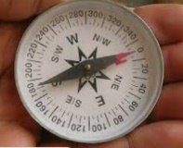
Activity 1: Introduction — FFA Value Statements Reinforce Ag Ed for All
Part 1
Directions:
Complete the following activities when instructed to do so by your teacher. Note: If you’re a virtual student, use the “Virtual Wall Activity Sheet” for Questions 1 to 4.

- How did you choose which wall to stand by?

- What were the consequences of choosing a wall?

- What about this process was unfair?

- From what you experienced, can you make a decision to go to a particular wall and feel good about that choice even if you were eliminated?

Part 2
Directions:
Complete the following activities when instructed to do so by your teacher or after you have completed the “Virtual Wall Activity Sheet.”
A value is a belief that governs our actions and decisions. It is like a compass that gives the organization direction, even in confusing times and situations. It answers the organizational question, “Which way do we go?”

- What are some examples of a value a person might have?

- What are some ways you can tell a person has that particular value? In other words, how do they communicate the value?

Part 3
Directions:
Read the article “FFA Value Statements Reinforce Ag Ed for All,” found at FFA.org/the-feed/ffa-value-statements-affirm-wide-welcome/ and complete the following activities.

National FFA Value Statement 1: We ________ and _________ every individual’s ___________ and ___________________.
- In purple, circle the two words that stand out the most to you. Why do these words stand out?

Write one way you can take action on this value this school year.
- What were your first thoughts when you read this value statement?

- What does this value statement mean to you?

National FFA Value Statement 2: We ___________ every individual’s _____________________ to advance our __________________ and the industry of agriculture.
- In green, circle the two words that stand out the most to you. Why do these words stand out?
Write one way you can take action on this value this school year.

- What were your first thoughts when you read this value statement?

- What does this value statement mean to you?

National FFA Value Statement 3: We ___________ an environment that allows every individual to _____________ and _____________________ their differences.
- In brown, circle the two words that stand out the most to you. Why do these words stand out?

Write one way you can take action on this value this school year.

- What were your first thoughts when you read this value statement?

- What does this value statement mean to you?

National FFA Value Statement 4: We create _________________ opportunities for every individual to ______________ their ______________ and __________________________ endeavors.
- In orange, circle the two words that stand out the most to you. Why do these words stand out?
Write one way you can take action on this value this school year.

- What were your first thoughts when you read this value statement?

- What does this value statement mean to you?

Why are values important for any group, organization or person?


Part 4
Directions:

Values are very important. Select a company that you have a personal interest in. Examples: Nike, Cover Girl Cosmetics, John Deere, Adidas, Lululemon, Culver’s, McDonalds, NFL, MLB, NCAA, etc.

- Company selected: _________________________________

- Using the company website, determine what its values are.

- How do you think these values drive the company in its day-to-day tasks?

- Think about the values from the company you just selected and compare those to the ones from FFA.
- What are the similarities?

- Why do you think two organizations/companies could have similarities in their values? Or why are there differences?


Develop a values statement that can be used to guide you each day.

Virtual Wall Activity Sheet
Directions:
Complete the activities below in order.

Bell Ringer: Sitting where you are, point to the direction North. Did you get it right? (Circle your answer.) Yes No
Why or why not?

Consider this: Each of us has a compass, but it’s not external. It is an internal compass that, if we follow its direction, will point us to the correct path to walk through life, despite all of life’s confusions. Today, we are going to explore three questions as they relate to the directions that organizations take. The skills you learn today are put into practice by the world’s largest companies and will help you increase your ability to think strategically and critically.

Just like a compass, we all have a true direction that we follow. Using the squares below highlight the square that you fit in the best. Note: Some of the choices will be eliminated after you choose! This is just to demonstrate a concept.
- Hair Color
North
Blonde Hair
South
Brown Hair
East
Red Hair
West
Black Hair/other hair color (ex. blue)

North
Crossover/SUV
Ex. Chevy Equinox, Chevy Tahoe
South
Compact Car
Ex. Honda Civic, Nissan Leaf
East
Pick-up Truck
Ex. Chevy Silverado, Ford F-150
West
Minivan
Ex. Chrysler Pacifica

- Vehicle Preference

Facebook
Instagram
Snapchat
TikTok

- Social Media Preference

Loyal
Creative
Free Spirit
Reserved
- I am …

STOP!

- Now that you have made your selections, use the next sheet to see if your selections made it through!
- Hair Color
North
Blonde Hair
South
Brown Hair
East
Red Hair
West
Black Hair

North
Crossover/SUV
Ex. Chevy Equinox, Chevy Tahoe
South
Compact Car
Ex. Honda Civic, Nissan Leaf
East
Pick-up Truck
Ex. Chevy Silverado, Ford F-150
West
Minivan
Ex. Chrysler Pacifica
- Vehicle Preference

Facebook
Instagram
Snapchat
TikTok
- Social Media Preference

Loyal
Creative
Free Spirit
Reserved
- I am …

- How did you choose which box to highlight?

- What were the consequences of choosing that box?

- What about this process was unfair?

- From what you experienced, can you make a decision to select a particular box and feel good about that choice even if it was eliminated?

**Now, complete Parts 2 through 4 on the “FFA Value Statements Reinforce Ag Ed for All” worksheet.**

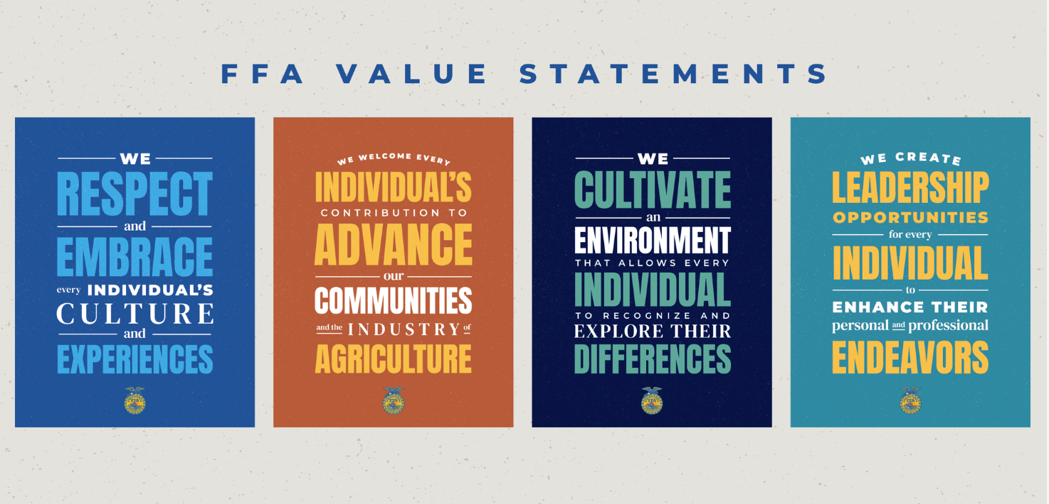
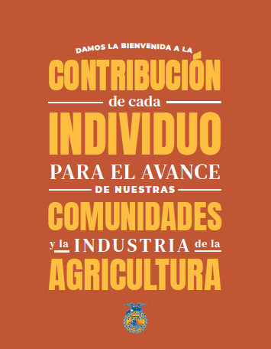
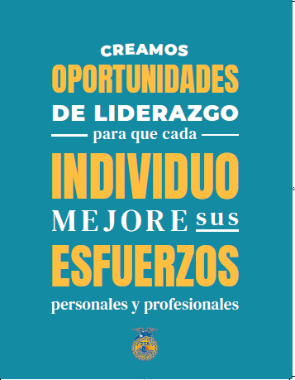
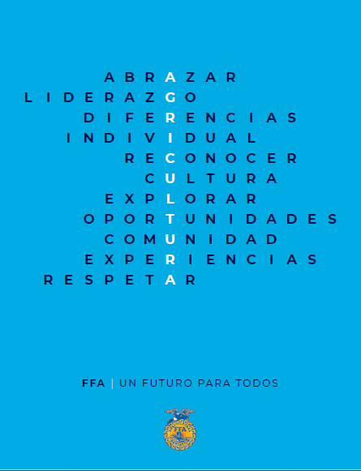
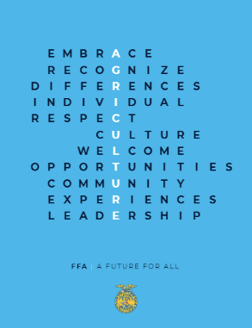
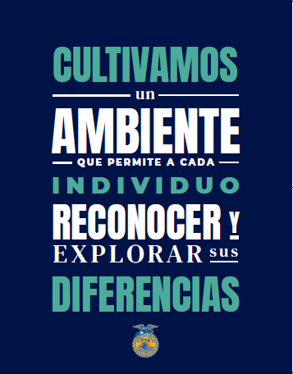
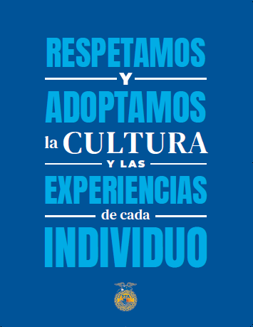

Activity 2: Values
Part 1
Directions:
- Imagine the circle below as one week.
- Divide the circle to represent the amount of time that you spend on each activity you take part in. You can divide the circle however you would like if it is representative of the time being spent on the selected activity. These activities can be anything that you do during the week: school, sleep, work, homework, religious time, music, friends, video games, athletics, clubs/organizations, family time, etc.
  - NOTE: Everything should equal 168 hours (one week). Each activity should have a different color and contain a label for the activity and time used (Example: FFA practice 3 hours).
Answer the following questions about the circle you just completed.

- Are you satisfied with the sizes of your slices? Are there any that surprise you?

- Ideally, how large would you want each slice to be?

- What could you do to change the size of some of your slices?

Part 2:
Directions:
Watch the video “Values | Ethics Defined” from Texas McCombs at https://youtu.be/SCjYaatMJuY and complete the activities below.
What are values?

Where do our values come from?

Can values change over time? Why or why not?

What role do values play in our everyday lives?

Create a statement you could share with someone that does not know anything about values and their role in our lives.

To better understand the values that you have, complete the following statements about yourself.
- I would prefer to keep to myself that …

- I will share only with my friends that …

- I would quietly take a position in favor of …

- I would argue strongly in favor of …

- I would be willing to physically fight for …

- I would be willing to die for …

Based on your responses above, identify three main values you hold in life.

- ____________________________________________________

- ____________________________________________________

- ____________________________________________________
Thinking about the chart activity and what you just learned about values, create an image below that depicts your three most important values. Use color and pictures to highlight your values.

Part 3:
Directions:
Read the FFA Creed and use a highlighter to identify the values that you find.
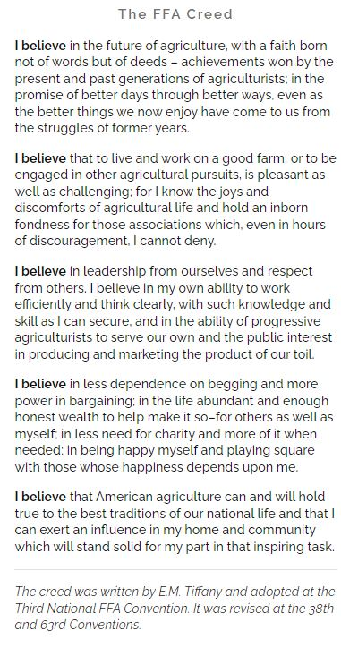
Which value do you resonate with the most?

Why?
What application does the FFA Creed have to you?
What role do you think the FFA Creed plays in the overall organization?

Directions:
Create a shield that represents your own personal creed.


Part 4
Directions:
Develop three scenarios in which your values would drive how you would react and how a friend may react based on their values. Use the values that were hung up around the classroom to inform yourself about the values of your classmates.
Scenario | My First Reaction to This Scenario | My Reaction Based on My Values | A Classmate’s Reaction Based on Their Values
Example: Your best friend posted a picture of their family on the beach in Mexico on social media. | I value family, and I appreciate that a classmate is enjoying time with their family. | Family is important to me, and I understand when family comes first for others. | I value travel and world view so I appreciate that someone is in Mexico to experience a different culture.

How can your personal values impact your future career?

Exit Ticket:

What are values?

What are two ways values impact our understanding of others?

What are three ways values play a role in our day-to-day lives?
1.

2.

3.

Activity 3: Working With Each Other (Emotions)
Part 1
Directions:
Listen to the story that your teacher reads with your classmates’ help and complete the following table.

Question | Your Thoughts
- What different feeling did Baby Bear exhibit throughout the story?

- What did _______________________ do to demonstrate their feelings?

- What about Mama Bear? What feelings did she reveal throughout the story?

- What did _______________________ do to demonstrate their feelings?

- What feelings did Papa Bear display throughout the story? How could you tell?

- What did _______________________ do to demonstrate their feelings?

Through this story, we were able to identify many personal feelings. What words can be used to collectively describe these individual feelings? When we talk about the feelings we experience daily, we can term that as what?

E _____ _____ _____ ______ ______ _____
Listen to your teacher and record the definition for this term when there is a range:
Listen to your teacher and record the definition for this term here:
Why do you think it is important to understand these terms? How can they help you moving forward?
Part 2
Directions:
In the chart below, identify seven situations you have encountered lately and the emotion(s) that you experienced.
Situations Chart
Situation | Emotion(s) Experienced
Why do you think these emotions happened in these different situations?
Do you think others in your class would have had similar emotions to these same situations? Why or why not?
Directions: Based on the emotions identified by you and your class, identify the seven emotions that resonate with you the most and list them below. Note: All seven emotions below cannot be from the previous activity.
Emotions | Draw an emoji that depicts this emotion for you. | What could/does this emotion look like for a peer? | Describe a specific situation in which this emotion would be expressed.
1.
2.
3.
4.
5.
6.
7.
Why do you think different people show different emotions in different situations?

How can understanding that others may exhibit different emotions help you when working with others?

Emotion Resonation Chart
Directions: This list includes the emotions that we have been discussing.
- Circle in purple the emotions that make you feel good.
- Strike through in red the emotions that you associate with bad feelings.
Love | Hatred | Happiness
Sadness | Joy | Anger
Fear | Excitement | Anticipation
Sorrow | Surprise | Compassion
Guilt | Jealousy | Hope
Disgust | Grief
Why do the words that you circled make you feel good?
Why do the words that you struck through make you feel bad?

Is it important to feel all emotions, both good and bad? Why or why not?

Part 3
Directions:
Use this resource, https://kidshealth.org/en/teens/stressful-feelings.html, to complete the questions to learn how to work through emotions.

- Step 1: I__________________ the E____________________
  - Why is this step important?

  - Why is it important to be aware of how you feel?

  - Why should you not hide how you feel from yourself?

  - How can knowing why you feel the way that you do be important?

  - Why should you not blame? What could happen if you do place blame?

  - YOUR FEELINGS/EMOTIONS ARE NORMAL!

- Step 2: T_________________ A_________________
  - What are three positive ways to express emotions?

  - What are three negative ways to express emotions?

- Identify three ways in which you could help change your mood and build positive emotions when presented with negative emotions.
(1)

(2)

(3)

- Always remember, it is OK to seek someone for support.

- Step 3: G_______ H________ With D_________________ E________________

Think back to the past week, and identify a scenario when you had negative emotions. | My scenario is …
How were you feeling? | I was feeling …
What could you have done differently with your emotions in this situation? | I could/should have …
How can you take action? | I can take action by …
Directions:
Read each of the scenarios below and identify the steps that should be taken to help with the negative emotions that are occurring.

Scenario 1: Maya is easily angered by the actions of her family and friends. She often takes offense when they simply offer her help and advice. Maya denies that she is ever angry or has a bad temper. Often, she tries to fight off her emotions but still appears to be angry and hateful to others.

    - What steps should be taken for Maya to work through her emotions?

Scenario 2: Xavier’s older brother seems to do well at everything he attempts. He gets good grades, is the star of the basketball team and has many friends. Xavier feels as though his parents are constantly comparing him to his older brother and that they are never satisfied with Xavier’s performance. Often, Xavier is jealous of his brother. Instead of letting his jealousy turn into anger, Xavier becomes motivated to improve his own grades and find a talent that he, too, can be good at.
    - What steps should be taken for Xavier to work through his emotions?

How can learning to work through negative emotions have a positive impact on you, those around you and your future?

Activity 4: Responding Respectfully
Directions:
Emotions can flare the most when discussing topics with people with opposing views from our own.
(1) With a partner, you are going to complete the left side of the chart below with the topic assigned by your teacher. Work with your partner to determine how to discuss the topic respectfully with the prompts provided (left side of chart).
(2) Select a topic of your choice that could be misunderstood and complete the counterclaim sentence starters (right side of chart). Counterclaims are an argument offered in opposition to another argument. Example: After a bank sues a customer for an unpaid debt, the customer counterclaims (sues back) against the bank for fraud in gaining the debt.
(3) Share the counterclaims with another peer to practice conducting respectful conversations.
Teacher Provided Topic: _______________________________ | Your Topic: ___________________________________________
Critics argue that … | Critics argue that …
While it might be true that …  Still, all in all … | While it might be true that …  Still, all in all …
Others might say that …  but I argue … | Others might say that …  but I argue …
A common argument against this position is …  but … | A common argument against this position is …  but …
It may be true …  but … | It may be true …  but …
It’s easy to think …  but when you look at the facts … | It’s easy to think …  but when you look at the facts …
It is often thought … | It is often thought …
How are these counterclaims effective in having a conversation about a topic that may be misunderstood?

Why is it important to be nonaggressive and nonconfrontational when discussing a misunderstood topic?

Activity 5: Perspective
Part 1:
Directions:
Within your class, find someone who matches a box on the bingo board below. Write the classmate’s name in the box that describes that classmate. The first student to get “Bingo!” and call it out, wins!

FIND SOMEONE WHO …
and write the classmate’s name in the box.

Has blue eyes | Plays a sport in school | Has a pet | Likes chocolate | Plays a musical instrument
Is left-handed | Was born in the same month as you | Has never flown on a plane | Has traveled outside of the United States | Likes the same genre of music
Has the same shoe size as you | Is the same height as you | FREE SPACE | Has a name that starts with the same letter as yours | Has the same hair color
Has the same SAE as you | Has competed in the same CDE | Likes the same genre of books | Has the same favorite color | Has the same type of phone
Likes the same type of food | Likes the same snacks | Has been to a national park | Has been to Washington D.C. | Has received a Greenhand or Discovery FFA Degree

Identify three cool facts you learned about your peers.

1.

2.

3.
Identify two unique differences you found between you and your peers.

1.

2.
What does this activity say about your class?

Part 2:
Directions:
- Select and highlight two questions from each column below. Answer all six questions in the box with the question.
- When your teacher says “Go!” find six different classmates and share the question you selected and your answer. Then, listen respectfully to the question and answer of your classmate. As you rotate, write the question, a summary of the answer and the person’s name you talked with on the “Rotation Answer Chart” worksheet. You should share all six questions to complete the task, meaning you should talk with six different classmates and share each question and answer you selected once.

Column 1 | Column 2 | Column 3
What is your most prized possession and why? | What is the best place you have ever traveled to? | If you could change one thing about school, what would it be and why?
What is the most important decision you have ever made so far? | What do you like/dislike that everyone else seems to dislike/like? | Do you speak any other languages? Which languages would you most like to learn and why?
What is something that always makes you smile? Why? | What is the best meal you have ever eaten? What made it the best? | If you could take a class with any expert, who would you choose and why?
What do you wish more people understood about you? | What is one question you wish people would ask you less? | Do you prefer to work individually or in groups? Why?

Rotation Answer Chart

Student Name | Question | Answer Summary
What is one thing you will take away from this activity, and how will you apply it?

Part 3
Directions:
Travel to each station in the room with a partner and follow the instructions. Record information below.
Station 1 | - What did you find to be the most challenging? Why?  - What types of accommodations would have helped you perform your assigned tasks?
Station 2 | - Did your mixture taste correct? Why or why not?  - What did you find to be the most challenging? Why?  - What types of accommodations would have helped you perform your assigned tasks?
Station 3 | - What did you find to be the most challenging? Why?  - What types of accommodations would have helped you perform your assigned task?
Why are accommodations important to consider and have?

Station Instructions (to be cut up and placed around the room with needed supplies)
Station 1
Materials | - Masking tape/painter’s tape
Partner? | - Each person will participate at the same time.
Directions | - Using the provided tape, tape down your thumbs to the palm of your hands so they are no longer able to move freely.  - Now proceed to do the following:  - Open the door.  - Type a text message or email.  - Blow your nose.  - Get a drink of water.  - Respond to the questions on your answer sheet.
Station 2
Materials | - Blindfold  - Plastic cups  - Measuring cups  - Measuring spoons  - Drink mix powder  - Water  - Pitcher (or other large drink-type container)  - Mixing spoon
Partner? | - One person will lead, one will be blindfolded
Directions | - One partner will tie the blindfold over their eyes, ensuring they are not able to see anything.  - The partner not wearing the blindfold is going to verbally guide the blindfolded partner to complete the tasks below. Remember: YOU MAY NOT LEAD YOUR PARTNER WITH ANYTHING OTHER THAN YOUR VOICE!  - Locate the table that contains the first set of materials.  - Once you arrive, the student wearing the blindfold needs to locate the empty container.  - Locate the water.  - Locate the measuring cup.  - Measure 1.5 cups of water into the empty container.  - Remove the blindfold and place the blindfold on the other partner who had been the guide.  - The partner not wearing the blindfold is going to verbally guide the blindfolded partner to complete the tasks below. Remember: YOU MAY NOT LEAD YOUR PARTNER WITH ANYTHING OTHER THAN YOUR VOICE!  - Pick up the cup of water your partner just filled with water.  - Locate the table that contains the second set of materials.  - Locate the measuring spoons.  - Measure 2 tablespoons of drink mix.  - Add drink mix to water.  - Mix without spilling.  - Remove the blindfold.  - Take two empty cups and pour a drink from your mixture.  - Sample your mixture.  - Respond to the questions on your answer sheet.
Station 3
Materials | - Technology device  - Access this website: http://geon.github.io/programming/2016/03/03/dsxyliea  - Pencil/Pen  - Lined paper
Partner? | - Each person will participate at the same time.
Directions | - Collect a piece of lined paper and a writing utensil.  - Do not talk during this activity.  - Open the website listed in the materials.  - Read and write the first sentence on the webpage.  - Respond to the questions on your answer sheet.
Activity 6: Who Decides at the Local Level?
Directions:
Today, you will assume the role of a stakeholder in the local community. (The term “stakeholder” is defined as a person with a specific interest about a subject.) Your class will turn into a community during this activity.
All stakeholders of the community will meet together on ______________ (date due).
It is your job to make sure your opinion on the essential question is understood by others attending the community meeting. Your group will research the essential question and prepare a presentation that represents the stance of the role you have been assigned. This presentation will be shared with the community. You will then ask questions of the other groups. Using the diagram provided below, fill in your notes to prepare for the community meeting. Be sure to use reputable sources and think about the essential question from all angles to prepare yourself for the questions you may receive. You will be required to speak for three to five minutes. You must cover the following topics as they relate to the essential question: plants, animals, food and the environment.
Essential Question: Who should be able to direct the future of the agriculture industry?
Stakeholder Name:

__________________________
How do you, as a stakeholder, feel about this question? (Use the stakeholder profile sheet to answer this question.)
What is your opinion about the way agriculture impacts the environment and local ecosystems?
What is your opinion about the way animals are produced and cared for?
What is your opinion about the way plants are grown, harvested and managed?
What is your opinion about the way food is produced and packaged?
Other Notes
Stakeholder Name:
____________________

Directions:
Using the boxes below, record information, research points, questions, etc. that you can use to guide your questions for other stakeholders, your responses to other stakeholders and your overall understanding of each stakeholder. (Put yourself in that stakeholder’s “shoes” when researching information for the boxes.)

Sarah
Marie
Davi (owns 15,000 acres)
Xander
Damian

Marcus
Anya (Local Grocery Store Owner)

Who Decides at the Local Level? Profile Sheet


Sarah

- Healthy food is important.
- Food must be affordable.
- Prefers products that are
  - Cage free/free range.
  - Organic.
  - Non-GMO.
  - Natural.
- Grows herbs and spices in a window box.
Marie

- Concerned with conventional farming practices:
  - Soil erosion
  - Chemical runoff
- Works with biodiversity of plants and animals and concerned with the impact agriculture has
- Consumes little red meat
- Agrees with no-till practices in farming
- Does not agree with farm subsidies and feels a farmer should be paid the actual price of a product (If it costs $8 to produce a gallon of milk, that is what the consumer should pay.)
Davi (owns 15,000 acres)

- Sells grain to the local elevator, which can then be
  - Sold all over the U.S.
  - Available for export
  - Available for use in animal feed
- Concerned with preserving the soil and not contaminating the waterways
- Uses commercial pesticides
- Plants GMO seed
- Owns a confinement swine operation
Xander

- Owns a major food production company
- Concerned with global image
- Turning a profit is important.
- Raw product can be sourced from any reputable source.
- Provides product to stores all over the world/nation.
Damian

- Does not believe in the use of animals and animal byproducts
- Donates to animal rights organizations
- Does not agree with modern farming practices
- Maintains a small personal greenhouse for some vegetable production
Marcus

- Does not agree with using chemicals on food products
- Feels small markets/farmers markets are the best place to sell and purchase food products
- Does not agree with confined feeding operations
- Plants non-GMO grain
- Uses no-till farming practices

Anya (Local Grocery Store Owner)

- Concerned with turning a profit
- Needs to meet the food purchasing needs of all by carrying a variety of products that have been produced in various ways to meet the choices of customers
- Must carry products that range in price
- Has local connections and family
- Sources products both locally and from bigger companies

Where Do We Go from Here?
Directions:
After going through the forum, complete the following activity. Be ready to share your responses with the class!

- Circle, in green, how you felt throughout this experience.
- Circle, in blue, how you feel at the conclusion of this experience.

3. Record two key thoughts you had during this process.
What was your group’s greatest accomplishment during this experience? Why?
What was your group’s greatest challenge during this experience? Why?
Describe why you had these thoughts and feelings during the activity and why you feel as you do now.
What, specifically, will you take away from this experience? How will you use this in the future?
Answer the essential question and explain the thought process behind your answer. Who should be able to direct the future of the agriculture industry?

Activity Rubric
Category | Excellent  (20–15 points) | Good  (14–10 points) | Needs Improvement  (9–5 points) | Poor  (5–0 points) | Points Earned
Information | A minimum of five facts per category was presented clearly and accurately and covered animals, food, plants and the environment. | A minimum of four facts per category was presented accurately and covered animals, food, plants and the environment but lacked clarity. | A minimum of three facts for each category was presented. Information lacked accuracy and clarity. One of the required categories (food, animals, plants or the environment) was missing. | Less than three facts for each category were presented. Information significantly lacked clarity and accuracy. Multiple required categories (animal, plant, food and the environment) were left out.
Organization | All information is clearly tied to an idea and organized in a tight and logical fashion. | 75% of the discussion points were clearly tied to an idea and organized in a tight, logical fashion. | 50% of the discussion points were clearly tied to an idea but had limited organization. | Less than 50% of the discussion points were tied to an idea, and all arguments lacked organization.
Participation | Participated throughout the meeting by presenting and asking and answering questions; engaged in final discussion | Participated throughout the experience but responses were short and somewhat limited | Participated in many of the aspects of the meeting but did not participate in one of the parts (presentation, questioning, discussion) | Little to no participation in two or more components (presentation, questioning, discussion) of the meeting
Effectiveness of Presentation  (Creativity, quality and power, clear with right pace and word pronunciation, no distractions, appropriate gestures, poised) | Preparation is very evident with little distraction from content due to hand gestures, posture or word pronunciation. | Some preparation is evident. Some distracting hand gestures, posture or word pronunciation was used. | Little preparation is evident. Distracting hand gestures, posture and word pronunciation were used throughout presentation. | No preparation is evident. Many distracting hand gestures, postures and word pronunciations were used.
Time: Two to five minutes | Presented for four to five minutes | Presented for three to four minutes or went over time | Presented for two to three minutes | Presented for less than two minutes
Respect | All statements, body language and responses were respectful. Presenters used appropriate language. | Statements and responses were respectful. Presenters used appropriate language, but once or twice body language was not appropriate. | Most statements and responses were respectful. Presenters used appropriate language, but there was one sarcastic remark. | Statements, responses and/or body language were borderline appropriate. Some sarcastic remarks were made.
Questions  - Appropriate response  - Knowledge based on facts/research  - Appropriate questions asked of others | Responses and questions were clear, concise and based on facts, showing research had been done. | Responses and questions were clear and concise; however, facts and research may have been lacking. | Responses and questions were not quite clear or concise. Little to no research-based facts were utilized. | Responses were very vague. Responses utilized little to no research-based facts to support statements.

Comments: Total: ____________
Activity 7: Communication Is Key
Part 1
Directions:
In the box below, use each of the letters in the word “influence” and identify for each letter one word that comes to mind when you hear the phrase “to influence others, you must …” See the image to the right for an example.
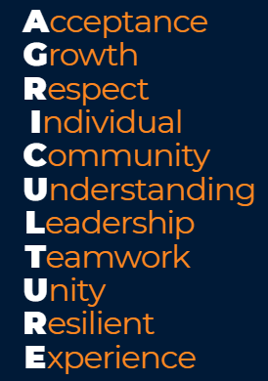
I

N

F

L

U

E

N

C

E
What does the word “influence” have to do with communication?
Think back through the past week and write down a scenario when you tried to influence someone. This could be a family member, friend or teacher.

What are the four types of influential communication? Unscramble the following words to find out! Be sure to include two examples as a reference.
Scrambled Term | Unscrambled Term | Example Shared in Class by Your Teacher | Develop Your Own Example
- mminucaocti

- sbeeifl

- tttseduia

- nnnttsiioe

- noticsa

- Let’s look at three techniques for being persuasive by matching the term with the definition. Then, to the left of the term in the box provided, draw an image to help you remember the term.

Logic/Logos These statements bring about strong feelings through personal references.

Emotion/Pathos These statements are supported by evidence such as facts, testimonials and expert opinion.

Credibility/Ethos These statements establish the communicator as believable and trustworthy through competence and sincerity.

- Using the three pieces of persuasive communication (logic, emotion, credibility), identify which method of influencing is being described in each scenario.

- ______________ According to the United States Department of Agriculture, “poor nutrition is a leading cause of illness in the United States.”
- ______________ Eminent domain took part of my family farm to put in a highway.
- ______________ I am a doctor of veterinary medicine and specialize in small animal nutrition. When considering the feline diet, protein is an important component to proper nutrition.
Using the space below, create a concept map to depict the relationship among the terms we have used in the lesson today. Check out this resource from UNC to learn more about concept maps.

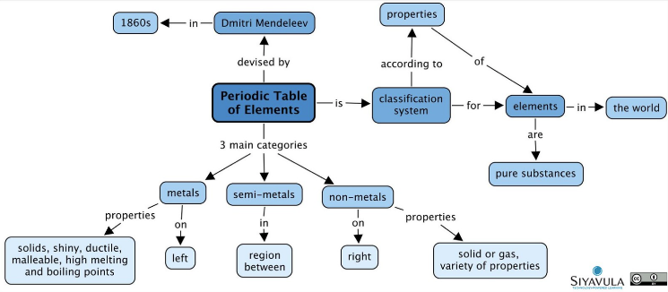
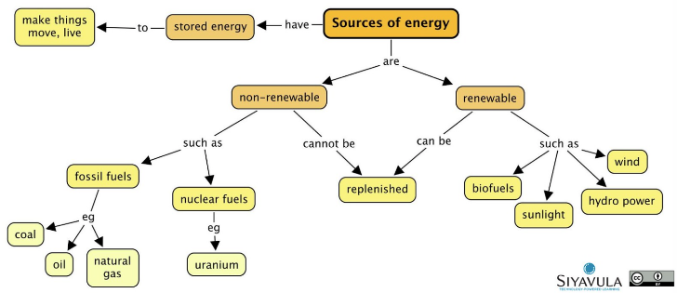

Part 2
Directions:
Using the space below, plan a two- to 4-minute podcast about a misconception that exists in the agriculture industry. You may pick any misconception that you feel strongly about.
- Be sure to include statements that utilize logic, emotion and credibility while keeping in mind the way in which communication can influence others when developing your podcast.
- Be sure your podcast is organized in a manner that flows and has a beginning, middle and end to your topic to ensure clarity and understanding from your listener.

- Topic: ________________________________________________________________________________________________________________
  - Logic

  - Emotion

  - Credibility

  - How will I convince others?

- Introduction:

- Middle:

- Conclusion:
Podcast Rubric
Area | 4 Points | 3 Points | 2 Points | 1 Point
Content | All content is accurate. There are no factual errors. | Most of the content is accurate, but there is one piece of information that seems inaccurate. | The content is generally accurate and interview based, but one piece of information is clearly inaccurate. | Content is confusing or contains more than one factual error.
Clarity and Creativity | The podcast is easy to understand, and all elements are clearly written or spoken. Creativity was used. | The podcast is easy to understand, and most elements are clearly written or spoken. Some creativity was used. | The podcast is hard to understand with very quiet speaking or very hard to read writing. Little creativity was used. | The podcast is hard to understand, and one cannot follow the thought process. No creativity was used.
Narration and Preparedness | The podcast is clearly rehearsed and presented with no mistakes.  Student spoke slowly and clear. | One mistake is heard in the podcast. | Two mistakes are heard in the podcast. | Three or more mistakes are heard in the podcast.  Student spoke very fast and was unclear.
Logic, Emotion and Credibility Statements | All three statements were included fluidly. | Two statements were included fluently. | One statement was included fluently. | Logic, credibility and emotion statements were not included or were extremely weak.
Time | Video was two to four minutes in length. |  |  | Student was either under or over the allotted time frame.

Comments: Total: ________/20

Activity 8: Backgrounds
Directions:
Today, you will have the opportunity to learn more about some amazing agriculturists and how their backgrounds have contributed to the industry. Follow the steps below to complete this activity.

- Who will you research (select one a person from the list and write the name on the line): ____________________________________________________
A World Food Prize Laureate Dr. Temple Grandin Norman Borlaug
George Washington Carver A Wonder Woman of Agriculture

- Using the template below, develop a LinkedIn profile for the scientist you selected.
  - Tip: LinkedIn is a professional networking tool that allows professionals to make meaningful connections in the industry.

Image
Name: _______________________________________
Current Title: __________________________________________________________________
Position Description:

Brief description of the impact on the agriculture industry.
About:
- Where did this person grow up?

- What is/was this person’s home like?

- What struggles did this person have to overcome to get to where they are today?

- What about this person’s background do you think led them to the field of study they are now known for?
List the skills this person has:
Message
Using this space, develop a collage that depicts how different backgrounds come together to impact an industry that society relies on.
How can/could your personal background impact the agriculture industry?
How do different backgrounds lead to advancements in any industry, especially agriculture?
Thinking about the individual you just highlighted, what about this person’s background stood out to you? What personal struggle did this person have to overcome?
Activity 9: What to Ask
Part 1
Directions:
Using the resource “Survey Questions 101: Do You Make These 7 Mistakes?” (https://www.qualtrics.com/blog/writing-survey-questions/), complete the following activities to learn about surveys and their development.

Read the article “Survey Questions 101: Do You Make These 7 Mistakes?” and identify each of the mistakes.

- ___________________________________________________________________________________
- ___________________________________________________________________________________
- ___________________________________________________________________________________
- ___________________________________________________________________________________
- ___________________________________________________________________________________
- ___________________________________________________________________________________
- ___________________________________________________________________________________
- How many years have you played basketball?

- 1-2 years
- 2-3 years
- 3-4 years
- 4-5 years
- 5-6 years

2. Which instrument is your favorite?

- Saxophone
- Violin
- Flute
- Cello
- Triangle

3. To what level do you like Ben and Jerry’s Ice Cream?

- Like a lot
- Like
- Neutral
- Dislike
- Dislike a lot

- What is your favorite food?

- Which shoe is the most attractive and best for basketball?

- Air Jordan
- AND1
- Nike
- Adidas
- Other

- Which type of animal do you own?

- Cat
- Dog
- Rabbit
- Hamster
- Other

Why is it important to develop well-written questions for a survey?

Using what you read in the resource above, examine the questions below and complete the following tasks: (1) Draw a green circle around the questions written correctly, (2) draw a red circle around the questions written incorrectly and (3) in purple, correct the questions that you identified as poorly written.
Part 2
Directions:
Follow the steps below to plan your own survey.
- Determine the topic for your survey that will answer a question. Select a topic of interest to you and the question you will aim to answer. Examples: cloning in animals (Is cloning sustainable?), business that needs to be added to your local community (What type of business would benefit those with pets?), a need for your sports team/musical organization (What major resource is lacking?), etc.

Topic: _________________________________________________________________________________

Question: _____________________________________________________________________

- Who will take your survey? (Ex. Parents, community members, teachers, etc.)

Target Audience: _______________________________________________________

- Write out the demographic information you will ask. (Ex. Age, gender, education)

- Develop seven or more survey questions in the space provided.

- Have a peer review your questions and provide feedback.
- Make any necessary changes.
- Place your questions in a format that will allow for distribution. (Ex. A Word document for a paper survey or an online format like SurveyMonkey (does require a free account)
What was most challenging about creating your survey?
What did you enjoy the most about this process?
Part 3
Directions:
Now that you have gathered your data, let’s determine your results.

- Topic: _____________________________________________________________________
- Question: _________________________________________________________________
- Who took your survey?

- List the demographic information results here:

- What are the major findings of the survey?

- Did the demographics and responses show any trends in results? (Ex. one age group had similar viewpoints)

- What are the overall conclusions you can draw from the survey?

- Develop a final statement based on the results and conclusions of the survey.
How have the results of your survey influenced your thoughts on the topic?

Why is it important to gather information before making a decision?
Information/Data for Analysis (from an Agriscience Research Project)
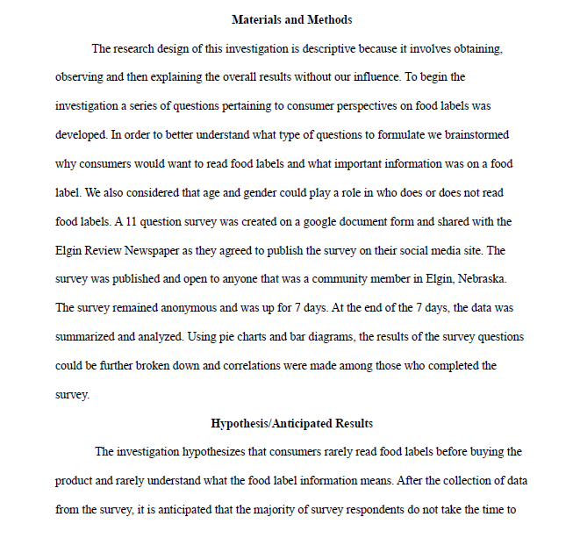
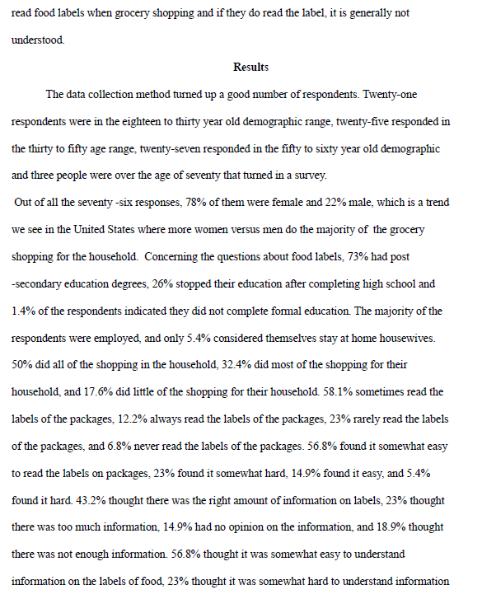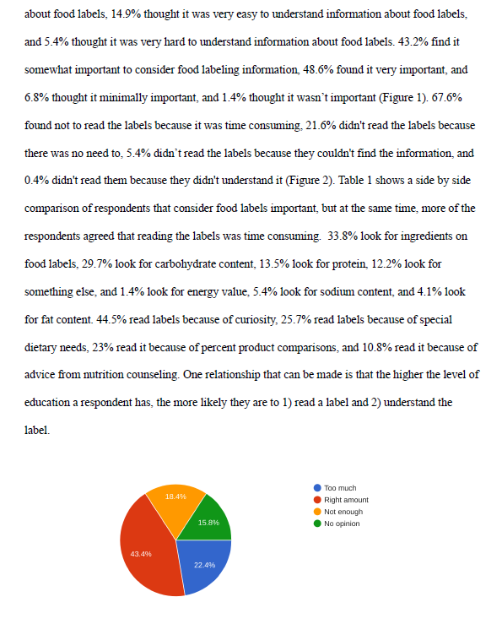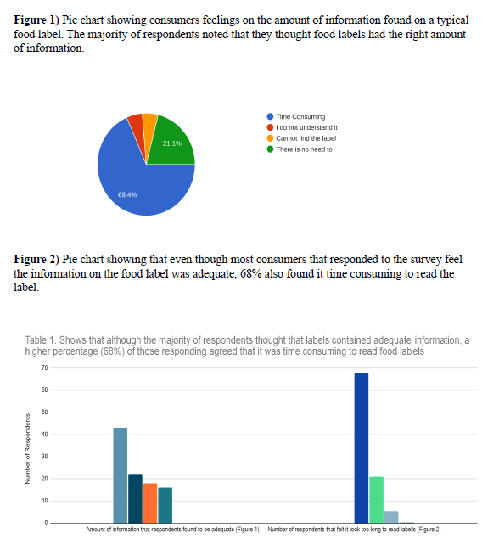

Activity 10: Contributions for Advancement
Directions:
Follow the steps below to interview three individuals about their thoughts on an important agricultural topic (select your topic below or one assigned by your teacher).
2. Who will you interview?
- One adult from school (administrator, non-agriculture teacher, custodian, etc.)
  - Name: ________________________________

- One community member
  - Name: ________________________________

- One member of your family
  - Name: ________________________________

- One classmate
  - Name: ________________________________
*Consider selecting individuals of different ages,
backgrounds, etc.

- Circle the topic you are researching:

- CRISPR technology
- Artificial intelligence usage in agricultural practices
- Food labeling in the meat industry
- Animal-based meat vs. meat alternatives
- You own or teacher selected topic:

______________________________________________

Interview Questions:

- What is your name?

- How old are you?

- Do you support [insert your topic]?
  - Why or why not?

- Why do you think [insert topic] is so controversial?

- What would you say to someone with an opposing view to you?

- What impact do you think [insert topic] has/could have/will have on the agriculture industry?

- What impact do you think [insert topic] has/could have/will have on the overall economy?

- Is there anything else you would like to add?

- Thank you for taking time out of your day to discuss [insert topic] with me. I appreciate your thoughts. Have a wonderful day!
Interview tips/tricks:
- Be sure to share the topic with the person you would like to interview BEFORE the interview.

- Consider sending the questions to the people
you are going to interview in advance so they have time to think about the questions that will be asked.

- Make sure you set enough time aside for the conversation.

- Don’t be afraid to ask questions that come to mind based on what is shared.

- The interview should feel like a conversation.

- Host the interview in a place that is free of distraction.

- Take good notes!

Directions:
Now that you have completed your interviews, think through all the responses you received. Develop a 90-second reel/video about what you have learned. Be sure to include the following:
- Did you see any major differences in responses based on age, gender, family vs. community vs. school vs. peer, etc.?
- What conclusions can you draw from the responses you received about the topic?
- How has your opinion of the topic been impacted based upon what you learned?
- Why do you think it is important to gain the viewpoints of different people?
- Overall, how did this process impact you?
- Include anything else you want to add.

Video Rubric
Area | 4 Points | 3 Points | 2 Points | 1 Point
Content | All content is accurate and based on the interview. There are no factual errors. | Most of the content is accurate and interview based, but there is one piece of information that seems inaccurate. | The content is generally accurate and interview based, but one piece of information is clearly inaccurate. | Content is confusing or contains more than one factual error.
Clarity and Creativity | The video is easy to understand, and all elements are clearly written or spoken. Creativity was used. | The video is easy to understand, and most elements are clearly written or spoken. Some creativity was used. | The video is hard to understand with very quiet speaking or very hard to read writing. Little creativity was used. | The video is hard to understand, and one cannot follow the thought process. No creativity was used.
Narration and Preparedness | The video is clearly rehearsed and presented with no mistakes.  Student spoke slowly and clear. | One mistake is heard in the video. | Two mistakes are heard in the video. | Three or more mistakes are heard in the video.  Student spoke very fast and was unclear.
Time | Video was 90 to 120 seconds in length. |  |  | Student was either under or over the allotted time frame.
Total: _____________
Comments:

___________________________________________________________________________________________________

___________________________________________________________________________________________________

___________________________________________________________________________________________________

___________________________________________________________________________________________________

___________________________________________________________________________________________________

___________________________________________________________________________________________________

___________________________________________________________________________________________________

___________________________________________________________________________________________________

Activity 11: It Is All About Partnerships and Relationships
Part 1
Directions:
Read each scenario below and consider each piece to learn how to think through different situations.
Scenario | Processing
In two months, the annual sports banquet will be a celebration of all that has been accomplished in the semester. To help with funds, it has been recommended that each grade level, except for the seniors, should pitch in items. (Freshman: side dishes, Sophomores: desserts, Juniors: Drinks, Seniors: nothing)  Many students are upset that the seniors are not being asked to pitch in anything while the seniors agree with the assignments. Use the questions to think through this situation. | - My first thought is …  - What are the different opinions?  - What can I control?  - What can I do to keep things moving forward?  - What emotions do I need to be wary of?  - How can I unite everyone?  - What should I include in a response that will strengthen my partnership/relationship with the individuals with whom I am discussing this situation?  - My response:
This week in English class you were assigned to a group/group project where you will have to work to create a skit based on your latest read in class, Great Expectations by Charles Dickens. Some of the individuals that have been assigned to your group are not people who you typically choose to work with. | - My first thought is …  - What are the different opinions?  - What can I control?  - What can I do to keep things moving forward?  - What emotions do I need to be wary of?  - How can I unite everyone?  - What should I include in a response that will strengthen my partnership/relationship with the individuals with whom I am discussing this situation?  - My response:
You work a part-time job after school and on weekends. One month ago, you asked for this weekend off but noticed you have been scheduled due to the staffing shortage. | - My first thought is …  - What are the different opinions?  - What can I control?  - What can I do to keep things moving forward?  - What emotions do I need to be wary of?  - How can I unite everyone?  - What should I include in a response that will strengthen my partnership/relationship with the individuals with whom I am discussing this situation?  - My response:

What did you find to be the most challenging during this activity?

Part 2
Directions:
Using the space provided, develop your own scenario (can be based on something you are working through now) and think through the different pieces to ensure a response that will build or foster relationships/partnerships.

Scenario | Response
- My first thought is …

- What are the different opinions?

- What can I control?

- What can I do to keep things moving forward?

- What emotions do I need to be wary of?

- How can I unite everyone?

- What should I include in a response that will strengthen my partnership/relationship with the individuals with whom I am discussing this situation?

- My response:

Why might a process like this help you to build partnerships and relationships with others?

Activity 12: How Everyone Contributes
Directions:
Watch and/or read each story below and complete the activities.

Story | Synthesis | Reflections and Thoughts
Read the article “FFA Alumna Shares Her Mental Health Struggle.” | - What did Maddison do when she felt helpless?  - What is the second leading cause of death in individuals aged 10 to 24? ____________________  - What has helped Maddison through her struggles?
Watch the video “Dairy Heifers SAE | Jonathan Jones.” | - How does Jonathan communicate?  - What challenges do you think arise?  - What skills has Jonathan gained from his SAE?
Read the article “Differently Abled, Similarly Involved.” | - What observance happens on December 3 each year?  - What is the purpose of this observance?  - How has the agriculture industry impacted each of these individuals?
Read the article “FFA Member Enjoys the Show.” | - Where does Caroline live?  - How has Caroline become involved in the agriculture industry?  - What impact has the agriculture industry had on Caroline?

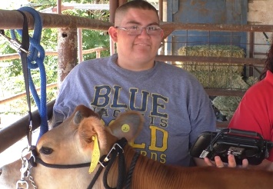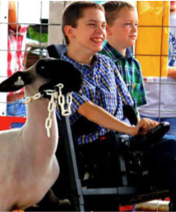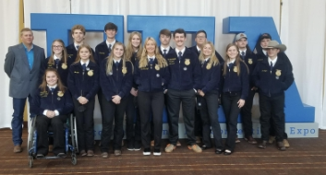
How are each of the individuals similar?

How has each of the individuals above contributed to agriculture in their own way?
How would society and the agriculture industry be different if individuals from all backgrounds, abilities and professional experiences were not a part of the industry?
What are three things you learned through this activity?

What are two things you will share will a friend or family member about what you have learned?

Summarize what you have learned in one word.
How does your unique perspective and/or background contribute to the agriculture industry?

Activity 13: Gaining a Global Perspective
Directions:
Today, you will assume the role of a country. Your class will turn into a global summit meeting during this activity. All countries will meet together on ______________ (date due). It is your job to make sure your opinion on the essential question is understood by others attending the summit. Your group will research the essential question and prepare a presentation that represents the stance of the role you have been assigned. This presentation will be shared at the summit. You will then ask questions of the other groups. Using the diagram provided below, fill in your notes to prepare for the summit meeting. Be sure to use reputable sources and think about the essential question from all angles to prepare yourself for the questions you may receive. You will be required to speak for three to five minutes. You must cover the following topics as they relate to the essential question: plants, animals, food and the environment.
Essential Question:
Which country should direct the future of the agriculture industry for our entire world?
How do you, as a country, feel about this question? (Use the stakeholder profile sheet to help answer this question.)
Describe how agriculture impacts the environment and local ecosystems.
What does animal production in your country look like?
What is the overall crop and plant production in your country?
How is food produced and packaged in your country?
Other Notes:
Country:
____________________
Describe the consumers in your country. How many are there? What food trends, preferences and regulations exist?

Directions:
Using the boxes below, record information, research points, questions, etc. that you can use to guide your questions for other countries, your responses to other countries and your overall understanding of each country. (Put yourself in that country’s “shoes” when researching information for the boxes.)
Country 1: _________________

Country 5: _________________
Country 4: _________________
Country 2: ________________

Country 3: ___________________

Country 6: __________________
Country 7: _____________________
Summarize your thoughts here by answering the essential question.
Who Decides at the Global Level? Profile Sheet
France
Commodities: wheat, corn, barley, oats

Government Structure:
Who do they trade with?

Culture Description:
Brazil
Commodities: coffee, soybeans, wheat, rice, corn, sugar cane, cocoa, citrus, beef

Government Structure:
Who do they trade with?

Culture Description:
Democratic Republic of Congo
Commodities: cassava, plantains, maize, coffee, sugar cane, cocoa, rice, rubber

Government Structure:
Who do they trade with?

Culture Description:
Philippines
Commodities: rice, corn, coconut, sugar cane, bananas, pineapple, coffee, mangoes, tobacco

Government Structure:
Who do they trade with?

Culture Description:
Russia
Commodities: wheat, barley, sunflower seed, oats potatoes, rye

Government Structure:
Who do they trade with?

Culture Description:

India
Commodities: milk, pulses, jute, rice, sugar cane, cotton, spices

Government Structure:
Who do they trade with?

Culture Description:

Turkey
Commodities: hazelnuts, chestnuts, apricots, figs, cherries, olives, quinces, tobacco, tea

Government Structure:
Who do they trade with?

Culture Description:
Japan
Commodities: rice, soybeans, wheat, barley

Government Structure:
Who do they trade with?

Culture Description:

Australia
Commodities: beef, wool, cotton, wheat, mutton, lamb

Government Structure:
Who do they trade with?

Culture Description:
China
Commodities: rice, millet, barley, cotton, potatoes, sugar beets, oilseeds, soybeans, corn

Government Structure:
Who do they trade with?

Culture Description:

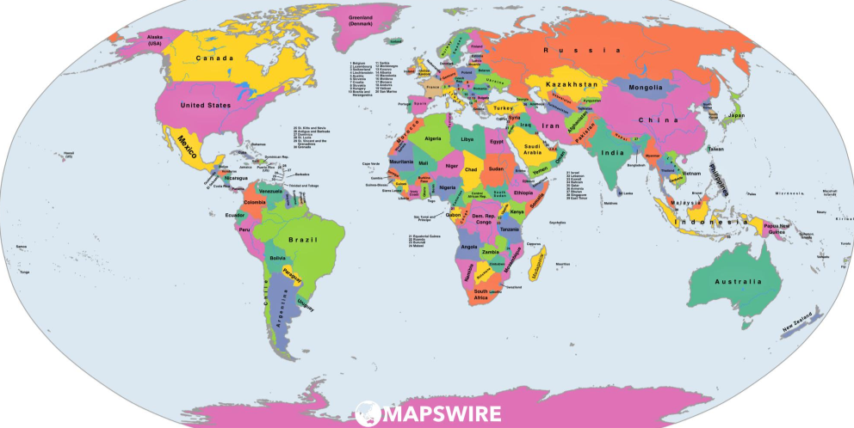
Where Do We Go from Here?
Directions:
After going through the forum, complete the following activity. Be ready to share your responses with the class!
- Circle, in green, how you felt throughout this experience.
- Circle, in blue, how you feel at the conclusion of this experience.

3. Record two key thoughts you had during this process.
What was your group’s greatest accomplishment during this experience? Why?
What was your group’s greatest challenge during this experience? Why?
Describe why you had these thoughts and feelings during the activity and why you feel as you do now.
What, specifically, will you take away from this experience? How will you use this in the future?
Answer the essential question and explain the thought process behind your answer. Which country should direct the future of the agriculture industry?

Activity Rubric
Category | Excellent  (20–15 points) | Good  (14–10 points) | Needs Improvement  (9–5 points) | Poor  (5–0 points) | Points Earned
Information | A minimum of five facts per category was presented clearly and accurately and covered animals, food, plants and the environment. | A minimum of four facts per category was presented accurately and covered animals, food, plants and the environment but lacked clarity. | A minimum of three facts for each category was presented. Information lacked accuracy and clarity. One of the required categories (food, animals, plants or the environment) was missing. | Less than three facts for each category were presented. Information significantly lacked clarity and accuracy. Multiple required categories (animal, plant, food and the environment) were left out.
Organization | All information is clearly tied to an idea and organized in a tight and logical fashion. | 75% of the discussion points were clearly tied to an idea and organized in a tight, logical fashion. | 50% of the discussion points were clearly tied to an idea but had limited organization. | Less than 50% of the discussion points were tied to an idea, and all arguments lacked organization.
Participation | Participated throughout the meeting by presenting and asking and answering questions; engaged in final discussion | Participated throughout the experience but responses were short and somewhat limited | Participated in many of the aspects of the meeting but did not participate in one of the parts (presentation, questioning, discussion) | Little to no participation in two or more components (presentation, questioning, discussion) of the meeting
Effectiveness of Presentation  (Creativity, quality and power, clear with right pace and word pronunciation, no distractions, appropriate gestures, poised) | Preparation is very evident with little distraction from content due to hand gestures, posture or word pronunciation. | Some preparation is evident. Some distracting hand gestures, posture or word pronunciation was used. | Little preparation is evident. Distracting hand gestures, posture and word pronunciation were used throughout the presentation. | No preparation is evident.  Many distracting hand gestures, postures and word pronunciations were used.
Time: Two to five minutes | Presented for four to five minutes | Presented for three to four minutes | Presented for two to three minutes | Presented for less than two minutes
Respect | All statements, body language and responses were respectful. Presenters used appropriate language. | Statements and responses were respectful. Presenters used appropriate language, but once or twice body language was not appropriate. | Most statements and responses were respectful. Presenters used appropriate language, but there was one sarcastic remark. | Statements, responses and/or body language were borderline appropriate. Some sarcastic remarks were made.
Questions  - Appropriate response  - Knowledge based on facts/research  - Appropriate questions asked of others | Responses and questions were clear, concise and based on facts, showing research had been done. | Responses and questions were clear and concise; however, facts and research may have been lacking. | Responses and questions were not quite clear or concise. Little to no research-based facts were utilized. | Responses were very vague. Responses utilized little to no research-based facts to support statements.
Total: ____________
Comments:
Activity 14: Company Influence in Agriculture
Complete the following activities for each of the companies listed below to learn about how inclusivity is woven throughout the agriculture industry.

Company: Tractor Supply Co. Logo:

In your own words, describe the mission of this company.

Based on the mission, what role does this company play in the agriculture industry?
Why is diversity and inclusion so important to this company?

How does having a diverse and equitable culture play a role in the company’s mission and goals?

Company: John Deere Logo:

In your own words, describe the mission of this company.
Based on the mission, what role does this company play in the agriculture industry?
Why is diversity and inclusion so important to this company?

How does having a diverse and equitable culture play a role in the company’s mission and goals?

Company: CHS Logo:

In your own words, describe the mission of this company.
Based on the mission, what role does this company play in the agriculture industry?
Why is diversity and inclusion so important to this company?

How does having a diverse and equitable culture play a role in the company’s mission and goals?

How does this impact you?
Summarize why these companies see such value in diversity and inclusion within their companies.
How does this type of diversity and inclusion in companies impact the agriculture industry?
Company: Bayer Logo:

In your own words, describe the mission of this company.
Based on the mission, what role does this company play in the agriculture industry?
Why is diversity and inclusion so important to this company?

How does having a diverse and equitable culture play a role in the company’s mission and goals?

Part 2:
Directions:
Select a company of your choice to research the equity, diversity and inclusivity that exists in the company. Then, complete the questions.
What does equity, diversity and inclusion look like for your school district? How could it be improved based upon what you have learned and seen from companies?
How could what you have learned be applied to your school to make it more inclusive of everyone?
What is one thing you can do this week to be more inclusive of those around you in your classroom, school, team, organization or community?
Are there any differences that exist between the company you chose and the agriculturally based ones you previously explored? Why or why not?
Company of Your Choice: Logo:

Industry this company works in: ________________________

In your own words, describe the mission of this company.
Based on the mission, what role does this company play in its industry?
Why is diversity and inclusion so important to this company?

How does having a diverse and equitable culture play a role in the company’s mission and goals?

Activity 15: Conclusion — Put Thoughts to Words, Words to Action
Directions:
Select an event you have the greatest interest in learning more about. (This could be an event that already occurs in your school or community or one you want to add.) Design a mini version of the event that you could host at your school (Ex. chili cook-off, 5K fun run, trivia night fundraiser, mock CDE/LDE, etc.). Use the guidelines below to plan your experience.
What event have you selected?

____________________________________
Why did you select this event?


Step 3: Identify at least two inclusion considerations for this event. (Ex. Chili cook-off should have a vegetarian option.)

Inclusion Consideration Why does this need to be considered? How will you ensure this is met?
1.

2.
Step 1: What are three major components to this event? Note: You can always include more! (Ex. chili cook-off would need judges, location, etc.)
Step 2: Create a numbered task list that will need to be completed to make the event possible. (Ex. purchase food)
What is the goal you hope attendees/participants will have achieved by the end of this event?
Step 4: Identify people that can help you put on your event. HINT: Think about teachers, janitors, parents, alumni and supporters.

Step 5: Draw a picture of how you are going to set up your event. Be sure to consider all the event components.

What are your biggest challenges with planning this event?
What skills can you learn from planning and putting on an event like this one?

KEY: Activity 2: Values
TEACHER NOTE: If an answer key for a worksheet is not found in the following pages, it is because the activity has a rubric attached to the worksheet and/or all answers are “answers will vary.”
Part 1
Directions:
- Imagine the circle below as one week.
- Divide the circle to represent the amount of time that you spend on each activity you take part in. You can divide the circle however you would like if it is representative of the time being spent on the selected activity. These activities can be anything that you do during the week: school, sleep, work, homework, religious time, music, friends, video games, athletics, clubs/organizations, family time, etc.
NOTE: Everything should equal 168 hours (one week). Each activity should have a different color and contain a label for the activity and time used. (Example: FFA practice 3 hours). Answers will vary.
Answer the following questions about what the circle you just completed.

- Are you satisfied with the sizes of your slices? Are there any that surprise you?

Answers will vary.

- Ideally, how large would you want each slice to be?

Answers will vary.

- What could you do to change the size of some of your slices?

Answers will vary.

Part 2:
Directions:
Watch the video “Values | Ethics Defined” from Texas McCombs (https://youtu.be/SCjYaatMJuY) and complete the activities below.
What are values?
Beliefs that each person has that leads the person to act in different ways.

Where do our values come from?
How a person is raised and/or from religious beliefs

Can values change over time? Why or why not?
Possibly. Most values are engrained from an early age.

What role do values play in our everyday lives?
They play a substantial role in the decisions we make every day.

Create a statement you could share with someone that does not know anything about values and the role they play in our lives.
Answers will vary.

To better understand the values that you have, complete the following statements about yourself. Answers will vary.
- I would prefer to keep to myself that …

- I will share only with my friends that…

- I would quietly take a position in favor of …

- I would argue strongly in favor of …

- I would be willing to physically fight for …

- I would be willing to die for …

Based on your responses above, identify three main values you hold in life. Answers will vary.

- ____________________________________________________

- ____________________________________________________

- ____________________________________________________
Thinking about the chart activity and what you just learned about values, create an image below that depicts your three most important values. Use color and pictures to highlight your value. Answers will vary.

Part 3:
Directions:
Read the FFA Creed and, using a highlighter, identify the values that you find. Answers will vary.
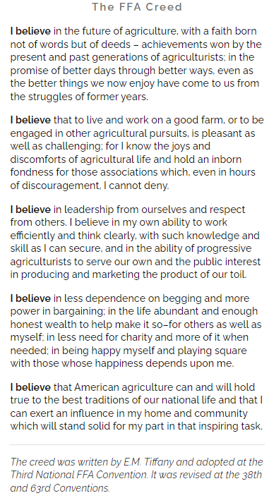
Which value do you resonate with the most?
Answers will vary.

Why? Answers will vary.
What application does the FFA Creed have to you? Answers will vary.
What role do you think the FFA Creed plays in the overall organization? Answers will vary.

Directions:
Now that you have read the FFA Creed and identified the values that exist, create a shield that represents your own personal creed. Answers will vary.

Part 4
Directions:
Develop three scenarios in which your values would drive how you would react and how a friend may react based on their values. Use the values that were hung up around the classroom to inform yourself about the values of your classmates.
Scenario | My Reaction | My Reaction Based on My Values | A Classmate’s Reaction
Example: Your best friend posted a picture of their family on the beach in Mexico on social media. | I value family, and I appreciate that a classmate is enjoying time with their family. | Family is important to me, and I understand when family comes first for others. | I value travel and world view so I appreciate that someone is in Mexico to experience a different culture.
Answers will vary. | Answers will vary. | Answers will vary. | Answers will vary.
Answers will vary. | Answers will vary. | Answers will vary. | Answers will vary.
Answers will vary. | Answers will vary. | Answers will vary. | Answers will vary.

How can your personal values impact your future career?
Answers will vary.

Exit Ticket:

What are values?

Beliefs that each person has that lead that person to act in different ways.

What are two ways values impact our understanding of others?

Answers will vary.

What are three ways values play a role in our day-to-day lives?
Answers will vary.

KEY: Activity 3: Working With Each Other (Emotions)
Part 1
Directions:
Listen to the story that your teacher reads with your classmates’ help, and complete the following table.
Answers will vary.

Question | Your Thoughts
- What different feeling did Baby Bear exhibit throughout the story?

- What did _______________________ do to demonstrate their feelings?

- What about Mama Bear? What feelings did she reveal throughout the story?

- What did _______________________ do to demonstrate their feelings?

- What feelings did Papa Bear display throughout the story? How could you tell?

- What did _______________________ do to demonstrate their feelings?

Through this story, we were able to identify many personal feelings. What words can be used to collectively describe these individual feelings? When we talk about the feelings we experience daily, we can term that as what?

E M O T I O N
Listen to your teacher and record the definition for this term when there is a range:
Range of Emotions
Why do you think it is important to understand these terms? How can they help you moving forward?
Answers will vary.
Listen to your teacher and record the definition for this term here:
A short-term reaction to an event happening in an individual’s life that is felt internally and displayed externally through that person’s outward behavior. It is a feeling or state of mind.
Part 2
Directions:
In the chart below, identify seven situations that you have encountered lately and the emotion(s) that you experienced.
Situations Chart
Situation | Emotion(s) Experienced
- Answers will vary. | Answers will vary.
- Answers will vary. | Answers will vary.
- Answers will vary. | Answers will vary.
- Answers will vary. | Answers will vary.
- Answers will vary. | Answers will vary.
- Answers will vary. | Answers will vary.
- Answers will vary. | Answers will vary.
Why do you think these emotions happened in these different situations? Answers will vary.
Do you think others in your class would have had similar emotions to these same situations? Why or why not? Answers will vary.
Directions: Based on the emotions identified by yourself and your class, identify the seven emotions that resonate with you the most and list them below. Note: All seven emotions below cannot be from the previous activity. Answers will vary.
Emotions | Draw an emoji that depicts this emotion for you. | What could/does this emotion look like for a peer? | Describe a specific situation in which this emotion would be expressed.
1.
2.
3.
4.
5.
6.
7.
Why do you think different people show different emotions in different situations?
Answers will vary.

How can understanding that others may exhibit different emotions help you when working with others?
Answers will vary.

Emotion Resonation Chart

Directions: This list includes the emotions that we have been discussing.
- Circle in purple the emotions that make you feel good.
- Strike through in red the emotions that you associate with bad feelings.
Love | Hatred | Happiness
Sadness | Joy | Anger
Fear | Excitement | Anticipation
Sorrow | Surprise | Compassion
Guilt | Jealousy | Hope
Disgust | Grief
Why do the words that you circled make you feel good?
Answers will vary.
Why do the words that you struck through make you feel bad? Answers will vary.

Is it important to feel all emotions, both good and bad? Why or why not?
Answers will vary.

Part 3
Directions:
Use this resource, https://kidshealth.org/en/teens/stressful-feelings.html, to complete the questions to learn how to work through emotions.

- Step 1: Identify the Emotion
  - Why is this step important?
Being able to identify the emotion can help to get to the root of why that emotion is happening.

  - Why is it important to be aware of how you feel?
Being aware of how you feel can help to determine why you are experiencing the feeling.

  - Why should you not hide how you feel from yourself?
Hiding feelings from yourself can cause them to build and cause a more intense reaction later.

  - How can knowing why you feel the way that you do be important?
Knowing how you feel can help you to work through the emotions in a positive and healthy way.

  - Why should you not blame? What could happen if you do place blame?
Blame does not make an emotion disappear because emotions come from inside of you. If you place blame, you could be ignoring your emotions. Acknowledging the feelings can help you to move on.

  - YOUR FEELINGS/EMOTIONS ARE NORMAL!

- Step 2: Take Action
  - What are three positive ways to express emotions?
Answers will vary. Examples: exercise, talking with someone

  - What are three negative ways to express emotions?
Answers will vary. Examples: hitting, screaming at another person
- three ways you could help change your mood and build positive emotions when presented with negative emotions. Answers will vary. Examples: go for a walk, watch a funny movie
(1)

(2)

(3)

- Always remember, it is OK to seek someone for support.

- Step 3: Get Help With Difficult Emotions

Think back to the past week, and identify a scenario when you had negative emotions. | My scenario is …
How were you feeling? | I was feeling …
What could you have done differently with your emotions in this situation? | I could/should have …
How can you take action? | I can take action by …

Directions:
Read each of the scenarios below and identify the steps that should be taken to help with the negative emotions that are occurring.

Scenario 1: Maya is easily angered by the actions of her family and friends. She often takes offense when they simply offer her help and advice. Maya denies that she is ever angry or has a bad temper. Often, she tries to fight off her emotions but still appears to be angry and hateful to others.

    - What steps should be taken for Maya to work through her emotions?
Answers will vary.

Scenario 2: Xavier’s older brother seems to do well at everything he attempts. He gets good grades, is the star of the basketball team and has many friends. Xavier feels as though his parents are constantly comparing him to his older brother and that they are never satisfied with Xavier’s performance. Often, Xavier is jealous of his brother. Instead of letting his jealousy turn into anger, Xavier becomes motivated to improve his own grades and find a talent that he, too, can be good at.
    - What steps should be taken for Xavier to work through his emotions?
Answers will vary.

How can learning to work through negative emotions have a positive impact on you, those around you and your future? Answers will vary. Example answer: Being able to work through negative emotions can help you to determine root cause and can impact how you react to others around you. Being able to healthfully work through emotions will help you to be a better colleague.

KEY: Activity 4: Responding Respectfully
Directions:
Emotions can flare the most when discussing topics with people with opposing views from our own.
(1) With a partner, you are going to complete the left side of the chart below with the topic assigned by your teacher. Work with your partner to determine how to discuss the topic respectfully with the prompts provided (left side of chart).
(2) Select a topic of your choice that could be misunderstood and complete the counterclaim sentence starters (right side of chart). Counterclaims are an argument offered in opposition to another argument. Example: After a bank sues a customer for an unpaid debt, the customer counterclaims (sues back) against the bank for fraud in gaining the debt.
(3) Share the counterclaims with another peer to practice conducting respectful conversations. These are example responses. Your topic and the student topic will change these responses.
Teacher Provided Topic: Large Scale Dairy Production is an Effective Way to Provide for the Economy | Your Topic: ___________________________________________
Critics argue that … Large scale dairies are cruel and animals suffer due to confinement, poor care, and close housing. | Critics argue that …
While it might be true that … Large numbers of animals are housed together.  Still, all in all … the animals are happier and healthier due to the ability of the farmer and veterinarian to keep excellent records of health and treat animals quickly. | While it might be true that …  Still, all in all …
Others might say that … with so many animals, there is no way to know each animal and their specific health needs.  but I argue … dairy farmers use technology such as pedometers and identification neck band devices that record everything about their cattle to know when something is off. | Others might say that …  but I argue …
A common argument against this position is … dairy cattle always belong outside on pastures since they are animals.  but … commonly used housing options allow for climate control. | A common argument against this position is …  but …
It may be true … never getting outside is unhealthy for the animal.  but … most dairy farms allow animal access to pastureland when appropriate based on weather and pasture conditions to keep health and safety in mind. | It may be true …  but …
It’s easy to think … that animals are neglected or mistreated with their being so many animals.  but when you look at the facts … the animals are safer, healthier, and happier due to how closely producers and other care givers can monitor | It’s easy to think …  but when you look at the facts …
It is often thought … that decreasing the scale of animal production would benefit all those involved, however meeting the needs of the economy would be a challenge. | It is often thought …
How are these counterclaims effective in having a conversation about a topic that may be misunderstood?
Example response: Counterclaims allow a person to identify thoughts they are hearing about a topic, identify the concerns, and respond in a manner that is informed and respectful.
Why is it important to be nonaggressive and nonconfrontational when discussing a misunderstood topic? Example response: When being nonaggressive and confrontational people are less likely to feel at ease or attacked which then produces emotions that can lead to ineffective conversations.
KEY: Activity 7: Communication Is Key
Part 1
Directions:
In the box below, use each of the letters in the word “influence” and identify one word for each letter that comes to mind when you hear the phrase “to influence others, you must …” See the image to the right for an example.
I Answers will vary.

N

F

L

U

E

N

C

E
What does the word “influence” have to do with communication?
We can use communication to influence others.
Think back through the past week and write down a scenario when you tried to influence someone. This could be a family member, friend or teacher. Answers will vary.

What are the four types of influential communication? Unscramble the following words to find out! Be sure to include two examples as a reference.
Scrambled Term | Unscrambled Term | Class Example | Develop Your Own Example
- mminucaocti | communication | Insert your own teacher example. | Answers will vary.
- sbeeifl | beliefs | “to persuade my audience that the world is round”  —Columbus  “to persuade my audience that TV violence is TV violence” | Answers will vary.
- tttseduia | attitudes | “to persuade my audience that all men and women are equal” —Martin Luther King, Jr.  “to persuade my audience that today’s teenagers are responsible and respectful” | Answers will vary.
- nnnttsiioe | intentions | “to persuade my audience to not build a military installation in Cuba” —John F. Kennedy  “to persuade my audience that they should go to college or a trade school” | Answers will vary.
- noticsa | actions | “to persuade my audience to help the poor and disabled” —Mother Teresa  “to persuade my audience that they should stop procrastinating” | Answers will vary.
- Let’s look at three techniques for being persuasive by matching the term with the definition. Then to the left of the term in the box provided, draw an image to help you remember the term.
Answers will vary.
Logic These statements bring about strong feelings through personal references.

Answers will vary.
Emotion These statements are supported by evidence such as facts, testimonials, expert opinion.

Answers will vary.

Credibility These statements establish the communicator as believable and trustworthy through competence and sincerity.

- Using the three pieces of persuasive communication (logic, emotion, credibility), identify which method of influence is being described in each scenario.

- Logic According to the United States Department of Agriculture, “poor nutrition is a leading cause of illness in the United States.”
- Emotion Eminent domain took part of my family farm to put in a highway.
- Credibility I am a doctor of veterinary medicine and specialize in small animal nutrition. When considering the feline diet, protein is an important component to proper nutrition.
In the space provided, develop a concept map to depict the relationship among the terms we have used:
Example concept map: Answers will vary.

Part 2
Directions:
Using the space below, plan a two- to four-minute podcast about a misconception that exists in the agriculture industry. You may pick any misconception that you feel strongly about. Be sure to include statements that utilize logic, emotion and credibility while keeping in mind the way communication can influence others when developing your podcast. Lastly, be sure your podcast is organized in a manner that flows and has a beginning, middle and end to your topic to ensure clarity and understanding from your listener. Answers will vary.
- Topic: ________________________________________________________________________________________________________________
  - Logic

  - Emotion

  - Credibility

  - How will I convince others?

- Introduction:

- Middle:

- Conclusion:

KEY: Activity 9: What to Ask
Part 1
Directions:
Using the resource “Survey Questions 101: Do You Make These 7 Mistakes?” (https://medium.com/@Qualtrics/survey-questions-101-do-you-make-these-7-mistakes-290f6b07ce43), complete the following activities to learn about surveys and their development.
Read the article “Survey Questions 101: Do You Make These 7 Mistakes?” and identify each of the mistakes.

- Failing to avoid leading words/questions
- Failing to give mutually exclusive choices
- Not asking direct questions
- Forgetting to add a “prefer not to answer” option
- Failing to cover all possible answer choices
- Not using unbalanced scales carefully
- Not asking only one question at a time
- How many years have you played basketball?

- 1-2 years
- 3-4 years
- 5-6 years
- 7-8 years
- 9-10 years

2. Which instrument is your favorite?
- Saxophone
- Violin
- Flute
- Cello
- Other
3. To what level do you like Ben and Jerry’s Ice Cream?

- Like a lot
- Like
- Neutral
- Dislike
- Dislike a lot

- What is your favorite fruit?

- Apple
- Oranges
- Peaches
- Bananas
- Other

- Which shoe is the most attractive and best for basketball?

- Air Jordan
- AND1
- Nike
- Adidas
- Other

- Which type of animal do you own?

- Cat
- Dog
- Rabbit
- Hamster
- Other

Why is it important to develop well-written questions for a survey?
If you do not write questions well, you will not gain the information that you need.

Using what you read in the resource above, examine the questions below and complete the following tasks: (1) Draw a green circle around the questions written correctly, (2) draw a red circle around the questions written incorrectly and (3) in purple, correct the questions that you identified as poorly written.
Part 2
Directions:
Follow the steps below to plan your survey. Answers will vary.
- Determine the topic for your survey. Select one that is of interest to you. Examples: cloning in animals, what business needs to be added to your local community, a need for your sports team/musical organization, etc.

Topic: _________________________________________________________________________________

- Who will you have take your survey? (Ex. parents, community members, teachers, etc.)

Target Audience: _______________________________________________________

- Write out the demographic information you will ask. (Ex. age, gender, education)

- Develop seven or more survey questions in the space provided.

- Have a peer review your questions and provide feedback.
- Make any necessary changes.
What was most challenging about creating your survey? Answers will vary.
What did you enjoy the most about this process? Answers will vary.
Part 3
Directions:
Now that you have gathered your data, let’s determine your results. Answers will vary.

- Topic: _____________________________________________________________________
- Who took your survey?

- List the demographic information results here:

- What are the major findings of the survey?

- Did the demographics and responses show any trends in results? (Ex. one age group had similar viewpoints)

- What are the overall conclusions you can draw from the survey?

- Develop a final statement based on the results and conclusions of the survey.
How have the results of your survey influenced your thoughts on the topic?
Answers will vary.
Why is it important to gather information before making a decision?
Answers will vary. Example: Gathering data and information allows you to draw accurate conclusions that are based on facts. They also allow for multiple viewpoints/perspectives to be included.
KEY: Activity 12: How Everyone Contributes
Directions:
Watch and/or read each story below and complete the activities.

Story | Synthesis | Reflections and Thoughts
Read the article “FFA Alumna Shares Her Mental Health Struggle.” | - What did Maddison do when she felt helpless?  She attempted suicide.  - What is the second leading cause of death in individuals aged 10 to 24? Suicide  - What has helped Maddison through her struggles?  She went to a recovery center and now talks about her feelings and experiences.
Watch the video “Dairy Heifers SAE | Jonathan Jones.” | - How does Jonathan communicate?  He uses an augmented speaking device. He types in what he wants to say and it speaks for him.  - What challenges do you think arise?  Answers will vary. Ex. needing to speak to others and ask questions  - What skills has Jonathan gained from his SAE?  More independence to complete tasks, animal care skills, communication skills, collaboration skills
Read the article “Differently Abled, Similarly Involved.” | - What observance happens on December 3 each year?  International Day of Persons with Disabilities  - What is the purpose of this observance?  Raise awareness, establish support and celebrate all individuals’ impacts  - How has the agriculture industry impacted each of these individuals?  Answers will vary.
Read the article “FFA Member Enjoys the Show” | - Where does Caroline live?  Tipton Children’s Home in Tipton, Oklahoma  - How has Caroline become involved in the agriculture industry?  She shows pigs.  - What impact has the agriculture industry had on Caroline?  Answers will vary.

How are each of the individuals above similar?
Answers will vary. Example: Each individual has had a different challenge to overcome. However, through the challenge, they have each learned and grown as an individual.

How has each of the individuals above contributed to agriculture in their own way?
Answers will vary.
How would society and the agriculture industry be different if individuals from all backgrounds, abilities and professional experiences were not a part of the industry?
Answers will vary. Example: Having people from different backgrounds and abilities brings unique perspectives, ideas and critical-thinking abilities. By incorporating these different thoughts, we can only aid in making the agriculture industry better as well as more inclusive of everyone.
What are three things you learned through this activity? Answers will vary.

What are two things you will share will a friend or family member about what you have learned?

Summarize what you have learned in one word.
How does your unique perspective and/or background contribute to the agriculture industry?
Answers will vary.

KEY: Activity 14: Company Influence in Agriculture
Complete the following activities for each of the companies listed below to learn about how inclusivity is woven throughout the agriculture industry.

Company: Tractor Supply Co. Logo:

In your own words, describe the mission of this company.
Answers will vary.
Based on the mission, what role does this company play in the agriculture industry? Answers will vary.
Why is diversity and inclusion so important to this company?
Answers will vary.

How does having a diverse and equitable culture play a role in the company’s mission and goals?
Answers will vary.

How does having a diverse and equitable culture play a role in their mission and goals?


Company: John Deere Logo:

In your own words, describe the mission of this company.
Answers will vary.
Based on the mission, what role does this company play in the agriculture industry? Answers will vary.
Why is diversity and inclusion so important to this company? Answers will vary.

How does having a diverse and equitable culture play a role in the company’s mission and goals? Answers will vary.



How does this impact you? Answers will vary.
Summarize why these companies see such value in diversity and inclusion within their companies? Answers will vary.
How does this type of diversity and inclusion in companies impact the agriculture industry? Answers will vary.
Company: CHS Logo:

In your own words, describe the mission of this company.
Answers will vary.In your own words, describe the mission of this company.
Based on the mission, what role does this company play in the agriculture industry? Answers will vary.Based on the mission, what role does this company play in the agriculture industry?
Why is diversity and inclusion so important to this company? Answers will vary.

How does having a diverse and equitable culture play a role in the company’s mission and goals? Answers will vary.
Why is diversity and inclusion so important to this company?

How does having a diverse and equitable culture play a role in the company’s mission and goals?

Company: Bayer Logo:

In your own words, describe the mission of this company.
Answers will vary.
Based on the mission, what role does this company play in the agriculture industry? Answers will vary.
Why is diversity and inclusion so important to this company? Answers will vary.

How does having a diverse and equitable culture play a role in the company’s mission and goals? Answers will vary.

Part 2:
Directions:
Select a company of your choice to research the equity, diversity and inclusivity that exists in the company. Then, complete the questions. Answers will vary.
What does equity, diversity and inclusion look like for your school district? How could it be improved based upon what you have learned and seen from companies? Answers will vary.
How could what you have learned be applied to your school to make it more inclusive of everyone?
Answers will vary.
What is one thing you can do this week to be more inclusive of those around you in your classroom, school, team, organization or community? Answers will vary.
Are there any differences that exist between the company you chose and the agriculturally based ones you previously explored? Why or why not? Answers will vary.
Company of Your Choice: Logo:

Industry this company works in: ________________________

In your own words, describe the mission of this company.
Answers will vary.
Based on the mission, what role does this company play in its industry? Answers will vary.
Why is diversity and inclusion so important to this company? Answers will vary.

How does having a diverse and equitable culture play a role in the company’s mission and goals? Answers will vary.

