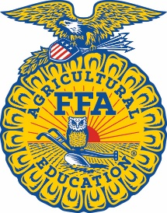
CONTACT
Contact name
Contact email
Contact phone

Headline goes here

CITY/STATE of EVENT, (Day, date, year/Company/Alumni/FFA chapter name) – XXXXX

National FFA Week always runs from Saturday to Saturday and encompasses Feb. 22, George Washington's birthday. This year, the week kicks off on Feb. 21 and culminates on Saturday, Feb. 28.

The National FFA Board of Directors designated the weeklong tradition, which began in 1948, recognizing Washington's legacy as an agriculturist and farmer. A group of young farmers founded FFA in 1928, and the organization has been influencing generations that agriculture is more than planting and harvesting — it involves science, business and more.

The National FFA Organization is a school-based national youth leadership development organization of more than 1,042,245 student members as part of 9,407 local FFA chapters in all 50 states, Puerto Rico and the U.S. Virgin Islands.

# # #

About National FFA Organization
The National FFA Organization is a school-based national youth leadership development organization of more than 1,042,245 student members as part of 9,407 local FFA chapters in all 50 states, Puerto Rico and the U.S. Virgin Islands. The FFA mission is to make a positive difference in the lives of students by developing their potential for premier leadership, personal growth and career success through agricultural education. For more, visit the National FFA Organization online at FFA.org and on Facebook, Instagram, LinkedIn and Twitter.

About National FFA Foundation
The National FFA Foundation builds partnerships with industry, education, government, other foundations and individuals to secure financial resources that recognize FFA member achievements, develop student leaders and support the future of agricultural education. A separately registered nonprofit organization, the foundation is governed by a board of trustees that includes the national FFA president, educators, business leaders and individual donors. For more, visit FFA.org/Give.

