Farm & Research Associate SAE
Created: 03/2024 by the National FFA Organization
Description of Lesson: Learn about Lane Drewery’s agricultural research SAE. Explore what happens at the agricultural research company he works at and then discover the agricultural research sites in your own state from land-grant universities.
Student Learning Objectives:
After completing these activities, students will …
- Explore an agricultural research SAE.
- Investigate the impact of agricultural research.

Suggested Grade Level:
Grades 9 and 10 (This lesson is written so instructors can scale up or down based on class needs.)

Suggested Time: 60 minutes (*Time requirements may vary based upon student understanding and class schedule.)

Resources/References:
- Video: “Farm & Research Associate SAE,” https://vimeo.com/857915280
- Website: “Agricenter International,” https://www.agricenter.org/

Equipment and Supplies Needed:
- A copy of the “Agricultural Research” worksheet for each student
- Internet access to play the video in real-time or embed it in a PowerPoint ahead of time
- Devices to complete a webquest

Vocabulary:
- Internship
- Production Agriculture
- Research

Cross-Curricular Connections:
Technology
Complete a webquest about Agricenter International and then research the agricultural research sites provided by land-grant universities.

Virtual Instruction Ideas:
This entire lesson can be taught virtually. All student handouts can be sent or posted electronically.

Student Activity Sheets:
Direct access to student activity sheets without lesson plan or answer key for easy upload to a learning management system or printing for classwork.

https://ffa.box.com/s/kfkh7dg0tb2n2e39mxff84x0jr71eiap (Word)
https://ffa.box.com/s/wkjxh6xewes6tv5s2kbr5iqm62oivzdg (Non Designed Word)
https://ffa.box.com/s/y6nxnlxkohsqrx1kxe0jhkjtt1i2xsk1 (PDF)
https://docs.google.com/document/d/1fHj5l4sYCcZqVCz9rdUbq5aiwNR7t6QCDujaLJa1pTY/copy (Google)

These Activities Are Aligned to the Following Standards:
AFNR Performance Element
- CS.01. Analyze how issues, trends, technologies and public policies impact systems in the Agriculture, Food & Natural Resources Career Cluster
- CS.05. Describe career opportunities and means to achieve those opportunities in each of the Agriculture, Food & Natural Resources career pathways.
- CS.06. Analyze the interaction among AFNR systems in the production, processing and management of food, fiber and fuel and the sustainable use of natural resources.
FFA Precept
- FFA.PL-A.Action: Assume responsibility and take the necessary steps to achieve the desired results, no matter what the goal or task at hand.
- FFA.PL-C.Vision: Visualize the future and how to get there.
- FFA.PG-I.Professional Growth: Assume responsibility for attaining and improving upon the skills needed for career success.
Common Core – Writing
- CCSS.ELA-LITERACY.W.9-10.6 Use technology, including the Internet, to produce, publish, and update individual or shared writing products, taking advantage of technology's capacity to link to other information and to display information flexibility and dynamically.
- CCSS.ELA-LITERACY.W.9-10.8 Gather relevant information from multiple authoritative print and digital sources, using advanced searches effectively; assess the usefulness of each source in answering the research question; integrate information into the text selectively to maintain the flow of ideas, avoiding plagiarism and following a standard format for citation.
Common Core – Speaking and Listening
- CCSS.ELA-LITERACY.SL.9-10.2 Integrate multiple sources of information presented in diverse media or formats (e.g., visually, quantitatively, orally) evaluating the credibility and accuracy of each source.
- CCSS.ELA-LITERACY.SL.9-10.5 Make strategic use of digital media (e.g., textual, graphical, audio, visual, and interactive elements) in presentations to enhance understanding of findings, reasoning, and evidence and to add interest.
AFNR Career Ready Practices
- CRP.02. Apply appropriate academic and technical skills. Career-ready individuals readily access and use the knowledge and skills acquired through experience and education to be more productive.
- CRP.04. Communicate clearly, effectively, and with reason. Career-ready individuals communicate thoughts, ideas and action plans with clarity, whether using written, verbal and/or visual methods.
- CRP.06. Demonstrate creativity and innovation. Career-ready individuals regularly think of ideas that solve problems in new and different ways, and they contribute those ideas in a useful and productive manner to improve their organization.
- CRP.07. Employ valid and reliable research strategies. Career-ready individuals are discerning in accepting and using new information to make decisions, change practices or inform strategies.
- CRP.11. Use technology to enhance productivity. Career-ready individuals find and maximize the productive value of existing and new technology to accomplish workplace tasks and solve workplace problems.
Partnership for 21st Century Skills
- Critical Thinking and Problem Solving
- Information Literacy
- Initiative and Self-direction
- Media Literacy
- Productivity and Accountability

Lesson Plan:
- Bell Ringer: Give an example of when research has been used to solve a problem that exists.

- Introduction: Agricultural research is vital to the future of agriculture. Without companies and universities conducting specific research within agriculture, the industry is not able to progress and keep up with the demand. Learn more about one FFA member who works at a local agricultural research company for his SAE. Then, explore that specific company more through a webquest. Finally, learn about the agricultural research sites in your state that are operated by your land-grant university.

- Activity: Each student needs a copy of the worksheet “Agricultural Research.”
  - Part 1: Show the SAE video about agricultural research in class. Students will complete Part 1 as they watch the video to learn more about this SAE.
Video: “Farm & Research Associate SAE,” https://vimeo.com/857915280
  - Part 2: Students will use their device to complete the webquest about Agricenter International. Then they will research what a land-grant university is, which school is their state’s land-grant university and what agricultural research sites exist in their state from their land-grant university.

- Optional – Extended Learning Opportunities (Not factored into time requirement):
  - Reach out to your local land-grant university to invite someone from the agricultural research sites to speak to your class on the importance of agricultural research.

- Exit Ticket: If you could work in the agricultural research industry, what area of agriculture would you want to complete research in and why?

Agricultural Research
Aligned to the following standards:
CS.01; CS.05; CS.06; FFA.PL-A; FFA.PL-C; FFA.PG-I; CCSS.W.9-10.6; CCSS.W.9-10.8; CCSS.SL.9-10.2; CCSS.SL.9-10.5; CRP.02; CRP.04; CRP.06; CRP.07; CRP.11
Part 1
Directions:
Watch the SAE video “Farm and Research Associate SAE,” https://vimeo.com/857915280, and answer the questions below.
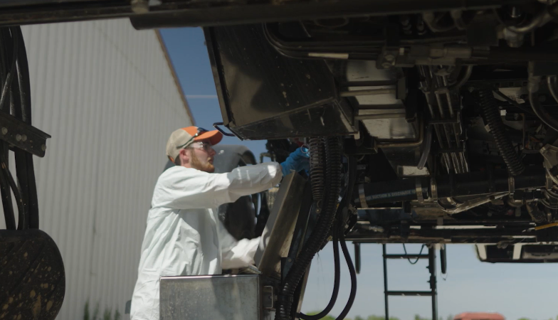
- Where does Lane work?

- List two tasks Lane does at his job.

- Name one thing he mentions he’s learned since starting his SAE.

- Which agriculture class helped him prepare for his SAE?
  - Animal science
  - Horticulture
  - Landscape management
  - Sustainable agriculture

- What other agriculture classes might be helpful for this SAE?

- How did Lane get his full-time position at Agricenter International?
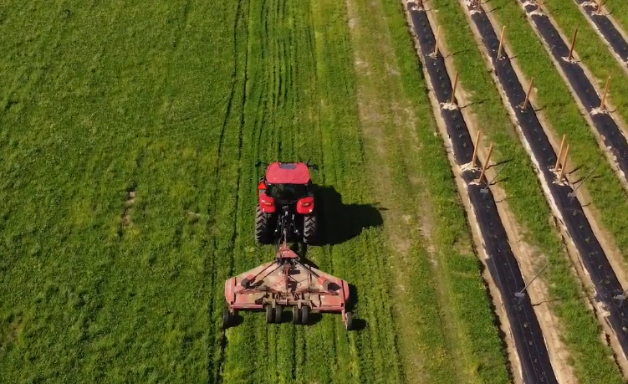
Part 2
Directions:
Explore the Agricenter International website to learn more about the company. Answer the questions below as you click through the website. Agricenter International website: https://www.agricenter.org/.

On the homepage, use the green circles to answer the matching questions below. Draw a line between the fact and the correct number.

The economic impact of Agricenter International 600

Total number of acres being farmed 10,000

Number of visitors to Agricenter International annually $524 million

Number of students educated in STEM 1.3 million

Total number of acres used for research 1,000

On the homepage, click on “Ag Research” to answer the next set of questions.

- What does Agricenter International strive to do?

- Circle the types of crops the company researches.
  - Corn
  - Cabbage
  - Tobacco
  - Cotton
  - Soybeans
  - Apples
  - Rice
  - Wheat
  - Sorghum
  - Bermuda
- Annually, Agricenter researchers conduct over ________________ research trials for more than ___________ companies including those in ____________ countries across the globe.
- List the types of trials Agricenter International conducts.

While Agricenter International is a private agricultural research company, there are agricultural research sites in every state that are operated by land-grant universities. Use Google or another search engine to help you answer the following questions.

- What is a land-grant university?

- What is the land-grant university in your home state?

- Name two agricultural research sites found in your home state.

Based on the information you learned above, answer the following questions.

- Why do you think agricultural research is important?

- How can local farmers benefit from agricultural research?

- How can agricultural companies (such as John Deere, Bayer, etc.) benefit from agricultural research?

- Search for an article on agricultural research and summarize it below.

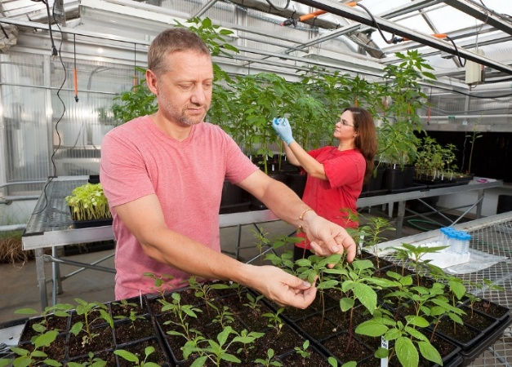

KEY: Agricultural Research
Part 1
Directions:
Watch the SAE video “Farm & Research Associate SAE,” https://vimeo.com/857915280, and answer the questions below.

- Where does Lane work?
Agricenter International

- List two tasks Lane does at his job.
  - Maintains the plots and research

  - Hands-on with large equipment

- Name one thing he mentions he’s learned since starting his SAE.
Spraying crops and operating the large equipment

- Which agriculture class really helped him prepare for his SAE?
  - Animal science
  - Horticulture
  - Landscape management
  - Sustainable agriculture

- What other agriculture classes might be helpful for this particular SAE?
Answers will vary.

- How did Lane get his full-time position at Agricenter International?
It started as an internship that his agriculture teacher helped him get, and the position turned into a full-time position.
Part 2
Directions:
Explore the Agricenter International website to learn more about the company. Answer the questions below as you click through the website. Agricenter International website: https://www.agricenter.org/.

On the homepage, use the green circles to answer the matching questions below. Draw a line between the fact and the correct number.

The economic impact of Agricenter International 600

Total number of acres being farmed 10,000

Number of visitors to Agricenter International annually $524 million

Number of students educated in STEM 1.3 million

Total number of acres used for research 1,000

On the homepage, click on “Ag Research” to answer the next set of questions.

- What does Agricenter International strive to do?
They strive to improve the efficiency and efficacy of agri-industry by providing a place to test and showcase new technologies.

- Circle the types of crops the company researches.
  - Corn
  - Cabbage
  - Tobacco
  - Cotton
  - Soybeans
  - Apples
  - Rice
  - Wheat
  - Sorghum
  - Bermuda
- Annually, Agricenter researchers conduct over 250 research trials for more than 60 companies including those in 13 countries across the globe.
- List the types of trials Agricenter International conducts.
  - Pesticide Evaluation
  - Biostimulants
  - Nutritionals
  - Plant Growth Regulators
  - Fertility
  - Irrigation
  - Variety Testing
While Agricenter International is a private agricultural research company, there are agricultural research sites in every state that are operated by land-grant universities. Use Google or another search engine to help you answer the following questions.

- What is a land-grant university?
An institution that has been designated by its state legislators or Congress to receive the benefits of the Morrill Acts of 1862 and 1890, or the Equity in Educational Land-Grant Status Act of 1994 (https://www.aplu.org/about-us/history-of-aplu/what-is-a-land-grant-university/)

- What is the land-grant university in your home state?
Answers will vary.

- Name two agricultural research sites found in your home state.
  - Answers will vary.

Based on the information you learned above, answer the following questions.

- Why do you think agricultural research is important?
Answers will vary.

- How can local farmers benefit from agricultural research?
Answers will vary.

- How can agricultural companies (such as John Deere, Bayer, etc.) benefit from agricultural research?
Answers will vary.

- Search for an article on agricultural research and summarize it below:
Answers will vary.

