Fiber & Oil Crop Production SAE
Created: 03/2024 by the National FFA Organization
Description of Lesson: Learn about Mitch Hopkins’s fiber and oil crop production SAE. Research a variety of topics focused on cotton by completing a choice board.
Student Learning Objectives:
After completing these activities, students will …
- Explore a fiber and oil crop production SAE.
- Research a variety of cotton production topics.

Suggested Grade Level:
Grades 9 and 10 (This lesson is written so instructors can scale up or down based on class needs.)

Suggested Time: 60 minutes (*Time requirements may vary based upon student understanding and class schedule.)

Resources/References:
- Video: “Fiber & Oil Crop Production SAE,” https://vimeo.com/857891450
- Video: “Eli Whitney Invents the Cotton Gin,” https://youtu.be/GiV3kswk4aI?si=KyhtQ70FoCUTgK4s
- Website: “What Is the Cotton Belt?” https://hundredpercentcotton.com/farm/cotton-belt/
- Website: “USDA Statistics by State,” https://www.nass.usda.gov/Statistics_by_State/index.php
- Website: “Cotton Acres,” https://www.cottonacres.com/wp-content/uploads/2016/03/lesson-plan-social-studies-science-for-grade-1st-8th.jpg
- Website: “Cotton Ball Parts,” https://thesoilhuggersjourney.files.wordpress.com/2014/08/cotton-parts-copy-small1.jpg
- Website: “What Can You Make From a Bale of Cotton?” https://www.cottonboard.org/assets/2889/bale_of_cotton_infographic_final_(1).pdf
- Website: “Britannic Kids: Cotton,” https://kids.britannica.com/students/article/cotton/273829

Equipment and Supplies Needed:
- A copy of the “Cotton Chronicles” worksheet for each student
- Internet access to play the video in real-time or embed it in a PowerPoint ahead of time
- Devices to complete the choice board activities

Vocabulary:
- Cotton
- Cotton Bale
- Cotton Belt
- Cotton Boll
- Cotton Gin
- Harvest

Cross-Curricular Connections:
Science | English/Language Arts | Technology | Social Studies
Label the parts of a cotton plant and cotton boll. | Write a one-page paper about Eli Whitney and the cotton gin. | Explore the process of cotton going from seed to end product. | Learn about the history of cotton, including who Eli Whitney is and what the cotton gin is.  Learn about the Cotton Belt and which states are included.

Virtual Instruction Ideas:
This entire lesson can be taught virtually. All student handouts can be sent or posted electronically.

Student Activity Sheets:
Direct access to student activity sheets without lesson plan or answer key for easy upload to a learning management system or printing for classwork.

https://ffa.box.com/s/4z3yt2dizufa3ybnmapjtgbc9gftoyak (Word)
https://ffa.box.com/s/2d0dnu2lkilm857mpvemx4qqy6ee7yku (Non Designed Word)
https://ffa.box.com/s/kb1i7w6l5kt8jkhqv1ba7uq3r7emusrz (PDF)
https://docs.google.com/document/d/1Ez5mKCUk_hq7sIvGZ_DI-cmX0h8ahk3xw3lOdzWOdt4/copy (Google)

These Activities Are Aligned to the Following Standards:
AFNR Performance Element
- CS.01. Analyze how issues, trends, technologies and public policies impact systems in the Agriculture, Food & Natural Resources Career Cluster
- CS.02. Evaluate the nature and scope of the Agriculture, Food, and Natural Resources Career Cluster and the role of agriculture, food, and natural resources (AFNR) in society and the economy.
- CS.05. Describe career opportunities and means to achieve those opportunities in each of the Agriculture, Food & Natural Resources career pathways.
- CS.06. Analyze the interaction among AFNR systems in the production, processing and management of food, fiber and fuel and the sustainable use of natural resources.
FFA Precept
- FFA.PL-A.Action: Assume responsibility and take the necessary steps to achieve the desired results, no matter what the goal or task at hand.
- FFA.PL-C.Vision: Visualize the future and how to get there.
- FFA.PL-E.Awareness: Understand personal vision, mission and goals.
- FFA.PG-I.Professional Growth: Assume responsibility for attaining and improving upon the skills needed for career success.
- FFA.CS-P.Technical/Function Skills in Agriculture: Obtain knowledge and skills needed for a career in agriculture and related industries.
Common Core – Writing
- CCSS.ELA-LITERACY.W.9-10.2 Write informative/explanatory texts to examine and convey complex ideas, concepts, and information clearly and accurately through the effective selection, organization, and analysis of content.
- CCSS.ELA-LITERACY.W.9-10.3 Write narratives to develop real or imagined experiences or events using effective technique, well-chosen details, and well-structured event sequences.
- CCSS.ELA-LITERACY.W.9-10.4 Produce clear and coherent writing in which the development, organization, and style are appropriate to task, purpose, and audience.
- CCSS.ELA-LITERACY.W.9-10.6 Use technology, including the Internet, to produce, publish, and update individual or shared writing products, taking advantage of technology's capacity to link to other information and to display information flexibility and dynamically.
- CCSS.ELA-LITERACY.W.9-10.7 Conduct short as well as more sustained research projects to answer a question (including a self-generated question) or solve a problem; narrow or broaden the inquiry when appropriate; synthesize multiple sources on the subject, demonstrating understanding of the subject under investigation.
- CCSS.ELA-LITERACY.W.9-10.8 Gather relevant information from multiple authoritative print and digital sources, using advanced searches effectively; assess the usefulness of each source in answering the research question; integrate information into the text selectively to maintain the flow of ideas, avoiding plagiarism and following a standard format for citation.
Common Core – Speaking and Listening
- CCSS.ELA-LITERACY.SL.9-10.2 Integrate multiple sources of information presented in diverse media or formats (e.g., visually, quantitatively, orally) evaluating the credibility and accuracy of each source.
- CCSS.ELA-LITERACY.SL.9-10.5 Make strategic use of digital media (e.g., textual, graphical, audio, visual, and interactive elements) in presentations to enhance understanding of findings, reasoning, and evidence and to add interest.
Common Core – Reading: Informational Text
- CCSS.ELA-LITERACY.RI.9-10.1 Cite strong and thorough textual evidence to support analysis of what the text says explicitly as well as inferences drawn from the text.
- CCSS.ELA-LITERACY.RI.9-10.4 Determine the meaning of words and phrases as they are used in a text, including figurative, connotative, and technical meanings; analyze the cumulative impact of specific word choices on meaning and tone (e.g., how the language of a court opinion differs from that of a newspaper).
AFNR Career Ready Practices
- CRP.02. Apply appropriate academic and technical skills. Career-ready individuals readily access and use the knowledge and skills acquired through experience and education to be more productive.
- CRP.04. Communicate clearly, effectively, and with reason. Career-ready individuals communicate thoughts, ideas and action plans with clarity, whether using written, verbal and/or visual methods.
- CRP.05. Consider the environmental, social and economic impact of decisions. Career-ready individuals understand the interrelated nature of their actions and regularly make decisions that positively impact and/or mitigate negative impact on other people, organizations and the environment.
- CRP.06. Demonstrate creativity and innovation. Career-ready individuals regularly think of ideas that solve problems in new and different ways, and they contribute those ideas in a useful and productive manner to improve their organization.
- CRP.07. Employ valid and reliable research strategies. Career-ready individuals are discerning in accepting and using new information to make decisions, change practices or inform strategies.
- CRP.08. Utilize critical thinking to make sense of problems and persevere in solving them. Career-ready individuals readily recognize problems in the workplace, understand the nature of the problem, and devise effective plans to solve the problem.
- CRP.11. Use technology to enhance productivity. Career-ready individuals find and maximize the productive value of existing and new technology to accomplish workplace tasks and solve workplace problems.
Partnership for 21st Century Skills
- Communication
- Critical Thinking and Problem Solving
- Global Awareness
- Implement Innovations
- Information Literacy
- Initiative and Self-direction
- Media Literacy
- Productivity and Accountability
- Think Creatively

Lesson Plan:
- Bell Ringer: Name two things made from cotton.

- Introduction: The production of cotton is one of the United States’ most important industries, with 17 states in the Cotton Belt growing the bulk of the crop. Cotton is a material that is used almost daily by people all over the world. Today, we will learn about one FFA member’s SAE in fiber and oil crop production, focusing mainly on cotton. Then we will dive deeper into the world of cotton by completing a choice board to learn more about the crop.

- Activity: Each student needs a copy of the worksheet “Cotton Chronicles.”
  - Part 1: Show the SAE video about fiber and oil crop production in class. Students will complete Part 1 as they watch the video to learn more about this SAE.
Video: “Fiber & Oil Crop Production SAE,” https://vimeo.com/857891450
  - Part 2: Students will use their device to complete three of the squares on the choice board. Each square involves technology to research or use a link to help them complete that activity. Most activities involve using blank paper, but two have separate worksheets, which are included.

- Optional – Extended Learning Opportunities (Not factored into time requirement):
  - If you live in an area where cotton is grown, ask a nearby producer for bolls of cotton. Then have your students dissect the bolls and label the parts. This gives them an up-close view of the parts of a cotton boll. If you are struggling to find a cotton grower, reach out to your land-grant university or cooperative extension office for help.
  - Have your students research alternative fibers that can be used for clothing instead of cotton. Compare and contrast the durability of these fibers to cotton. Take it a step further and bring in samples of different fibers or fabrics.

- Exit Ticket: What do you think would happen to the agricultural community in the United States if we no longer grew cotton? What do you think would happen to Americans as a whole?

Cotton Chronicles
Aligned to the following standards:
CS.01; CS.02; CS.05; CS.06; FFA.PL-A; FFA.PL-C; FFA.PL-E; FFA.PG-I; FFA.CS-P; CCSS.W.9-10.2; CCSS.W.9-10.3; CCSS.W.9-10.4; CCSS.W.9-10.6; CCSS.W.9-10.7; CCSS.W.9-10.8; CCSS.SL.9-10.2; CCSS.SL.9-10.5; CCSS.RI.9-10.1; CCSS.RI.9-10.4; CRP.02; CRP.04; CRP.05; CRP.06; CRP.07; CRP.08; CRP.11
Part 1
Directions:
Watch the SAE video “Fiber & Oil Crop Production SAE,” https://vimeo.com/857891450, and answer the questions below.

- Mitch grows which two crops:
  - Cotton
  - Sunflowers
  - Soybeans
  - Tobacco
- Fill in the blanks for the process of cotton at his farm:
The cotton ________ then comes to collect the bales.
In the fall, Mitch runs the cotton ________________.

After harvest, they tag their cotton ____________, or modules.

The cotton gin takes the _____________, the cotton __________ and any unwanted material out of the cotton.
The cotton gin puts the cotton in the ___________________ for storage.

- Why is operating the equipment Mitch’s favorite part?

- What caused stress within his SAE?

- What is Mitch’s advice for students starting an SAE?

Part 2
Directions:
Complete three activities from the choice board provided below. All activities focus on cotton. Some activities will require you to research topics, go to specific websites or watch a video. Then answer the final question at the bottom.

Eli Whitney and The Cotton Gin  Using this video, write a one-page essay about Eli Whitney and his invention. Be sure to answer the following questions in your essay:  - Who is Eli Whitney?  - Why did he see a need for the cotton gin?  - When did he invent the cotton gin?  - Where was the cotton gin most needed?  - How does the cotton gin work?  - What was the impact that the cotton gin had on cotton production at that time?  Video: https://www.youtube.com/watch?v=GiV3kswk4aI | The Cotton Belt  Using this link, label and color in the Cotton Belt on the United States map provided by your teacher.  Then, using this link, research each Cotton Belt state to learn how many harvested acres of cotton are recorded for the most recent year. Write the total for each state.  (Tip: Click on the state, then the Agricultural Overview document.)  Based on the number from the step above, place a star on the state that harvested the most cotton.  Link 1: https://hundredpercentcotton.com/farm/cotton-belt/  Link 2: https://www.nass.usda.gov/Statistics_by_State/index.php | Parts of Cotton  On a blank sheet of paper, draw and label a cotton plant including the following parts: boll, flower, square, leaf, branch and stem.  (Use this link to see an example.)  On the same paper or the back, draw and label a cotton boll including the following parts: cotton boll (with seed still inside), calyx, cotton separated and seed separated.  (Use this link to see an example.)  Link 1: https://www.cottonacres.com/wp-content/uploads/2016/03/lesson-plan-social-studies-science-for-grade-1st-8th.jpg  Link 2: https://thesoilhuggersjourney.files.wordpress.com/2014/08/cotton-parts-copy-small1.jpg
Made From Cotton  Many items we use daily come from cotton. Create a poster on a blank sheet of paper that showcases five items made from cotton. Include a drawing of each item and tell how we use the item.  Use this infographic to help learn about items made from cotton.  Link: https://www.cottonboard.org/assets/2889/bale_of_cotton_infographic_final_(1).pdf | Cotton Bales  One bale of cotton can produce many different things. Complete the webquest worksheet about cotton bales provided by your teacher. You will need to use Google or another search engine to find the answers. | The Journey of Cotton  Read this article about cotton from Britannica. Then, on a blank sheet of paper, draw a timeline that showcases the journey of cotton from seed to end product. You should include the following stages: planting, harvesting, gins, manufacturing and products. For each stage on your timeline, include a brief description of what happens, how long it can take and three facts specific to that stage that you learned from the article.  Link: https://kids.britannica.com/students/article/cotton/273829

Based on the information learned from the activities selected above, explain why cotton is such a valuable crop in the U.S. Please include two or three examples from your activities.

Map of the United States

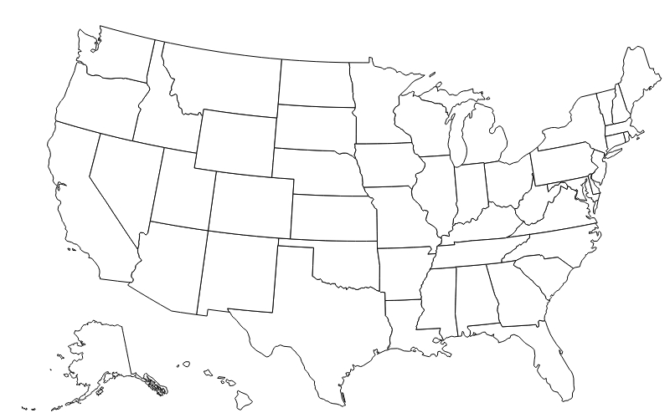

Cotton Bales

- How much does one cotton bale weigh?

- How many $100 bills can one bale of cotton make?

- How many T-shirts can one bale of cotton make?

- How many pairs of jeans can one bale of cotton make?

- How many diapers can one bale of cotton make?

- Name two things that can be made from cotton linters.

- Name two things that can be made from cottonseed hulls.

- Name two things that can be made from cottonseed oil.

- How many yards of cotton are in a regulation baseball?

- One bale of cotton produces enough oil to cook how many snack-size bags of potato chips?

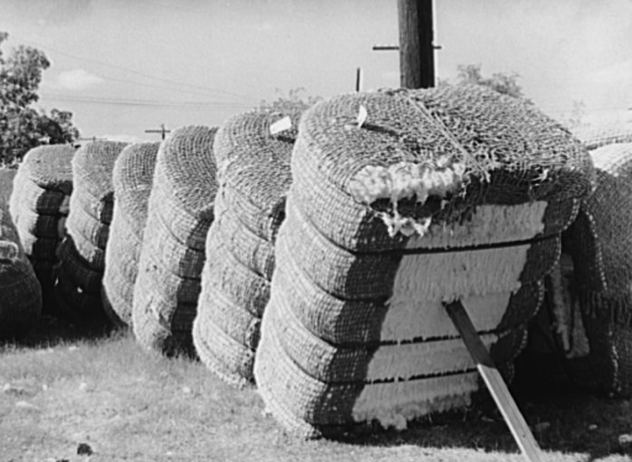

KEY: Cotton Chronicles
Part 1
Directions:
Watch the SAE video “Fiber & Oil Crop Production SAE,” https://vimeo.com/857891450, and answer the questions below.

- Mitch grows which two crops:
  - Cotton
  - Sunflowers
  - Soybeans
  - Tobacco
- Fill in the blanks for the process of cotton at his farm:
The cotton gin then comes to collect the bales.
In the fall, Mitch runs the cotton picker.

After harvest, they tag their cotton bale, or modules.

The cotton gin takes the seeds, the cotton lint and any unwanted material out of the cotton.
The cotton gin puts the cotton in the warehouse for storage.

- Why is operating the equipment Mitch’s favorite part?
He says it’s the easy part and he gets to enjoy all his hard work and effort he’s put in.

- What caused stress within his SAE?
Transitioning from an employee to the role of a co-owner with his parts for the business

- What is Mitch’s advice for students starting an SAE?
Find what you love and find a teacher that also loves that.

Part 2
Directions:
Complete three activities from the choice board provided below. All activities focus on cotton. Some activities will require you to research topics, go to specific websites or watch a video.

Eli Whitney and The Cotton Gin  Using this video, write a one-page essay about Eli Whitney and his invention. Be sure to answer the following questions in your essay:  - Who is Eli Whitney?  - Why did he see a need for the cotton gin?  - When did he invent the cotton gin?  - Where was the cotton gin most needed?  - How does the cotton gin work?  - What was the impact that the cotton gin had on cotton production at that time?  Video: https://www.youtube.com/watch?v=GiV3kswk4aI | The Cotton Belt  Using this link, label and color in the Cotton Belt on the United States map provided by your teacher.  Then, using this link, research each Cotton Belt state to learn how many harvested acres of cotton are recorded for the most recent year. Write the total for each state.  (Tip: Click on the state, then the Agricultural Overview document.)  Based on the number from the step above, place a star on the state that harvested the most cotton.  Link 1: https://hundredpercentcotton.com/farm/cotton-belt/  Link 2: https://www.nass.usda.gov/Statistics_by_State/index.php | Parts of Cotton  On a blank sheet of paper, draw and label a cotton plant including the following parts: boll, flower, square, leaf, branch and stem.  (Use this link to see an example.)  On the same paper or the back, draw and label a cotton boll including the following parts: cotton boll (with seed still inside), calyx, cotton separated and seed separated.  (Use this link to see an example.)  Link 1: https://www.cottonacres.com/wp-content/uploads/2016/03/lesson-plan-social-studies-science-for-grade-1st-8th.jpg  Link 2: https://thesoilhuggersjourney.files.wordpress.com/2014/08/cotton-parts-copy-small1.jpg
Made From Cotton  Many items we use daily come from cotton. Create a poster on a blank sheet of paper that showcases five items made from cotton. Include a drawing of each item and tell how we use the item.  Use this infographic to help learn about items made from cotton.  Link: https://www.cottonboard.org/assets/2889/bale_of_cotton_infographic_final_(1).pdf | Cotton Bales  One bale of cotton can produce many different things. Complete the webquest worksheet about cotton bales provided by your teacher. You will need to use Google or another search engine to find the answers. | The Journey of Cotton  Read this article about cotton from Britannica. Then, on a blank sheet of paper, draw a timeline that showcases the journey of cotton from seed to end product. You should include the following stages: planting, harvesting, gins, manufacturing and products. For each stage on your timeline, include a brief description of what happens, how long it can take and three facts specific to that stage that you learned from the article.  Link: https://kids.britannica.com/students/article/cotton/273829

Based on the information learned from the activities selected above, explain why cotton is such a valuable crop in the U.S. Please include two or three examples from your activities:

Answers will vary.

Map of the United States

- Virginia – Answers will vary based on year.
- North Carolina – Answers will vary based on year.
- South Carolina – Answers will vary based on year.
- Georgia – Answers will vary based on year.
- Florida – Answers will vary based on year.
- Tennessee – Answers will vary based on year.
- Alabama – Answers will vary based on year.
- Mississippi – Answers will vary based on year.
- Louisiana – Answers will vary based on year.
- Arkansas – Answers will vary based on year.
- Missouri – Answers will vary based on year.
- Kansas – Answers will vary based on year.
- Oklahoma – Answers will vary based on year.
- Texas – Answers will vary based on year.
- New Mexico – Answers will vary based on year.
- Arizona – Answers will vary based on year.
- California – Answers will vary based on year.

Cotton Bales

- How much does one cotton bale weigh?
480 lbs.

- How many $100 bills can one bale of cotton make?
313,600

- How many T-shirts can one bale of cotton make?
1,217

- How many pairs of jeans can one bale of cotton make?
215

- How many diapers can one bale of cotton make?
3,085

- Name two things that can be made from cotton linters.
Paper, ice cream (Other answers may apply.)

- Name two things that can be made from cottonseed hulls.
Soap, fertilizers (Other answers may apply.)

- Name two things that can be made from cottonseed oil.
Salad dressing, makeup, toothpaste (Other answers may apply.)

- How many yards of cotton are in a regulation baseball?
150 yards

- One bale of cotton produces enough oil to cook how many snack-size bags of potato chips?
6,000

