Mapping the River
Aligned to the following standards:
FFA.PL-A.; FFA.PL-B.; FFA.PL-D.; FFA. PL-F.; FFA.PG-H.; FFA.CS-M.; FFA.CS-N.; FFA.CS-O; CCSS.ELA-RI.9-10.4; CCSS.ELA-W.9-10.2; CCSS.W.9-10.4; CCSS.ELA-W.9-10.6; CCSS.ELA-SL.9-10.4; CCSS.ELA-WHST.9.10.2; CCSS.ELA-WHST.9.10.4; CCSS.ELA-WHST.9.10.6; MP1; MP2; MP6; CRP.04; CRP.06; CRP.08; CRP.11; AG-NR2; NRS.02
Directions:


Watch the video “Fiona Haggerty – SAE – Mapping of River” (https://vimeo.com/300298494) and respond by answering the questions below.
1) What is Fiona’s SAE?

2) What motivated her to start the SAE?

3) What were her beginning steps in starting the SAE?

4) What has Fiona learned most from her SAE?

5) What skills did she gain?

6) What activities in the classroom helped in her SAE?

7) What is one way you can apply what you learned from the video to your future?

Aligned to the following standards:
FFA.PL-A.; FFA.PL-B.; FFA.PL-D.; FFA. PL-F.; FFA.PG-H.; FFA.CS-M.; FFA.CS-N.; FFA.CS-O; CCSS.ELA-RI.9-10.4; CCSS.ELA-W.9-10.2; CCSS.W.9-10.4; CCSS.ELA-W.9-10.6; CCSS.ELA-SL.9-10.4; CCSS.ELA-WHST.9.10.2; CCSS.ELA-WHST.9.10.4; CCSS.ELA-WHST.9.10.6; MP1; MP2; MP6; CRP.04; CRP.06; CRP.08; CRP.11; AG-NR2; NRS.02
SAEs and Careers
Directions
To answer the questions below, visit the SAE Idea Cards, available at.
https://FFA.box.com/v/saeideacards. (Career focus areas include agribusiness
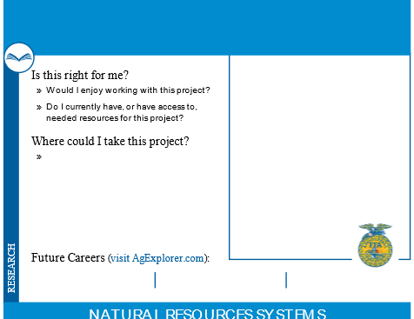

systems, animal systems, biotechnology systems, environmental service
1) What other SAEs are related to Fiona’s? Identify 3 and the career focus area in which they fit.

2) What are careers related to the SAEs you identified above? For example, Develop a forest wildlife management plan for a local landowner. — Forester

3) For the careers identified above, what are the educational requirements? (Visit AgExplorer.ffa.org.)

systems, food products and processing systems, natural resources
systems, plant systems, power, structural and technical systems and
agricultural education.)

Aligned to the following standards:
FFA.PL-A.; FFA.PL-B.; FFA.PL-D.; FFA. PL-F.; FFA.PG-H.; FFA.CS-M.; FFA.CS-N.; FFA.CS-O; CCSS.ELA-RI.9-10.4; CCSS.ELA-W.9-10.2; CCSS.W.9-10.4; CCSS.ELA-W.9-10.6; CCSS.ELA-SL.9-10.4; CCSS.ELA-WHST.9.10.2; CCSS.ELA-WHST.9.10.4; CCSS.ELA-WHST.9.10.6; MP1; MP2; MP6; CRP.04; CRP.06; CRP.08; CRP.11; AG-NR2; NRS.02
National and State Parks
directions
Visit the National Park Service volunteer webpage, https://www.nps.gov/getinvolved/volunteer.htm. Answer the questions below.

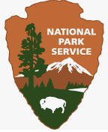
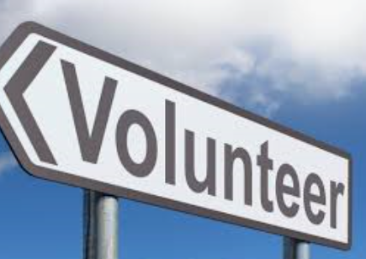

1) What national parks are located in or near your state? Use this site to locate a park near you: https://www.nps.gov/findapark/index.htm.

2) What volunteer opportunities are available at one of the parks near you or in general with the National Park Service?

__

3) Why is volunteering important? (Use the box
below for additional space.)

