Floral Shop Flow
Part 1
Directions:
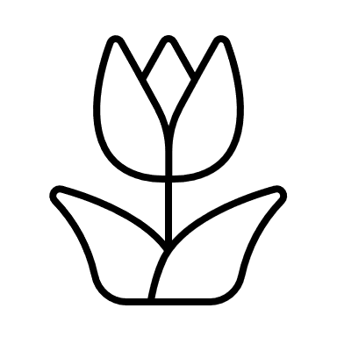
Watch the SAE video “Floral Shop SAE,” https://vimeo.com/165364620, and complete the activities below.
Ashley is from
_______________________.
Which type of SAE does Ashley have? Circle the correct type.

School-Based Research Entrepreneurship Placement
List three tasks that Ashley routinely completes in her SAE by writing them on the petals of the flower. Then, shade the flower your favorite color.
List three tools or resources Ashley uses in her SAE.

What is Ashley’s favorite part of her SAE?

What would be your favorite part of an SAE like Ashley’s?

List four skills that are important to have or build upon within an SAE.

Draw what motivates you to start an SAE or to keep your current program going.
Draw or explain what motivated Ashley to start her floral SAE.

Part 2
Directions:
The National FFA Floriculture Career Development Event (CDE) allows students to identify plants, judge flower arrangements and solve problems. Try your hand at the floriculture CDE by completing the sample activities below. Utilize the resources found on the National FFA website (https://www.ffa.org/participate/cdes/floriculture/) to learn more about this opportunity.

General Knowledge Exam Sample Questions
- Most fungal diseases grow best in ___________.
  - dry, arid air
  - low-moisture conditions
  - high-moisture conditions
  - seasons with drought

- If green plants show a ________ color, this suggests a nitrogen deficiency.
  - white
  - yellow
  - dark green
  - purple

- The recommended daytime temperature range for indoor plants is _________.
  - 60 to 70 degrees F
  - 55 to 80 degrees F
  - 60 to 85 degrees F
  - 50 to 85 degrees F

- Joe placed a box of apples in his flower cooler. The next day he saw some cut flowers looking bad and deteriorating. Could the apples have caused this problem?
  - Yes, fruit produces ethylene gas, which can cause flowers to senesce.
  - Yes, diseases on fruit are easily transferred to cut flowers causing their deterioration.
  - No, storing fruit in a cooler with cut flowers in never a problem. The flowers deteriorated from some other pathogen.
  - No, the apples could not have caused damage to the cut flowers in such a short time.

- What are the three secondary colors in flower arrangements?
  - Red, yellow, blue
  - Orange, green, violet
  - Purple, yellow, blue
  - Green, purple, red

Problem Solving
- You are preparing the wholesale floral order for a large event. The company needs 60 centerpieces for the dinner tables. Each centerpiece will include six sunflowers. Sunflowers come in bunches of five stems. How many bunches will you need to order from the wholesaler for the event? Show how you solved the problem in the box below and circle your answer.

- Makayla works for a florist and is completing an order for a birthday arrangement. She used the materials listed below. What will the customer be charged assuming a 60% markup, 5.3% tax and a $12 delivery charge? There is no tax on the delivery charge. Show your work in the box below and circle your answer.

Quantity Used | Item Description | Cost
1 | Glass Vase | $3.75 each
2.5 yards | Ribbon Bow | $0.55 per yard
1 bundle | Leatherleaf Fern | $3.25 per bundle
5 stems | Oriental Lily | $2.25 per stem
6 stems | Rose | $1.05 per stem
3 stems | Mums | $0.33 per stem
1 stem | Baby’s Breath | $0.25 per stem
Scenario 3
Mixed Planter Combination Scenario: Your agriculture teacher has asked you to create a mixed planter combination for the annual Fall Heritage Days that will take place this weekend on the town square. The planters will be used for decoration and then will be sold after the event is over as an FFA fundraiser. You have been given the freedom to choose your own plant material for your container as long as you keep the sale price to $35.00. Utilize this LINK to help you select the best plants for this project.

Cost of Products
Bacopa: $7.00 Calibrachoa: $7.00 Card and Cardette: No cost
Container: $8.00 Flare Salvia: $10.00 Mums: $6.00
Ornamental Millet: $10.00 Pansies: $6.00 Soil: $4.00 Verbena: $7.00
No tax or shipping necessary

Decide what items you will utilize from the list above to create the mixed planter. Explain your decisions for each plant selection, and be sure to include the total amount you spent for the arrangement.

Floriculture Plant ID
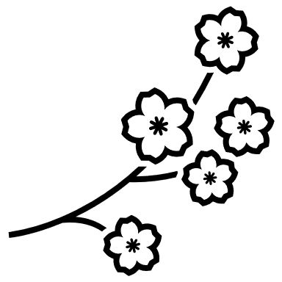
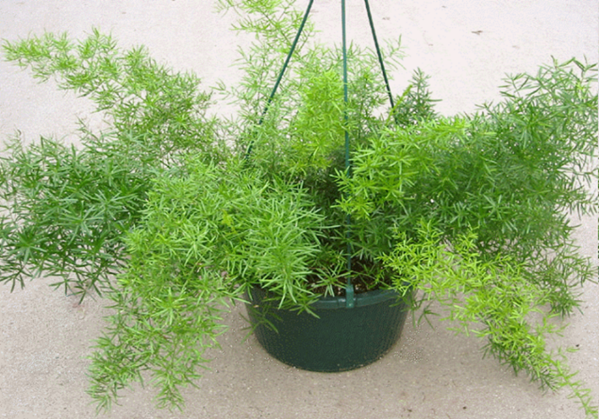
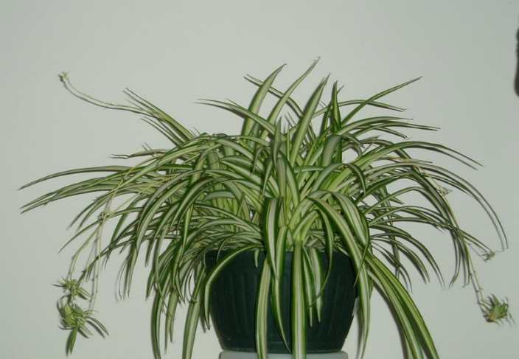
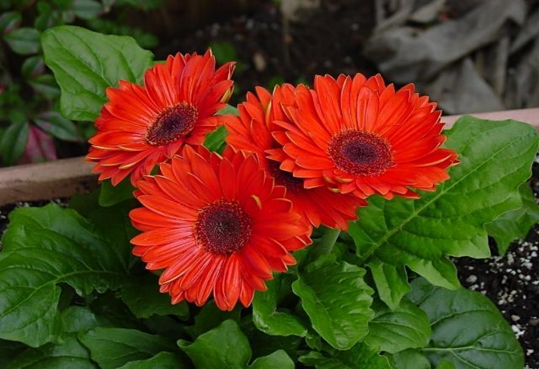
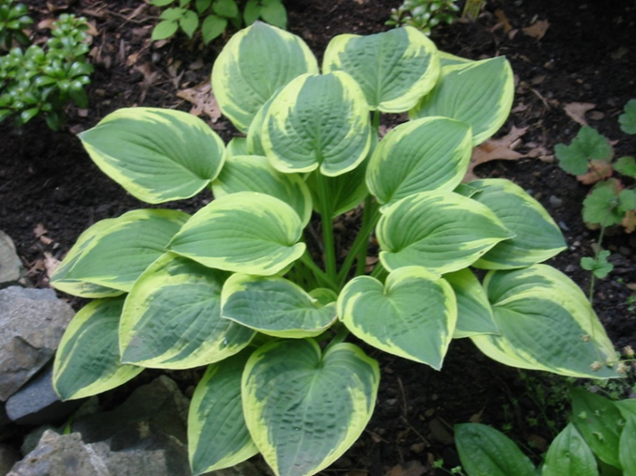
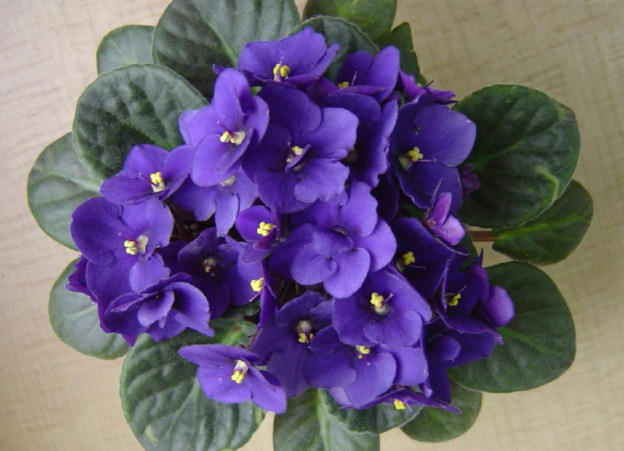
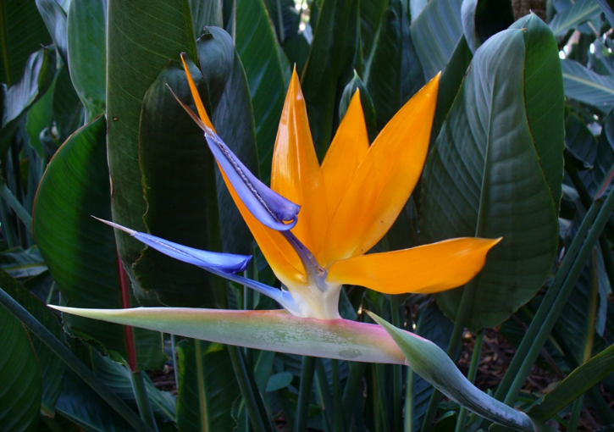
Identify each of the floral plants below. Don’t forget to utilize the resources on the floriculture CDE website.
_______________________________________ _______________________________________ _______________________________________ _______________________________________
_______________________________________ _______________________________________

Which activity did you enjoy the most? Explain.

.

List three skills you can gain from participating in the floriculture CDE.

Identify two careers that align with the floriculture CDE. Utilize the https://agexplorer.ffa.org/ website to help you identify those careers.

On a scale of 1 to 10, how do you feel about trying the floriculture CDE in the future?

