Floral Fun
Created: 08/2022 by the National FFA Organization
Description of Lesson: Peek into this floral shop supervised agricultural experience (SAE) to motivate your students to try new opportunities in FFA by learning about a unique SAE.

Student Learning Objectives:
After completing these activities, students will …
- Discover what it is like to work in a floral shop.
- Develop a basic understanding of the floriculture career development event (CDE).
- Utilize mathematics skills in real-world settings.

Suggested Grade Level:
Grades 9 and 10 (This lesson is written so instructors can scale up or down based on class needs.)

Suggested Time: 60-90 minutes (*Time requirements may vary based upon student understanding and class schedule.)
Resources/References:
- Video: “Floral Shop SAE,” https://vimeo.com/165364620
- Website: National FFA Floriculture CDE, FFA.org/participate/cdes/floriculture/

Related Resources:
- National FFA Environmental and Natural Resources CDE, FFA.org/participate/cdes/environmental-and-natural-resources/
- National FFA Forestry CDE, FFA.org/participate/cdes/forestry/
- National FFA Nursery/Landscape CDE, FFA.org/participate/cdes/nursery-landscape/
- Proficiency Awards, FFA.org/participate/awards/proficiencies/
- Agriscience Fair, FFA.org/participate/awards/agriscience-fair/
- SAE Grants, FFA.org/participate/grants-and-scholarships/sae-grants/

Equipment and Supplies Needed:
- A copy of the “Floral Shop Flow” worksheet for each student
- Internet access to play the video in real time or embed it in a PowerPoint ahead of time
- Calculator

Vocabulary:
- Cut flowers
- Fresh flowers
- Florists
- Floral design
- Commercial grower
- Retail florists
- Floral preservative
- Conditioning
- Transpiration
- Vase life
- Processing
- Bent neck
- Ethylene

Cross-Curricular Connections:
Mathematics
- Students will calculate costs and supplies needed in floriculture.
- Students will calculate taxes into the final costs of goods and services.

Virtual Instruction Ideas:
This lesson can be used in a virtual setting by providing students with digital copies of worksheets and website addresses to complete the activities.

Student Activity Sheets:
Direct access to student activity sheets without lesson plan or answer key for easy upload to a learning management system or printing for classwork.

Link (Word)
Link (PDF)
Link (Google)

These Activities are Aligned to the Following Standards:
AFNR Performance Element
- PS.02. Apply principles of classification, plant anatomy and plant physiology to plant production and management.
FFA Precept
- FFA.PL-A. Action: Assume responsibility and take the necessary steps to achieve the desired results, no matter what the goal or task at hand.
- FFA.PL-C. Vision: Visualize the future and how to get there.
- FFA.PG-J. Mental Growth: Embrace cognitive and intellectual development relative to reasoning, thinking and coping.
- FFA-CS-M. Communication: Effectively interact with others in personal and professional settings.
- FFA.CS-N. Decision Making: Analyze a situation and execute an appropriate course of action.
Common Career Technical Core
- AG-PL2 Apply the principles of classification, plant anatomy and plant physiology to plant production and management.
NASDCTEc
- AGPB01.02 Examine and explain basic plant anatomy and physiology using taxonomic and other classifications to build a working understanding of functional differences among plant structures.
Common Core – Speaking and Listening
- CCSS.ELA-Literacy.SL.9-10.4 Present information, findings, and supporting evidence clearly, concisely, and logically such that listeners can follow the line of reasoning and the organization, development, substance, and style are appropriate to purpose, audience, and task.
Common Core – Science & Technical Subjects
- CCSS.ELA-Literacy.RST.9-10.4 Determine the meaning of symbols, key terms, and other domain-specific words and phrases as they are used in a specific scientific or technical context relevant to grades 9-10 texts and topics.
Common Core – Math Practices
- CCSS.MATH.PRACTICE.MP1 Make sense of problems and persevere in solving them.
- CCSS.MATH.PRACTICE.MP3 Construct viable arguments and critique the reasoning of others.
- CCSS.MATH.PRACTICE.MP5 Use appropriate tools strategically.
- CCSS.MATH.PRACTICE.MP6 Attend to precision.
Common Core – Math (Specific)
- CCSS.MATH.CONTENT.HSN. Q.A.2 Define appropriate quantities for the purpose of descriptive modeling.
- CCSS.MATH.CONTENT.HSN. Q.A.3 Choose a level of accuracy appropriate to limitations on measurement when reporting quantities.
AFNR Career Ready Practices
- CRP.02. Apply appropriate academic and technical skills. Career-ready individuals readily access and use the knowledge and skills acquired through experience and education to be more productive.
- CRP.04. Communicate clearly, effectively, and with reason. Career-ready individuals communicate thoughts, ideas, and action plans with clarity, whether using written, verbal and/or visual methods.
- CRP.05. Consider the environmental, social, and economic impact of decisions. Career-ready individuals understand the interrelated nature of their actions and regularly make decisions that positively impact and/or mitigate negative impact on other people, organizations, and the environment.
- CRP.06. Demonstrate creativity and innovation. Career-ready individuals regularly think of ideas that solve problems in new and different ways, and they contribute those ideas in a useful and productive manner to improve their organization.
- CRP.07. Employ valid and reliable research strategies. Career-ready individuals are discerning in accepting and using new information to make decisions, change practices or inform strategies.
- CRP.08. Utilize critical thinking to make sense of problems and persevere in solving them. Career-ready individuals readily recognize problems in the workplace, understand the nature of the problem, and
- devise effective plans to solve the problem.
- CRP.11 Use technology to enhance productivity. Career-ready individuals find and maximize the productive value of existing and new technology to accomplish workplace tasks and solve workplace problems.
Partnership for 21st Century Skills
- Communication
- Critical Thinking and Problem Solving
- Implement Innovations
- Information, Communications, and Technology Literacy
- Initiative and Self-direction
- Productivity and Accountability
- Think Creatively

Lesson Plan:
- Bell Ringer: Ask students to brainstorm on a piece of paper or by utilizing a Jamboard or something similar to come up with a list of events or occasions when fresh cut flowers are used or needed. Have a class discussion on why we utilize fresh cut flowers.

- Introduction: In this SAE video, students will get the chance to see a less traditional SAE that might just spark them into starting their own plan. Students will get the chance to see what it is like to work in a floral shop and how other experiences through FFA like CDEs and community service projects spark ideas such as SAE programs. Students will also try out parts of the floriculture CDE to see an example of the three-circle model in action as well as utilize their mathematics skills in real-life scenarios.

- Activity: Each student needs a copy of the worksheet “Floral Shop Flow.”
Part 1: Students watch the SAE video Floral Shop SAE https://vimeo.com/165364620 and complete the questions in Part 1.
Part 2: Students utilize the National FFA website to learn more about the floriculture CDE https://www.ffa.org/participate/cdes/floriculture/ and complete several of the tasks involved in in this CDE.

- Optional – Extended Learning Opportunities (Not factored into time requirement):
  - Provide students with live or fake flowers to make a small arrangement to build on their experiences with the floriculture CDE. Depending on timing, you could have them make an arrangement that could be used as a gift for an upcoming holiday or event.

- Exit Ticket: Ask students to give two examples of why the floriculture industry is an important part of the agriculture industry.

Floral Shop Flow
Aligned to the following standards: PS.02.; FFA.PL-A; FFA.PL-C; FFA.PG-J; FFA-CS-M; FFA-CS-N; AG-PL2; AGPB01.02; CCSS.ELA.SL.9-10.4; CCSS.ELA.RST.9-10.4; MP1; MP3; MP5; MP6; CCSS.MATH.CONTENT.HSN. Q.A.2; CCSS.MATH.CONTENT.HSN. Q.A.3; CRP.02; CRP.04; CRP.05; CRP.06; CRP.07; CRP.08; CRP.11
Part 1
Directions:

Watch the SAE video “Floral Shop SAE,” https://vimeo.com/165364620, and complete the activities below.
Ashley is from
_______________________.
Which type of SAE does Ashley have? Circle the correct type.

School-Based Research Entrepreneurship Placement
List three tasks that Ashley routinely completes in her SAE by writing them on the petals of the flower. Then, shade the flower your favorite color.
List three tools or resources Ashley uses in her SAE.

What is Ashley’s favorite part of her SAE?

What would be your favorite part of an SAE like Ashley’s?

List four skills that are important to have or build upon within an SAE.

Draw what motivates you to start an SAE or to keep your current program going.
Draw or explain what motivated Ashley to start her floral SAE.

Part 2
Directions:
The National FFA Floriculture Career Development Event (CDE) allows students to identify plants, judge flower arrangements and solve problems. Try your hand at the floriculture CDE by completing the sample activities below. Utilize the resources found on the National FFA website (https://www.ffa.org/participate/cdes/floriculture/) to learn more about this opportunity.

General Knowledge Exam Sample Questions
- Most fungal diseases grow best in ___________.
  - dry, arid air
  - low-moisture conditions
  - high-moisture conditions
  - seasons with drought

- If green plants show a ________ color, this suggests a nitrogen deficiency.
  - white
  - yellow
  - dark green
  - purple

- The recommended daytime temperature range for indoor plants is _________.
  - 60 to 70 degrees F
  - 55 to 80 degrees F
  - 60 to 85 degrees F
  - 50 to 85 degrees F

- Joe placed a box of apples in his flower cooler. The next day he saw some cut flowers looking bad and deteriorating. Could the apples have caused this problem?
  - Yes, fruit produces ethylene gas, which can cause flowers to senesce.
  - Yes, diseases on fruit are easily transferred to cut flowers causing their deterioration.
  - No, storing fruit in a cooler with cut flowers in never a problem. The flowers deteriorated from some other pathogen.
  - No, the apples could not have caused damage to the cut flowers in such a short time.

- What are the three secondary colors in flower arrangements?
  - Red, yellow, blue
  - Orange, green, violet
  - Purple, yellow, blue
  - Green, purple, red

Problem Solving
- You are preparing the wholesale floral order for a large event. The company needs 60 centerpieces for the dinner tables. Each centerpiece will include six sunflowers. Sunflowers come in bunches of five stems. How many bunches will you need to order from the wholesaler for the event? Show how you solved the problem in the box below and circle your answer.

- Makayla works for a florist and is completing an order for a birthday arrangement. She used the materials listed below. What will the customer be charged assuming a 60% markup, 5.3% tax and a $12 delivery charge? There is no tax on the delivery charge. Show your work in the box below and circle your answer.

Quantity Used | Item Description | Cost
1 | Glass Vase | $3.75 each
2.5 yards | Ribbon Bow | $0.55 per yard
1 bundle | Leatherleaf Fern | $3.25 per bundle
5 stems | Oriental Lily | $2.25 per stem
6 stems | Rose | $1.05 per stem
3 stems | Mums | $0.33 per stem
1 stem | Baby’s Breath | $0.25 per stem
Scenario 3
Mixed Planter Combination Scenario: Your agriculture teacher has asked you to create a mixed planter combination for the annual Fall Heritage Days that will take place this weekend on the town square. The planters will be used for decoration and then will be sold after the event is over as an FFA fundraiser. You have been given the freedom to choose your own plant material for your container as long as you keep the sale price to $35.00. Utilize this LINK to help you select the best plants for this project.

Cost of Products
Bacopa: $7.00 Calibrachoa: $7.00 Card and Cardette: No cost
Container: $8.00 Flare Salvia: $10.00 Mums: $6.00
Ornamental Millet: $10.00 Pansies: $6.00 Soil: $4.00 Verbena: $7.00
No tax or shipping necessary

Decide what items you will utilize from the list above to create the mixed planter. Explain your decisions for each plant selection, and be sure to include the total amount you spent for the arrangement.

Floriculture Plant ID
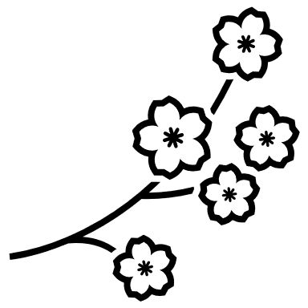
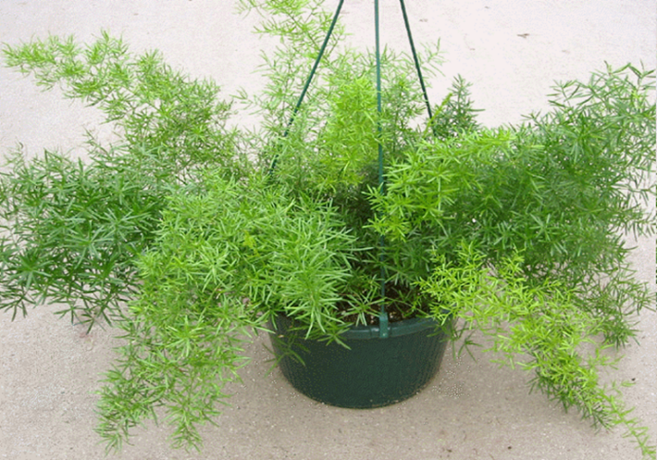
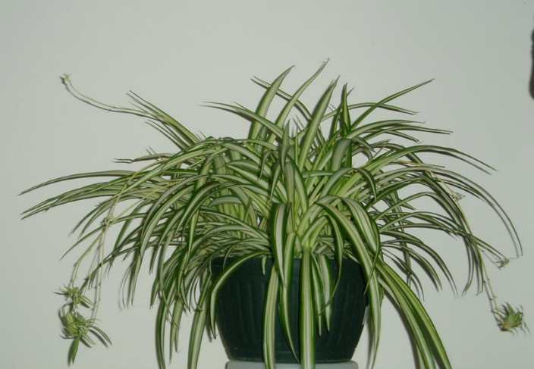
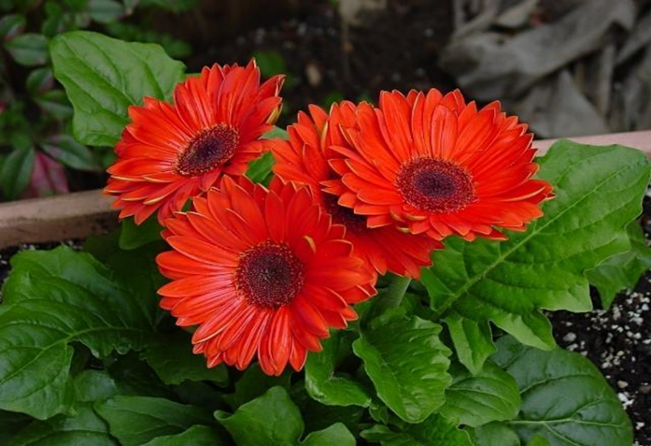
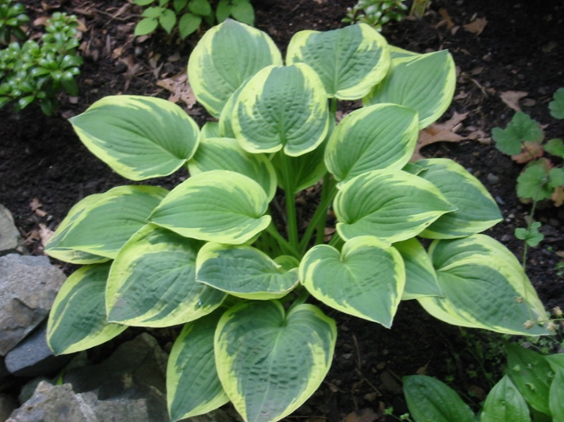
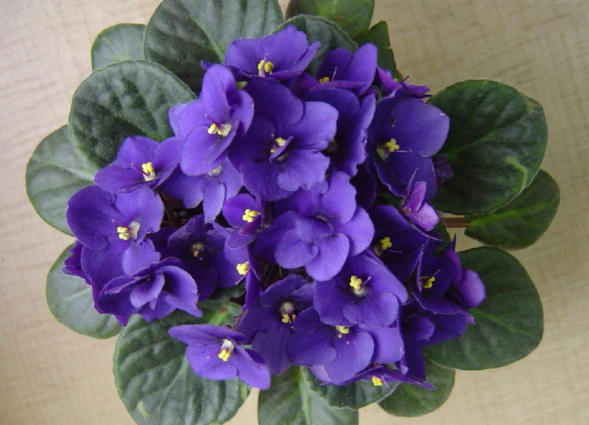
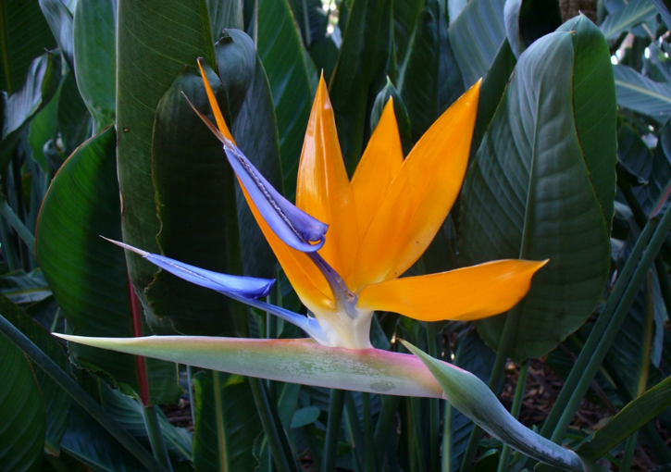
Identify each of the floral plants below. Don’t forget to utilize the resources on the floriculture CDE website.
_______________________________________ _______________________________________ _______________________________________ _______________________________________
_______________________________________ _______________________________________

Which activity did you enjoy the most? Explain.

.

List three skills you can gain from participating in the floriculture CDE.

Identify two careers that align with the floriculture CDE. Utilize the https://agexplorer.ffa.org/ website to help you identify those careers.

On a scale of 1 to 10, how do you feel about trying the floriculture CDE in the future?

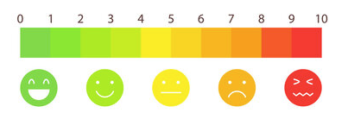

KEY: Floral Shop Flow
Aligned to the following standards: PS.02.; FFA.PL-A; FFA.PL-C; FFA.PG-J; FFA-CS-M; FFA-CS-N; AG-PL2; AGPB01.02; CCSS.ELA-Literacy.SL.9-10.4; CCSS.ELA-Literacy.RST.9-10.4; CCSS.MATH.PRACTICE.MP1; CCSS.MATH.PRACTICE.MP3; CCSS.MATH.PRACTICE.MP5; CCSS.MATH.PRACTICE.MP6; CCSS.MATH.CONTENT.HSN. Q.A.2; CCSS.MATH.CONTENT.HSN. Q.A.3; CRP.02; CRP.04; CRP.05; CRP.06; CRP.07; CRP.08; CRP.11

Part 1
Directions:
Watch the SAE video “Floral Shop SAE,” https://vimeo.com/165364620, and complete the activities below.
Virginia

Ashley is from
_______________________.
Which type of SAE does Ashley have? Circle the correct type.
School-Based Research Entrepreneurship Placement
List three tasks that Ashley routinely completes in her SAE by writing them on the petals of the flower. Then, shade the flower your favorite color.
List three tools or resources Ashley uses in her SAE.

Watering can
Gloves
Scissors
Shears
Floral foam
Buckets
Vases

What is Ashley’s favorite part of her SAE?
Always something new to do each day, interacting with others

What would be your favorite part of an SAE like Ashley’s?
Answers will vary.

Watering
Cutting flowers

Designing
Delivering

List four skills that are important to have or build upon within an SAE.
- Examples: responsibility, organization, communication, dedication

Draw what motivates you to start an SAE or to keep your current program going.
Answers will vary.
Draw or explain what motivated Ashley to start her floral SAE.
CDEs: forestry, agronomy
Community service

Part 2
Directions:
The National FFA Floriculture Career Development Event (CDE) allows students to identify plants, judge flower arrangements and solve problems. Try your hand at the floriculture CDE by completing the sample activities below. Utilize the resources found on the National FFA website to learn more about this opportunity.

General Knowledge Exam Sample Questions
- Most fungal diseases grow best in ___________.
  - dry, arid air
  - low-moisture conditions
  - high-moisture conditions
  - seasons with drought

- If green plants show a ________ color, this suggests a nitrogen deficiency.
  - white
  - yellow
  - dark green
  - purple

- The recommended daytime temperature range for indoor plants is _________.
  - 60 to 70 degrees F
  - 55 to 80 degrees F
  - 60 to 85 degrees F
  - 50 to 85 degrees F

- Joe placed a box of apples in his flower cooler. The next day he saw some cut flowers looking bad and deteriorating. Could the apples have caused this problem?
  - Yes, fruit produces ethylene gas, which can cause flowers to senesce.
  - Yes, diseases on fruit are easily transferred to cut flowers causing their deterioration.
  - No, storing fruit in a cooler with cut flowers in never a problem. The flowers deteriorated from some other pathogen.
  - No, the apples could not have caused damage to the cut flowers in such a short time.

- What are the three secondary colors in flower arrangements?
  - Red, yellow, blue
  - Orange, green, violet
  - Purple, yellow, blue
  - Green, purple, red

Problem Solving
- You are preparing the wholesale floral order for a large event. The company needs 60 centerpieces for the dinner tables. Each centerpiece will include six sunflowers. Sunflowers come in bunches of five stems. How many bunches will you need to order from the wholesaler for the event? Show how you solved the problem in the box below and circle your answer.

60 X 6 = 360 stems needed
360/5 per bunch = 72 bunches needed

- Makayla works for a florist and is completing an order for a birthday arrangement. She used the materials listed below. What will the customer be charged assuming a 60% markup, 5.3% tax and a $12 delivery charge? There is no tax on the delivery charge. Show your work in the box below and circle your answer.
Total cost of materials is $27.17.
$27.17 X .60 (markup) = $16.30
$27.17 + $16.30= $43.47
$43.47 X.053 (tax) = $2.30
$43.47 + $2.30 = $45.77
$45.77 + $12 (delivery fee) = $57.77
Quantity Used | Item Description | Cost
1 | Glass Vase | $3.75 each
2.5 yards | Ribbon Bow | $0.55 per yard
1 bundle | Leatherleaf Fern | $3.25 per bundle
5 stems | Oriental Lily | $2.25 per stem
6 stems | Rose | $1.05 per stem
3 stems | Mums | $0.33 per stem
1 stem | Baby’s Breath | $0.25 per stem
Scenario 3
Mixed Planter Combination Scenario: Your agriculture teacher has asked you to create a mixed planter combination for the annual Fall Heritage Days that will take place this weekend on the town square. The planters will be used for decoration and then will be sold after the event is over as an FFA fundraiser. You have been given the freedom to choose your own plant material for your container as long as you keep the price to $35.00. Utilize this LINK to help you select the best plants for this project.

Cost of Products
Bacopa: $7.00 Calibrachoa: $7.00 Card and Cardette: No cost
Container: $8.00 Flare Salvia: $10.00 Mums: $6.00
Ornamental Millet: $10.00 Pansies: $6.00 Soil: $4.00 Verbena: $7.00
No tax or shipping necessary

Decide what items you will utilize from the list above to create the mixed planter. Explain your decisions for each plant selection, and be sure to include the total amount you spent for the arrangement.
Answers will vary.
Floriculture Plant ID
Identify each of the floral plants below. Don’t forget to utilize the resources on the floriculture CDE website.
Sprengeri Fern Spider plant

Gerbera Daisy Hosta

African Violet Bird of Paradise

Which sample activity did you enjoy the most? Explain.
Answers will vary.

List three skills you can gain from participating in the floriculture CDE.
- Problem solving Organization
- Business management Laboratory skills

- Sales and service skills Knowledge of how to safely handle chemicals

Identify two careers that align with the floriculture CDE. Utilize https://agexplorer.ffa.org/ website to help you identify those careers.
- Floriculture shop owner/manager
- Customer sales and service rep

On a scale of 1 to 10, how do you feel about trying the floriculture CDE in the future?

