Food Labels: Tell Me More
Created: 08/2017 by the National FFA Organization

Student Learning Objectives:
After completing these activities, students will…
- Determine the factors that are considered for food labels.
- Distinguish the variables involved with using “natural” in food labels.
- Design a food label that encourages consumers to make a purchase.

Time Required: 45 minutes
Resources: FFA.org
Equipment and Supplies Needed:
- A copy of the “Food Labels—The Red Bell Pepper” worksheet for each student
- Internet access or printed copies of the article “5 Questions You Should Be Asking When Buying ‘Natural’ Labelled Foods.” http://www.dowagro.com/en-us/on-the-table/2017/05/5-questions-you-should-be-asking-when-buying-natural-labelled-foods#.WYKiFWzrvic

This quick lesson plan would work well as Part Of:
- A unit about agricultural advocacy.
- A food science unit about food safety and labeling.

These activities are aligned to the following standards:

FFA Precept
- FFA.PL-A.Action: Assume responsibility and take the necessary steps to achieve the desired results, no matter what the goal or task at hand.
- FFA.PG-I.Professional Growth: Assume responsibility for attaining and improving upon the skills needed for career success.
- FFA.PG-J.Mental Growth: Embrace cognitive and intellectual development relative to reasoning, thinking and coping.
- FFA.CS-M.Communication: Effectively interact with others in personal and professional settings.
AFNR Cluster Skills
- CS.01. Analyze how issues, trends, technologies and public policies impact systems in the Agriculture, Food & Natural Resources Career Cluster.
Common Core - Writing
- CCSS.ELA-LITERACY.W.9-10.1 Write arguments to support claims in an analysis of substantive topics or texts, using valid reasoning and relevant and sufficient evidence.
- CCSS.ELA-LITERACY.W.9-10.2 Write informative/explanatory texts to examine and convey complex ideas, concepts, and information clearly and accurately through the effective selection, organization, and analysis of content.
- CCSS.ELA-LITERACY.W.9-10.4 Produce clear and coherent writing the development, organization, and style are appropriate to task, purpose, and audience.
Common Core - Speaking and Listening
- CCSS.ELA-LITERACY.SL.9-10.1 Initiate and participate effectively in a range of collaborative discussions (one-on-one, in groups, and teacher-led) with diverse partners on grades 9-10 topics, texts, and issues, building on others' ideas and expressing their own clearly and persuasively.
- CCSS.ELA-LITERACY.SL.9-10.4 Present information, findings, and supporting evidence clearly, concisely, and logically such that listeners can follow the line of reasoning and the organization, development, substance, and style are appropriate to purpose, audience, and task.
Common Core - Language
- CCSS.ELA-LITERACY.L.9-10.6 Acquire and use accurately general academic and domain-specific words and phrases, sufficient for reading, writing, speaking, and listening at the college and career readiness level; demonstrate independence in gathering vocabulary knowledge when considering a word or phrase important to comprehension or expression.
Common Core - Math Practices
- CCSS.MP3: Construct viable arguments and critique the reasoning of others.
- CCSS.MP6: Attend to precision.
- CCSS.MP7: Look for and make use of structure.
AFNR Career Ready Practices
- CRP.02. Apply appropriate academic and technical skills. Career-ready individuals readily access and use the knowledge and skills acquired through experience and education to be more productive.
- CRP.04. Communicate clearly, effectively, and with reason. Career-ready individuals communicate thoughts, ideas and action plans with clarity, whether using written, verbal and/or visual methods.
- CRP.05. Consider the environmental, social and economic impact of decisions. Career-ready individuals understand the interrelated nature of their actions and regularly make decisions that positively impact and/or mitigate negative impact on other people, organizations and the environment.
- CRP.06. Demonstrate creativity and innovation. Career-ready individuals regularly think of ideas that solve problems in new and different ways, and they contribute those ideas in a useful and productive manner to improve their organization.
- CRP.08. Utilize critical thinking to make sense of problems and persevere in solving them. Career-ready individuals readily recognize problems in the workplace, understand the nature of the problem, and devise effective plans to solve the problem.
Partnership for 21st Century Skills
- Civic Literacy
- Communication
- Critical Thinking and Problem Solving
- Information Literacy
- Information, Communications, and Technology Literacy
- Initiative and Self-direction
- Media Literacy

Lesson Plan:
- Introduction: Start the lesson or class by having two common, identical products at the front of the classroom (examples: vegetables, water bottles, pencils, etc.). On one of the products, add a label that gives more information about the product (for example, name of product, what it is made of, when it was made and where it is from). On the other product, do not include information.

Allow students to look at the product close-up, and ask them which product they would purchase. (Ask for a volunteer or have students cast their votes using ballots.) Discuss why students made their decisions and come to the conclusion that we most often purchase items when we know more information. For example, when buying a used car, we will ask for the Carfax report (official site for reference: https://www.carfax.com/?partner=GPC_4&click=sem&gclid=CNnp1eyKxdUCFeKeMgodU5gLog&gclsrc=ds)
so that we can at least get some information about the car’s history. Or, when purchasing clothing, we might look at the label to see how much it costs or how to take care of it (dry clean or regular washing). Do these reports or labels tell us everything we need to know? No; however, it allows us to have a better understanding before making the choice to spend/waste our money. Food is no different. As consumers, it is important to have a better understanding of food before purchasing, both for health reasons and to also determine if we are spending our money wisely.

- Activity: Each student needs a copy of the handout “5 Questions You Should Be Asking When Buying ‘Natural’ Labelled Foods.”
  - The direct URL is http://www.dowagro.com/en-us/on-the-table/2017/05/5-questions-you-should-be-asking-when-buying-natural-labelled-foods#.WYKiFWzrvic.

- Follow Up: Have students share the food labels they created and vote on which one is most convincing.

- Leveling Up: Have students research 10 vegetables or fruits and determine the vitamins and amino acids found in each one. Pretend that those 10 vegetables and fruits are the key produce items for a farmer’s market and develop an advertisement or marketing plan that will help educate and sell to consumers.

Food Labels—The Red Bell Pepper
Directions:
Answer the questions below using the information found in the article “5 Questions You Should Be Asking When Buying ‘Natural’ Labelled Foods.”

Part 1: Before reading the article, consider the ingredients found within a bell pepper and describe your thoughts/reaction:
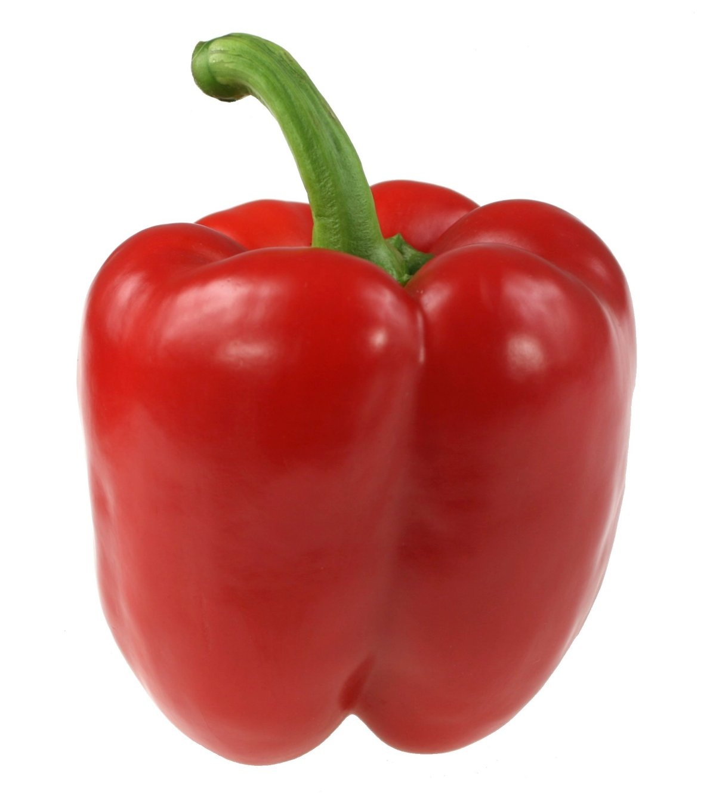
My reaction after reading the ingredients found within a red bell pepper. (Circle the one that applies to your thoughts and feelings.)
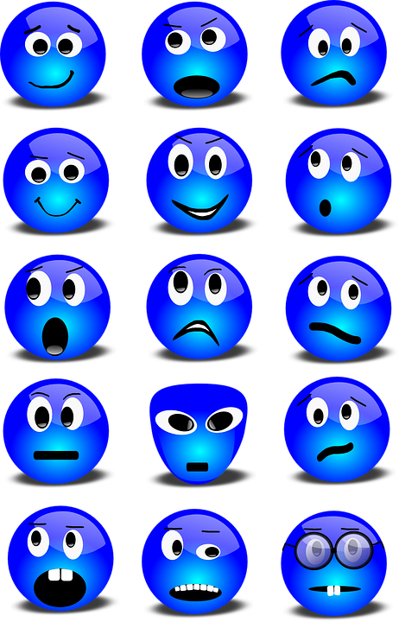
Explain your emoji choice including why you chose it and the general thoughts and feelings you have about the ingredients found in a red bell pepper.

________________________________________________________________________________________________________________________
________________________________________________________________________________________________________________________
________________________________________________________________________________________________________________________

Ingredients found within a red bell pepper:
- Thiamine
- Pantothenic acid
- Focalin
- Methionine
- Alpha-tocopherol
- Niacin

Part 2: Read “5 Questions You Should Be Asking When Buying ‘Natural’ Labelled Foods” and answer the following questions.

1. The ingredients listed above are actually v__________________ and a______________ a______________ found in a red bell pepper.

2. What are the regulations for using the term “natural” on food labels?
______________________________________________________________________________________________________________________________________________________________________________________________________

3. Summarize five important things to remember when making informed decisions during grocery shopping:
1. ___________________________________________________________________________________________
2. ___________________________________________________________________________________________
3. ___________________________________________________________________________________________
4. ___________________________________________________________________________________________
5. ___________________________________________________________________________________________

4. True/False: When foods are made with natural ingredients, they are typically low in fat, sugar and salt.

5. True/False: All food from grocery stores is meant to be safe to eat no matter what labels are attached to them.
Aligned to the following standards:
FFA.PL-A; FFA.PG-I; FFA.PG-J; FFA.CS-M; CS.01; CCSS.W.9-10.1; CCSS.W.9-10.2; CCSS.W.9-10.4; CCSS.SL.9-10.1; CCSS.SL.9-10.4; CCSS.L.9-10.6; CCSS.MP3; CCSS.MP6; CCSS.MP7; CRP.02; CRP.04; CRP.05; CRP.06; CRP.08

Part 3: Now that you know most ingredients found within a red bell pepper are natural, design a label that will persuade customers to buy a red pepper for themselves.
Red Bell Pepper Label Design

1. Explain the importance of each component within the label you created.

____________________________________________________________________________________________________________________________________________________________________________________________________________________________________________________________________________________________________________________________________________________________________________________________________________

2. Why is it important for consumers to understand food labels and the information they give us?
______________________________________________________________________________________________________________________________________________________________________________________________________

3. List three lessons you will apply at a grocery store or restaurant because of reading the article and creating a new food label for the red bell pepper.

1.___________________________________________________________________________________________

2.___________________________________________________________________________________________

3.___________________________________________________________________________________________

Aligned to the following standards:
FFA.PL-A; FFA.PG-I; FFA.PG-J; FFA.CS-M; CS.01; CCSS.W.9-10.1; CCSS.W.9-10.2; CCSS.W.9-10.4; CCSS.SL.9-10.1; CCSS.SL.9-10.4; CCSS.L.9-10.6; CCSS.MP3; CCSS.MP6; CCSS.MP7; CRP.02; CRP.04; CRP.05; CRP.06; CRP.08

Food Labels—The Red Bell Pepper-Answer Key
Directions:
Answer the questions below using the information found in the article “5 Questions You Should Be Asking When Buying ‘Natural’ Labelled Foods.”

Part 1: Before reading the article, consider the ingredients found within a bell pepper and describe your thoughts/reaction:
My reaction after reading the ingredients found within a red bell pepper. (Circle the one that applies to your thoughts and feelings.)
Explain your emoji choice including why you chose it and the general thoughts and feelings you have about the ingredients found in a red bell pepper.

Answers will vary ________________________________________________________________________________________________________________________
________________________________________________________________________________________________________________________
________________________________________________________________________________________________________________________

Ingredients found within a red bell pepper:
- Thiamine
- Pantothenic acid
- Focalin
- Methionine
- Alpha-tocopherol
- Niacin

Part 2: Read “5 Questions You Should Be Asking When Buying ‘Natural’ Labelled Foods” and answer the following questions.

1. The ingredients listed above are actually vitamins___ and amino_____ acids______ found in a red bell pepper.

2. What are the regulations for using the term “natural” on food labels?
There really are no standard regulations as the U.S. Food and Drug Administration (FDA) doesn’t regulate the use of the term “natural” on food labels.

3. Summarize five important things to remember when making informed decisions during grocery shopping:
1. Just because a company uses “natural” on a label does not mean it directly relates to the ingredients or processing.
2. When a product makes a claim of “natural ingredients,” be sure to read the entire ingredient list.
3. When a product says “no artificial colors or flavors,” this does not mean that the product does not contain them.
4. Any meat product containing the word “natural” has to explain the meaning for that specific product as there are more regulations for meats.
5. Often the words, “natural” or “no artificial” brings the thoughts of healthier, but this is not necessarily true. Makde sure to read the nutrition labels.

4. True/False: When foods are made with natural ingredients, they are typically low in fat, sugar and salt.

5. True/False: All food from grocery stores is meant to be safe to eat no matter what labels are attached to them.

