FOODPRINT ISSUE

The Problem of Food Waste
Almost half of our food is wasted in the United States. How does this happen? What can we do to solve our enormous food waste problem?
SHARE:
America wastes roughly 40 percent of its food.¹ Of the estimated 125 to 160 billion pounds of food that goes to waste every year, much of it is perfectly edible and nutritious. Food is lost or wasted for a variety of reasons: bad weather, processing problems, overproduction and unstable markets cause food loss long before it arrives in a grocery store, while overbuying, poor planning and confusion over labels and safety contribute to food waste at stores and in homes.² Food waste also has a staggering price tag, costing this country approximately $218 billion per year.³Uneaten food also puts unneeded strain on the environment by wasting valuable resources like water and farmland. At a time when 12 percent of American households are food insecure ⁴, reducing food waste by just 15 percent could provide enough sustenance to feed more than 25 million people, annually.⁵

What Is Wasted Food?
There are two main kinds of wasted food: food loss and food waste. Food loss is the bigger category, and incorporates any edible food that goes uneaten at any stage. In addition to food that’s uneaten in homes and stores, this includes crops left in the field, food that spoils in transportation, and all other food that doesn’t make it to a store. Some amount of food is lost at nearly every stage of food production.⁶ Food waste is a specific piece of food loss, which the US Department of Agriculture’s (USDA) Economic Research Service (ERS), defines as “food discarded by retailers due to color or appearance and plate waste by consumers.”⁷ Food waste includes the half-eaten meal left on the plate at a restaurant, food scraps from preparing a meal at home and the sour milk a family pours down the drain. ⁸

WASTE LESS WHEN YOU COOK
COOKING SUSTAINABLY

Where Is Food Lost?
Edible food is discarded at every point along the food chain: on farms and fishing boats, during processing and distribution, in retail stores, in restaurants and at home. ⁹

Food Loss on Farms
Food production in the US uses 15.7 percent of the total energy budget, 50 percent of all land and 80 percent of all freshwater consumed. ¹⁰¹¹¹² Yet 20 billion pounds of produce is lost on farms every year. ¹³ Food loss occurs on farms for a variety of reasons. To hedge against pests and weather, farmers often plant more than consumers demand. Food may not be harvested because of damage by weather, pests and disease. Market conditions off the farm can lead farmers to throw out edible food. If the price of produce on the market is lower than the cost of transportation and labor, sometimes farmers will leave their crops un-harvested. This practice, called dumping, happens when farmers are producing more of a product that people are willing to buy, or when demand for a product falls unexpectedly. During the COVID-19 pandemic, for example, farmers lost a major portion of their business due to restaurant and school lunchroom closures. This led them to the painful decision to plow over edible crops and dump up to 3.7 million gallons of milk per day onto fields rather than go through the additional cost of harvesting and processing products they could not sell.¹⁴ While the government has programs to buy excess produce and donate it to food shelves and emergency relief organizations, the highly specialized processing and transportation networks for many products makes donation difficult and expensive.¹⁵ Cosmetic imperfections (leading to so-called “ugly produce”) are another significant source of food waste on farms both before and after harvest, as consumers are less interested in misshaped or blemished items. Food safety scares and improper refrigeration and handling can also force farmers to throw out otherwise edible food.¹⁶ Finally, in recent years, farmers have been forced to leave food in the fields due to labor shortages caused by changing immigration laws. ¹⁷

Food Loss on Fishing Boats
A recent study by the Food and Agriculture Organization of the United Nations (FAO) estimates that eight percent of the fish caught in the world’s marine fisheries is discarded — about 78.3 million tons per year. ¹⁸ Discards are the portion of the catch of fish that are not retained and are often returned dead or dying back into the water. ¹⁹ Other studies estimate that 40 to 60 percent of the fish caught by European trawlers in the North Sea are discarded at sea. ²⁰²¹And a recent US study found that 16 to 32 percent of bycatch are thrown away by American commercial fishing boats. ²² Tropical shrimp trawling has the highest discard rate and accounts for over 27 percent of total estimated discards. ²³ Discarding throws the ocean’s ecosystem off balance by increasing food for scavengers and killing large numbers of target and non-target fish species. ²⁴

Food Loss in Produce Packing Houses
Some produce that does not meet strict retailer or consumer cosmetic standards goes to suppliers for processing, but even if they are willing to accept the produce, the supplier must be close enough to justify transportation costs and able to accept large volumes of produce. These cost barriers make it particularly challenging for small and midsize farmers to get these secondary items to processors. ²⁵
Of the estimated 125 to 160 billion pounds of food that goes to waste every year, much of it is perfectly edible and nutritious.

Food Loss in Manufacturing Facilities
Most waste at manufacturing and processing facilities is generated while trimming off edible portions, such as skin, fat, crusts and peels from food. Some of this is recovered and used for other purposes — in the US, about 33 percent of food waste from manufacturing goes to animal feed.²⁶ Even with this recovered and reused material taken out of the calculation, about two billion pounds of food are wasted in the food processing or manufacturing stage.²⁷ A number of issues, like overproduction, product damage and technical problems at manufacturing facilities contribute to these large quantities of food waste.²⁸ Much like farms, food processing facilities are vulnerable to labor disruptions and shortages. During the COVID-19 outbreak, many meat processing facilities closed as workers fell ill, which forced processing plants to close. This meant that the animals, which could no longer be processed, were slaughtered and discarded by the thousand.²⁹

Food Loss in Transportation and Distribution Networks
During food transportation and distribution, perishable foods are vulnerable to loss, especially in developing nations where access to adequate and reliable refrigeration, infrastructure and transportation can be a challenge. While this is not a significant source of food waste in the US; food waste does occur when produce spoils from improper refrigeration. ³⁰ A larger problem occurring at this stage is the rejection of perishable food shipments, which are thrown out if another buyer can’t be found quickly. It is estimated that between two and five percent of food shipments are rejected by food buyers. ³¹ Even if these goods make it to market, they are often wasted anyway because of shorter shelf lives. Often, rejected food shipments are donated to food rescue organizations, but the quantities are too large to accept. ³²

Where is Food Wasted?

Food Waste in Retail Businesses
An estimated 43 billion pounds of food were wasted in US retail stores in 2010. ³³ This is particularly disconcerting given that in 2016, 12.3 percent of American households were food insecure. ³⁴ Most of the loss in retail operations is in perishables, including baked goods, produce, meat, seafood and prepared meals. ³⁵ The USDA estimates that supermarkets lose $15 billion annually in unsold fruit and vegetables alone. ³⁶ Unfortunately, wasteful practices in the retail industry are often viewed as good business strategies. Some of the main drivers for food loss at retail stores include: overstocked product displays, expectation of cosmetic perfection of fruits, vegetables and other foods, oversized packages, the availability of prepared food until closing, expired “sell by” dates, damaged goods, outdated seasonal items, over purchasing of unpopular foods and under staffing. ³⁷
Currently, only 10 percent of edible wasted food is recovered each year, in the US. ³⁸ Barriers to recovering food are liability concerns, distribution and storage logistics and funds needed for gleaning, collecting, packaging and distribution. The Good Samaritan Food Donation Act, signed into law in 1996, provides legal liability protection for food donors and recipients and tax benefits for participating businesses. However, awareness about this law and trust in the protections it offers remains low. ³⁹

15 EASY WAYS TO REDUCE FOOD WASTE
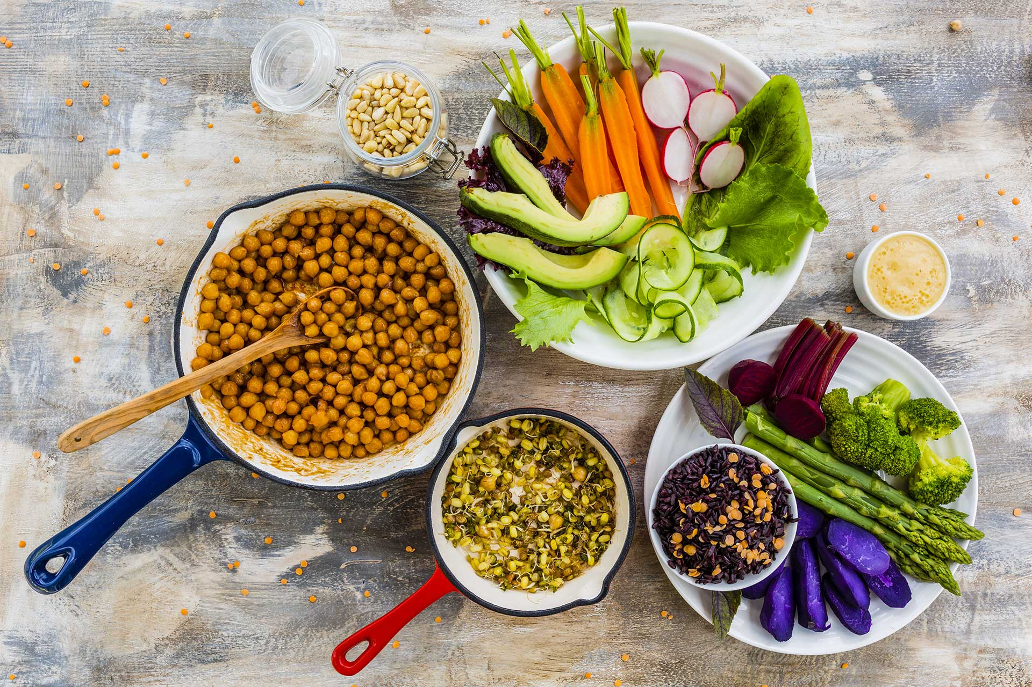WHAT TO KNOW BEFORE YOU THROW

Food Waste in Restaurants and Institutions
US restaurants generate an estimated 22 to 33 billion pounds of food waste each year. Institutions — including schools, hotels and hospitals — generate an additional 7 to 11 billion pounds per year. ⁴⁰ Approximately 4 to 10 percent of food purchased by restaurants is wasted before reaching the consumer. Drivers of food waste at restaurants include oversized portions, inflexibility of chain store management and extensive menu choices. ⁴¹ According to the Cornell University Food and Brand Lab, on average, diners leave 17 percent of their meals uneaten and 55 percent of edible leftovers are left at the restaurant. ⁴²This is partly due to the fact that portion sizes have increased significantly over the past 30 years, often being two to eight times larger than USDA or Federal Drug Administration (FDA) standard servings.
Kitchen culture and staff behavior such as over-preparation of food, improper ingredient storage and failure to use food scraps and trimmings can also contribute to food loss. ⁴³ All-you-can-eat buffets are particularly wasteful, since extra food cannot legally be reused or donated due to health code restrictions. ⁴⁴ The common practice of keeping buffets fully stocked during business hours (rather than allowing items to run out near closing) creates even more waste.

Food Waste in Households
Households are responsible for the largest portion of all food waste. ReFED estimates that US households waste 76 billion pounds of food per year. ⁴⁵ Approximately 40 to 50 percent of food waste (including 51 to 63 percent of seafood waste ⁴⁶ happens at level of the consumer. ⁴⁷ In the US, an average person wastes 238 pounds of food per year (21 percent of the food they buy), costing them $1,800 per year. ⁴⁸ In terms of total mass, fresh fruits and vegetables account for the largest losses at the consumer level (19 percent of fruits and 22 percent of vegetables), followed by dairy (20 percent), meat (21 percent) and seafood (31 percent). ⁴⁹ Major contributors to household food waste include:

LEARN MORE
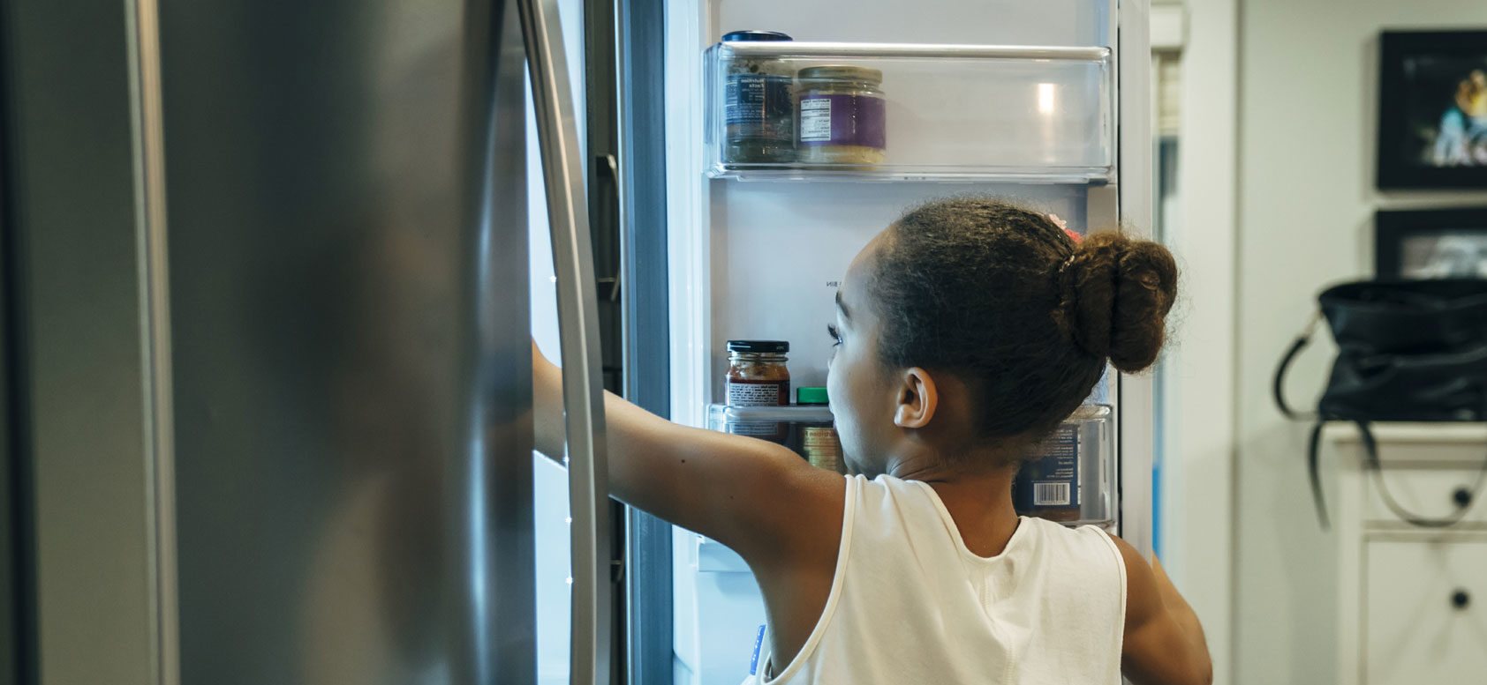THE BEST WAYS TO STORE FRUITS AND VEGETABLES TO REDUCE FOOD WASTE
- Food Spoilage — About two-thirds of food waste at home is due to food not being used before it goes bad. ⁵⁰Food spoilage at home occurs due to improper storage, lack of visibility in refrigerators, partially used ingredients and misjudged food needs. ⁵¹
- Over-Preparing — The remaining third of household food waste is the result of people cooking or serving too much food. ⁵² Cooking portions have increased over time, and large meals often include more food than we can finish. The Cornell Food and Brand lab found that since 2006, serving sizes in the classic cookbook The Joy of Cooking have increased by 36 percent. ⁵³ In addition, people often forget to eat leftovers, and end up throwing them away.
- Date Label Confusion — An estimated 80 percent of Americans prematurely discard food due to confusion over the meaning of date labels (e.g., “sell by,” “best if used by,” “expires by,” and so forth). ⁵⁴ In reality, “sell by” and “use by” dates are not federally regulated and only serve as manufacturer suggestions for peak quality. Research on date labeling from the UK suggests that standardizing food date labeling and clarifying its meaning to the public could reduce household food waste by as much as 20 percent. ⁵⁵
- Overbuying — Sales on unusual products and promotions that encourage impulse and bulk food purchases at retail stores often lead consumers to purchase items that do not fit into their regular meal plans and, therefore, spoil before they can be used. ⁵⁶
- Poor Planning — Without meal plans and shopping lists, consumers often make inaccurate estimates of what and how many ingredients they will use during the week. Unplanned restaurant meals or food delivery can also lead to food at home going bad before it can be used. ⁵⁷

COMPOSTING 101
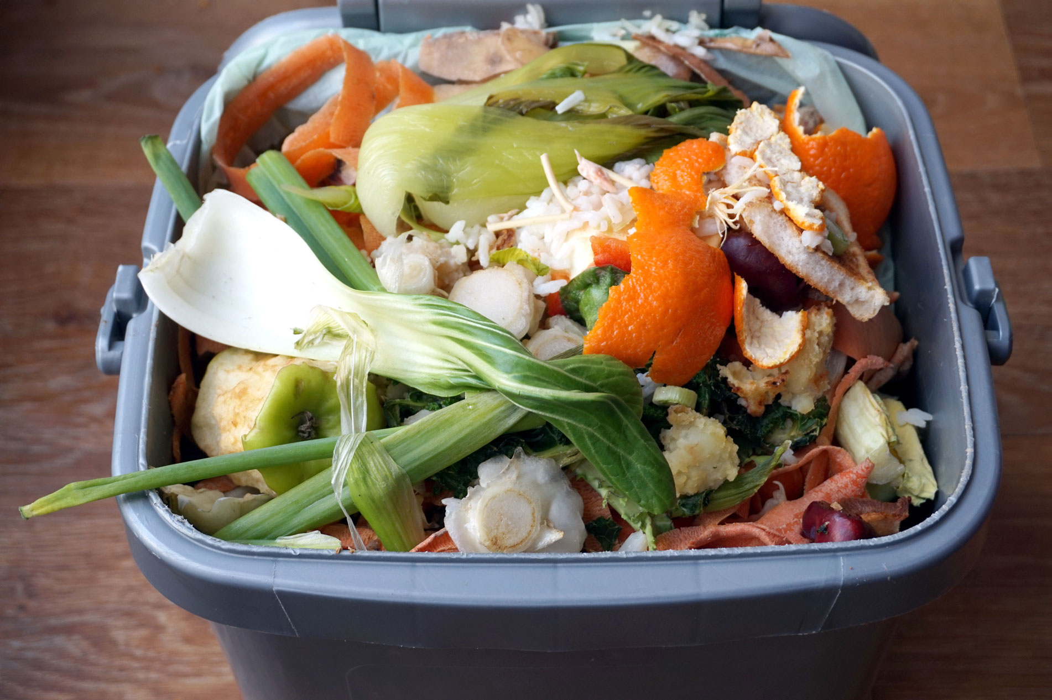HOW TO GET STARTED

The Biggest Reasons Food Gets Wasted
There are several macro-level drivers of the food waste problem in the US and globally. One is the difficulty of turning new consumer awareness into action. Public awareness about food waste in the US has improved significantly over the last few years. This is largely due to the efforts of organizations like the Ad Council and their Save the Food campaign, and coverage of the topic from Last Week Tonight with John Oliver, National Geographic, BBC, Consumer Reports and the more than 3,300 articles written about the issue by major news and business outlets between 2011 and 2016 — a 205 percent increase over that period. ⁵⁸
Additionally, in 2015, the USDA and the US Environmental Protection Agency adopted federal targets to cut food waste by 50 percent by 2030. ⁵⁹ In 2016 a survey by the Ad Council of 6700 adults, 75 percent of respondents said that food waste was important or very important to them. However, limited data makes it difficult to assess whether this awareness has turned into action and whether or not people are actually wasting less food now than they were before. Homes remain a large source of food waste and more needs to be done to help educate the public and provide people with resources to help them implement food saving practices at home. ⁶⁰
Another reason why food waste has become such a large problem is that it has not been effectively measured or studied. A comprehensive report on food losses in the US is needed to characterize and quantify the problem, identify opportunities and establish benchmarks against which progress can be measured. A study of this type by the European Commission in 2010 proved to be an important tool for establishing reduction goals in Europe and can serve as a model for US policymakers. ⁶¹

What Are the Environmental Impacts of Food Waste?
Only five percent of food is composted in the US and as a result, uneaten food is the single largest component of municipal solid waste. ⁶² In landfills, food gradually breaks down to form methane, a greenhouse gas that’s up to 86 times more powerful than carbon dioxide. ⁶³ According to a report from the UK based organization WRAP, if food were removed from UK landfills, the greenhouse gas abatement would be equivalent to removing one-fifth of all the cars in the UK from the road. ⁶⁴
Consumer food waste also has serious implications for energy usage. A study by the consulting group McKinsey found that, on average, household food losses are responsible for eight times the energy waste of farm-level food losses due to the energy used along the food supply chain and in preparation. ⁶⁵
In addition, food waste is responsible for more than 25 percent of all the freshwater consumption in the US each year, and is among the leading causes of fresh water pollution. ⁶⁶ Given all the resources demanded for food production, it is worth our while to make sure that the food we produce is not wasted.

