Forever Blue Network
Created: 03/2021 by the National FFA Organization
Description: The Forever Blue Network is an opportunity for networking and professional and personal development. Using this WebQuest, enroll and engage juniors and seniors in the Forever Blue Network.

Time Required: 45 minutes

Resources/References:
- Website: The Forever Blue Network, https://foreverbluenetwork.org/

Introduction:
- Before Getting Started:
  - Verify that each student is a junior or a senior in high school as this platform is intended for students nearing graduation.
  - Each student needs to have an FFA ID number. If a student does not have an FFA ID number, consider adding them to your roster as AgEd only. Note: Some states do not allow for AgEd only on the FFA roster. Also, some states use a different platform from FFA.org to complete the chapter roster.
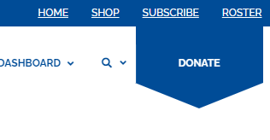
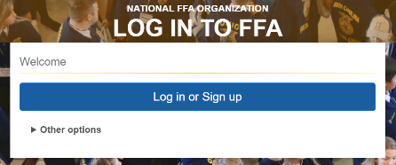
    - To find the FFA ID number of each student, or add them as AgEd only, begin by going to the roster on FFA.org and logging in.

- Provide a hard copy of or the link to (https://foreverbluenetwork.org/) the “Forever Blue Network Exploration” worksheet to each student.
- Students will create an account on the Forever Blue Network.
  - Students begin by selecting “Get Started” or “Start Networking” on the home screen.
  - Select a method to sign in/create your account.
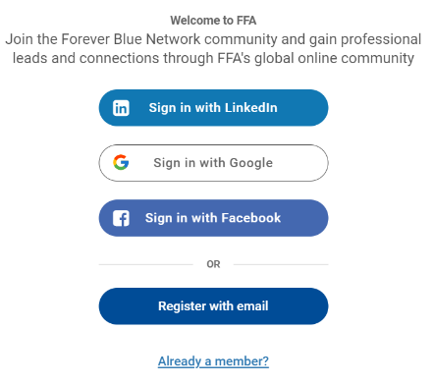

  - Next, students will be prompted to identify the following: Email, First/Last Name, State Association, FFA ID and date of birth.
  - Once approved, students will have access to the Forever Blue Network.

Forever Blue Network WebQuest
Directions:
Go to the Forever Blue Network website at https://foreverbluenetwork.org/ and create an account using your FFA ID number. Note: If you do not know your FFA ID number, ask your teacher.
How can an online network help you to achieve your goals?
What is the first thing you notice (what stands out) when you log in to the Forever Blue Network? Why?

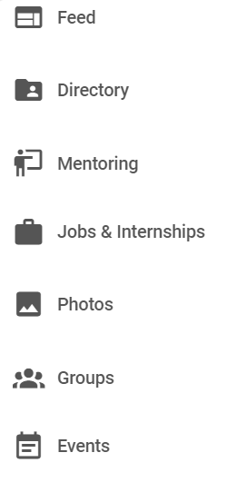
Identify four words that summarize the Forever Blue Network.
How can you use the Forever Blue Network to prepare you for life after high school?
What do you find here? How could you use this?
What do you find here? How could you use this?
What do you find here? How could you use this?
What do you find here? How could you use this?
What do you find here? How could you use this?
What do you find here? How could you use this?
What do you find here? How could you use this?
*Found on the left side …

