FFA New Horizons Teaching Guide Activity

Created: Spring 2020 by the National FFA Organization

This activity sheet is a general worksheet to be used with any of the articles found in the FFA New Horizons magazine.

Student learning objectives:
After completing these activities, students will …
- Evaluate how to deliver an agricultural message to different audiences.
- Analyze key information in an article.
- Determine the agricultural career focus area that best fits the article content.

Time required: 30 minutes
Resources:
- FFA New Horizons Teaching Guides, https://FFA.box.com/v/newhorizonsteachingguides
- FFA New Horizons, https://FFA.box.com/s/4nyqyx4fm95emghdoukry38l2y0idpm5, https://en.calameo.com/accounts/5107524

Equipment and supplies needed:
- A copy of the “Read All About It!” worksheet for each student
- Internet access to access the articles or download ahead of time

These activities are aligned to the following standards:

FFA Precept
- FFA.PL-A.Action: Assume responsibility and take the necessary steps to achieve the desired results, no matter what the goal or task at hand.
- FFA.PL-E.Awareness: Understand personal vision, mission and goals.
- FFA.PL-F.Continuous Improvement: Accept responsibility for learning and personal growth.
- FFA.PG-I.Professional Growth: Assume responsibility for attaining and improving upon the skills needed for career success.
- FFA.PG-J.Mental Growth: Embrace cognitive and intellectual development relative to reasoning, thinking and coping.
- FFA.CS-N.Decision Making: Analyze a situation and execute an appropriate course of action.
Common Core – Literacy in Science & Technical Subjects: Writing
- CCSS.ELA-Literacy.WHST.9.10.4: Produce clear and coherent writing in which the development, organization, and style are appropriate to task, purpose, and audience.
Common Core – Reading: Informational Text
- CCSS.ELA-Literacy.RI.9-10.2: Determine a central idea of a text and analyze its development over the course of the text, including how it emerges and is shaped and refined by specific details; provide an objective summary of the text.
- CCSS.ELA-Literacy.RI.9-10.4: Determine the meaning of words and phrases as they are used in a text, including figurative, connotative, and technical meanings; analyze the cumulative impact of specific word choices on meaning and tone (e.g., how the language of a court opinion differs from that of a newspaper).
Common Core – Writing
- CCSS.ELA-Literacy.W.9-10.2: Write informative/explanatory texts to examine and convey complex ideas, concepts, and information clearly and accurately through the effective selection, organization, and analysis of content.
Common Core – Speaking and Listening
- CCSS.ELA-Literacy.SL.9-10.4: Present information, findings, and supporting evidence clearly, concisely, and logically such that listeners can follow the line of reasoning and the organization, development, substance, and style are appropriate to purpose, audience, and task.
AFNR Career Ready Practices
- CRP.02: Apply appropriate academic and technical skills. Career-ready individuals readily access and use the knowledge and skills acquired through experience and education to be more productive.
- CRP.04: Communicate clearly, effectively, and with reason. Career-ready individuals communicate thoughts, ideas and action plans with clarity, whether using written, verbal and/or visual methods.
Partnership for 21st Century Skills
- Critical Thinking and Problem Solving
- Flexibility and Adaptability
- Initiative and Self-Direction
- Leadership and Responsibility

Suggested use:
Select, or have students select, an article in the FFA New Horizons magazine and complete the attached worksheet. Suggested activities and lessons where this can be infused include, but are not limited to:
- part of an agricultural literacy lesson.
- sustained silent reading.
- part of an agriscience lesson.
- bell ringer and exit ticket activities, etc.

Read All About It!
Aligned to the following standards:
FFA.PL-A; FFA.PL-E; FFA.PL-F; FFA.PG-I; FFA.PG-J; FFA.CS-N; CCSS.ELA.WHST.9.10.4; CCSS.ELA.RI.9-10.2, CCSS.ELA.RI.9-10.4; CCSS.ELA.W.9-10.2; CCSS.ELASL.9-10.4; CRP.02; CRP.04
directions:
Select an article in the FFA New Horizons magazine and complete the activity below. Utilize these links to access an article: https://FFA.box.com/s/4nyqyx4fm95emghdoukry38l2y0idpm5, https://en.calameo.com/accounts/5107524
- Summarize the article in three sentences:

2. Choose a vocabulary or key word from the article and place it in the center circle of the chart below. Complete the rest of the model based on the word you selected.

Definition
Characteristics
Examples
Non-Examples



3. What are two facts you learned from this article?

4. Summarize this article in one word and then describe the word selected:

5. Create a social media post that summarizes this article:

6. From the bank below, choose two audiences, and write an article summary that is targeted for each audience you choose.

Circle the audience you have chosen.
Audiences: Animal Activists Elementary-Age Students Farmers/Ranchers Consumers
Researchers Retail Associates

Circle the audience you have chosen.
Audiences: Animal Activists Elementary-Age Students Farmers/Ranchers Consumers
Researchers Retail Associates

7. Draw a picture in the blank space below to summarize the article.

8. Circle the career focus area that the article fits best.
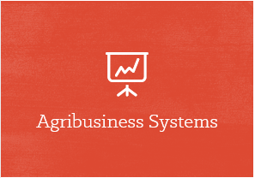

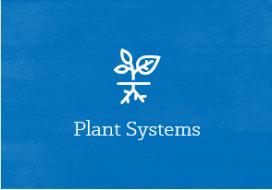


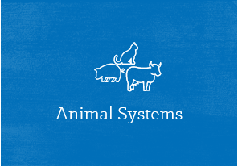
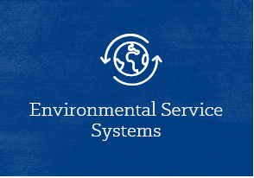
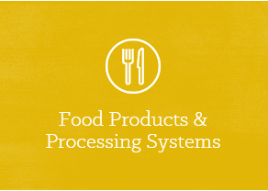
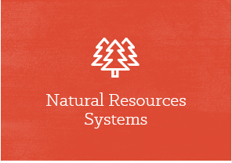

Descriptions of each career focus area:

Agribusiness Systems: The agribusiness field encompasses activities that contribute to successful agriculture production. This can include crop production, farm equipment, seed supply, marketing, natural resources and animal services.

Agricultural Education: Careers in agricultural education develop engaged citizens who understand the importance of the agriculture industry to our world, while teaching them technical skills in all areas of agriculture.

Animal Systems: Scientists and technicians in Animal Systems careers treat diseased or injured livestock, companion and exotic animals and work to keep them healthy.

Biotechnology Systems: Careers in this pathway help make plants more nutritious to eat and enable fish to grow twice as fast. They even use biotechnology to solve global issues.

Environmental Service Systems: People who work in the Environmental Service Systems career focus area may be involved with recycling, water and air pollution control, waste disposal and public health issues.

Food Products and Processing Systems: Some careers in food products and processing focus on diet, health and food safety by ensuring the quality of the foods we eat every day. Others work to develop new packaging, new products and new sales opportunities.

Natural Resources Systems: Career opportunities in Natural Resources Systems are available in both urban and rural settings, in the field and in the lab. Protecting wildlife, maintaining parks, consulting with research groups and keeping green areas are important needs everywhere.

Plant Systems: Plant Systems professionals help feed our growing population by monitoring the quality and safety of our food and helping consumers make sensible nutritional decisions.

Power, Structural and Technical Systems: Professionals in these fields apply knowledge of engineering, hydraulics, pneumatics, electronics, power, structures and controls to the field of agriculture. They also tackle exciting challenges such as how to conserve soil and water, how to create efficient production and how to conserve natural resources.

9. Which career focus area did you circle? Why?

10a. What are three careers that align with the career focus area you circled? Visit AgExplorer.FFA.org to help with this question.

10b. Align the careers that you highlighted in question 10a to one of the steps in the Agriculture, Food and Natural Resources (AFNR) Value Chain (FFA.org/value-chain/) and record your responses below. (Click on each step in the value chain to learn more.)
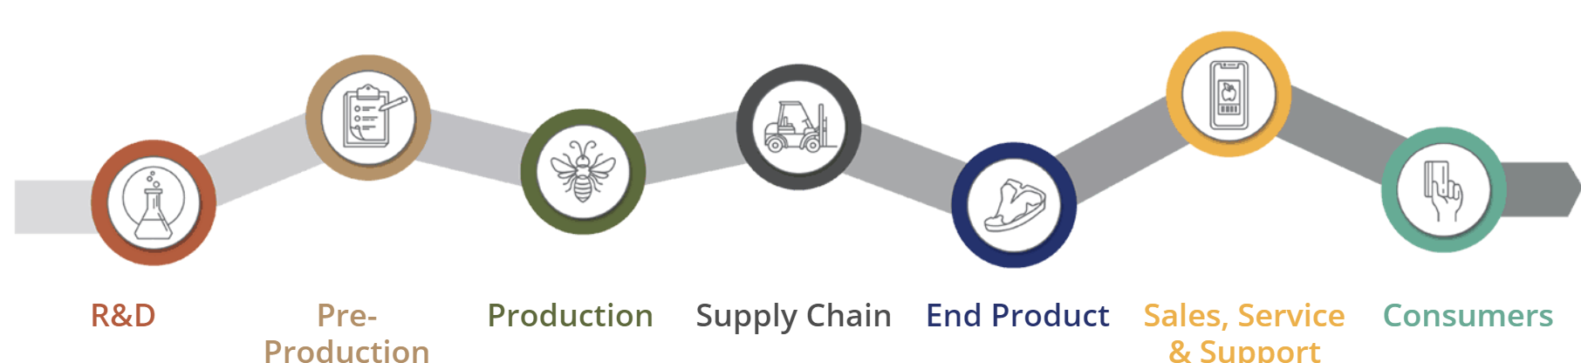
Career
Step in the AFNR Value Chain:
Career
Career
Step in the AFNR Value Chain:
Step in the AFNR Value Chain:
Why did you choose this step?
Why did you choose this step?
Why did you choose this step?

11. Based on what you have learned, create a new title and tag line for the article.

Create a hashtag for the new title and tag line:

