SAE: Preparing for the Next Step
Aligned to the following standards:
CS.05; FFA.PL-A; FFA.PL-E; FFA.PL-F; FFA.PG-I; FFA.PG-J; FFA.CS-N; AG5; CCSS.ELA.WHST.9.10.4; MP5; MP6; CRP.02; CRP.04
Directions:
Watch an SAE video and complete the activity below. The SAE videos can be found at FFA.org/ffa-video-center/sae-video-library/.

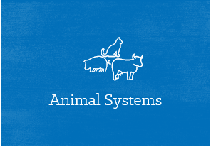

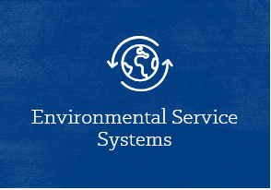
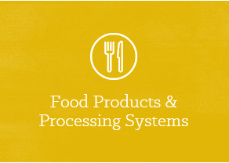




Circle the career focus area this SAE fits into. Record the focus area name here:
Three skills learned through this SAE are …
Three classes that would be beneficial in preparing for this SAE are …
Three daily tasks learned through this SAE are …
Two companies that would hire a person with this experience are …
Three vocabulary or interesting words that I heard are …
Summarize the video in three sentences.
SAE can impact me by …
Draw a picture that summarizes this video.

Which SAE category does this SAE fit into?

- Foundational
- Placement
- Entrepreneurship
- Research
- School-based Enterprise
- Service Learning

*More information can be found at https://ffa.box.com/s/m572qkpzzbdb9ew04haovv434k33pb9o.

I

