SAE Video Activity
Created: 02/2019 by the National FFA Organization

This worksheet is a general worksheet to be used with the videos in the SAE video library.
Student Learning Objectives:
After completing these activities, students will …
- Describe a supervised agricultural experience (SAE) program.
- Determine skills required for an SAE.
- Identify careers and career focus areas associated with an SAE.
Time Required: 30 minutes
Resources: SAE Video library, FFA.org/ffa-video-center/sae-video-library/
Equipment and Supplies Needed:
- A copy of the “SAE: Preparing for the Next Step” worksheet for each student
- Internet access to play the video in real time or embed it in a PowerPoint ahead of time
This quick Activity would work well as:
- A career lesson plan.
- A leadership lesson plan.
- An SAE lesson plan.
These activities are aligned to the following standards:
AFNR Performance Element
- CS.05: Describe career opportunities and means to achieve those opportunities in each of the Agriculture, Food & Natural Resources career pathways.
FFA Precept
- FFA.PL-A.Action: Assume responsibility and take the necessary steps to achieve the desired results, no matter what the goal or task at hand.
- FFA.PL-E.Awareness: Understand personal vision, mission and goals.
- FFA.PL-F.Continuous Improvement: Accept responsibility for learning and personal growth.
- FFA.PG-I.Professional Growth: Assume responsibility for attaining and improving upon the skills needed for career success.
- FFA.PG-J.Mental Growth: Embrace cognitive and intellectual development relative to reasoning, thinking and coping.
- FFA.CS-N.Decision Making: Analyze a situation and execute an appropriate course of action.
Common Career Technical Core
- AG5: Describe career opportunities and means to achieve those opportunities in each of the Agriculture, Food & Natural Resources career pathways.
Common Core – Literacy in Science & Technical Subjects: Writing
- CCSS.ELA-Literacy.WHST.9.10.4: Produce clear and coherent writing in which the development, organization, and style are appropriate to task, purpose, and audience.
Common Core – Math Practices
- CCSS.MP5: Use appropriate tools strategically.
- CCSS.MP6: Attend to precision.
AFNR Career Ready Practices
- CRP.02: Apply appropriate academic and technical skills. Career-ready individuals readily access and use the knowledge and skills acquired through experience and education to be more productive.
- CRP.04: Communicate clearly, effectively, and with reason. Career-ready individuals communicate thoughts, ideas and action plans with clarity, whether using written, verbal and/or visual methods.
Partnership for 21st Century Skills
- Critical Thinking and Problem Solving
- Flexibility and Adaptability
- Initiative and Self-direction
- Leadership and Responsibility
Suggested Use:
Select, or have students select, an SAE video and complete the attached worksheet. The worksheet helps students gather information about the purpose, skills, preparation and outcomes of an SAE program.

SAE: Preparing for the Next Step
Aligned to the following standards:
CS.05; FFA.PL-A; FFA.PL-E; FFA.PL-F; FFA.PG-I; FFA.PG-J; FFA.CS-N; AG5; CCSS.ELA.WHST.9.10.4; MP5; MP6; CRP.02; CRP.04
Directions:
Watch an SAE video and complete the activity below. The SAE videos can be found at FFA.org/ffa-video-center/sae-video-library/.
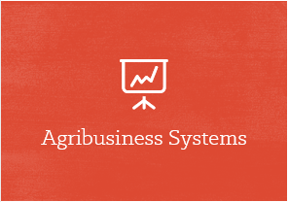
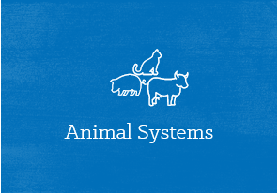

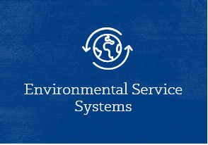
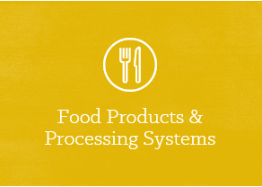
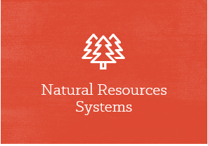
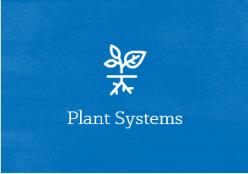


Circle the career focus area this SAE fits into. Record the focus area name here:
Three skills learned through this SAE are …
Three classes that would be beneficial in preparing for this SAE are …
Three daily tasks learned through this SAE are …
Two companies that would hire a person with this experience are …
Three vocabulary or interesting words that I heard are …
Summarize the video in three sentences.
SAE can impact me by …
Draw a picture that summarizes this video.

Which SAE category does this SAE fit into?

- Foundational
- Placement
- Entrepreneurship
- Research
- School-based Enterprise
- Service Learning

*More information can be found at https://ffa.box.com/s/m572qkpzzbdb9ew04haovv434k33pb9o.

I

