Get to KNow the 2021-22 National FFA Officers
Directions: Once the new officer team is announced on October 30, research and fill out the information below.
 SENTINEL

Name:

Region: State:
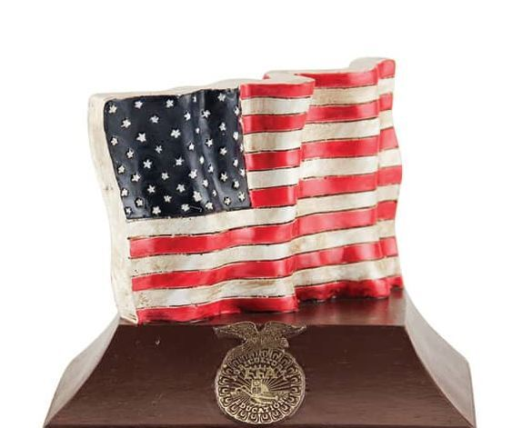 REPORTER

Name:

Region: State:
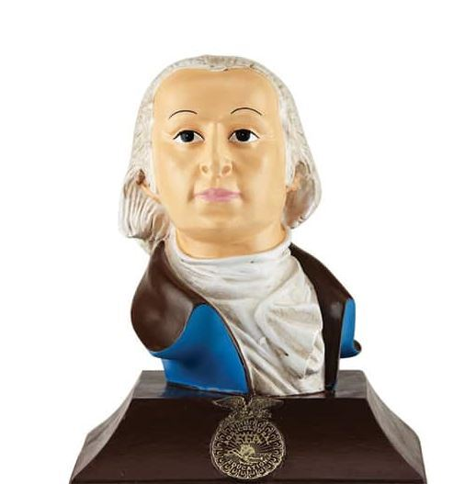 TREASURER

Name:

Region: State:
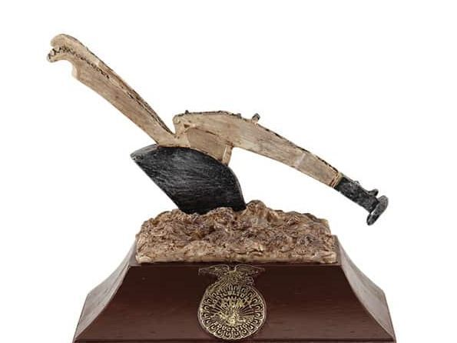VICE PRESIDENT

Name:

Region: State:
SECRETARY

Name:

Region: State:
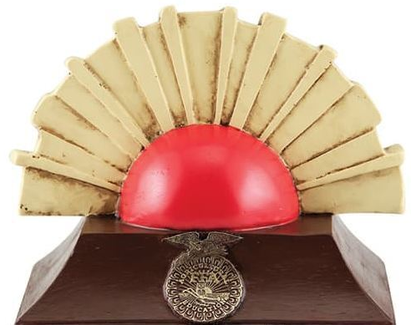 PRESIDENT

Name:

Region: State:

