Repurposing Pallets
Aligned to the following standards:
FFA.PL-A; FFA.PL-C; FFA.PL-E; FFA.PL-F; FFA.PG-I; FFA.CS-M; CCSS.SL.9-10.1; CCSS.SL.9-10.2; CRP.04; CRP.10

Directions:
Answer the questions below as you watch the video “Giancarlo Lomanto – SAE – Pallet Planter.” The video is available at https://vimeo.com/300298509.

Circle the area of agriculture that best fits this SAE.

Agribusiness Food Products & Processing

Animal Natural Resources

Biotechnology Plant

Environmental

Power, Structural & Technical

Why did you choose this area of agriculture?
What is Giancarlo’s SAE?


What tools and materials are needed for Giancarlo’s project, including personal protective equipment (PPE)?

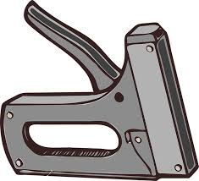
Why did Giancarlo start this project?

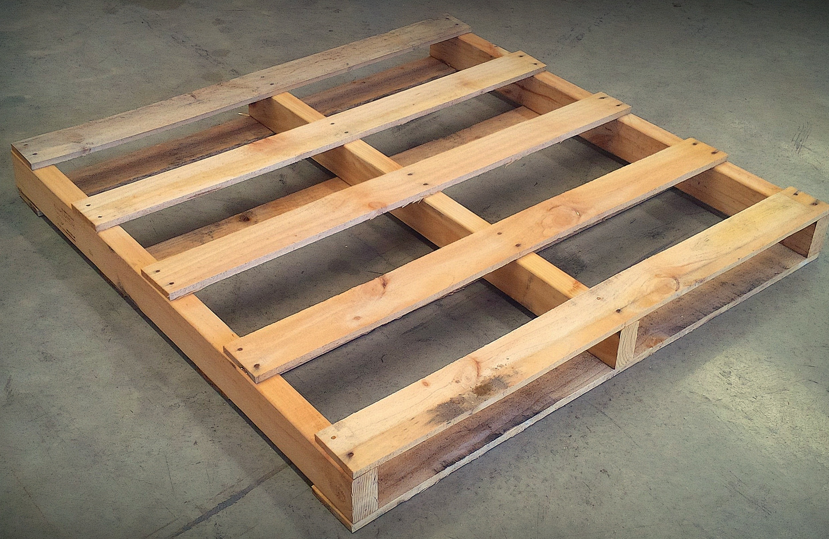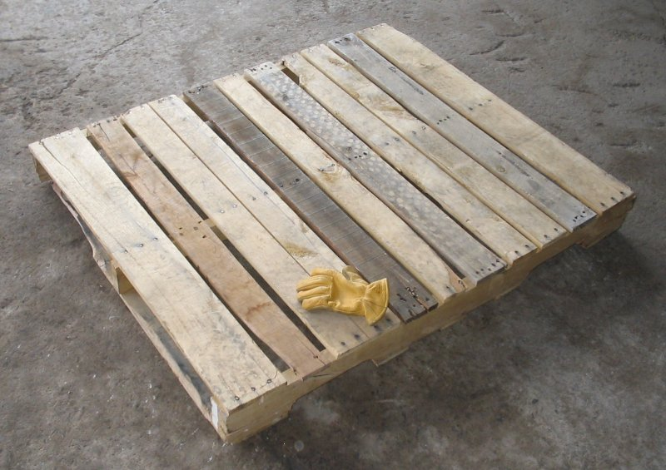

Why is wearing personal protective equipment (PPE) so important?

Repurpose for Beauty
Aligned to the following standards:
FFA.PL-A; FFA.PL-C; FFA.PL-E; FFA.PL-F; FFA.PG-I; FFA.CS-M; CCSS.SL.9-10.1; CCSS.SL.9-10.2; CRP.04; CRP.10

Directions:
Part 1: Utilize the space below to design your own pallet planter. Include measurements and a key that lists what each item on the plan represents.
Typical size of a pallet: 48” x 40”
Typical row spacing: This depends on the plants you choose.

Part 2: Now that you have your pallet planter design, choose which plants and other materials you need for your planter. List your materials in the space below and price them.

Material | Quantity | Unit Cost | Total Cost
Pallet (48” x 40”) |  | 18.00

Part 3: If you have the resources, construct your pallet planter.

Why is repurposing important?
In what other situations could you utilize the skills learned?

