Pallet Planters
Created: 06/2019 by the National FFA Organization

SAE Video Summary: Follow Giancarlo as he walks us through his supervised agricultural experience (SAE) program constructing pallet planters (planters made out of old pallets). He shows us the tools and materials he uses in creating pallet planters.
Student Learning Objectives:
After completing these activities, students will …
- Identify the tools and materials needed to create a pallet planter.
- Design a personalized pallet planter.

Time Required: 45 minutes
Resources:
- “Giancarlo Lomanto – SAE – Pallet Planter,” https://vimeo.com/300298509

Equipment and Supplies Needed:
- A copy of the “Repurposing Pallets” worksheet for each student
- A copy of the “Repurpose for Beauty” worksheet for each student
- Internet access to play the video in real time or embed it in a PowerPoint ahead of time

This quick lesson plan would work well as Part Of:
- An SAE lesson/unit.
- A plant science lesson.

Student Activity Sheets:
Direct access to student activity sheets without lesson plan or answer key for easy upload to learning management systems or printing for classwork.
https://ffa.box.com/s/v95of52s38sr23cbv4wy2saexs8ol5j4 (Word)
https://ffa.box.com/s/g7mn3vyt78ce7vyphb322yd2ez74osgh (PDF)
These activities are aligned to the following standards:
FFA Precept
- FFA.PL-A.Action: Assume responsibility and take the necessary steps to achieve the desired results, no matter what the goal or task at hand.
- FFA.PL-C.Vision: Visualize the future and how to get there.
- FFA.PL-E.Awareness: Understand personal vision, mission and goals.
- FFA.PL-F.Continuous Improvement: Accept responsibility for learning and personal growth.
- FFA.PG-I.Professional Growth: Assume responsibility for attaining and improving upon the skills needed for career success.
- FFA.CS-M.Communication: Effectively interact with others in personal and professional settings.
Common Core – Speaking and Listening
- CCSS.ELA-Literacy.SL.9-10.1 Initiate and participate effectively in a range of collaborative discussions (one-on-one, in groups, and teacher-led) with diverse partners on grades 9-10 topics, texts, and issues, building on others' ideas and expressing their own clearly and persuasively.
- CCSS.ELA-Literacy.SL.9-10.2 Integrate multiple sources of information presented in diverse media or formats (e.g., visually, quantitatively, orally) evaluating the credibility and accuracy of each source.
AFNR Career Ready Practices
- CRP.04. Communicate clearly, effectively, and with reason. Career-ready individuals communicate thoughts, ideas and action plans with clarity, whether using written, verbal and/or visual methods.
- CRP.10. Plan education and career path aligned to personal goals. Career-ready individuals take personal ownership of their own educational and career goals, and they regularly act on a plan to attain these goals.
Partnership for 21st Century Skills
- Communication
- Initiative and Self-Direction
- Leadership and Responsibility

Lesson Plan:
- Bell Ringer: Create a list of items found around the room that you can re-purpose.

- Introduction: Review students’ answers from the bell ringer. Now that we have looked at items that can be repurposed, we are going to watch a short video about a student who repurposes pallets as part of his SAE program.

- Activity:
  - Each student needs a copy of the worksheet “Repurposing Pallets.” Have students watch the video “Giancarlo Lomanto – SAE – Pallet Planter” (https://vimeo.com/300298509) and answer the accompanying questions.

  - Each student needs a copy of the worksheet “Repurpose for Beauty.”
Part 1: Students will design a pallet planter by choosing the planter layout and determining what type of plants they want to include.

Part 2: Students will utilize their designs to determine what it would cost to create their pallet planter.

Part 3: If time and materials allow, have students build their pallet planters.

- Follow-up: Upon completion of the activity, have students present their pallet planter designs to the class.

- Leveling Up: To take this lesson one step further, have students work together to design and implement a pallet planter garden at the school.

- Exit Ticket: Besides a pallet planter, what else can be created with an old pallet?

Repurposing Pallets
Aligned to the following standards:
FFA.PL-A; FFA.PL-C; FFA.PL-E; FFA.PL-F; FFA.PG-I; FFA.CS-M; CCSS.SL.9-10.1; CCSS.SL.9-10.2; CRP.04; CRP.10

Directions:
Answer the questions below as you watch the video “Giancarlo Lomanto – SAE – Pallet Planter.” The video is available at https://vimeo.com/300298509.

Circle the area of agriculture that best fits this SAE.

Agribusiness Food Products & Processing

Animal Natural Resources

Biotechnology Plant

Environmental

Power, Structural & Technical

Why did you choose this area of agriculture?
What is Giancarlo’s SAE?


What tools and materials are needed for Giancarlo’s project, including personal protective equipment (PPE)?

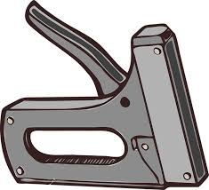
Why did Giancarlo start this project?

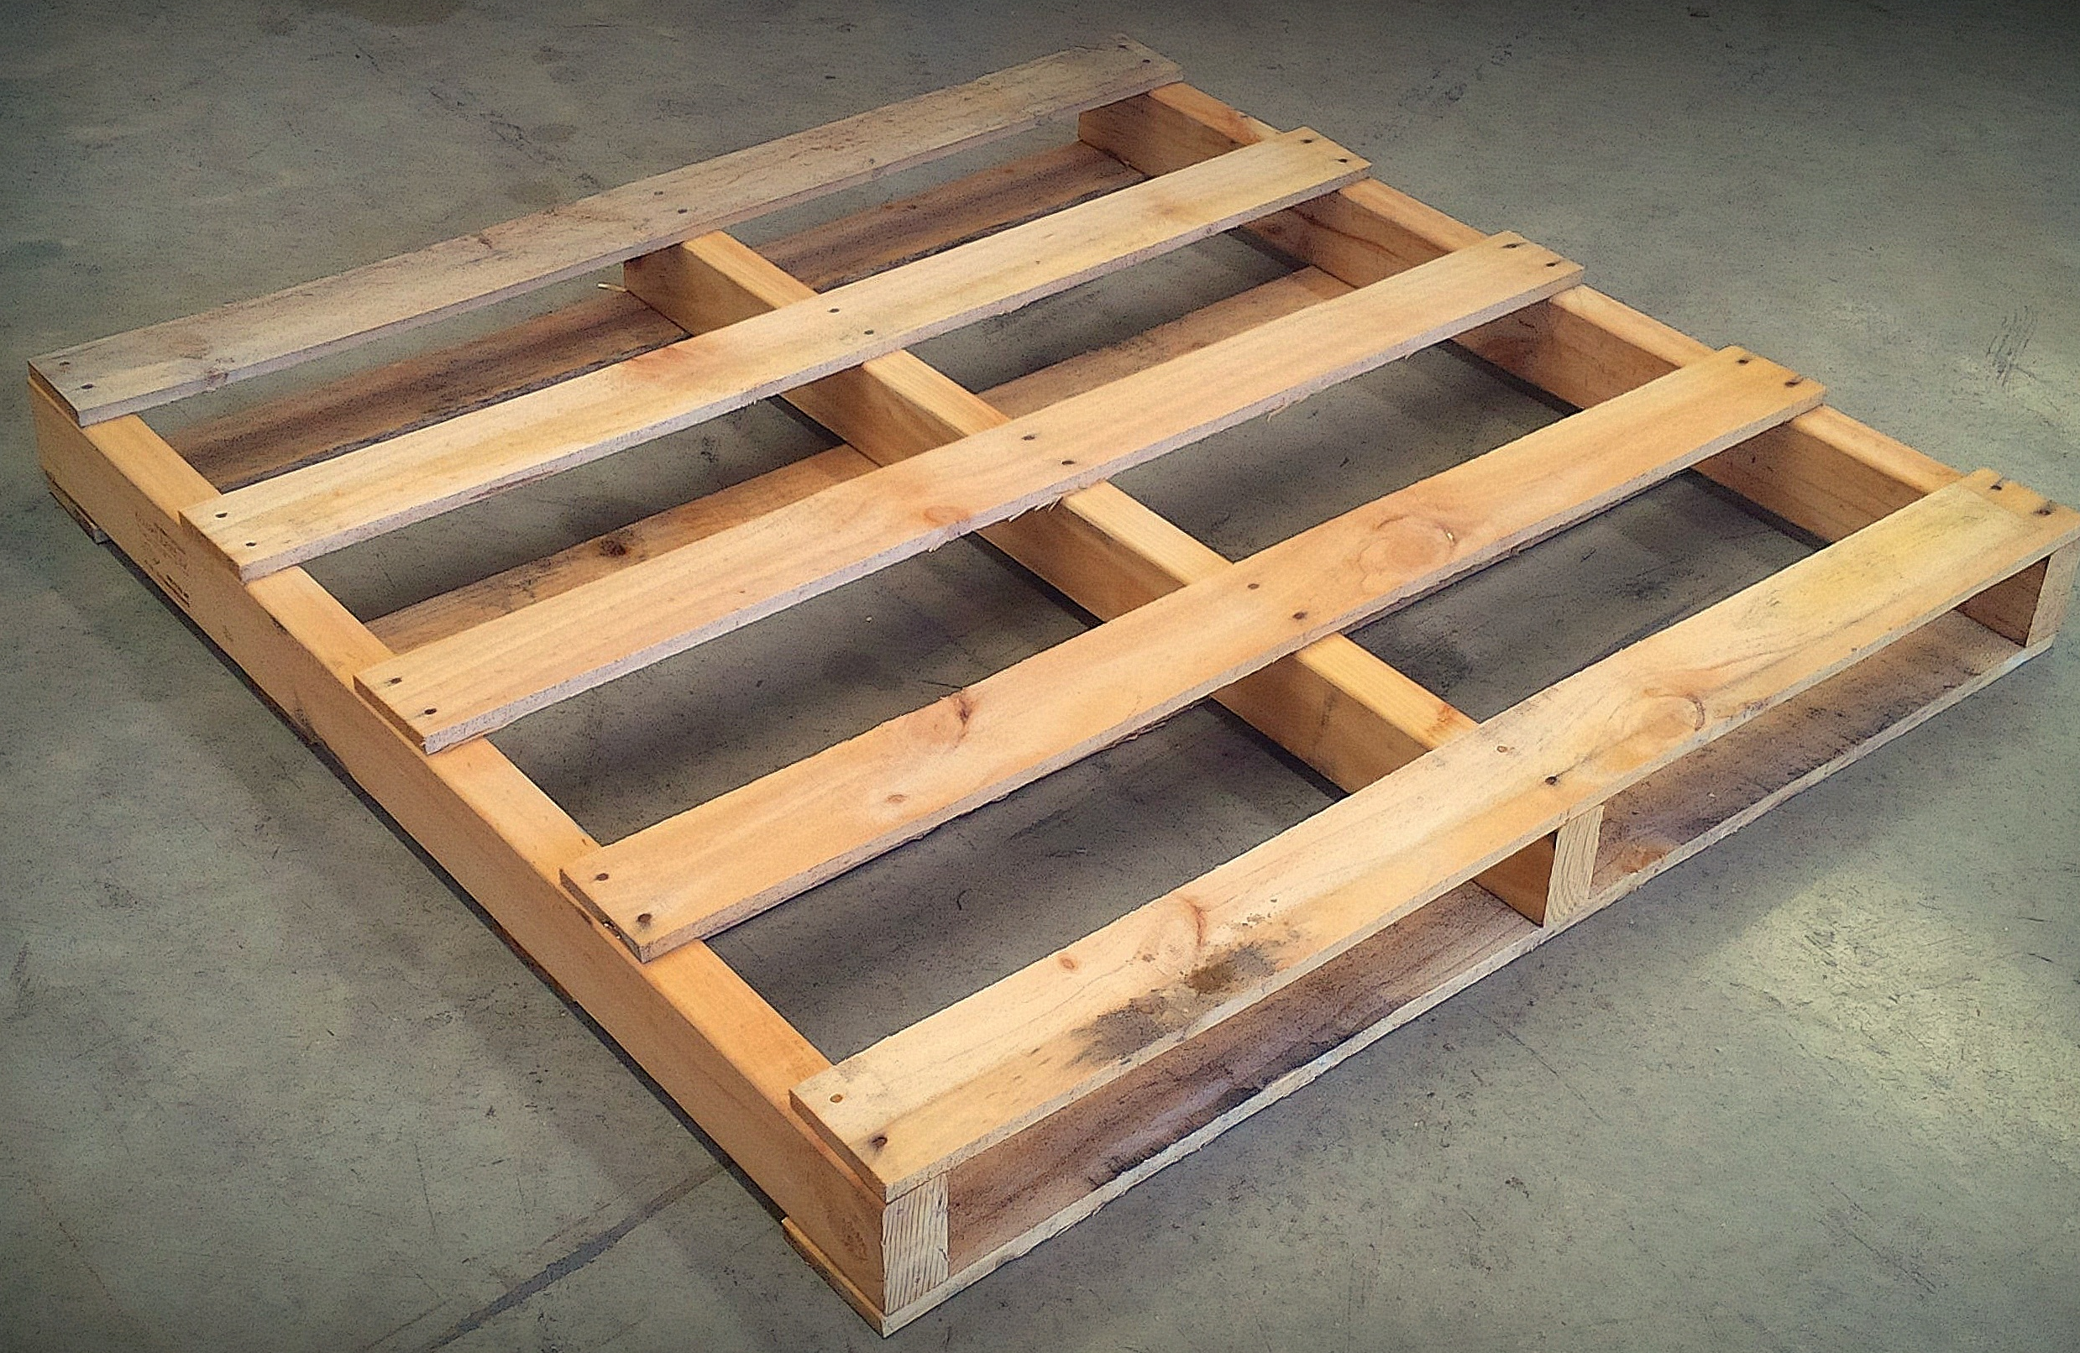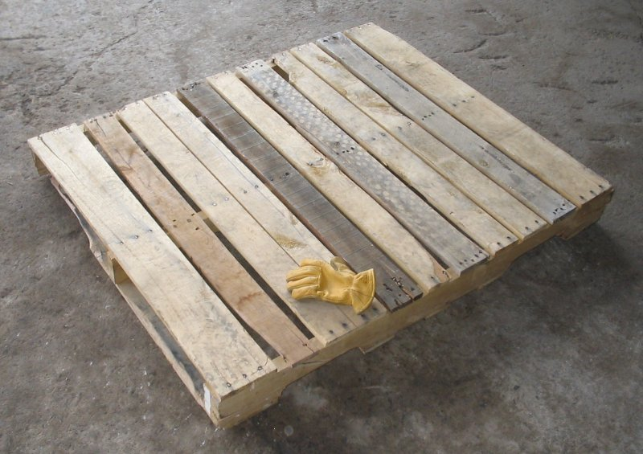

Why is wearing personal protective equipment (PPE) so important?

Repurpose for Beauty
Aligned to the following standards:
FFA.PL-A; FFA.PL-C; FFA.PL-E; FFA.PL-F; FFA.PG-I; FFA.CS-M; CCSS.SL.9-10.1; CCSS.SL.9-10.2; CRP.04; CRP.10

Directions:
Part 1: Utilize the space below to design your own pallet planter. Include measurements and a key that lists what each item on the plan represents.
Typical size of a pallet: 48” x 40”
Typical row spacing: This depends on the plants you choose.

Part 2: Now that you have your pallet planter design, choose which plants and other materials you need for your planter. List your materials in the space below and price them.

Material | Quantity | Unit Cost | Total Cost
Pallet (48” x 40”) |  | 18.00

Part 3: If you have the resources, construct your pallet planter.

Why is repurposing important?
In what other situations could you utilize the skills learned?

KEY: Repurposing Pallets
Aligned to the following standards:
FFA.PL-A; FFA.PL-C; FFA.PL-E; FFA.PL-F; FFA.PG-I; FFA.CS-M; CCSS.SL.9-10.1; CCSS.SL.9-10.2; CRP.04; CRP.10

Directions:
Answer the questions below as you watch the video “Giancarlo Lomanto – SAE – Pallet Planter.” The video is available at https://vimeo.com/300298509.

Circle the area of agriculture that best fits this SAE.

Agribusiness Food Products & Processing

Animal Natural Resources

Biotechnology Plant

Environmental Service

Power, Structural & Technical

Ideally, students will choose one of the red-circled options.

Why did you choose this area of agriculture?
Answers will vary based on the area the student chooses.
What is Giancarlo’s SAE?

He repurposes pallets into pallet planters.

Answers could vary, but safety is key!
Answers could vary, but safety is key!

What tools and materials are needed for Giancarlo’s project, including personal protective equipment (PPE)?

Pallets
Weed fabric
Staple gun
Drill
Circular saw
Safety glasses
Gloves

Why did Giancarlo start this project?

During a youth program he saw a pallet planter at school that wasn’t in the best shape and he wanted to improve it.

Why is wearing personal protective equipment (PPE) so important?

Answers could vary, but safety is key!

