Olive Oil Production
Aligned to the following standards:
CS.05; CS.06; FFA.PL-A; FFA.PG-J; FFA.CS-N; AG5; AG6; CCSS.ELA.SL.9-10.2; CCSS.ELA.SL.9-10.4; CCSS.ELA.WHST.9.10.4; MP1; MP5; MP6; CRP.02; CRP.04
Part 1
Directions:
Read over and answer the questions below while you watch the video “Giovanni Garcia and Luke Anderson – SAE – Olive Oil,” available at https://vimeo.com/278917849.

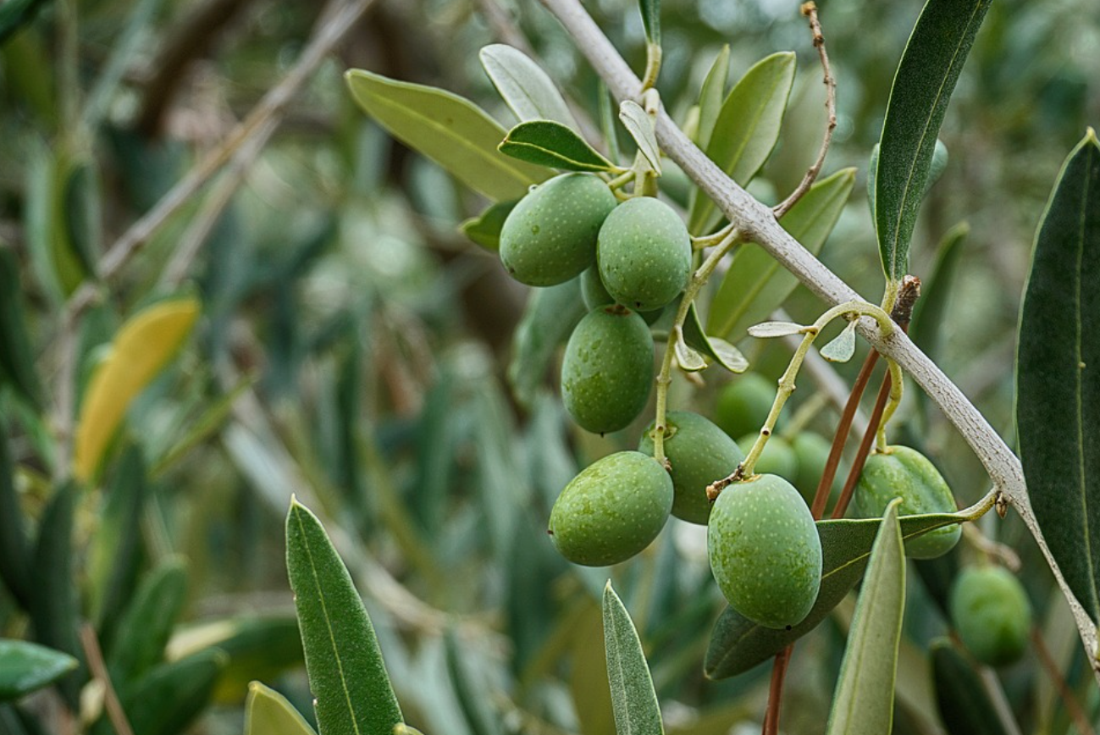
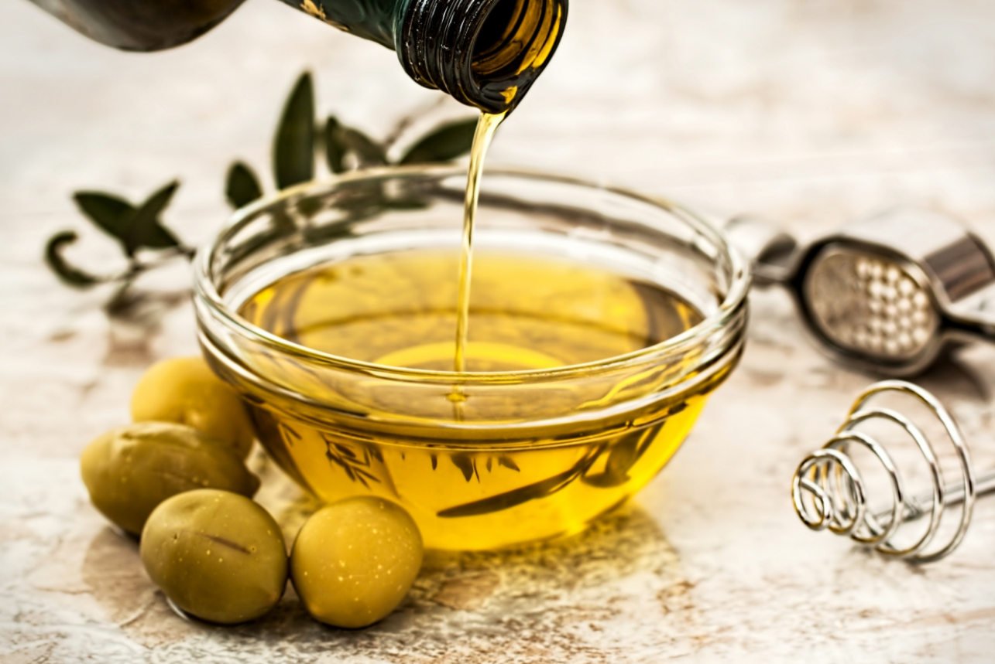
What is Giovanni and Luke’s SAE? What do they do? _____________________________________________________________________________________________________________________________________________________________________________________________________________

- What was Luke and Giovanni’s motivation for starting this SAE? ______________________________________________________________
- What challenges have they faced? ______________________________________________________________
- What skills have they learned? _____________________________________________________________________________________________

What class did Giovanni and Luke take to better prepare themselves for this SAE?

_______________________________
What has their SAE done for them? ________________________________________________________________________________________________________________________________________________________________________________________________________________________
What can an SAE do for you? ________________________________________________________________________________________________________________________________________________________________________________________________________________________

Part 2
Aligned to the following standards:
CS.05; CS.06; FFA.PL-A; FFA.PG-J; FFA.CS-N; AG5; AG6; CCSS.ELA.SL.9-10.2; CCSS.ELA.SL.9-10.4; CCSS.ELA.WHST.9.10.4; MP1; MP5; MP6; CRP.02; CRP.04
Directions:
Giovanni and Luke described their SAE and showed us their work on the farm, but what happens between the farm and the oil we cook with?

Using the following diagram and your research skills, develop a lab procedure (as you do in science class) that would take a person through the process of olive oil production. Include a brief description and purpose next to each step. There will be 8 steps in total.

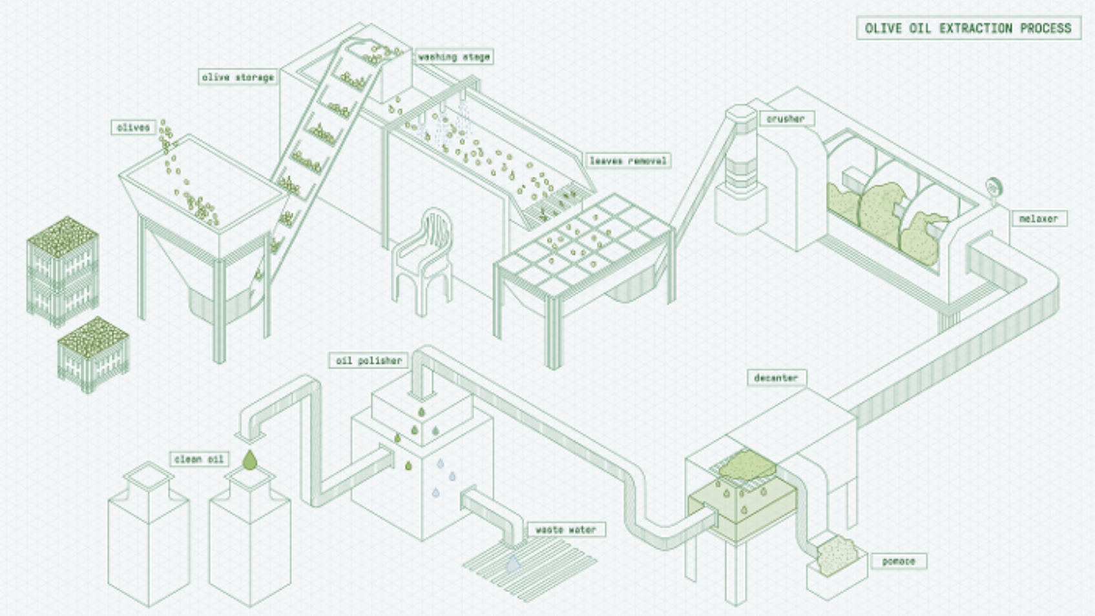
(3) Washing

(2) Storage

(5) Crusher

(1) Olives in

(4) Leaf Removal

(6) Malaxer

(8) Oil Polisher

(7) Decanter

Clean Oil

Waste Water
Pomate

Title: _____________________________________

(1) Olives added in: Olives are harvested and added to the bulk tank to begin the process.

(2)

(3)

(4)

(5)

(6)

(7)

(8)

Part 3
Aligned to the following standards:
CS.05; CS.06; FFA.PL-A; FFA.PG-J; FFA.CS-N; AG5; AG6; CCSS.ELA.SL.9-10.2; CCSS.ELA.SL.9-10.4; CCSS.ELA.WHST.9.10.4; MP1; MP5; MP6; CRP.02; CRP.04
Directions:
Select a food product of your choice, draw the production process and then write a lab procedure for the food product.
Illustration:

Title: _____________________________________

(1)

Part 4
Aligned to the following standards:
CS.05; CS.06; FFA.PL-A; FFA.PG-J; FFA.CS-N; AG5; AG6; CCSS.ELA.SL.9-10.2; CCSS.ELA.SL.9-10.4; CCSS.ELA.WHST.9.10.4; MP1; MP5; MP6; CRP.02; CRP.04
Part 4
Directions:
Now that you have a better understanding of how some food products are produced, answer the following questions.

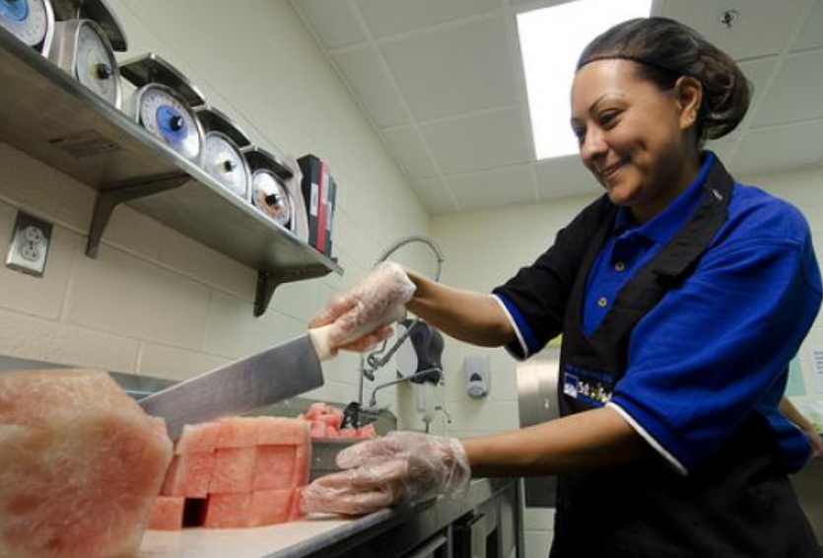
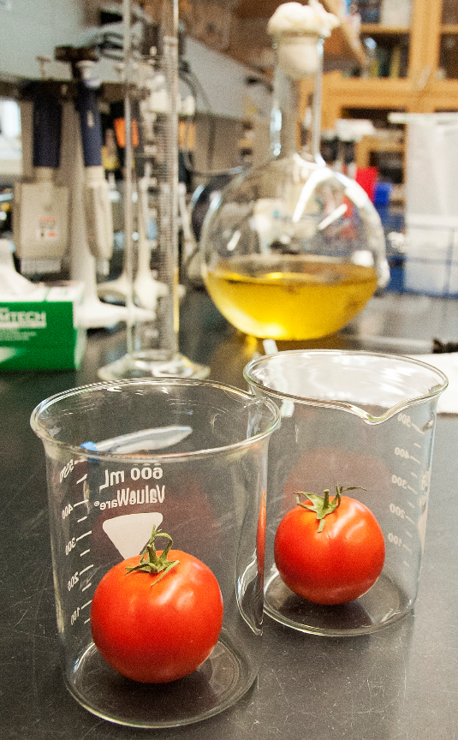
Visit AgExplorer.ffa.org. Identify three careers in the food products and processing career focus area that would be involved in some way with the production of the food you selected above:

- ____________________________________________
- ____________________________________________
- ____________________________________________
Identify three courses in high school you could take to prepare you for a career in the food products and processing career focus area.

- ____________________________________________
- ____________________________________________
- ____________________________________________
What role can an SAE play in helping you achieve your career goals? Write a minimum of three sentences.

