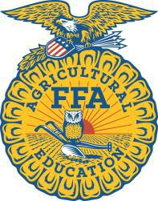

Olives to Oil

Lesson Plan

Created: 02/2019 by the National FFA Organization

SAE Video Summary: Learn about a unique olive oil production supervised agricultural experience (SAE) program from Giovanni and Luke. These two students work together in a school- based SAE where they are responsible for helping produce the olives, harvesting the olive oil, and labeling and packaging the final product.

STUDENT LEARNING OBJECTIVES:
After completing these activities, students will …
1. Describe a production SAE.
2. Describe and explain the outcomes of an SAE.
3. Describe the production of olive oil.
4. Describe careers in a food products and processing career focus area.

TIME REQUIRED: 60 minutes

RESOURCES:
1. Video: “Giovanni Garcia and Luke Anderson – SAE – Olive Oil,” https://vimeo.com/278917849.
2. Website: AgExplorer, AgExplorer.ffa.org

EQUIPMENT AND SUPPLIES NEEDED:
1. A copy of the “Olive Oil Production” worksheet for each student
2. Internet access to play the video in real time or embed it in a PowerPoint ahead of time
3. Access to computers

THIS QUICK LESSON PLAN WOULD WORK WELL AS PART OF:
1. An SAE lesson.
2. A food science lesson.
3. A plant science lesson.

STUDENT ACTIVITY SHEETS:

Direct access to student activity sheets without lesson plan or answer key for easy upload to learning management systems or printing for classwork.
https://ffa.box.com/s/0h1x2d14ewojythmbap0gjioycpq5ch1 (Word)

https://agexplorer.ffa.org/https://ffa.box.com/s/3mpgknio7dwo58q33oh4jo4ephu72zgk (PDF)

THESE ACTIVITIES ARE ALIGNED TO THE FOLLOWING STANDARDS:
AFNR Performance Element
• CS.05: Describe career opportunities and means to achieve those opportunities in each of the Agriculture, Food & Natural Resources career pathways.
• CS.06: Analyze the interaction among AFNR systems in the production, processing and management of food, fiber and fuel and the sustainable use of natural resources.
FFA Precept
• FFA.PL-A.Action: Assume responsibility and take the necessary steps to achieve the desired results, no matter what the goal or task at hand.
• FFA.PG-J.Mental Growth: Embrace cognitive and intellectual development relative to reasoning, thinking and coping.
• FFA.CS-N.Decision Making: Analyze a situation and execute an appropriate course of action.
Common Career Technical Core
• AG5: Describe career opportunities and means to achieve those opportunities in each of the Agriculture, Food & Natural Resources Career Pathways.
• AG6: Analyze the interaction among AFNR systems in the production, processing, and management of food, fiber,
and fuel and the sustainable use of natural resources.
Common Core – Speaking and Listening
• CCSS.ELA-Literacy.SL.9-10.2: Integrate multiple sources of information presented in diverse media or formats (e.g., visually, quantitatively, orally) evaluating the credibility and accuracy of each source.
• CCSS.ELA-Literacy.SL.9-10.4: Present information, findings, and supporting evidence clearly, concisely, and logically such that listeners can follow the line of reasoning and the organization, development, substance, and style are appropriate to purpose, audience, and task.
Common Core – Literacy in Science & Technical Subjects: Writing
• CCSS.ELA-Literacy.WHST.9.10.4: Produce clear and coherent writing in which the development, organization, and
style are appropriate to task, purpose, and audience.
Common Core- Math Practices
• CCSS.MP1: Make sense of problems and persevere in solving them.
• CCSS.MP5: Use appropriate tools strategically.
• CCSS.MP6: Attend to precision.
AFNR Career Ready Practices
• CRP.02: Apply appropriate academic and technical skills. Career-ready individuals readily access and use the
knowledge and skills acquired through experience and education to be more productive.
• CRP.04: Communicate clearly, effectively, and with reason. Career-ready individuals communicate thoughts, ideas and action plans with clarity, whether using written, verbal and/or visual methods.
Partnership for 21st Century Skills
• Critical Thinking and Problem Solving
• Think Creatively

LESSON PLAN:
1. Bell Ringer: Olive oil has become very popular in the kitchen over the years due to its perceived health benefits.
How is olive oil produced?

2. Introduction: Having a supervised agricultural experience (SAE) program can have a great impact on your skills, ability to communicate, confidence and content knowledge. Today, we are going to watch a short video about two students whose SAE involves olive oil production. After the video, we will learn how olive oil is produced and compare that to other products in the food science industry.

3. Activity: Each student needs a copy of the worksheet “Olive Oil Production.”
a. Part 1: Have student watch the video “Giovanni Garcia and Luke Anderson – SAE – Olive Oil”
(https://vimeo.com/278917849) and answer the accompanying questions.

b. Part 2: After the video and questions, have students analyze the provided diagram of how olive oil is produced once the olives leave the orchard. Students will create a lab procedure outlining the olive oil production process. Students will need to include the steps, a description of each step and the purpose of each step. Some research may be needed.

c. Part 3: Now that students have an idea of how a food production line works, each student will select a product of their own choice, create a lab procedure and draw a diagram to match. The diagram should be modeled on the olive oil activity. Have students share their products with the class when finished.

d. Part 4: Students will research the careers Giovanni and Luke could have in the food products and processing career focus area. Students will use AgExplorer (AgExplorer.ffa.org) to explore the careers in this career focus area, think critically about the courses they need to take in high school to prepare for these careers and consider the potential impact on their futures.

4. Follow-up: Invite food science professionals into the classroom to talk about food production, the steps to gain employment in the food science industry and the impact of an SAE on their career goals.

5. Leveling Up: Have students create their products from Activity 3 (Ex: yogurt).

6. Exit Ticket: How is olive oil produced? What steps would you need to take to have an SAE and career in the food products and processing career focus area?

NAME:

Olive Oil Production

Part 1

DIRECTIONS:

CCSS.ELA.SL.9-10.4; CCSS.ELA.WHST.9.10.4; MP1; MP5; MP6; CRP.02; CRP.04
Read over and answer the questions below while you watch the video “Giovanni Garcia and Luke Anderson – SAE – Olive
Oil,” available at Ahttps://vimeo.com/278917849.

1. What was Luke and Giovanni’s

motivation for starting this SAE?

2. What challenges have they faced?

3. What skills have they learned?

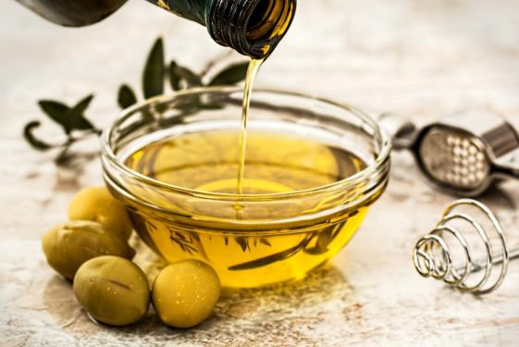

What has their SAE done for them?
What can an SAE do for you?

______ ___ ____ ___ ___ ___ __

______ ___ ____ ___ ___ __

______ ___ ____ ___ ___ ___ __

______ ___ ____ ___ ___ ___ __
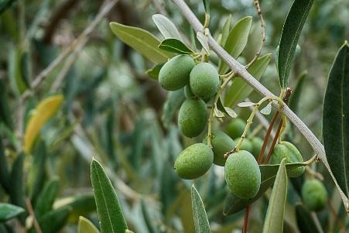

What is Giovanni and Luke’s SAE? What do they do? _____________________________________________________________________________________________________________________________________________________________________________________________________________
What class did Giovanni and Luke take to better prepare themselves for this SAE?

_______________________________

______ ___ ____ ___ ___ ___ _
Part 2
Aligned to the following standards:
CS.05; CS.06; FFA.PL-A; FFA.PG-J; FFA.CS-N; AG5; AG6; CCSS.ELA.SL.9-10.2; CCSS.ELA.SL.9-10.4; CCSS.ELA.WHST.9.10.4; MP1; MP5; MP6; CRP.02; CRP.04
Directions:
Giovanni and Luke described their SAE and showed us their work on the farm, but what happens between the farm and the oil we cook with?

Using the following diagram and your research skills, develop a lab procedure (as you do in science class) that would take a person through the process of olive oil production. Include a brief description and purpose next to each step. There will be 8 steps in total.
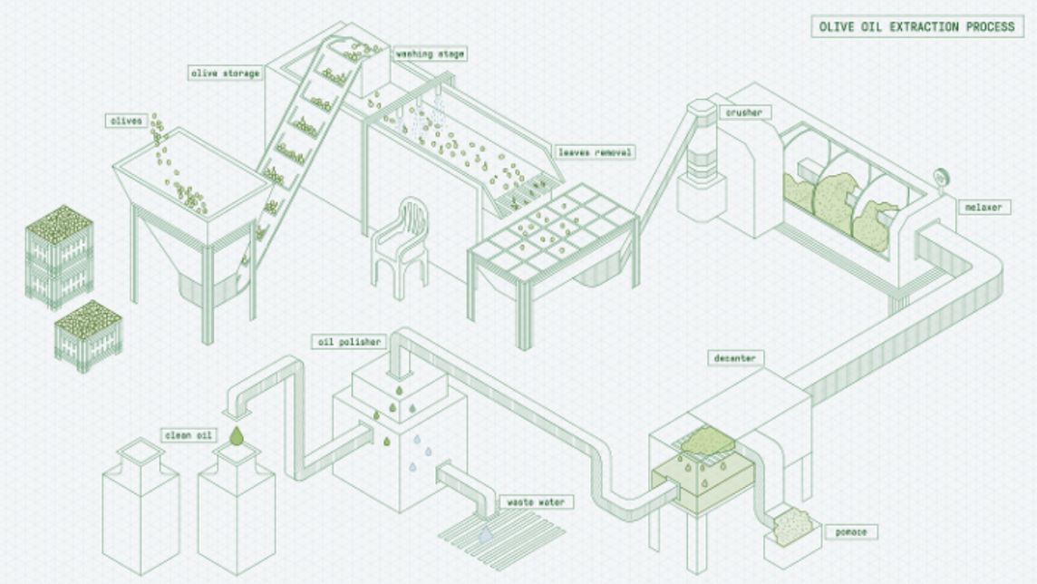
(3)Washing

(2)Storage

(5)Crusher

(1)Olives in

(4)Leaf Removal

(6)Malaxer

(8)Oil Polisher

(7)Decanter

Clean Oil

Waste Water
Pomate

Title: _____________________________________

(1)

(2)

(3)

(4)

(5)

(6)

(7)

(8)

Part 3
Aligned to the following standards:
CS.05; CS.06; FFA.PL-A; FFA.PG-J; FFA.CS-N; AG5; AG6; CCSS.ELA.SL.9-10.2; CCSS.ELA.SL.9-10.4; CCSS.ELA.WHST.9.10.4; MP1; MP5; MP6; CRP.02; CRP.04
Directions:
Select a food product of your choice and draw the production process and then write out a lab procedure for that food product.

Illustration:

Title:

(1)

Aligned to the following standards:
CS.05; CS.06; FFA.PL-A; FFA.PG-J; FFA.CS-N; AG5; AG6; CCSS.ELA.SL.9-10.2; CCSS.ELA.SL.9-10.4; CCSS.ELA.WHST.9.10.4; MP1; MP5; MP6; CRP.02; CRP.04

Part 4
Part 4

DIRECTIONS:
Now that you have a better understanding of how some food products are produced, answer the following questions.

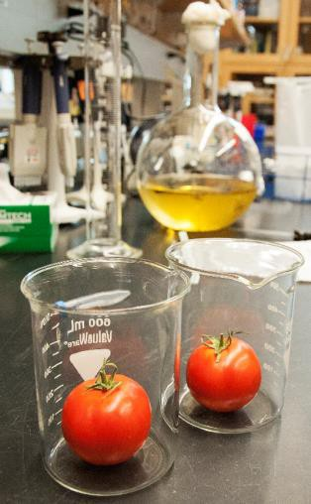Visit AgExplorer.com. Identify three careers in the food products and processing career focus area that would be involved in some way with the production of the food you selected above:

1.
2.
3.

Identify three courses in high school you could take to prepare you for a career in the food products and processing career focus area.
1.
2.
3.

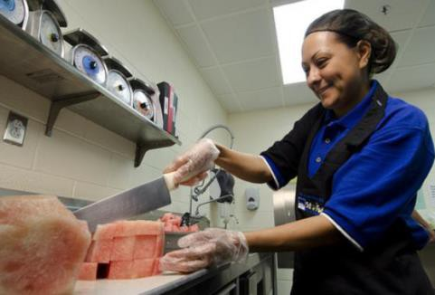

What role can an SAE play in helping you achieve your career goals? Write a minimum of three sentences.

Key: Olive Oil Production

Part 1

DIRECTIONS:
Read over and answer the questions below while you watch the video “Giovanni Garcia and Luke Anderson – SAE – Olive
Oil,” available at https://vimeo.com/278917849.

1. What was Luke and Giovanni’s motivation for starting this SAE? They both have a background in
farming and an interest in this area for their future.
2. What challenges have they faced?

This SAE is hard work.

3. What skills have they learned?

Hard work and communication

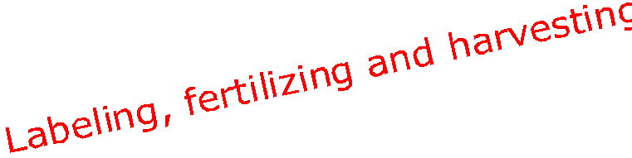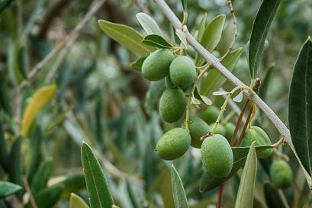What has their SAE done for them?

This SAE has better prepared them for their future careers and the real world.
What can an SAE do for you? Answers will vary.

Part 2

DIRECTIONS:
Giovanni and Luke described their SAE and showed us their work on the farm, but what happens between the farm and the oil we cook with?

Using the following diagram and your research skills, develop a lab procedure (as you do in science class) that would take a person through the process of olive oil production. Include a brief description and purpose next to each step. There will be 8 steps in total.

(2) Storage

(1) Olives in
(3) Washing

(4) Leaf
Removal

(5) Crusher

(6) Malaxer

(8) Oil Polisher

(7) Decanter

Clean Oil

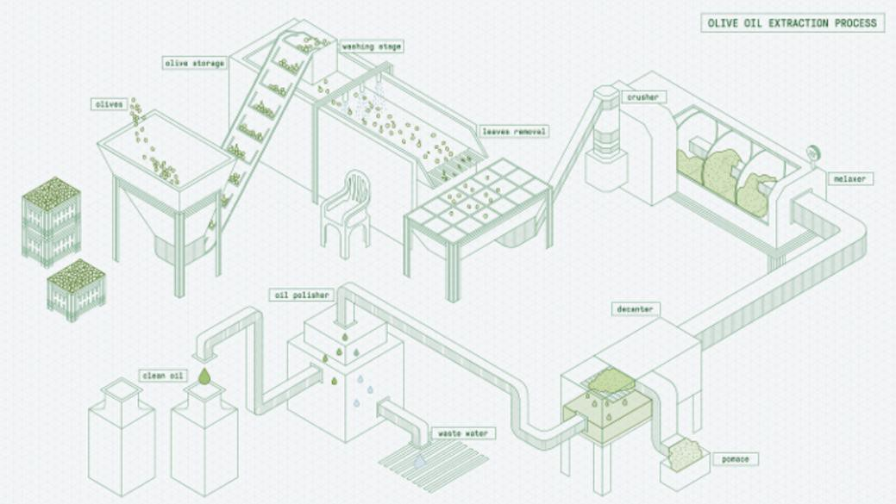Waste
Water

Pomace

Title: Olive Oil Production

(1) Olives in: Olives are harvested and added to the bulk tank to begin the process.

(2) Storage: Olives are stored until they are ready for the washing stage.

(3) Washing: Olives are washed to remove any dirt or debris that may be present.

(4) Leaf removal: Leaves need to be removed so that only olives are being crushed for a pure final product.

(5) Crusher: Stone or metal hammers are used to crush the olives until they are no longer whole to prepare them for the next step.

(6) Malaxer/Malaxation: Using small mixing blades, oil droplets are removed and are allowed to combine to create bigger oil droplets.

(7) Decanter: The separation of wet oil and pomace (solids).

(8) Oil polisher: The product is “spun” one more time to remove any remaining water, which is then separated from the oil.

