Global Climate
Created: 09/2015 by the National FFA Organization

Student Learning Objectives
After completing these activities students will…
- Determine examples of climate change and explain the impacts of each
- Identify and explain current solutions to climate change
Time Required: 45 minutes
Resources:

- FFA.org

- Food Security In a Changing Climate Infographic- http://croplife.org/wp-content/uploads/2014/09/Climate-Change-Brochure.pdf

Equipment and Supplies Needed:
- A copy of the “Climate: Friend or Foe” worksheet for each student.
- Internet access to view the infographic or printed copies of the infographic.

This quick lesson plan would work well as:
- Single Period Lesson
- Part of a series on agricultural technology and solutions
- Part of an agriscience unit

These activities are aligned to the following standards:

AFNR Performance Element
- PS.01. Develop and implement crop management plan for a given production goal that accounts for environmental factors.
FFA Precept
- FFA.CS-N. Decision Making: Analyze a situation and execute an appropriate course of action.
Common Career Technical Core
- AG-PL1 Develop and implement crop management plan for a given production goal that accounts for environmental factors.
NASDCTEc
- AGPB01.03 Examine and apply fundamentals of production and harvesting when producing plants to demonstrate plant management and production techniques.
AFNR Cluster Skills
- CS.02. Evaluate the nature and scope of the Agriculture, Food & Natural Resources Career Cluster and the role of agriculture, food and natural resources (AFNR) in society and the economy.
- CS.06. Analyze the interaction among AFNR systems in the production, processing and management of food, fiber and fuel and the sustainable use of natural resources.
Common Core- Reading: Informational Text
- CCSS.ELA-Literacy.RI.9-10.2 Determine a central idea of a text and analyze its development over the course of the text, including how it emerges and is shaped and refined by specific details; provide an objective summary of the text.
Common Core- Speaking and Listening
- CCSS.ELA-Literacy.SL.9-10.4 Present information, findings, and supporting evidence clearly, concisely, and logically such that listeners can follow the line of reasoning and the organization, development, substance, and style are appropriate to purpose, audience, and task.
Common Core- Science & Technical Subjects
- CCSS.ELA-Literacy.RST.9-10.4 Determine the meaning of symbols, key terms, and other domain-specific words and phrases as they are used in a specific scientific or technical context relevant to grades 9-10 texts and topics.
Common Core- Literacy in Science & Technical Subjects: Writing
- CCSS.ELA-Literacy.WHST.9-10.9 Draw evidence from informational texts to support analysis, reflection, and research.
Common Core- Math Practices
- CCSS.MP1: Make sense of problems and persevere in solving them.
- CCSS.MP3: Construct viable arguments and critique the reasoning of others.
- CCSS.MP6: Attend to precision.
Next Generation Science
- HS-LS2-3 Construct and revise an explanation based on evidence for the cycling of matter and flow of energy in aerobic and anaerobic conditions.
AFNR Career Ready Practices
- CRP.05. Consider the environmental, social and economic impact of decisions. Career-ready individuals understand the interrelated nature of their actions and regularly make decisions that positively impact and/or mitigate negative impact on other people, organizations and the environment.
- CRP.06. Demonstrate creativity and innovation. Career-ready individuals regularly think of ideas that solve problems in new and different ways, and they contribute those ideas in a useful and productive manner to improve their organization.
Partnership for 21st Century Skills
- Critical Thinking and Problem Solving
- Implement Innovations
- Information, Communications, and Technology Literacy
Lesson Plan:
- Introduction:

Science has long proven that changes are occurring in our climate. Climate change causes erratic weather patterns, extreme temperatures, and changes in natural resources, threatening a farmer’s ability to sustainably produce and maintain quality crops.

This activity will help us understand the impacts of climate change and explore solutions that revolutionizes the agricultural industry’s response to this threat.

- Activity:

Each student needs a copy of the handout “Climate: Friend or Foe.”

Give students time to study the “Food Security in a Changing Climate” infographic. The direct url is http://croplife.org/wp-content/uploads/2014/09/Climate-Change-Brochure.pdf

- Follow-up:

- Have students find 2-3 online resources that they believe can provide information and data that can be used to help create solutions for the impacts of climate change.
- Ask students how climate could negatively impact agricultural communities globally. How could it positively impact other agricultural communities?
- Find three known examples of climate change impact in developing countries. Ask students what may inhibit agriculture producers in these areas from accessing technologies outlined in the infographic.

Climate: Friend or Foe?
Directions:
Study the “Food Security in a Changing Climate Infographic.”
After studying the infographic match the impacts from the list below with climate events.

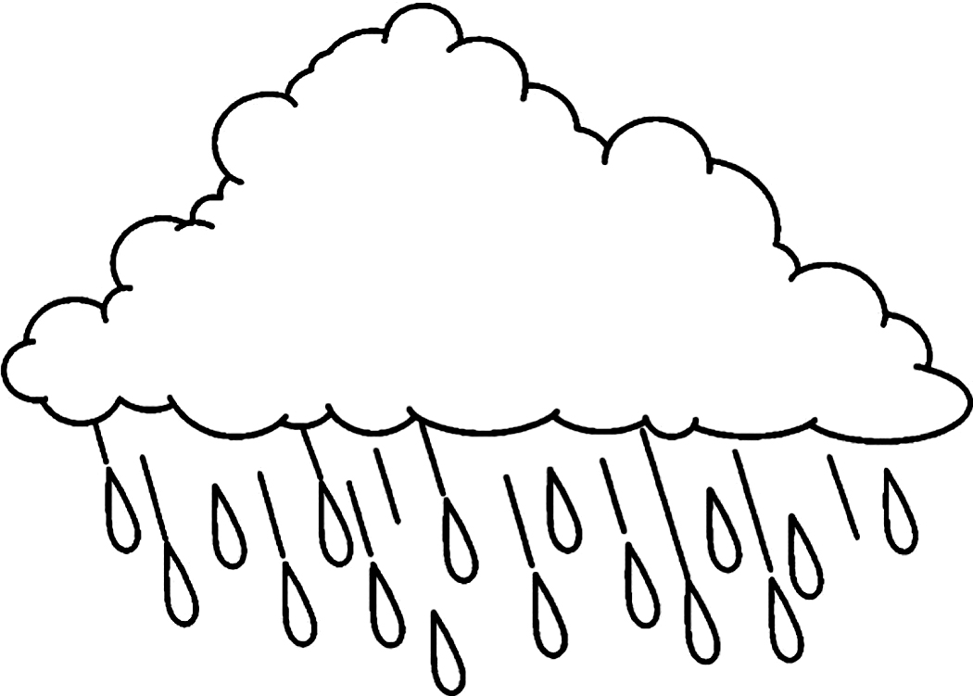
Impacts

- Increases difficulty of planting

- Raises flood risk

- Damages crops

- Causes crop failures and loss of arable land

- Reduces surface water and depletes aquifers

- Disrupts flowering and pollination of crops

- Increases weed, insect, and disease pressures

- Removes topsoil

- Drowns crops



Excessive Precipitation
Flooding




Excessive Heat
Drought

Today’s Technologies
List the 4 current technologies mentioned in the infographic and use what you have learned to explain how each can help farmers address climate change.

Technology | How does it help?
Aligned to the following standards:
FFA.PL-A; FFA-PL.F; FFA.PG-I; FFA.PG-J; FFA.CS-M; CS.05.; CCSS.W.9-12.2; CCSS.SL.9-12.1; CCSS.SL.9-12.2; CRP.02; CRP.04; CRP.10

Aligned to the following standards:
PS.01.; FFA.CS-N.; AG-PL1; AGPB01.03; CS.02.; CS.06.; CCSS.ELA-Literacy.RI.9-10.2; CCSS.ELA-Literacy.SL.9-10.4; CCSS.ELA-Literacy.RST.9-10.4; CCSS.ELA-Literacy.RST.9-10.4; CCSS.ELA-Literacy.WHST.9-10.9; CCSS.MP1; HS-LS2-3; CRP.05.; CRP.06.
Aligned to the following standards:
NRS.01; AGPE01.01; CCSS.ELA-Literacy.RI.9-10.3; CCSS.ELA-Literacy.SL.9-10.1; RST.9.10.1; RST.9.10.2; RST.9.10.4; RST.9.10.5; RST.9.10.6; RST.9.10.8; RST.9.10.9; WHST.9.10.7; WHST.9.10.9; MP3; MP6; AG-NR2; HS-LS2-6; HS-LS2-7

