Learning Journey: Africa
Created: 05/2016 by the National FFA Organization

Student Learning Objectives
After completing these activities students will…
- Reflect on agricultural opportunities in Africa.
- Understand factors influencing development in Africa.
- Discuss with classmates potential ways to advocate for agriculture in developing countries.

Time Required: 30 minutes
Resources: FFA.org
Video – Cargill: Africa Learning Journey http://link.brightcove.com/services/player/bcpid4199086649001?bckey=AQ~~,AAABexgSXbE~,bAKYV6SvEJNwVP3nQkR-zcL-iNotVAK4&bclid=4195522083001&bctid=4414473197001
Equipment and Supplies Needed:
- A copy of the “Learning Journey: Africa” worksheet for each student.
- Internet access to play the video in real time or embed it in a PowerPoint ahead of time.

This quick lesson plan would work well as:
- Supplement to agribusiness curriculum
- Reflection activity for ag leadership curriculum
- Topic for ag issues discussion/CDE

These activities are aligned to the following standards:

AFNR Performance Element
- CS.01. Analyze how issues, trends, technologies and public policies impact systems in the Agriculture, Food & Natural Resources Career Cluster
- CS.02. Evaluate the nature and scope of the Agriculture, Food & Natural Resources Career Cluster and the role of agriculture, food and natural resources (AFNR) in society and the economy.
FFA Precept
- FFA.PL-A.Action: Assume responsibility and take the necessary steps to achieve the desired results, no matter what the goal or task at hand.
- FFA.PG-J.Mental Growth: Embrace cognitive and intellectual development relative to reasoning, thinking and coping.
- FFA.CS-N.Decision Making: Analyze a situation and execute an appropriate course of action.
Common Career Technical Core
- AG1 Analyze how issues, trends, technologies and public policies impact systems in the Agriculture, Food & Natural Resources Career Cluster.
- AG2 Evaluate the nature and scope of the Agriculture, Food & Natural Resources Career Cluster and the role of agriculture, food, and natural resources (AFNR) in society and the economy.
NASDCTEc
- AGC10.04 Envision emerging technology and globalization and project its influence on widespread markets to demonstrate an understanding of technologies and trends that will impact the AFNR industry.
Common Core- Speaking and Listening
- CCSS.ELA-Literacy.SL.9-10.2 Integrate multiple sources of information presented in diverse media or formats (e.g., visually, quantitatively, orally) evaluating the credibility and accuracy of each source.
- CCSS.ELA-Literacy.SL.9-10.4 Present information, findings, and supporting evidence clearly, concisely, and logically such that listeners can follow the line of reasoning and the organization, development, substance, and style are appropriate to purpose, audience, and task.
- CCSS.ELA-Literacy.SL.9-10.1 Initiate and participate effectively in a range of collaborative discussions (one-on-one, in groups, and teacher-led) with diverse partners on grades 9-10 topics, texts, and issues, building on others' ideas and expressing their own clearly and persuasively.

Common Core- Math Practices
- CCSS.MP1: Make sense of problems and persevere in solving them.
- CCSS.MP3: Construct viable arguments and critique the reasoning of others.
- CCSS.MP6: Attend to precision.
AFNR Career Ready Practices
- CRP.02. Apply appropriate academic and technical skills. Career-ready individuals readily access and use the knowledge and skills acquired through experience and education
to be more productive.
- CRP.04. Communicate clearly, effectively, and with reason. Career-ready individuals communicate thoughts, ideas and action plans with clarity, whether using written, verbal and/or visual methods.
- CRP.06. Demonstrate creativity and innovation. Career-ready individuals regularly think of ideas that solve problems in new and different ways, and they contribute those ideas in a useful and productive manner to improve their organization.
- CRP.08. Utilize critical thinking to make sense of problems and persevere in solving them. Career-ready individuals readily recognize problems in the workplace, understand the nature of the problem, and
devise effective plans to solve the problem.
Partnership for 21st Century Skills
- Information, Communications, and Technology Literacy
- Global Awareness
- Think Creatively
- Communication
- Critical Thinking and Problem Solving

Lesson Plan:
- Introduction:

Countries in Africa are often the focus of media when discussing development and impoverished countries. Many organizations, governments, and companies have committed resources and expertise to aid in the development process.

The Cargill: Africa Learning Journey video broadly outlines many discussions surrounding agricultural development in Zambia and South Africa. These countries are often on opposite ends of the spectrum, but this video highlights common challenges and opportunities.

- Activity:

Each student needs a copy of the handout “Learning Journey: Africa.”
Show the video Cargill: Africa Learning Journey. The direct URL is http://link.brightcove.com/services/player/bcpid4199086649001?bckey=AQ~~,AAABexgSXbE~,bAKYV6SvEJNwVP3nQkR-zcL-iNotVAK4&bclid=4195522083001&bctid=4414473197001

Review the following questions as a class and have students record their observations on the worksheet:

- Are farming conditions similar across all African countries? If not, what factors influence differences?

- What opportunities are available for African farmers? Do they have advantages over farmers in other parts of the world?

- What role should companies like Cargill play in helping small holder farmers make their operations more efficient and productive?

- Why do organizations and media focus on Africa when it comes to hunger, poverty and development? Do other parts of the world have similar conditions?

- What solutions could you and your classmates help develop to aid smallholder farmers like those in Africa?

- Follow-up:

- Have students do research individually or in pairs on an African country of their choice. Direct students to identify advantages that these countries have, not just shortcomings.
- Connect your class with an international NGO or company working in an African country and begin a regular dialogue with that organization. Have students develop focus questions for each interaction. Examples of NGO or companies include: AgriCorps, Peace Corps, USAID, Catholic Relief Services, etc.

- Leveling Up:

- Have students research careers in international development. Students should identify important subjects to study in high school and college in order to have one of these careers.
- Encourage students to use development topics for CDEs and/or agriscience projects.

Learning Journey: Africa
Directions:
Watch the video Cargill: Africa Learning. As you watch the video, write down words and thoughts that come to mind.
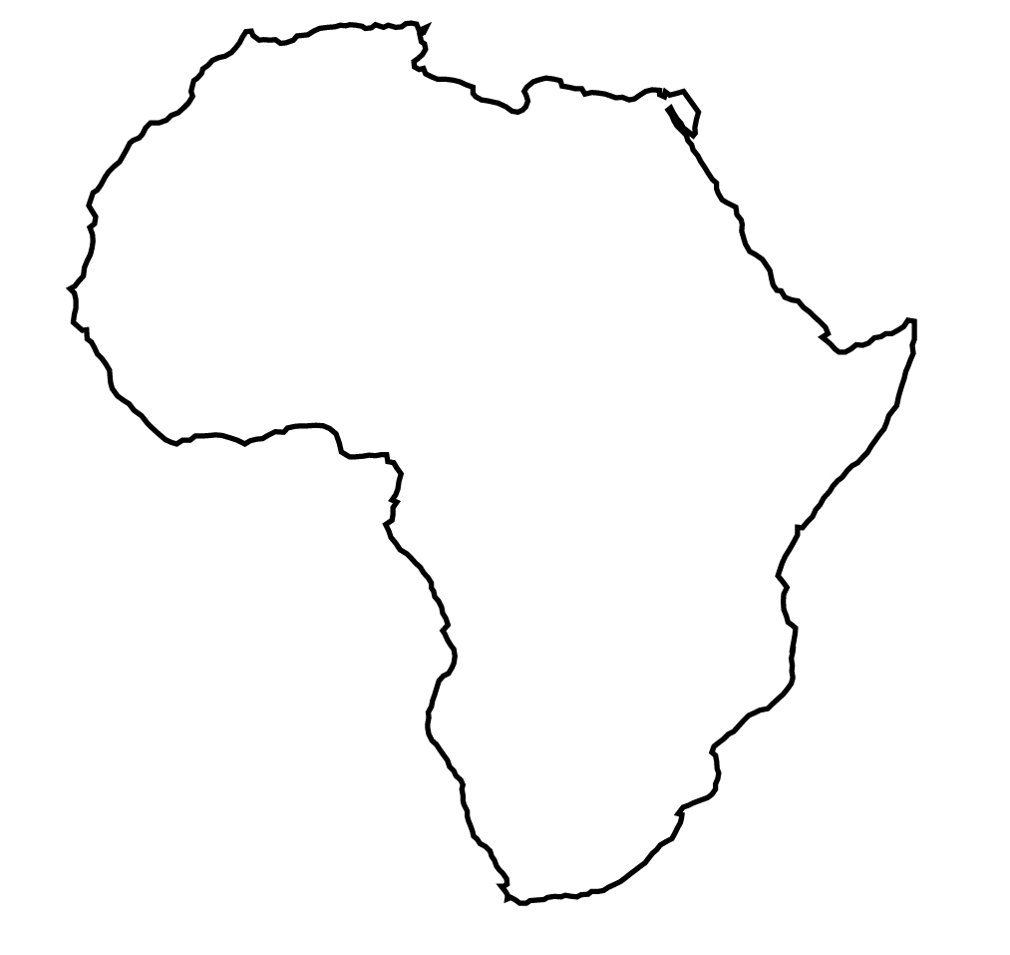

Answer the following questions based on the movie:

1. Are farming conditions similar across all African countries? If not, what factors influence differences?

2. What opportunities are available for African farmers? Do they have advantages over farmers in other parts of the world?

3. What role should companies like Cargill play in helping small holder farmers make their operations more efficient and productive?

4. Why do organizations and media focus on Africa when it comes to hunger, poverty, and development? Do other parts of the world have similar conditions? Explain.

5. What solutions could you and your classmates develop to aid smallholder farmers like those in Africa?

Aligned to the following standards: CS.01, CS.02, FFA.PL-A., FFA.PG-J., FFA.CS-N., AG1, AG2, AGC10.04, CCSS.ELA.SL.9-10.2, CCSS.ELA.SL.9-10.4, CCSS.ELA.SL.9-10.1, CCSS.MP1, CCSS.MP3, CCSS.MP6, CRP.02, CRP.04, CRP.06, CRP.08

