Life’s Real Passengers
Created: 01/2025 by the National FFA Organization
Description of Lesson: We are all real people with real stories. In this retiring address, 2023-24 National FFA Sectary Grant Norfleet shares his story about life’s real passengers.
Student Learning Objectives:
After completing these activities, students will …
- Identify traits, experiences and values that contribute to their individuality.
- Understand how embracing individuality and equality creates a more inclusive environment.

Suggested Grade Level:
Grades 9 and 10 (This lesson is written so instructors can scale up and down based on class needs.)

Suggested Time: 60 minutes (*Time requirements may vary based upon student understanding and class schedule.)

Resources/References:
- Vimeo Video: “Life’s Real Passengers” | Grant Norfleet 2024 Retiring Address, https://vimeo.com/1023058399

Related Resources:
- Retiring Addresses and Keynote Speeches, FFA.org/ffa-video-center/convention-keynotes-and-retiring-addresses/
- FFA Values Lesson Series, https://FFA.box.com/s/u9qnfyvape9sy3d3xc85hlgxdxghq3dg
- Keynote-Retiring Address Lessons, https://FFA.box.com/v/retiringaddresslessons

Equipment and Supplies Needed:
- A copy of the “Life’s Real Passengers” worksheet for each student
- Internet access to play the video in real time or embed it in a PowerPoint ahead of time

Vocabulary:
- Individuality
- Unique

Cross-Curricular Connections:
English/Language Arts
Write about unique traits.

SAE and FFA Connections:
- Agricultural Communications and Education SAE Idea Cards, https://FFA.box.com/s/x7e4v2qzxcwkleuqkun3mt0421m5nejx
- Extemporaneous Public Speaking LDE, FFA.org/participate/ldes/extemporaneous-public-speaking/
- Prepared Public Speaking LDE, FFA.org/participate/prepared-public-speaking/
Student Activity Sheets:
Direct access to student activity sheets without lesson plan or answer key for easy upload to a learning management system or printing for classwork.

https://ffa.box.com/s/13q7bgewvis3in4mx37ecauru4634fnv (Word)
https://ffa.box.com/s/8736z7hbx3fz7ecu1ket9rm7mqtlssjh (PDF)
https://docs.google.com/document/d/11UTyPM0QFmAXz3ro4PL9Nnmvz6Wo6_ZJs7fjgO5CbVI/copy (Google)

These Activities Are Aligned to the Following Standards:
FFA Precept
- FFA.PL-A.Action: Assume responsibility and take the necessary steps to achieve the desired results, no matter what the goal or task at hand.
- FFA.PL-D.Character: Conduct oneself appropriately in relation to others regardless of the situation.
- FFA.PL-E.Awareness: Understand personal vision, mission and goals.
AFNR Career Ready Practices
- CRP.01. Act as a responsible and contributing citizen and employee. Career-ready individuals understand the obligations and responsibilities of being a member of a community, and they demonstrate this understanding every day through their interactions with others.
- CRP.04. Communicate clearly, effectively, and with reason. Career-ready individuals communicate thoughts, ideas and action plans with clarity, whether using written, verbal and/or visual methods
Partnership for 21st Century Skills
- Communication
- Initiative and Self-direction
- Leadership and Responsibility
- Productivity and Accountability
- Think Creatively
Lesson Plan:
- Bell Ringer: How would you describe yourself in two sentences?

- Introduction: Give a copy of the “Life’s Real Passengers” worksheet to each student. Today, we are going to watch a retiring address from the 97th National FFA Convention & Expo. This retiring address was given by 2023-24 National FFA Secretary Grant Norfleet. In his speech, we will learn about real people around the world and in each of us. As we are watching the video, look over the questions on the worksheet “Life’s Real Passengers” and be ready for the answers.

- Activity: Each student needs a copy of the worksheet “Life’s Real Passengers.”
  - Part 1: Have students watch the retiring address of the 2023-24 National FFA Secretary Grant Norfleet. The video is available at https://vimeo.com/1023058399. While students watch the video, have them answer the questions.
  - Part 2: In this activity, students will explore their unique traits through a series of questions.

- Follow-up: Have students write down unique traits and qualities of at least two people they interact with throughout the week. Have a class discussion about why these traits stood out to them and why uniqueness is important.

- Optional – Extended Learning Opportunities (Not factored into time requirement):
  - This should take 15 minutes. Have students create a “Passenger Profile” about someone they admire (e.g., a classmate, mentor, family member, etc.), listing their unique qualities and experiences and why they should be celebrated. Post them around your classroom for everyone to see!

- Exit Ticket: Take one minute to “dump” everything you learned during this lesson. Feel free to write, draw, illustrate or give examples.

Life’s Real Passengers
Aligned to the following standards:
FFA.PL-A; FFA.PL-D; FFA.PL-E; CRP.01; CRP.04.
Part 1
Directions:
Answer the following questions while watching the retiring address of 2023-24 National FFA Secretary Grant Norfleet, “Life’s Real Passengers.” The video is available at https://vimeo.com/1023058399.

- How much does Grant’s luggage weigh?


- What is one thing that Grant learned while serving as a national officer?

- What is one of Grant’s favorite things to do to pass time in the airport?

- Circle the person you would give the parachute to (the farmer, the tennis player, the garbage man, the nurse or yourself). Explain why in two or three sentences.






- What age did Grant and his brother start showing cattle?

- What two jobs are always left to do in the barn?

- Why was Grant making his brother scoop poop every time?

- Fill in the blank:
When we only see the __________, we lose sight of the fact that __________ deserves a parachute.

- After listening to Grant’s speech, does your answer change about who to give the parachute to? Why or why not?

- What is one key takeaway from this retiring address?

Part 2
Directions:
In Grant Norfleet’s retiring address, he emphasizes that each and every one of us are real people with unique life experiences. In this activity, you will explore your unique traits that make you who you are today.
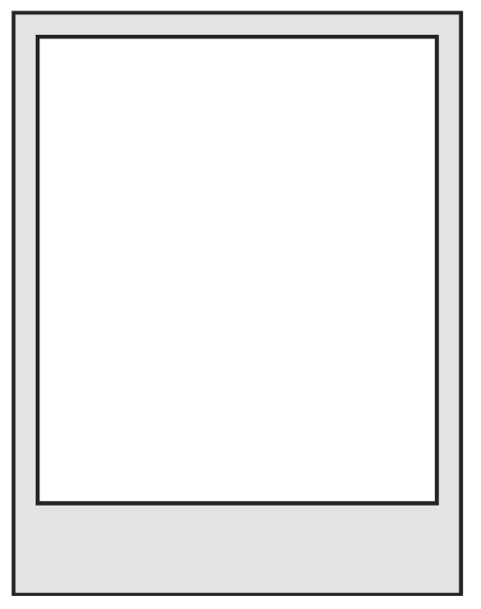
My Self Portrait
3. Describe yourself in three words.

2. List three skills or talents you have.

1. What is one experience or moment in your life that has shaped who you are today? Why was it impactful?
6. What two values or beliefs are most important to you?

a. How do they guide your actions?
7. How do you express your individuality in your daily life (e.g., through hobbies, style or actions)?

5. Who has had the biggest influence on your life so far, and what did they teach you?
4. Describe a challenge you’ve faced. What did you learn about yourself from overcoming it?

8. What is one thing about yourself that you are proud of and why?

9. What do you think people misunderstand about you, and what do you wish they knew?
KEY: Life’s Real Passengers
Part 1
Directions:
Answer the following questions while watching the retiring address of 2023-24 National FFA Secretary Grant Norfleet, “Life’s Real Passengers” The video is available at https://vimeo.com/1023058399.

- How much does Grant’s luggage weigh?
49.5lbs

- What is one thing that Grant learned while serving as a national officer?
No matter where you are in the world, every airport experience is exactly the same.

- What is one of Grant’s favorite things to do to pass time in the airport?
To watch people as they pass by

- Circle the person you would give the parachute to (the farmer, the tennis player, the garbage man, the nurse or yourself). Explain why in two or three sentences.

Answers will vary.

- What age did Grant and his brother start showing cattle?
8 years old

- What two jobs are always left to do in the barn?
- The feed scooper
- The pooper scooper

- Why was Grant making his brother scoop poop every time?
He thought he was better than him.

- Fill in the blank:
When we only see the surface, we lose sight of the fact that everyone deserves a parachute.

- After listening to Grant’s speech, does your answer change about who to give the parachute to? Why or why not?
Answers will vary.

- What is one key takeaway from this retiring address?
Answers will vary.

Part 2
Directions:
In Grant Norfleet’s retiring address, he emphasizes that each and every one of us are real people with unique life experiences. In this activity, you will explore your unique traits that make you who you are today. Please answer the questions below.
My Self Portrait
3. Describe yourself in three words.
- Answers will vary.

2. List three skills or talents you have.
- Answers will vary.

- What is one experience or moment in your life that has shaped who you are today? Why was it impactful?
Answers will vary.
6. What two values or beliefs are most important to you?
- Answers will vary.

- How do they guide your actions?
Answers will vary.
5. Who has had the biggest influence on your life so far, and what did they teach you?
Answers will vary.

4. Describe a challenge you’ve faced. What did you learn about yourself from overcoming it?
Answers will vary.

7. How do you express your individuality in your daily life (e.g., through hobbies, style or actions)?
- Answers will vary.

8. What is one thing about yourself that you are proud of and why?
Answers will vary.

9. What do you think people misunderstand about you, and what do you wish they knew?
Answers will vary.

