Research: An SAE Opportunity
Aligned to the following standards:
FFA.PL-A; FFA.PL-C; FFA.PL-E; FFA.PG-I; FFA.PG-J; FFA.CS-N; CCSS.ELA.RI.9-10.4; CCSS.SL.9-10.2; CCSS.SL.9-10.4; CCSS.ELA.WHST.9.10.4; MP1; MP3; MP5; MP6; CRP.02; CRP.04; CRP.06; CRP.07; CRP.08; CRP.11
Part 1
Directions:
Read over and answer the questions below while you watch the video “Grace Ramcke and Hannah Colonese – SAE – Ctenophore,” available at https://vimeo.com/300298552.
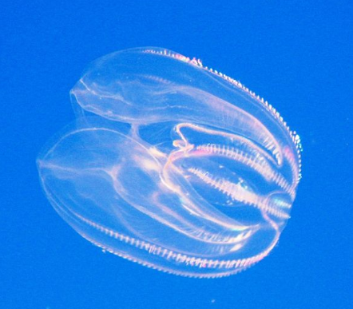


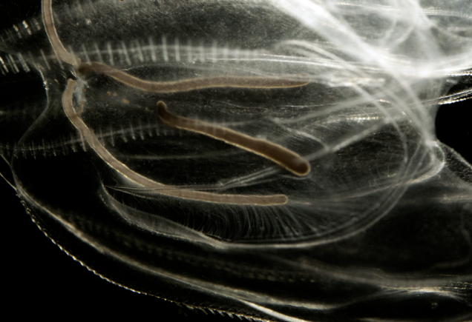
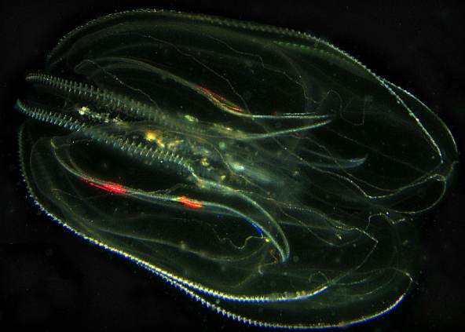
Say What???
Ctenophore = ten-uh-fawr
Where is Grace and Hannah’s school located?

What impact do you think the location of their school has on their SAE opportunities?

In Grace and Hannah’s opinion, what can an SAE include?
- Working in a lab
- Research and a presentation
- Working at a local fast food restaurant
How are they hoping their research will be used?
What was the first step Hannah and Grace had to take for their SAE?
What was the first major challenge encountered in this SAE?
How did they work to solve the problem? ________________________________________________________________________________________________
What was the outcome?
When should you start your SAE?

- Early in your schooling
- After you have experience
- In your senior year

What role does research have in the agriculture industry? Give an example.

Part 2
Directions:
As demonstrated by Hannah and Grace, research is an important component to not only their SAE, but also in helping to solve real-world problems. Learn and identify the different steps to completing research, and apply those concepts to a new project.
Using the following resource, https://resources.finalsite.net/images/v1657279465/basdk12org/bedze3dlvq43znqnbpau/researchprocesschecklist.pdf, identify and describe the steps in the research process.

Step 1:

Step 2:

Step 3:

Step 4:

Step 5:

Step 6:
Description 1:
Description 2:
Description 3:
Description 4:
Description 5:
Description 6:
Now that you understand the process, describe what Hannah and Grace’s process would have been for their ctenophore SAE. Include an example at each step.

Step 1:

Step 2:

Step 3:

Step 4:

Step 5:

Step 6:
Now, develop your own research plan. Use the following website to assist you in developing an idea and mapping it out just as we practiced above (https://resources.finalsite.net/images/v1657279465/basdk12org/bedze3dlvq43znqnbpau/researchprocesschecklist.pdf).

Step 1:

Step 2:

Step 3:

Step 4:

Step 5:

Step 6:

