Ctenophores
Created: 05/2019 by the National FFA Organization

SAE Video Summary: Follow Grace and Hannah as they walk us through their supervised agricultural experience (SAE) program working with water-based animals known as ctenophores. Grace and Hannah are driven by their research because they know that one day their results will help with human medicine.
Student Learning Objectives:
After completing these activities, students will …
- Describe a ctenophore.
- Illustrate the research process.
- Design a research project.

Time Required: 60 minutes
Resources:
- “Grace Ramcke and Hannah Colonese – SAE – Ctenophore,” https://vimeo.com/300298552
- Butler Area Senior High School Library, https://www.basdk12.org/1/Content2/understandingtheresearchprocess

Equipment and Supplies Needed:
- A copy of the “Research: An SAE Opportunity” worksheet for each student
- Internet access to play the video in real time or embed it in a PowerPoint ahead of time.

This quick lesson plan would work well as Part Of:
- An SAE lesson/unit.
- A plant science lesson.
- A research lesson/unit.

Student Activity Sheets:
Direct access to student activity sheets without lesson plan or answer key for easy upload to learning management systems or printing for classwork.
https://ffa.box.com/s/sbvgcm882smn5sf4bv759x00thyrpm2l (Word)
https://ffa.box.com/s/w1rehocviz1v4ezmk6hj8wf4pl0qdf6w (PDF)
These activities are aligned to the following standards:
FFA Precept
- FFA.PL-A.Action: Assume responsibility and take the necessary steps to achieve the desired results, no matter what the goal or task at hand.
- FFA.PL-C.Vision: Visualize the future and how to get there.
- FFA.PL-E.Awareness: Understand personal vision, mission and goals.
- FFA.PG-I.Professional Growth: Assume responsibility for attaining and improving upon the skills needed for career success.
- FFA.PG-J.Mental Growth: Embrace cognitive and intellectual development relative to reasoning, thinking and coping.
- FFA.CS-N.Decision Making: Analyze a situation and execute an appropriate course of action.
Common Core – Reading: Informational Text
- CCSS.ELA-Literacy.RI.9-10.4: Determine the meaning of words and phrases as they are used in a text, including figurative, connotative, and technical meanings; analyze the cumulative impact of specific word choices on meaning and tone (e.g., how the language of a court opinion differs from that of a newspaper).
Common Core – Speaking and Listening
- CCSS.ELA-Literacy.SL.9-10.2: Integrate multiple sources of information presented in diverse media or formats (e.g., visually, quantitatively, orally) evaluating the credibility and accuracy of each source.
- CCSS.ELA-Literacy.SL.9-10.4: Present information, findings, and supporting evidence clearly, concisely, and logically such that listeners can follow the line of reasoning and the organization, development, substance, and style are appropriate to purpose, audience, and task.
Common Core – Literacy in Science & Technical Subjects: Writing
- CCSS.ELA-Literacy.WHST.9.10.4: Produce clear and coherent writing in which the development, organization, and style are appropriate to task, purpose, and audience.
Common Core – Math Practices
- CCSS.MP1: Make sense of problems and persevere in solving them.
- CCSS.MP3: Construct viable arguments and critique the reasoning of others.
- CCSS.MP5: Use appropriate tools strategically.
- CCSS.MP6: Attend to precision.
AFNR Career Ready Practices
- CRP.02: Apply appropriate academic and technical skills. Career-ready individuals readily access and use the knowledge and skills acquired through experience and education to be more productive.
- CRP.04: Communicate clearly, effectively, and with reason. Career-ready individuals communicate thoughts, ideas and action plans with clarity, whether using written, verbal and/or visual methods.
- CRP.06: Demonstrate creativity and innovation. Career-ready individuals regularly think of ideas that solve problems in new and different ways, and they contribute those ideas in a useful and productive manner to improve their organization.
- CRP.07: Employ valid and reliable research strategies. Career-ready individuals are discerning in accepting and using new information to make decisions, change practices or inform strategies.
- CRP.08: Utilize critical thinking to make sense of problems and persevere in solving them. Career-ready individuals readily recognize problems in the workplace, understand the nature of the problem, and devise effective plans to solve the problem.
- CRP.11: Use technology to enhance productivity. Career-ready individuals find and maximize the productive value of existing and new technology to accomplish workplace takes and solve workplace problems.
Partnership for 21st Century Skills
- Critical Thinking and Problem Solving
- Flexibility and Adaptability
- Initiative and Self-Direction
- Leadership and Responsibility
- Think Creatively

Lesson Plan:
- Bell Ringer: What role does research play in the development of new technologies across all industries?

- Introduction: Research is a critical step in every industry. From developing new medications, surgical procedures, drones, and agricultural seed hybrids, we could not progress without research. Today, we are going to learn about a research SAE and then look at how research projects are mapped out.

- Activity:
  - Part 1: Each student needs a copy of the worksheet “Research: An SAE Opportunity.” Students should first read the questions and then answer the questions while watching the video “Grace Ramcke and Hannah Colonese – SAE – Ctenophore,” https://vimeo.com/300298552.
  - Part 2: After watching the video, students will learn about the steps needed to prepare for and complete research. Students will use the website Butler Area Senior High School Library, https://resources.finalsite.net/images/v1657279465/basdk12org/bedze3dlvq43znqnbpau/researchprocesschecklist.pdf, to learn about the process. First, students should read and record the six steps. Then, using specific examples, students will write the steps that Grace and Hannah would have had to take in their research. Finally, students will map out their own research using the six steps.

- Follow-up: Have students complete their research projects and present it to the rest of the class.

- Leveling Up: Have students create a poster and present/compete in the FFA agriscience fair.

- Exit Ticket: What role and impact does research have across all industries?

Research: An SAE Opportunity
Aligned to the following standards:
FFA.PL-A; FFA.PL-C; FFA.PL-E; FFA.PG-I; FFA.PG-J; FFA.CS-N; CCSS.ELA.RI.9-10.4; CCSS.SL.9-10.2; CCSS.SL.9-10.4; CCSS.ELA.WHST.9.10.4; MP1; MP3; MP5; MP6; CRP.02; CRP.04; CRP.06; CRP.07; CRP.08; CRP.11
Part 1
Directions:
Read over and answer the questions below while you watch the video “Grace Ramcke and Hannah Colonese – SAE – Ctenophore,” available at https://vimeo.com/300298552.
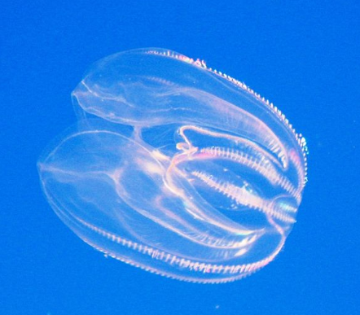


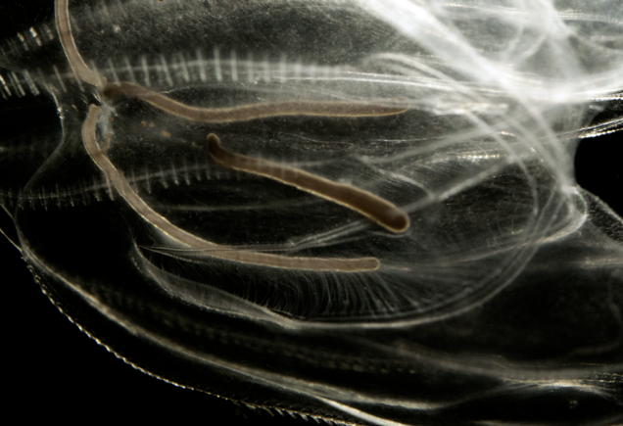
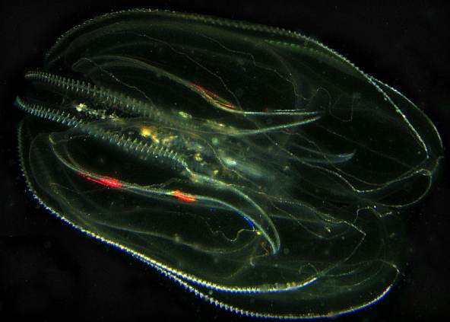
Say What???
Ctenophore = ten-uh-fawr
Where is Grace and Hannah’s school located?

What impact do you think the location of their school has on their SAE opportunities?

In Grace and Hannah’s opinion, what can an SAE include?
- Working in a lab
- Research and a presentation
- Working at a local fast food restaurant
How are they hoping their research will be used?
What was the first step Hannah and Grace had to take for their SAE?
What was the first major challenge encountered in this SAE?
How did they work to solve the problem? ________________________________________________________________________________________________
What was the outcome?
When should you start your SAE?

- Early in your schooling
- After you have experience
- In your senior year

What role does research have in the agriculture industry? Give an example.

Part 2
Directions:
As demonstrated by Hannah and Grace, research is an important component to not only their SAE, but also in helping to solve real-world problems. Learn and identify the different steps to completing research, and apply those concepts to a new project.
Using the following resource, https://resources.finalsite.net/images/v1657279465/basdk12org/bedze3dlvq43znqnbpau/researchprocesschecklist.pdf, identify and describe the steps in the research process.

Step 1:

Step 2:

Step 3:

Step 4:

Step 5:

Step 6:
Description 1:
Description 2:
Description 3:
Description 4:
Description 5:
Description 6:
Now that you understand the process, describe what Hannah and Grace’s process would have been for their ctenophore SAE. Include an example at each step.

Step 1:

Step 2:

Step 3:

Step 4:

Step 5:

Step 6:
Now, develop your own research plan. Use the following website to assist you in developing an idea and mapping it out just as we practiced above (https://resources.finalsite.net/images/v1657279465/basdk12org/bedze3dlvq43znqnbpau/researchprocesschecklist.pdf)
Step 1:

Step 2:

Step 3:

Step 4:

Step 5:

Step 6:

KEY — Research: An SAE Opportunity
Aligned to the following standards:
FFA.PL-A; FFA.PL-C; FFA.PL-E; FFA.PG-I; FFA.PG-J; FFA.CS-N; CCSS.ELA.RI.9-10.4; CCSS.SL.9-10.2; CCSS.SL.9-10.4; CCSS.ELA.WHST.9.10.4; MP1; MP3; MP5; MP6; CRP.02; CRP.04; CRP.06; CRP.07; CRP.08; CRP.11
Part 1
Directions:
Read over and answer the questions below while you watch the video “Grace Ramcke and Hannah Colonese – SAE – Ctenophore,” available at https://vimeo.com/300298552.
In Grace and Hannah’s opinion, what can an SAE include?
- Working in a lab
- Research and a presentation
- Working at a local fast food restaurant
Say What???
Ctenophore = ten-uh-fawr
Where is Grace and Hannah’s school located?

New Haven, Conn.

What impact do you think the location of their school has on their SAE opportunities?

Being in Conneticut, they are close to water. Being close to water means that they have a lot of interest and opportunity in the area for more water-based SAE programs.

How are they hoping their research will be used?
The ctenophores are going to be placed in the brains of those with PTSD to follow the brain patterns.
What was the first step Hannah and Grace had to take for their SAE?

Complete research about the animal to be able to provide the optimum environment for survival.
What was the first major challenge encountered in this SAE?

All of the ctenophores died.
How did they work to solve the problem? They consulted with other researchers to get ideas and methods for success with ctenophores.
What was the outcome?

The ctenophores are now surviving to 10 weeks of age.
When should you start your SAE?

- Early in your schooling
- After you have experience
- In your senior year

What role does research have in the agriculture industry? Give an example.
Answers will vary.

Part 2
Directions:
As demonstrated by Hannah and Grace, research is an important component to not only their SAE, but also in helping to solve real-world problems. Learn and identify the different steps to completing research, and apply those concepts to a new project.
Using the following resource, https://resources.finalsite.net/images/v1657279465/basdk12org/bedze3dlvq43znqnbpau/researchprocesschecklist.pdf, identify and describe the steps in the research process.

Step 1: Task definition

Step 2: Information-seeking strategies

Step 3: Location and access

Step 4: Use of information

Step 5: Synthesis

Step 6: Evaluation
Description 1: Questions must be asked to identify the problem and need. Who, what, when, where, why
Description 2: Determine where you will find all the important information; What sources will be used? Validity of resources
Description 3: How will I find this information?
Description 4: When the researcher finds, reads and understanding the information needed
Description 5: Putting together all the information into a product
Description 6: Reflect and ask if the product is what was expected, needed, etc.
Now that you understand the process, describe what Hannah and Grace’s process would have been for their ctenophore SAE. Include an example at each step. Answers will vary but should follow the six-step process and include examples.

Step 1:

Step 2:

Step 3:

Step 4:

Step 5:

Step 6:
Now, develop your own research plan. Use the following website to assist you in developing an idea and mapping it out just as we practiced above (https://resources.finalsite.net/images/v1657279465/basdk12org/bedze3dlvq43znqnbpau/researchprocesschecklist.pdf)

Step 1:

Step 2:

Step 3:

Step 4:

Step 5:

Step 6:

