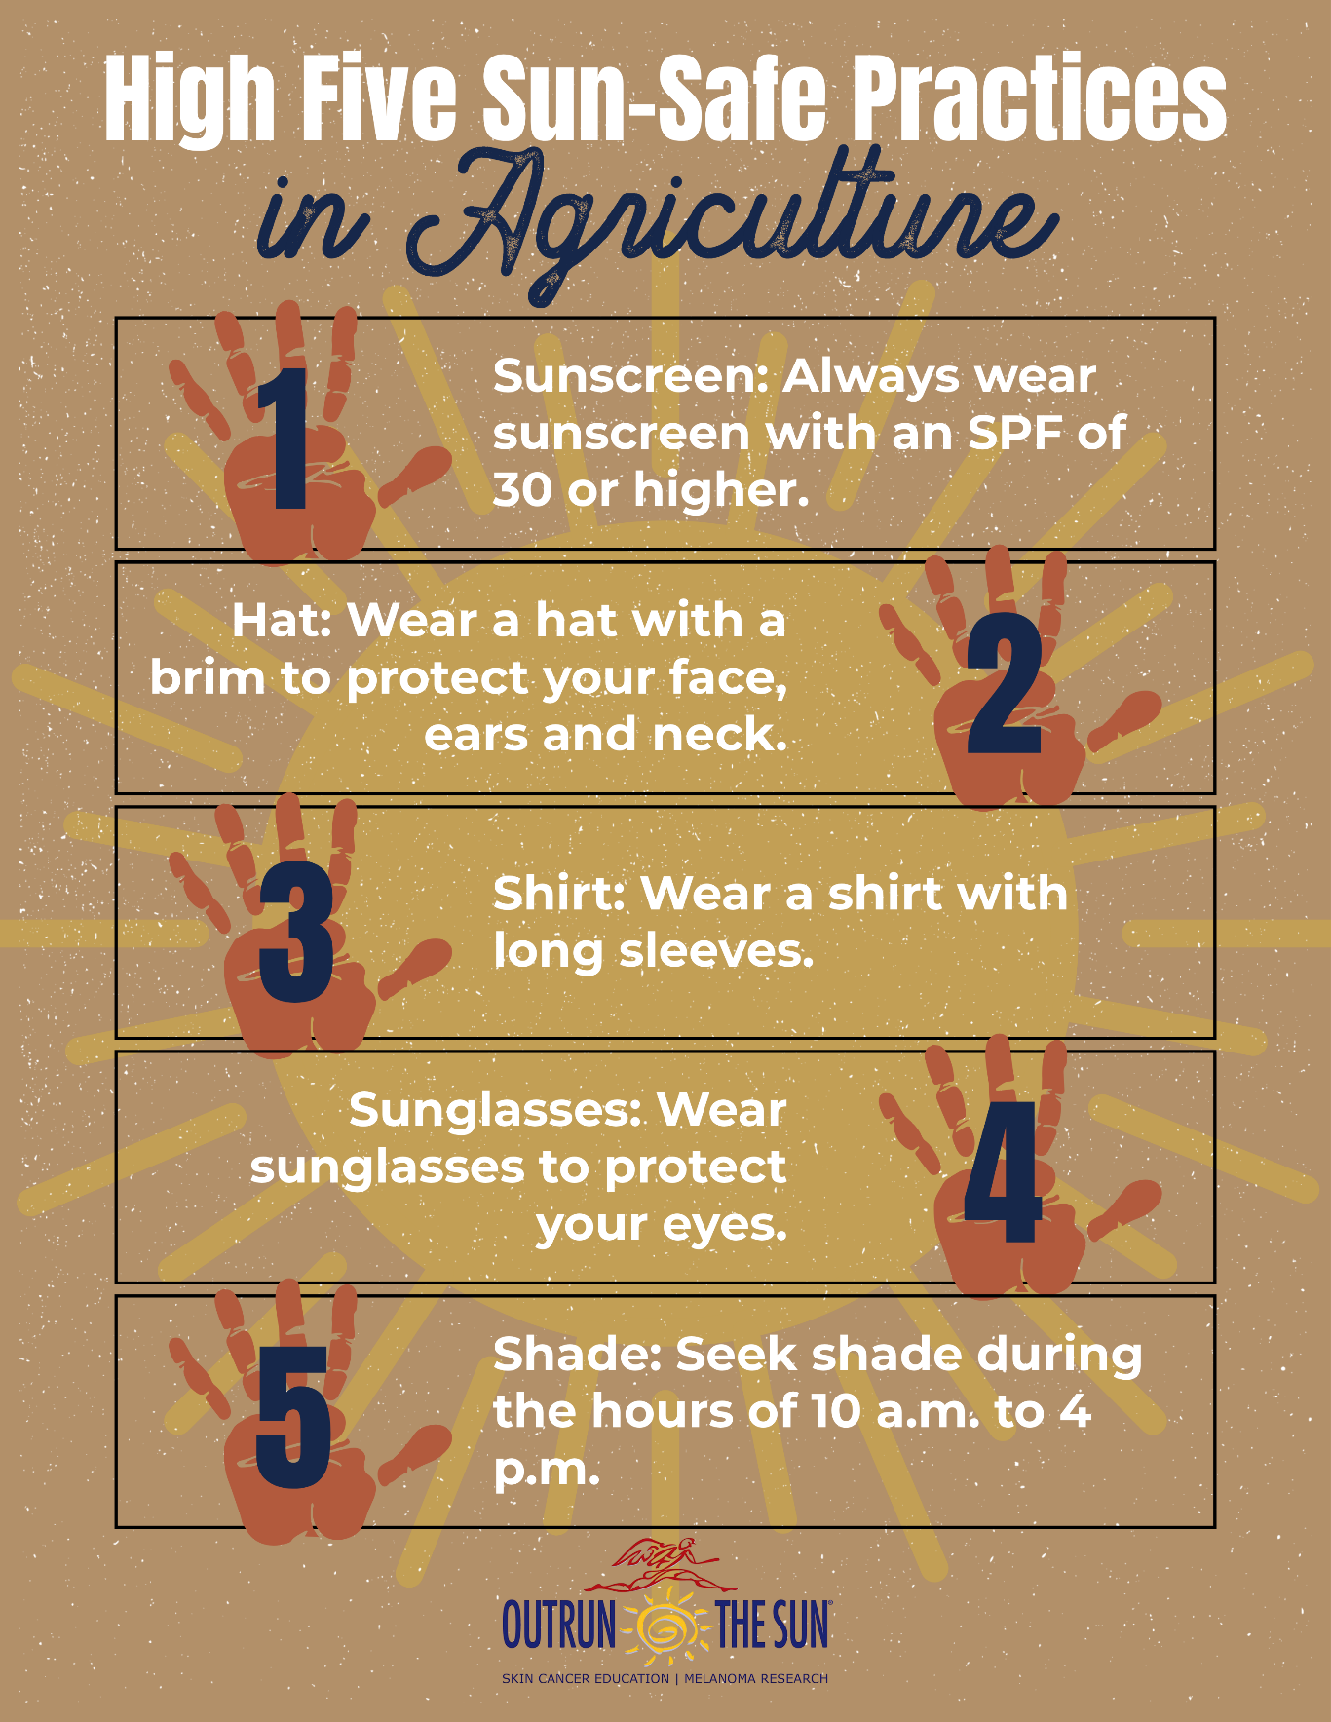
High Five Sun-Safe Practices

