Keep Climbing and Aiming High
Created: 01/2019 by the National FFA Organization

Retiring Address Video Summary: Success boils down to two important components, persistence and focus. In this retiring address, 2017-18 National FFA Southern Region Vice President Ian Bennett discusses how we encounter challenges on our path to success and how we need to be persistent and focused throughout these many challenges to achieve success.

Student Learning Objectives:
After completing these activities, students will …
- Identify what is needed to reach a goal.
- Establish goals while considering potential challenges.

Time Required: 45 minutes
Resources: “Dragon’s Tooth and Arrowheads, Ian Bennett Retiring Address,” https://vimeo.com/297305745

Equipment and Supplies Needed:
- A copy of the “Challenges Happen” worksheet for each student
- Internet access to play the video in real time or embed it in a PowerPoint ahead of time

This quick lesson plan would work well as Part of:
- A leadership lesson plan.
- A lesson focused on goal setting.
- An SAE goal-building lesson plan.

Student Activity Sheets:
Direct access to student activity sheets without lesson plan or answer key for easy upload to learning management systems or printing for classwork.
https://ffa.box.com/s/127fqq321vz1t6d5p02cda5hj7v5hayz (Word)
https://ffa.box.com/s/gke1ui9f7gxzuh75z2dajtv4860xkcwk (Non-Designed)
https://ffa.box.com/s/6btsv6x5zr82beby3o921uki683f519u (PDF)
These activities are aligned to the following standards:

FFA Precept
- FFA.PL-A.Action: Assume responsibility and take the necessary steps to achieve the desired results, no matter what the goal or task at hand.
- FFA.PL-C.Vision: Visualize the future and how to get there.
- FFA.PL-E.Awareness: Understand personal vision, mission and goals.
- FFA.PG-J.Mental Growth: Embrace cognitive and intellectual development relative to reasoning, thinking and coping.
- FFA.CS-N.Decision Making: Analyze a situation and execute an appropriate course of action.

Common Core–Math Practices
- CCSS.MP1: Make sense of problems and persevere in solving them.
- CCSS.MP5: Use appropriate tools strategically.
- CCSS.MP6: Attend to precision.

AFNR Career Ready Practices
- CRP.02: Apply appropriate academic and technical skills. Career-ready individuals readily access and use the knowledge and skills acquired through experience and education to be more productive.
- CRP.04: Communicate clearly, effectively, and with reason. Career-ready individuals communicate thoughts, ideas and action plans with clarity, whether using written, verbal and/or visual methods.
- CRP.06: Demonstrate creativity and innovation. Career-ready individuals regularly think of ideas that solve problems in new and different ways, and they contribute those ideas in a useful and productive manner to improve their organization.
- CRP.08: Utilize critical thinking to make sense of problems and persevere in solving them. Career-ready individuals readily recognize problems in the workplace, understand the nature of the problem, and devise effective plans to solve the problem.

Partnership for 21st Century Skills
- Communication
- Critical Thinking and Problem Solving
- Flexibility and Adaptability
- Initiative and Self-direction
- Leadership and Responsibility

Lesson Plan:
- Bell Ringer: If your life was perfect, how would it look? On a separate sheet of paper, draw a picture and label the components that help make it perfect.

- Introduction: Today, we are going to watch a retiring address from the 91st National FFA Convention & Expo. This retiring address was given by 2017-18 National FFA Southern Region Vice President Ian Bennett. In his speech, he recognizes that when people are faced with challenges they often quit or try to figure out how to go around the challenge. Ian discusses why it is important to have persistence and focus to reach our dreams and goals in life.

Before watching the video, look over the questions on the “Challenges Happen” worksheet, and be ready to listen for the answers as you view the video.

- Activity: Each student needs a copy of the worksheet “Challenges Happen.” Students will then watch the retiring address of 2017-18 National FFA Southern Region Vice President Ian Bennett and complete the activities. The video, “Dragon’s Tooth and Arrowheads, Ian Bennett Retiring Address,” is available at https://vimeo.com/297305745.

- Follow-up: Have students share a challenge with a classmate and talk through how they are going to work toward success.

- Leveling Up: Have students identify a challenge in the school and develop a plan to overcome that challenge to reach success. (Example: Create a plan to increase school spirit, increase attendance at FFA meetings, etc.) Here are some guiding questions to get started:
- What is the challenge?
- What resources do you need to reach the end goal?
- What action steps are needed to achieve success?
- How are you going to evaluate if you have reached your goal?

- Exit Ticket: Why is it important to keep overcoming challenges in life?

Challenges Happen
Aligned to the following standards:
FFA.PL-A; FFA.PL-C; FFA.PL-E; FFA.PG-J; FFA.CS-N; MP1; MP5; MP6; CRP.02; CRP.04; CRP.06; CRP.08
Directions:
Fill in the blanks and answer the questions below while watching “Dragon’s Tooth and Arrowheads,” the retiring address of 2017-18 National FFA Southern Region Vice President Ian Bennett. The video is available at https://vimeo.com/297305745.

According to Ian, what two things does success boil down to?

- _______________________________________________

- ______________________________________________
However, challenges lead to

______________________________.
What specific geographical point was Ian trying to reach in his story?

____________________________________
Most people

___________________________

when they meet a challenge.
How do you handle challenges that you meet when working toward success?


Aligned to the following standards:
FFA.PL-A; FFA.PL-C; FFA.PL-E; FFA.PG-J; FFA.CS-N; MP1; MP5; MP6; CRP.02; CRP.04; CRP.06; CRP.08
To be successful in life, what must you focus on?

- The end goal
- What you need to do next
- What you are currently doing
- The steps it will take


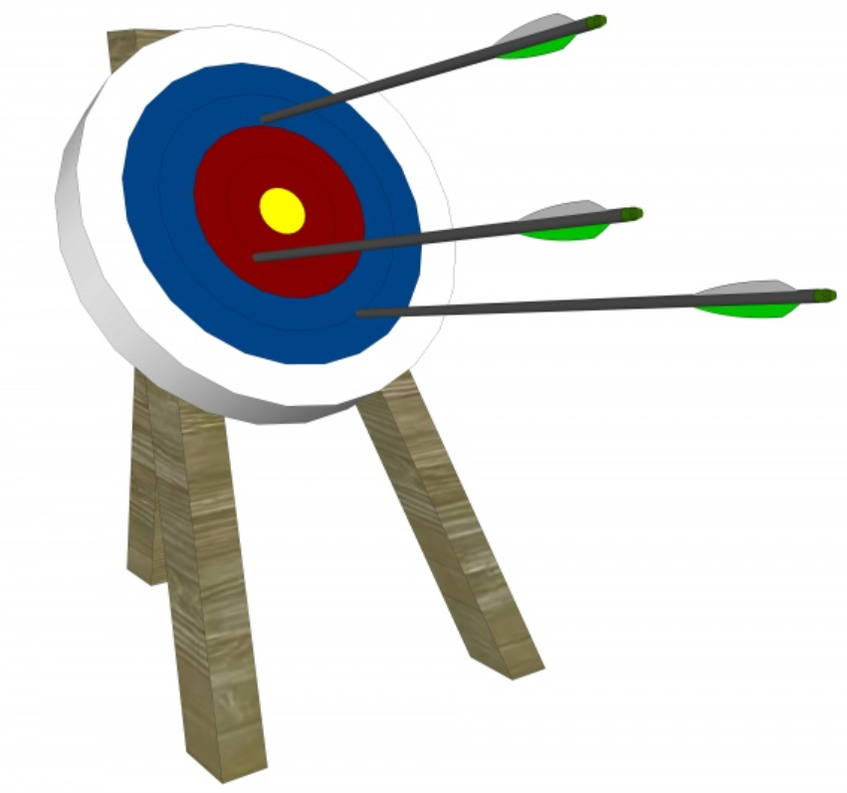
Directions:
Look at each arrow. According to Ian, which arrow(s) matter when trying to overcome a challenge to be successful? Circle the arrow that best represents the answer to this question and explain your reasoning.

Aligned to the following standards:
NRS.01; AGPE01.01; CCSS.RI.9-10.3; CCSS.SL.9-10.1; RST.9.10.1; RST.9.10.2; RST.9.10.4; RST.9.10.5; RST.9.10.6; RST.9.10.8; RST.9.10.9; WHST.9.10.7; WHST.9.10.9; MP3; MP6; AG-NR2; HS-LS2-6; HS-LS2-7

Identify three things you can do right now to be successful.
- ______________________________________________________________________________

- ______________________________________________________________________________

- ______________________________________________________________________________
What have you tried and fell short of accomplishing?

- _________________________________________________________________________________

- _________________________________________________________________________________
What do you want to accomplish?

____________________________________________________________________________________________________________________________________________________________________________________
Aligned to the following standards:
FFA.PL-A; FFA.PL-C; FFA.PL-E; FFA.PG-J; FFA.CS-N; MP1; MP5; MP6; CRP.02; CRP.04; CRP.06; CRP.08

Why is it important to not get discouraged by challenges we encounter in our lives?

Describe how Ian’s speech relates to what you have experienced in your life.

Aligned to the following standards:
FFA.PL-A; FFA.PL-C; FFA.PL-E; FFA.PG-J; FFA.CS-N; MP1; MP5; MP6; CRP.02; CRP.04; CRP.06; CRP.08
Key — Challenges Happen
Directions:
Fill in the blanks and answer the questions below while watching “Dragon’s Tooth and Arrowheads,” the retiring address of 2017-18 National FFA Southern Region Vice President Ian Bennett. The video is available at https://vimeo.com/297305745.
According to Ian, what two things does success boil down to?

- Persistence

- Focus
However, challenges lead to

success.
What specific geographical point was Ian trying to reach in his story?

Dragon’s Tooth rock
Most people

quit or try to go around

when they meet a challenge.
How do you handle challenges that you meet when working toward a goal? Answer will vary.

Aligned to the following standards:
FFA.PL-A; FFA.PL-C; FFA.PL-E; FFA.PG-J; FFA.CS-N; MP1; MP5; MP6; CRP.02; CRP.04; CRP.06; CRP.08
To be successful in life, what must you focus on?

- The end goal
- What you need to do next
- What you are currently doing
- The steps it will take

Directions:
Analyze each arrow. According to Ian, which arrow(s) matter when trying to overcome a challenge to be successful? Circle the arrow that best represents the answer to this question and explain your reasoning.

Ian says that you must focus on what you are currently doing to be successful.

Aligned to the following standards:
NRS.01; AGPE01.01; CCSS.RI.9-10.3; CCSS.SL.9-10.1; RST.9.10.1; RST.9.10.2; RST.9.10.4; RST.9.10.5; RST.9.10.6; RST.9.10.8; RST.9.10.9; WHST.9.10.7; WHST.9.10.9; MP3; MP6; AG-NR2; HS-LS2-6; HS-LS2-7

