Challenges Happen
Aligned to the following standards:
FFA.PL-A; FFA.PL-C; FFA.PL-E; FFA.PG-J; FFA.CS-N; MP1; MP5; MP6; CRP.02; CRP.04; CRP.06; CRP.08
Directions:
Fill in the blanks and answer the questions below while watching “Dragon’s Tooth and Arrowheads,” the retiring address of 2017-18 National FFA Southern Region Vice President Ian Bennett. The video is available at https://vimeo.com/297305745.
- According to Ian, what two things does success boil down to?

- _______________________________________________

- ______________________________________________

- However, challenges lead to ______________________________.

- Most people ___________________________ when they meet a challenge.

- What specific geographical point was Ian trying to reach in his story? ____________________________________
- How do you handle challenges that you meet when working toward success?

- To be successful in life, what must you focus on?

- The end goal
- What you need to do next
- What you are currently doing
- The steps it will take

Directions:
Look at each arrow. According to Ian, which arrow(s) matter when trying to overcome a challenge to be successful? Circle the arrow that best represents the answer to this question and explain your reasoning.


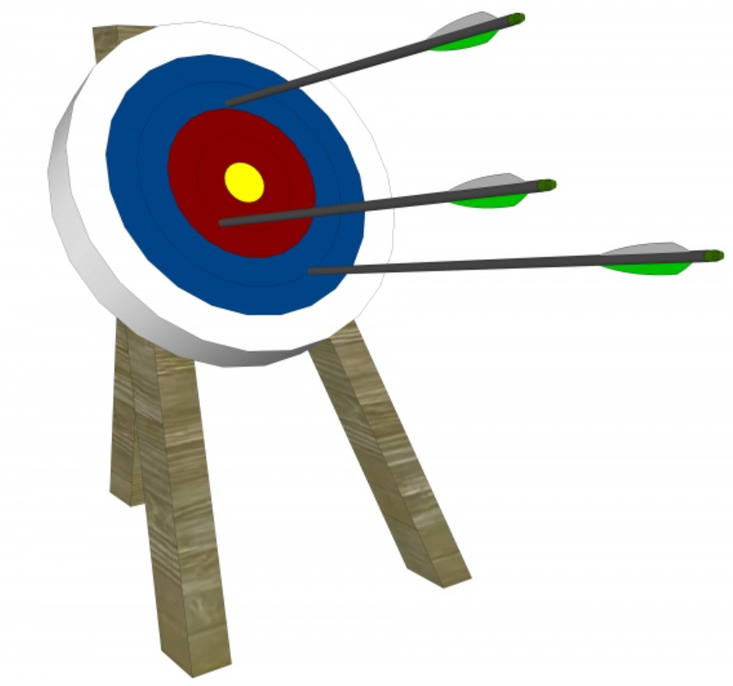

- Identify three things you can do right now to be successful.

- What have you tried and fell short of accomplishing?

- What do you want to accomplish?

- Why is it important to not get discouraged by challenges we encounter in our lives?

- Describe how Ian’s speech relates to what you have experienced in your life.

