Introduction to Sustainability Online Modules
Created: 04/2025 by the National FFA Organization
Agriculture teachers may use this guide to implement the online Introduction to Sustainability modules with their students. These modules are designed for students to complete independently on their own devices. The modules are written to build upon each other but may also be used independently, depending on the needs of your classroom. The guide contains helpful directions, tips, tricks and supporting documents for use with the online modules.
Table of Contents

- Educational Standards Alignment
  - The Introduction to Sustainability modules are aligned with national education standards.
- Module Descriptions and Student Learning Objectives
  - The Introduction to Sustainability modules are designed to introduce students to the broad field of sustainability. This section includes a short description of each module’s content as well as a list of the learning objectives the modules are designed to meet.
- Instructions for Accessing the Online Modules
  - Modules may be accessed through FFA.org or by downloading and importing the module packages into your LMS. This guide contains directions for both.
- Navigating the Online Modules
  - Here are some helpful tips and tricks for navigating the modules and the various activities within them.
- Companion Student Journals for the Modules
  - Each module has a companion student journal with all the reflection questions throughout the module that you can have students fill out as they complete the module.

Thank you to our current partners in sustainability:


Educational Standards Alignment
AFNR Performance Element
- CS.01. Analyze how issues, trends, technologies and public policies impact systems in the Agriculture, Food & Natural Resources Career Cluster.
- CS.03. Examine and summarize the importance of health, safety and environmental management systems in AFNR workplaces.
- CS.04. Demonstrate stewardship of natural resources in AFNR activities.
- CS.05. Describe career opportunities and means to achieve those opportunities in each of the Agriculture, Food & Natural Resources career pathways.
- CS.06. Analyze the interaction among AFNR systems in the production, processing and management of food, fiber and fuel and the sustainable use of natural resources.
FFA Precept
- FFA.PL-A.Action: Assume responsibility and take the necessary steps to achieve the desired results, no matter what the goal or task at hand.
- FFA.PL-C.Vision: Visualize the future and how to get there.
- FFA.PL-E.Awareness: Understand personal vision, mission and goals.
- FFA.PL-F.Continuous Improvement: Accept responsibility for learning and personal growth.
- FFA.PG-I.Professional Growth: Assume responsibility for attaining and improving upon the skills needed for career success.
- FFA.PG-J.Mental Growth: Embrace cognitive and intellectual development relative to reasoning, thinking and coping.
- FFA.PG-L.Spiritual Growth: Define personal beliefs, values, principles and sense of balance.
- FFA.CS-M.Communication: Effectively interact with others in personal and professional settings.
- FFA.CS-N.Decision Making: Analyze a situation and execute an appropriate course of action.
- FFA.CS-P.Technical/Function Skills in Agriculture: Obtain knowledge and skills needed for a career in agriculture and related industries.
Common Career Technical Core
- AG1 Analyze how issues, trends, technologies and public policies impact systems in the Agriculture, Food & Natural Resources Career Cluster.
- AG3 Examine and summarize the importance of health, safety, and environmental management systems in AFNR businesses.
- AG4 Demonstrate stewardship of natural resources in AFNR activities.
- AG5 Describe career opportunities and means to achieve those opportunities in each of the Agriculture, Food & Natural Resources Career Pathways.
- AG6 Analyze the interaction among AFNR systems in the production, processing, and management of food, fiber, and fuel and the sustainable use of natural resources.
NASDCTEc
- AGC09.02 Select, research and examine critical aspects of career opportunities in one or more AFNR career pathways in order to gain an understanding of the breadth of occupations within this cluster.
Common Core – Reading: Informational Text
- CCSS.ELA-Literacy.RI.9-10.2 Determine a central idea of a text and analyze its development over the course of the text, including how it emerges and is shaped and refined by specific details; provide an objective summary of the text.
Common Core – Writing
- CCSS.ELA-Literacy.W.9-10.1 Write arguments to support claims in an analysis of substantive topics or texts, using valid reasoning and relevant and sufficient evidence.
- CCSS.ELA-Literacy.W.9-10.2 Write informative/explanatory texts to examine and convey complex ideas, concepts, and information clearly and accurately through the effective selection, organization, and analysis of content.
Common Core – Science & Technical Subjects
- CCSS.ELA-Literacy.RST.9.10.4 Determine the meaning of symbols, key terms, and other domain-specific words and phrases as they are used in a specific scientific or technical context relevant to grades 9-10 texts and topics.
Common Core – Literacy in Science & Technical Subjects: Writing
- CCSS.ELA-Literacy.WHST.9.10.1 Write arguments focused on discipline-specific content.
- CCSS.ELA-Literacy.WHST.9.10.2 Write informative/explanatory texts, including the narration of historical events, scientific procedures/ experiments, or technical processes.
- CCSS.ELA-Literacy.WHST.9.10.4 Produce clear and coherent writing in which the development, organization, and style are appropriate to task, purpose, and audience.
Next Generation Science
- HS-ETS1-3 Evaluate a solution to a complex real-world problem based on prioritized criteria and trade-offs that account for a range of constraints, including cost, safety, reliability, and aesthetics as well as possible social, cultural, and environmental impacts.
Green/Sustainability Knowledge and Skill Statements
- AFNR Career Cluster, Statement 2 Analyze community practice or policy development related to sustainability in AFNR.
- AFNR Career Cluster, Statement 3 Communicate the impact of green and sustainability principles on agriculture, food and natural resource systems.
- AFNR Career Cluster, Statement 6 Use green technologies and sustainability practices to maintain safe and healthful working environments that sustain the natural environment and promote wellbeing in the AFNR workplaces.
- AFNR Career Cluster, Statement 7 Demonstrate an understanding of green and sustainability trends that are impacting processes and markets in AFNR.
AFNR Career Ready Practices
- CRP.02. Apply appropriate academic and technical skills. Career-ready individuals readily access and use the knowledge and skills acquired through experience and education to be more productive.
- CRP.04. Communicate clearly, effectively, and with reason. Career-ready individuals communicate thoughts, ideas and action plans with clarity, whether using written, verbal and/or visual methods.
- CRP.05. Consider the environmental, social and economic impact of decisions. Career-ready individuals understand the interrelated nature of their actions and regularly make decisions that positively impact and/or mitigate negative impact on other people, organizations and the environment.
- CRP.06. Demonstrate creativity and innovation. Career-ready individuals regularly think of ideas that solve problems in new and different ways, and they contribute those ideas in a useful and productive manner to improve their organization.
- CRP.11. Use technology to enhance productivity. Career-ready individuals find and maximize the productive value of existing and new technology to accomplish workplace tasks and solve workplace problems.
Partnership for 21st Century Skills
- Communication
- Critical Thinking and Problem Solving
- Environmental Literacy
- Information, Communications, and Technology Literacy
- Global Awareness
- Initiative and Self-direction
- Information, Communications, and Technology Literacy
- Think Creatively

Module Descriptions and Student Learning Objectives
The Introduction to Sustainability modules are designed to introduce students to the broad field of sustainability. The modules are parallel in content to the teacher-led Introduction to Sustainability lesson series available from FFA. Below is a short description of each module’s content as well as a list of the learning objectives the modules are designed to meet.

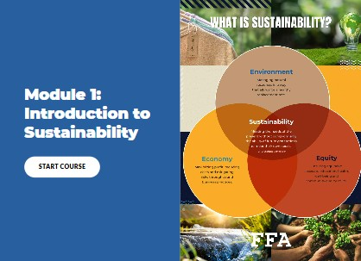
Module 1: Introduction to Sustainability
Sustainability is a HUGE buzzword these days. But what does it actually mean? Through this lesson, you will consider that question as you discover the core principles of sustainability, learn essential sustainability vocabulary and explore how sustainability looks within businesses and your own life.
Student Learning Objectives:
- Explain the core principles of sustainability.
- Define key terms related to sustainability.
- Explore actions that individuals and companies are taking to live and work more sustainably.

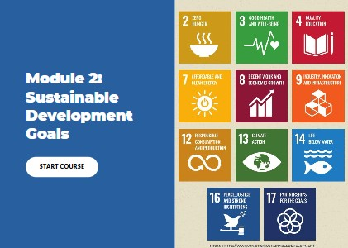
Module 2: Sustainable Development Goals
Globally, there are many conversations being had about sustainability. The governments of the world, businesses large and small and individuals of all kinds are looking at what they can do to be more sustainable. Through this lesson, you will learn about the United Nations and how world governments have come together to work toward a more sustainable future, dive into the world of the 17 Sustainable Development Goals targeted at different areas of sustainability and consider your own sustainability priorities.
Student Learning Objectives:
- Investigate the history of the United Nations and their Sustainable Development agenda.
- Explore the United Nations’ 17 Sustainable Development Goals (SDGs).
- Articulate personal priorities within the SDG framework.

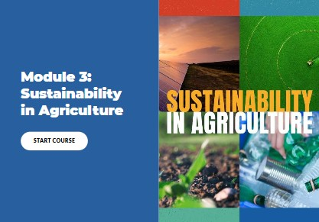
Module 3: Sustainability in Agriculture
Sustainable practices are crucial for the future of agriculture, ensuring that we can meet today’s needs without compromising the ability of future generations to meet theirs. In this module, we will explore four key focus areas: climate change, water conservation, soil health and waste management. We will explore how agriculture continues to evolve to meet sustainability goals and explore the many careers within the field of sustainable agriculture.
Student Learning Objectives:
- Identify key areas, industries and practices within agriculture where sustainability is important.
- Examine sustainability practices within the agriculture industry.
- Explore agricultural careers related to sustainability.

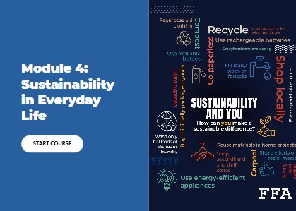
Module 4: Sustainability in Everyday Life
Often, the idea of “becoming sustainable” can be overwhelming. We are being bombarded from all sides with ways we can “go green” or “save the planet,” and it can be difficult to know what we should do. Should we do all of it? None of it? Can one person even make enough of a difference? These are all good questions. Let’s dive in and see what we can do as individuals to live more sustainably.
Student Learning Objectives:
- Explore individual practices to live more sustainably.
- Develop a personal plan identifying and implementing a single action students can take to live more sustainably.
Instructions for Accessing the Online Modules
There are two different ways to access the Introduction to Sustainability modules:
- Access them through FFA.org.
- Download the content packages to upload the modules into your own learning management system (LMS).

This section of the guide will give you directions for both access routes.

Option 1: Access Through FFA.org
- Click the links below to access the Sustainability Modules page on FFA.org.
  - Module 1: Introduction to Sustainability
  - Module 2: Sustainable Development Goals
  - Module 3: Sustainability in Agriculture
  - Module 4: Sustainability in Everyday Life
- Click on the module you would like to share with your students. The module will open in a new tab on your browser.

- Copy and paste the link in the address bar into your LMS or email to your students.
- Students will navigate through the module by opening each page and completing the activities as they progress.
- At the completion of each module, students will be required to earn a 70% or better on the Knowledge Check to access the certificate of completion.

*Notes:
- Accessing the modules through FFA.org will not allow students to save their place within the module. Students should complete the entire module in one sitting or leave the module open on their computers to avoid having to restart.
- As the teacher, you will not be able to see their responses to the questions using this access route. Students will receive a certificate of completion after passing the Knowledge Check that they may turn in as proof of completion; however, you may also consider using the accompanying student journals at the end of this educator guide as additional student accountability.

Option 2: Download Packages for LMS Upload
- Check that the LMS you are using allows you the ability to upload external packages into your course(s) and that you have the proper permissions to do so.
- Click here to access the LMS packages available for download. Select the best format for your LMS. Downloads are available in the following formats:
  - SCORM 1.2
  - AICC
  - xAPI
- Follow the procedures for uploading and importing external packages into your specific LMS. If you need assistance in doing so, consider visiting the “help” pages for your LMS or asking your school/district’s LMS administrator.

- Assign the module to your students within your LMS according to your standard assignment and grading practices.

Navigating the Modules
This section contains information about what you and your students will find within each module.
Module Dashboard  Each module opens to the module dashboard. This is the home page for the module. On this dashboard, you will find a short description of the module, a list of the module objectives and each of the sections contained within the module. From here, students will click on the section titles to navigate to the module content.  Note: The section for the summary and completion certificate will be locked until a passing score (70% or greater) is reached on the knowledge check. | 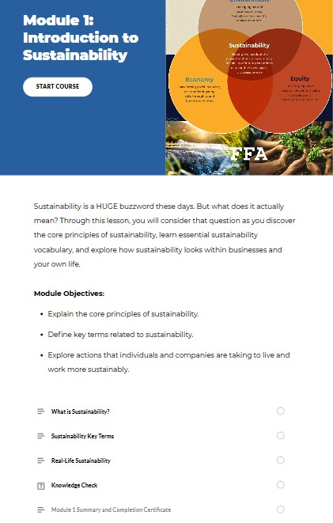
Module Sections  Each module is broken into sections. Each section begins with some background information and then continues with additional images, text passages, videos and activities for students to explore and complete to accomplish the module objectives. It is recommended that students complete the sections in the order that they appear. | 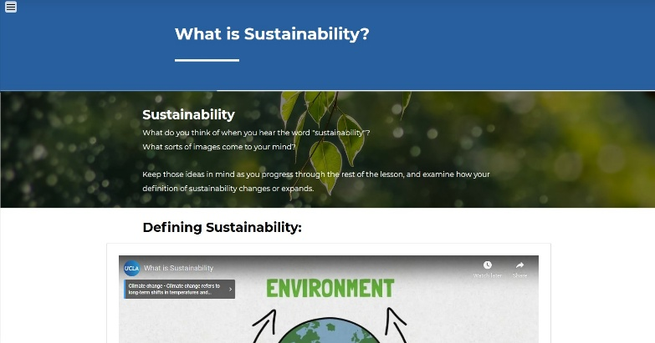
Concept Reviews  Modules 2 through 4 each contain a Concept Review page that provides a brief recap of what was covered in the previous modules. This is intended to contain helpful reminders about concepts previously covered and/or provide context to students who may only be completing one of the later modules. The information on these pages is summarized and does not reflect the full breadth and depth of information presented in each previous module. | 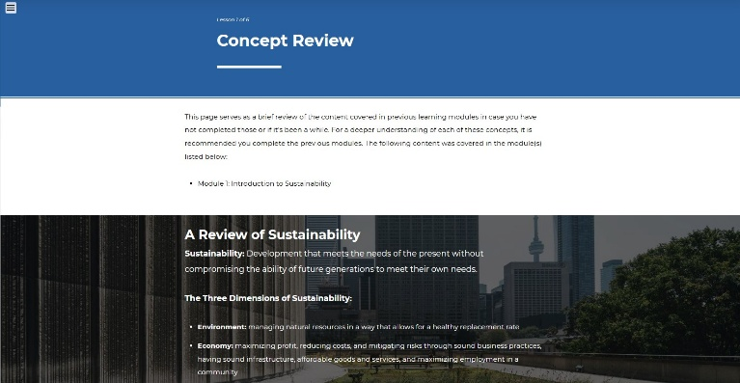
Module Activities  Throughout the content of the modules, there are various embedded activities for students to engage with the content. These activities are intended for students to think critically about the concepts they are reading and watching and help them process what they are learning.  Activities include tasks such as answering multiple choice or fill-in-the-blank questions, sorting items into various categories, matching terms and definitions, watching videos and answering embedded questions, completing case studies and reading through flash cards. In most cases, students will be required to complete each of the activities before advancing to the next piece of content. | 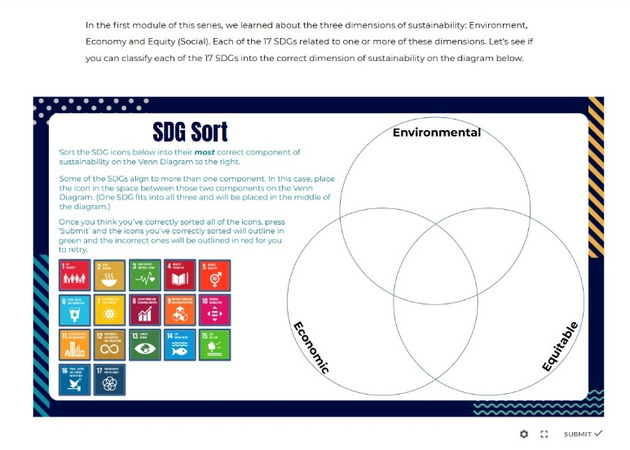  Example of a sorting activity.  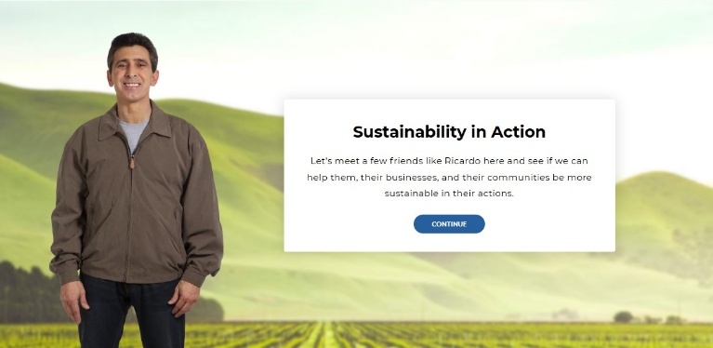  Example of a scenario-based activity.
Continue Buttons  Within the sections of the module, students will encounter “Continue” buttons that will allow them to progress through the content as they complete the activities. They will first appear locked like the first image to the right. Once students complete the activities above the buttons, they will turn blue and allow students to progress to the next piece of content. | Locked “Continue” button.  Unlocked “Continue” button.
Section Review  Each module section ends with a “Section Review,” which contains multiple free response questions for students to type in their answers. Students should follow the directions for all questions and press “Submit” after each response until directed to proceed to the next module section. | 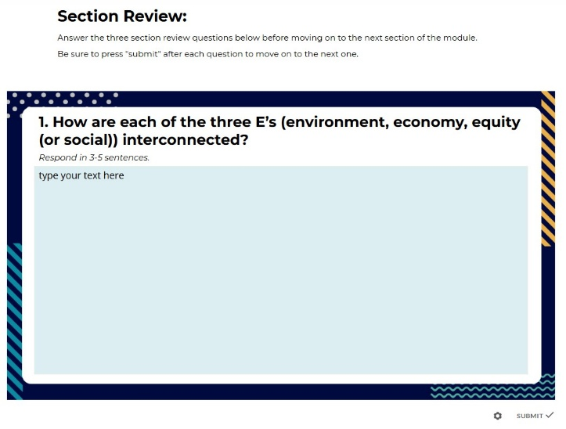
Knowledge Checks  Each module ends with a Knowledge Check. This is a short quiz about the content covered in the module. Question types include multiple choice, true/false and select all that apply. Students will select the best answers based on what they learned during the module.  A passing score of 70% or better is required on each knowledge check in order to unlock the module review and certificate of completion page where students may download a PDF of their certificate.  These knowledge checks may be taken as many times as needed in order to receive a passing score. | 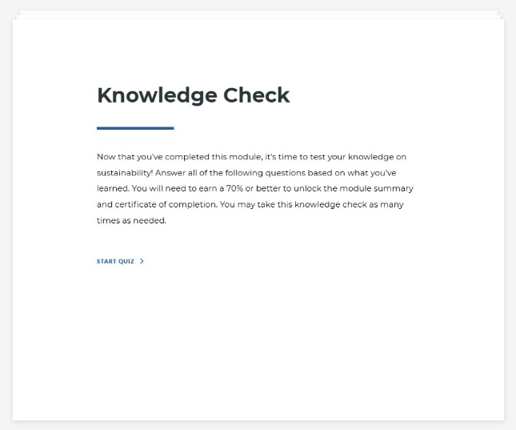  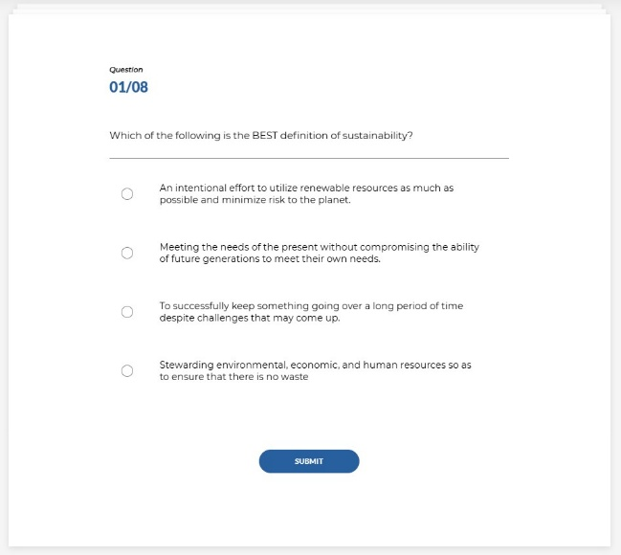
Module Summary and Completion Certificate  The module summary and review pages recap the content covered in the modules objective by objective as a final reminder of the core concepts. Additional links and resources are provided at the bottom of the page for students to explore further if they wish.  Finally, students will be able to access a fillable PDF certificate of completion for each module they complete. They can type their names in these certificates as proof of completion for each module. | 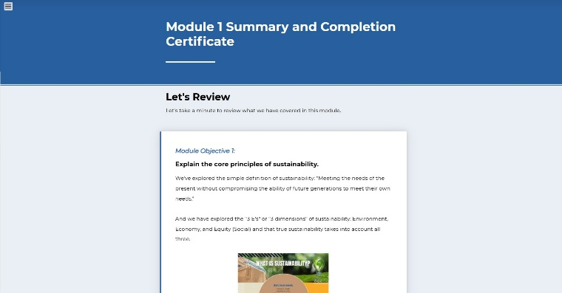  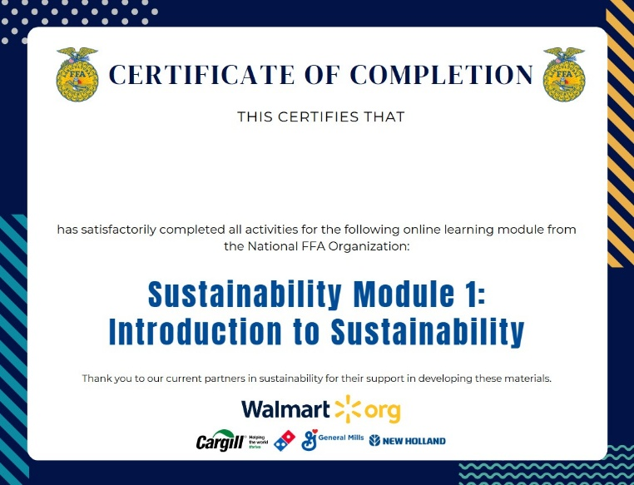

Companion Student Journals for the Modules
Each module has a companion student journal that you can have students fill out as they complete the module. Each journal contains every reflection question asked in the modules as well as a paper-based version of the knowledge check. These are designed so students can have something to keep a record of their answers and so teachers can have an additional option for a deliverable for students to submit besides the certificate of completion if desired. Click below to access the file version best suited for your needs.

Module 1: Introduction to Sustainability | Module 2: Sustainable Development Goals
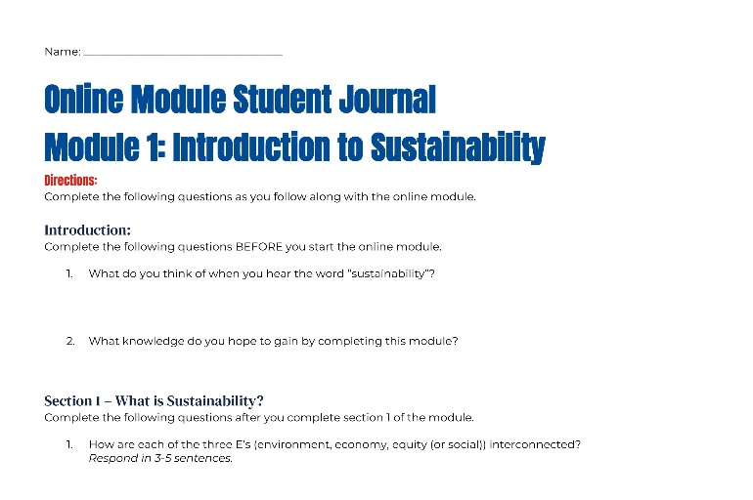 | 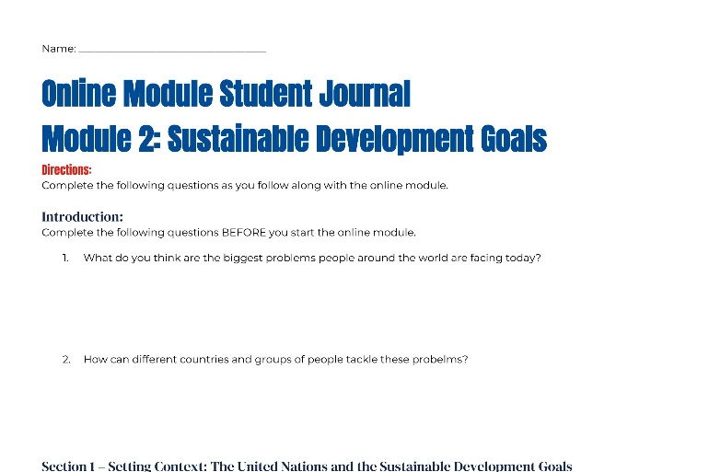
- Module 1 Student Journal (Word)  - Module 1 Student Journal (PDF)  - Module 1 Student Journal (Google Docs) | - Module 2 Student Journal (Word)  - Module 2 Student Journal (PDF)  - Module 2 Student Journal (Google Docs)
Module 3: Sustainability in Agriculture | Module 4: Sustainability in Everyday Life
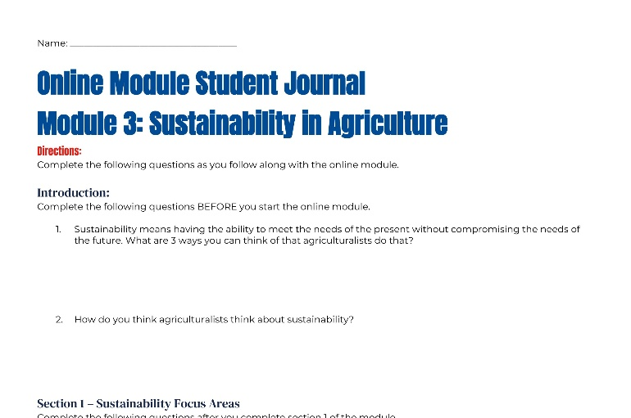 | 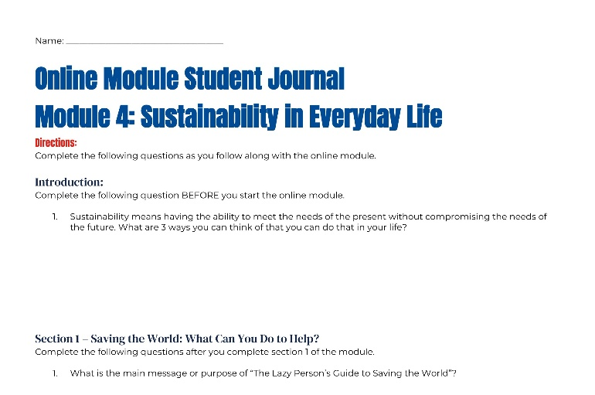
- Module 3 Student Journal (Word)  - Module 3 Student Journal (PDF)  - Module 3 Student Journal (Google Docs) | - Module 4 Student Journal (Word)  - Module 4 Student Journal (PDF)  - Module 4 Student Journal (Google Docs)

Answer keys for all of the Knowledge Checks within the student journals can be found here.

