A Chick, Chick Here
Aligned to the following standards:
AS.04; FFA.PL-A; FFA.PG-J; FFA.CS-M; FFA.CS-N; AG-ANI4; AGPC01.04; CCSS.RI.9-10.8; CCSS.RST.9-10.7; CCSS.RST.9-10.9; CCSS.MP7; CRP.02; CRP.05; CRP.07; CRP.08; CRP.11
Directions:
Answer the following questions as you watch the video “Backyard Chickens SAE | Ja’Kolbie Jones,” available at https://vimeo.com/318005504.
What is Ja’Kolbie’s SAE?


How did Ja’Kolbie get started in his SAE?

How many chickens does he have?
- 7
- 10
- 13
- 15

What are his daily responsibilities?


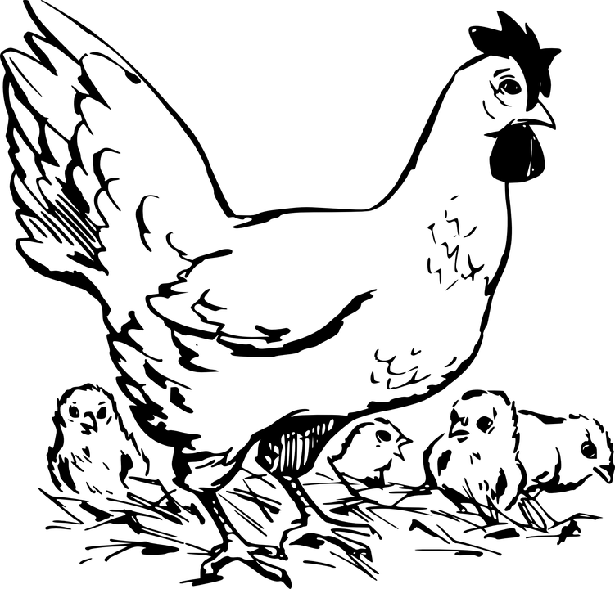
What skills has he gained from his SAE?

1.

2.

3.

How does he manage the chicken waste?

Who has helped the most with his SAE?

Everywhere a Chick
Aligned to the following standards:
AS.04; FFA.PL-A; FFA.PG-J; FFA.CS-M; FFA.CS-N; AG-ANI4; AGPC01.04; CCSS.RI.9-10.8; CCSS.RST.9-10.7; CCSS.RST.9-10.9; CCSS.MP7; CRP.02; CRP.05; CRP.07; CRP.08; CRP.11
Directions:
Complete the following activities to learn more about hatching chicken eggs.

- Over the course of 20 days, chickens develop inside the egg and hatch on the 21st day. In the boxes below, draw a representation of what that phase looks like and provide a written description as well. (The picture goes in the egg shape, and the description goes in the box below the egg.) Suggested resource: http://www.poultryhub.org/physiology/incubation/


Day 1

Day 2

Day 3

Day 4

Day 5

Day 6

Day 7

Day 8

Day 9

Day 10

Day 11

Day 12

Day 13

Day 14

Day 15

Day 16

Day 17

Day 18

Day 19

Day 20
- Now that we know how a chick develops, we can learn how to hatch eggs at home. The main stages of incubation each have a box below. Fill in the requested information. Suggested resource: https://www.purinamills.com/chicken-feed/education/detail/hatching-eggs-at-home-a-21-day-guide-for-baby-chicks
Aligned to the following standards:
AS.04; FFA.PL-A; FFA.PG-J; FFA.CS-M; FFA.CS-N; AG-ANI4; AGPC01.04; CCSS.RI.9-10.8; CCSS.RST.9-10.7; CCSS.RST.9-10.9; CCSS.MP7; CRP.02; CRP.05; CRP.07; CRP.08; CRP.11
Day 1: ______________________________

Temperature:

Humidity:

What I need to do to the eggs:

Days 1–18:
______________________________

Temperature:

Humidity:

What I need to do to the eggs:

Days 7–10:
______________________________

Temperature:

Humidity:

What I need to do to the eggs:

Days 18–21:
______________________________

Temperature:

Humidity:

What I need to do to the eggs:

Day 21:
______________________________

Temperature:

What I need to do to the eggs:

- What human errors/mistakes during incubation could cause eggs to not hatch?

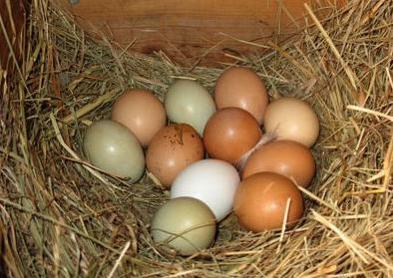
- If given the opportunity to incubate chicken eggs, would you try it? Why or why not?

