Backyard Chickens
Created: 03/2019 by the National FFA Organization

Ja’Kolbie’s supervised agricultural experience (SAE) program is raising chickens in his backyard. Follow along as he shares how he became interested in chickens and how he has used thriftiness and creative thinking to make the most of his space and materials.

Student Learning Objectives:
After completing these activities, students will …
- Explain and illustrate how chicken embryos develop.
- Outline the process of incubating and hatching chicken eggs.
- Reflect on the potential difficulties of incubating eggs.

Time Required: 180 minutes
Resources/References:
- Video: “Backyard Chickens SAE | Ja’Kolbie Jones,” https://vimeo.com/318005504
- Website: Poultry Hub, http://www.poultryhub.org/physiology/incubation/
- Article: “Hatching Eggs at Home,” https://www.purinamills.com/chicken-feed/education/detail/hatching-eggs-at-home-a-21-day-guide-for-baby-chicks

Equipment and Supplies Needed:
- A copy of the “A Chick, Chick Here” worksheet for each student
- A copy of the “Everywhere a Chick” worksheet for each student
- Internet access to play the video in real time or embed it in a PowerPoint ahead of time
- Technology access for students to research embryo development and incubation

Student activity sheets:
Direct access to student activity sheets without lesson plan or answer key for easy upload to learning management system or printing for classwork.
https://ffa.box.com/s/7bcc273feqjexo6u1vuyzarygli4o3eq (Word)
https://ffa.box.com/s/dqiv2xqj5z8mo9gcn3ia9uiif4keds1n (PDF)

Cross-Curricular Connections:
Science | English/Language Arts
Explain and illustrate how a chicken embryo develops  Outline the process of egg incubation | Written reflection of potential difficulties in incubating eggs

These activities are aligned to the following standards:

AFNR Performance Element
- AS.04. Apply principles of animal reproduction to achieve desired outcome for performance, development, and/or economic production.
FFA Precept
- FFA.PL-A.Action: Assume responsibility and take the necessary steps to achieve the desired results, no matter what the goal or task at hand.
- FFA.PG-J.Mental Growth: Embrace cognitive and intellectual development relative to reasoning, thinking, and coping.
- FFA.CS-M.Communication: Effectively interact with others in personal and professional settings.
- FFA.CS-N.Decision Making: Analyze a situation and execute an appropriate course of action.
Common Career Technical Core
- AG-ANI4 Apply principles of animal reproduction to achieve desired outcome for performance, development, and/or economic production.
NASDCTEc
- AGPC01.04 Analyze and summarize factors that influence an animal's reproduction cycle to demonstrate an understanding of the species response.
Common Core – Reading: Informational Text
- CCSS.ELA-Literacy.RI.9-10.8 Delineate and evaluate the argument and specific claims in a text, assessing whether the reasoning is valid and the evidence is relevant and sufficient; identify false statements and fallacious reasoning.
Common Core – Science & Technical Subjects
- CCSS.ELA-Literacy.RST.9-10.7 Translate quantitative or technical information expressed in words in a text into visual form (e.g., a table or chart) and translate information expressed visually or mathematically (e.g., in an equation) into words.
- CCSS.ELA-Literacy.RST.9-10.9 Compare and contrast findings presented in a text to those from other sources (including their own experiments), noting when the findings support or contradict previous explanations or accounts.
AFNR Career Ready Practices
- CRP.02. Apply appropriate academic and technical skills. Career-ready individuals readily access and use the knowledge and skills acquired through experience and education to be more productive.
- CRP.05. Consider the environmental, social and economic impact of decisions. Career-ready individuals understand the interrelated nature of their actions and regularly make decisions that positively impact and/or mitigate negative impact on other people, organizations and the environment.
- CRP.07. Employ valid and reliable research strategies. Career-ready individuals are discerning in accepting and using new information to make decisions, change practices or inform strategies.
- CRP.08. Utilize critical thinking to make sense of problems and persevere in solving them. Career-ready individuals readily recognize problems in the workplace, understand the nature of the problem, and devise effective plans to solve the problem.
- CRP.11. Use technology to enhance productivity. Career-ready individuals find and maximize the productive value of existing and new technology to accomplish workplace tasks and solve workplace problems.
Partnership for 21st Century Skills
- Productivity and Accountability

Lesson Plan:
- Bell Ringer: List five things that you know (or would like to know) about chickens and chicken eggs.

- Introduction: You don’t have to live on a farm to raise animals — sometimes, you just need a backyard. Today, we will learn how one student raises chicken in his backyard for his SAE.

- Activity:
  - Each student needs a copy of the worksheet “A Chick, Chick Here.” Have students complete the worksheet as they watch the video “Backyard Chickens SAE | Ja’Kolbie Jones,” available at https://vimeo.com/318005504. After students are done, transition into the next activity by discussing how Ja’Kolbie bought a chicken from a student who had hatched some eggs. Have a class discussion to learn what students already know about chicken embryo development and incubating eggs. These are questions you can use to lead the discussion:
    - How many days does it take for a chicken egg to hatch? (21 days)
    - What is the purpose of the yolk for the developing embryo? (Yolk is pure fat that provides nourishment to the developing chick.)
    - When hens sit on eggs, what are they doing? (Keeping the eggs warm so the embryos can develop.)
    - How do we imitate hens sitting on eggs? (We use incubators to keep eggs warm.)
    - When hens sit on eggs, they roll them around occasionally. Why might they do that? (It is to prevent the embryo from sticking to the shell from resting in the same position for too long.)
    - How do we imitate this rolling action when incubating eggs? (Rotating the eggs multiple times a day prevents the embryo from sticking to the shell.)
  - Give each student a copy of the worksheet “Everywhere a Chick.” Students will illustrate and explain what happens during each day of embryo development. Then, students will learn the process of incubating eggs by outlining what needs to happen during each stage of incubation.

- Follow-up: When students are done with the activity, have them share what they found most surprising about the embryo development process.

- Optional — Extended Learning Opportunities (Not factored into time requirement):
  - If this is a new topic for your students, consider finding an incubator and hatching a few chicken eggs as a class. It is a fantastic learning opportunity, and each student will get hands-on experience of how best to incubate eggs.

- Exit Ticket: Would you want to have backyard chickens of your own? Why or why not?

A Chick, Chick Here
Aligned to the following standards:
AS.04; FFA.PL-A; FFA.PG-J; FFA.CS-M; FFA.CS-N; AG-ANI4; AGPC01.04; CCSS.RI.9-10.8; CCSS.RST.9-10.7; CCSS.RST.9-10.9; CCSS.MP7; CRP.02; CRP.05; CRP.07; CRP.08; CRP.11
Directions:
Answer the following questions as you watch the video “Backyard Chickens SAE | Ja’Kolbie Jones,” available at https://vimeo.com/318005504.
What is Ja’Kolbie’s SAE?


How did Ja’Kolbie get started in his SAE?

How many chickens does he have?
- 7
- 10
- 13
- 15

What are his daily responsibilities?


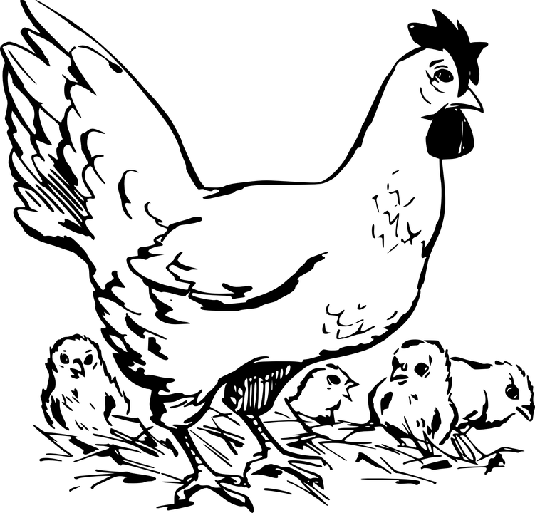
What skills has he gained from his SAE?

1.

2.

3.

How does he manage the chicken waste?

Who has helped the most with his SAE?

Everywhere a Chick
Aligned to the following standards:
AS.04; FFA.PL-A; FFA.PG-J; FFA.CS-M; FFA.CS-N; AG-ANI4; AGPC01.04; CCSS.RI.9-10.8; CCSS.RST.9-10.7; CCSS.RST.9-10.9; CCSS.MP7; CRP.02; CRP.05; CRP.07; CRP.08; CRP.11
Directions:
Complete the following activities to learn more about hatching chicken eggs.

- Over the course of 20 days, chickens develop inside the egg and hatch on the 21st day. In the boxes below, draw a representation of what that phase looks like and provide a written description as well. (The picture goes in the egg shape, and the description goes in the box below the egg.) Suggested resource: http://www.poultryhub.org/physiology/incubation/


Day 1

Day 2

Day 3

Day 4

Day 5

Day 6

Day 7

Day 8

Day 9

Day 10

Day 11

Day 12

Day 13

Day 14

Day 15

Day 16

Day 17

Day 18

Day 19

Day 20
- Now that we know how a chick develops, we can learn how to hatch eggs at home. The main stages of incubation each have a box below. Fill in the requested information. Suggested resource: https://www.purinamills.com/chicken-feed/education/detail/hatching-eggs-at-home-a-21-day-guide-for-baby-chicks
Aligned to the following standards:
AS.04; FFA.PL-A; FFA.PG-J; FFA.CS-M; FFA.CS-N; AG-ANI4; AGPC01.04; CCSS.RI.9-10.8; CCSS.RST.9-10.7; CCSS.RST.9-10.9; CCSS.MP7; CRP.02; CRP.05; CRP.07; CRP.08; CRP.11
Day 1: ______________________________

Temperature:

Humidity:

What I need to do to the eggs:

Days 1–18:
______________________________

Temperature:

Humidity:

What I need to do to the eggs:

Days 7–10:
______________________________

Temperature:

Humidity:

What I need to do to the eggs:

Days 18–21:
______________________________

Temperature:

Humidity:

What I need to do to the eggs:

Day 21:
______________________________

Temperature:

What I need to do to the eggs:

- What human errors/mistakes during incubation could cause eggs to not hatch?

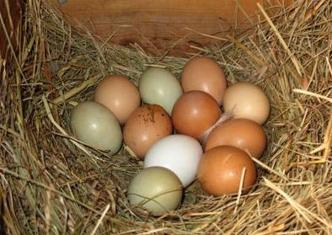
- If given the opportunity to incubate chicken eggs, would you try it? Why or why not?

KEY: A Chick, Chick Here
Aligned to the following standards:
AS.04; FFA.PL-A; FFA.PG-J; FFA.CS-M; FFA.CS-N; AG-ANI4; AGPC01.04; CCSS.RI.9-10.8; CCSS.RST.9-10.7; CCSS.RST.9-10.9; CCSS.MP7; CRP.02; CRP.05; CRP.07; CRP.08; CRP.11
Directions:
Answer the following questions as you watch the video “Backyard Chickens SAE | Ja’Kolbie Jones,” available at https://vimeo.com/318005504.
What is Ja’Kolbie’s SAE?
Raising backyard chickens
How did Ja’Kolbie get started in his SAE?
In middle school, a classmate was selling chicks he or she hatched and
Ja’Kolbie bought one.
How many chickens does he have?
- 7
- 10
- 13
- 15

What are his daily responsibilities?
Feed and water the chickens
Collect eggs
Clean eggs

What skills has he gained from his SAE?

- Time management (balancing sports, FFA and his SAE)

- Composting

- Responsibility (taking care of the chickens)

How does he manage the chicken waste?

He looked up videos to get ideas, started a compost pile with the waste and then planted some tomatoes.

Who has helped the most with his SAE?
He received help from his advisor, who has supported him throughout his SAE, and his grandparents, who take him to the store for feed and supplies. They also helped him build the coop.

KEY: Everywhere a Chick
Aligned to the following standards:
AS.04; FFA.PL-A; FFA.PG-J; FFA.CS-M; FFA.CS-N; AG-ANI4; AGPC01.04; CCSS.RI.9-10.8; CCSS.RST.9-10.7; CCSS.RST.9-10.9; CCSS.MP7; CRP.02; CRP.05; CRP.07; CRP.08; CRP.11
Directions:
Complete the following activities to learn more about hatching chicken eggs.

- Over the course of 20 days, chickens develop inside the egg and hatch on the 21st day. In the boxes below, draw a representation of what that phase looks like and provide a written description as well. (The picture goes in the egg shape, and the description goes in the box below the egg.) Suggested resource: http://www.poultryhub.org/physiology/incubation/

Student images will vary, but the descriptions should be similar to the ones given in the chart available at http://www.poultryhub.org/wp-content/uploads/2012/07/chick_embryo_development1.jpg.
Aligned to the following standards:
AS.04; FFA.PL-A; FFA.PG-J; FFA.CS-M; FFA.CS-N; AG-ANI4; AGPC01.04; CCSS.RI.9-10.8; CCSS.RST.9-10.7; CCSS.RST.9-10.9; CCSS.MP7; CRP.02; CRP.05; CRP.07; CRP.08; CRP.11
- Now that we know how a chick develops, we can learn how to hatch eggs at home. The main stages of incubation each have a box below. Fill in the requested information. Suggested resource: https://www.purinamills.com/chicken-feed/education/detail/hatching-eggs-at-home-a-21-day-guide-for-baby-chicks
Day 1:
____Setting Eggs______

Temperature: 100.5°F

Humidity: 50–55%

What I need to do to the eggs:
Plan to set a minimum of six eggs at one time. Setting fewer eggs, especially if the eggs were shipped, often results in one or no hatchlings. Place the eggs in the egg tray of the incubator, with the larger end facing up and the narrow end facing down in the incubator.

Days 1–17:
_______Turning the Eggs__________

Temperature: unchanged

Humidity: unchanged

What I need to do to the eggs:
Eggs must be physically turned to prevent the developing chick from sticking to the shell. They will need to be turned a minimum of 3 times per day, and 5 times is even better. If you are turning the eggs manually, gently make a mark with a pencil (never a pen!) that will help you keep track of which eggs have been turned.
Days 7–10:
___________Candling Eggs____

Temperature and Humidity: unchanged
What I need to do to the eggs:
Candle the eggs, keeping them out no longer than 5 to 10 minutes:
If the inside of the egg is clear (free from visible structures or dark areas) or there is a ring of red, the egg is infertile. Remove this egg from the incubator.
If you can see blood vessels within the egg, there is a live embryo inside. Blood vessels in chicken eggs are normally observable within 7 to 10 days of an egg's incubation.
Return to the Days 1–17 turning schedule.
Days 18–21:
_________Pre-hatching_______

Temperature: unchanged

Humidity: increase to 70%

What I need to do to the eggs:
By day 18, the embryo has developed into a chick and will take up most of the space in the egg.
Stop egg turning at day 18 with the larger end of the egg facing up. At this point, the chick will position itself for hatching inside the egg.
Day 21:
______Hatching Starts_________

Temperature: Once all chicks have hatched change incubator to 95°F, and the brooder should be 90–95°F.

What I need to do to the eggs:
When the big day comes, let the chick hatch on its own. Do not attempt to help. A chick can take up to 24 hours to completely hatch, although 5 to 7 hours is more common.
The peeping of the new baby chicks will encourage unhatched eggs to also start hatching. Once the chicks have dried, they can be moved into the brooder.

- What human errors/mistakes during incubation could cause eggs to not hatch?

Answers will vary.

- If given the opportunity to incubate chicken eggs, would you try it? Why or why not?

Answers will vary.

