Trees Everywhere
Aligned to the following standards:
FFA.PL-A; FF.PL-E; FFA.PL-F; FFA.PG-I; FFA.PG-J; FFA.CS-M; FFA.CS-N; CCSS.ELA.SL.9-10.2; MP1; MP5; MP6; CRP.02; CRP.04
Part 1



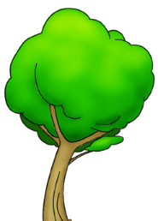
Directions:
What class did Jared take that helped him with his SAE?
Inside the tree, record three tasks that Jared is in charge of at the orchard.
How did Jared overcome this challenge?
What was Jared’s biggest challenge?
What three things has Jared learned through his SAE?
This SAE has been very beneficial to Jared. How could an SAE benefit you and your future?
Read over and answer the questions below while you watch the video
“Jared Mudd – SAE – Ranch Foreman – Orchard,”
available at https://vimeo.com/278943654.

Part 2
Aligned to the following standards:
FFA.PL-A; FF.PL-E; FFA.PL-F; FFA.PG-I; FFA.PG-J; FFA.CS-M; FFA.CS-N; CCSS.ELA.SL.9-10.2; MP1; MP5; MP6; CRP.02; CRP.04
Directions:
Answer the following questions to the best of your ability without help. Let’s see who can get the most right!

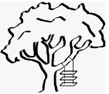
- Global forests removed ________ of fossil fuel emissions annually from 1990 to 2007.
  - 1/4
  - 1/3
  - 1/6
  - 1/2

- True or False

Office workers who can see trees from their windows report having significantly less stress and more satisfaction.

3. One large tree can provide enough oxygen for how many people?
a. 1
b. 2
c. 3
d. 4

- True or False

Trees can help reduce crime.

- True or False

Trees reduce the property value of homes because they require more maintenance and care.

Part 3
Aligned to the following standards:
FFA.PL-A; FF.PL-E; FFA.PL-F; FFA.PG-I; FFA.PG-J; FFA.CS-M; FFA.CS-N; CCSS.ELA.SL.9-10.2; MP1; MP5; MP6; CRP.02; CRP.04
Directions:
Now that you have learned about the importance of trees and how Jared Mudd has used his SAE to develop his skills in orchard management, let’s learn about how to plant our own trees. Watch this video, https://www.youtube.com/watch?v=W2xjDqbr1U4, to learn how to plant containerized trees and then complete the activities below.

Draw and label a flow chart to depict each step in the process of planting a containerized tree. Include a picture and label for each major step that a person would need to know and follow to properly plant the tree without causing damage.
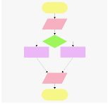
Example of what a flow chart can look like:

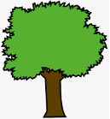
What is Arbor Day?

When is Arbor Day?
Identify three types of trees you can plant at your school.
How can planting new trees impact you?

