Dairy Farm
Aligned to the following standards:
FFA.PL-A; FFA.PL-E; FFA.PL-F; FFA.PG-J; FFA.CS-M; FFA.CS-N; CCSS.ELA.SL.9-10.1; CCSS.ELA.SL.9-10.2; CCSS.ELA.RST.9-10.4; CCSS.ELA.9-10.7; CCSS.ELA.RST.9-10.9; MP1; MP2; MP5; MP6; CRP.02; CRP.04; CRP.06; CRP.08
Part 1
Directions:
Read and answer the questions below while you watch the video “Jared Poldervaart – SAE – Dairy Herd,” available at https://vimeo.com/279310671.

How many cows are on the farm where Jared works?

- 450
- 650
- 850
- 1050

What were the beginning steps Jared took to develop his SAE?

Which of the following was one of Jared’s biggest challenges?

- Transportation to and from the farm
- Understanding herd genomics
- Time management between work and school

What did Jared do in his agriculture class to help him with his SAE?

What skills has Jared learned through this SAE?
1.

2.

3.

What has Jared learned through his SAE?

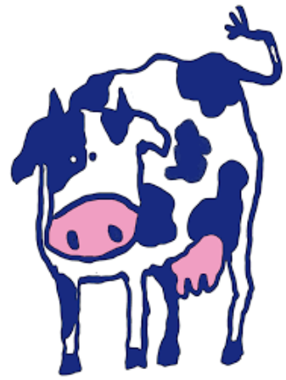

Part 2
Directions:
Aligned to the following standards:
FFA.PL-A; FFA.PL-E; FFA.PL-F; FFA.PG-J; FFA.CS-M; FFA.CS-N; CCSS.ELA.SL.9-10.1; CCSS.ELA.SL.9-10.2; CCSS.ELA.RST.9-10.4; CCSS.ELA.9-10.7; CCSS.ELA.RST.9-10.9; MP1; MP2; MP5; MP6; CRP.02; CRP.04; CRP.06; CRP.08
Productive dairy herds rely heavily on the farmer having a solid understanding of the herd genomics and genetics. Genomics and genetics become important because they help to ensure herd health and productivity. Learn about the impact of genetics through the activities below.
Genomics: Looking at all the genes of an organism and how they work together in relation to the growth and development of an organism
Genetics: Looking at the individual genes of an organism
Let’s take a look at genetics! Genetics are analyzed in animal systems, such as a dairy herd, to ensure high-producing, healthy animals. Using google, complete the crossword below to learn important vocabulary for the next activity.

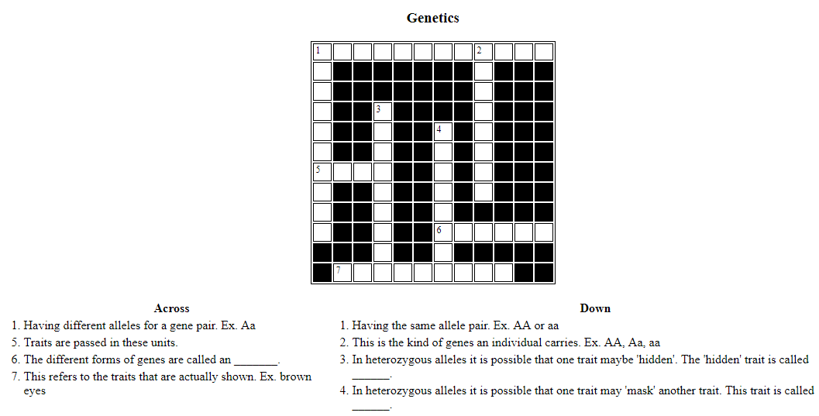

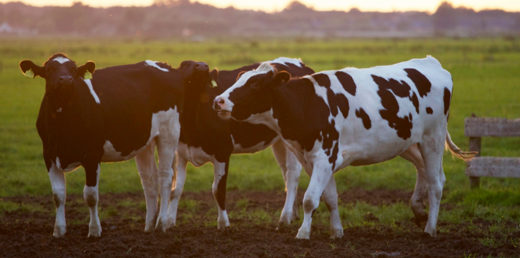
What role do genetics play in our everyday lives?
Using AgExplorer.ffa.org, identify three career focus areas (other than animal science) in which genetics would play a large role.

- ________________________________________________

- ________________________________________________

- ________________________________________________

Part 3
Directions:
Aligned to the following standards:
FFA.PL-A; FFA.PL-E; FFA.PL-F; FFA.PG-J; FFA.CS-M; FFA.CS-N; CCSS.ELA.SL.9-10.1; CCSS.ELA.SL.9-10.2; CCSS.ELA.RST.9-10.4; CCSS.ELA.9-10.7; CCSS.ELA.RST.9-10.9; MP1; MP2; MP5; MP6; CRP.02; CRP.04; CRP.06; CRP.08
In genetics there is a tool called a Punnett Square that can help determine the probable genotypic outcome of offspring. The genotype can then be used to determine the phenotype. Watch the video available at https://youtu.be/d4izVAkhMPQ, or use websites/videos similar to it, and then complete the Punnett square practice below.

- A homozygous purple (RR) flower is being crossed with a heterozygous purple flower (Rr). What color will the potential offspring be? ______________________
Show all work for full credit.

- A heterozygous black bull (Gg) has been crossed with a heterozygous black heifer (Gg). What percentage of the offspring will be black? _______________
What percentage of the offspring will be white? ______________
Show all work for full credit.

- A homozygous black lab (TT) is crossed with a homozygous yellow lab (tt). What percentage of the offspring will be chocolate? _______________________
What percentage of the offspring will be yellow? _________________
Show all work for full credit.

