Dairy Farm SAE
Created: 05/2019 by the National FFA Organization

SAE Video Summary: As part of Jared’s supervised agricultural experience (SAE) program, he works at a dairy farm. Jared manages the herd and its genetics to improve production and herd quality.
Student Learning Objectives:
After completing these activities, students will …
- Describe a dairy farm SAE.
- Identify key genetics terminology.
- Use a Punnett square.
- Demonstrate terminology understanding through the use of Punnett squares.

Time Required: 45 minutes
Resources:
- “Jared Poldervaart – SAE – Dairy Herd,” https://vimeo.com/279310671
- AgExplorer, AgExplorer.ffa.org
- Gregor Mendel’s Punnett Squares, https://youtu.be/d4izVAkhMPQ

Equipment and Supplies Needed:
- A copy of the “Dairy Farm” worksheet for each student
- Internet access to play the video in real time or embed it in a PowerPoint ahead of time
- Plastic Easter eggs
- Jellybeans

This quick lesson plan would work well as Part Of:
- An SAE lesson/unit.
- An animal genetics lesson.
- A biotechnology lesson.

Student Activity Sheets:
Direct access to student activity sheets without lesson plan or answer key for easy upload to learning management systems or printing for classwork.
https://ffa.box.com/s/5wiu0cm4t4vyh1ukg9pxrvb548dngknl (Word)
https://ffa.box.com/s/mu6epsuqlip8eecoo5h0raef4nj54pgo (PDF)
These activities are aligned to the following standards:
FFA Precept
- FFA.PL-A.Action: Assume responsibility and take the necessary steps to achieve the desired results, no matter what the goal or task at hand.
- FFA.PL-E.Awareness: Understand personal vision, mission and goals.
- FFA.PL-F.Continuous Improvement: Accept responsibility for learning and personal growth.
- FFA.PG-J.Mental Growth: Embrace cognitive and intellectual development relative to reasoning, thinking and coping.
- FFA.CS-M.Communication: Effectively interact with others in personal and professional settings.
- FFA.CS-N.Decision Making: Analyze a situation and execute an appropriate course of action.
Common Core – Speaking and Listening
- CCSS.ELA-Literacy.SL.9-10.1: Initiate and participate effectively in a range of collaborative discussions (one-on-one, in groups, and teacher-led) with diverse partners on grades 9-10 topics, texts, and issues, building on others' ideas and expressing their own clearly and persuasively.
- CCSS.ELA-Literacy.SL.9-10.2: Integrate multiple sources of information presented in diverse media or formats (e.g., visually, quantitatively, orally) evaluating the credibility and accuracy of each source.
Common Core – Science & Technical Subjects
- CCSS.ELA-Literacy.RST.9.10.4: Determine the meaning of symbols, key terms, and other domain-specific words and phrases as they are used in a specific scientific or technical context relevant to grades 9-10 texts and topics.
- CCSS.ELA-Literacy.RST.9-10.7: Translate quantitative or technical information expressed in words in a text into visual form (e.g., a table or chart) and translate information expressed visually or mathematically (e.g., in an equation) into words.
- CCSS.ELA-Literacy.RST.9.10.9: By the end of grade 10, read and comprehend science/technical texts in the grades 9-10 text complexity band independently and proficiently.
Common Core – Math Practices
- MP1: Make sense of problems and persevere in solving them.
- MP2: Reason abstractly and quantitatively.
- MP5: Use appropriate tools strategically.
- MP6: Attend to precision.
AFNR Career Ready Practices
- CRP.02: Apply appropriate academic and technical skills. Career-ready individuals readily access and use the knowledge and skills acquired through experience and education to be more productive.
- CRP.04: Communicate clearly, effectively, and with reason. Career-ready individuals communicate thoughts, ideas and action plans with clarity, whether using written, verbal and/or visual methods.
- CRP.06: Demonstrate creativity and innovation. Career-ready individuals regularly think of ideas that solve problems in new and different ways, and they contribute those ideas in a useful and productive manner to improve their organization.
- CRP.08: Utilize critical thinking to make sense of problems and persevere in solving them. Career-ready individuals readily recognize problems in the workplace, understand the nature of the problem, and devise effective plans to solve the problem.
Partnership for 21st Century Skills
- Critical Thinking and Problem Solving
- Flexibility and Adaptability
- Initiative and Self-Direction
- Leadership and Responsibility

Lesson Plan:
- Bell Ringer: On your own paper, answer this question: What are the required tools and materials you would need to be successful when running a dairy farm?

- Introduction: Genetics and genomics play a large role in all aspects of agriculture and everyday life. Today, we are going to learn a few basic genetics terms and how to put them to use to help determine what offspring may be like.

- Activity:
  - Part 1: Each student needs a copy of the worksheet “Dairy Farm.” Begin by having students read and answer the questions in the worksheet while watching the video “Jared Poldervaart – SAE – Dairy Herd,” available at https://vimeo.com/279310671.
  - Part 2: Explain to students that productive dairy herds rely heavily on the farmer having a solid understanding of the herd genomics and genetics. Genomics and genetics become important because they help to ensure herd health and productivity. Direct students to read the definitions of the words genetics and genomics to gain an understanding of the difference. Discuss the difference between the two terms. Next, we’ll take a look at genetics. Genetics are analyzed in animal systems, such as a dairy herd, to ensure high-producing, healthy animals. Using google, have students complete the crossword puzzle to learn important vocabulary needed for the next activity. After they complete the crossword, students will use AgExplorer to identify other career focus areas which would use genetics on a regular basis. Students need to then identify the role genetics plays in their everyday lives. Have students share their answers with their neighbors.
  - Part 3: Discuss with students that in genetics there is a tool called a Punnett square that can help determine the probable genotypic outcome of offspring. The genotype can then be used to help determine the phenotype. Have students watch the video available at https://youtu.be/d4izVAkhMPQ, and then complete the Punnett square practice provided.

- Follow-up: Jellybean genetics activity: Split apart plastic Easter eggs. Develop a “gene” for each color (Ex: pink = TT or Tt, green = tt). Match up different colored halves. Inside each new egg combination, place four correctly colored jellybeans that represent what the offspring/solution to the Punnett square would be. Write down the needed information on the board and hand out one egg to each student. Students need to draw and solve a Punnett square that would represent their egg. After they think they have a solution, have students open the egg and see if they are correct.

- Leveling Up: Have students track animals in a breeding program to determine the genetics being passed along.

- Exit Ticket: What role do genetics play in the agriculture industry when it comes to increasing food production and animal welfare?

Dairy Farm
Aligned to the following standards:
FFA.PL-A; FFA.PL-E; FFA.PL-F; FFA.PG-J; FFA.CS-M; FFA.CS-N; CCSS.ELA.SL.9-10.1; CCSS.ELA.SL.9-10.2; CCSS.ELA.RST.9-10.4; CCSS.ELA.9-10.7; CCSS.ELA.RST.9-10.9; MP1; MP2; MP5; MP6; CRP.02; CRP.04; CRP.06; CRP.08
Part 1
Directions:
Read and answer the questions below while you watch the video “Jared Poldervaart – SAE – Dairy Herd,” available at https://vimeo.com/279310671.

How many cows are on the farm where Jared works?

- 450
- 650
- 850
- 1050

What were the beginning steps Jared took to develop his SAE?

Which of the following was one of Jared’s biggest challenges?

- Transportation to and from the farm
- Understanding herd genomics
- Time management between work and school

What did Jared do in his agriculture class to help him with his SAE?

What skills has Jared learned through this SAE?
1.

2.

3.

What has Jared learned through his SAE?

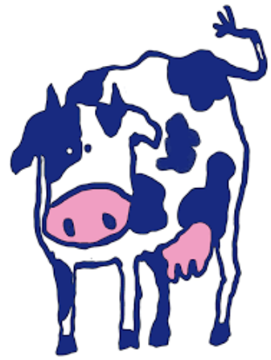

Part 2
Directions:
Aligned to the following standards:
FFA.PL-A; FFA.PL-E; FFA.PL-F; FFA.PG-J; FFA.CS-M; FFA.CS-N; CCSS.ELA.SL.9-10.1; CCSS.ELA.SL.9-10.2; CCSS.ELA.RST.9-10.4; CCSS.ELA.9-10.7; CCSS.ELA.RST.9-10.9; MP1; MP2; MP5; MP6; CRP.02; CRP.04; CRP.06; CRP.08
Productive dairy herds rely heavily on the farmer having a solid understanding of the herd genomics and genetics. Genomics and genetics become important because they help to ensure herd health and productivity. Learn about the impact of genetics through the activities below.
Genomics: Looking at all the genes of an organism and how they work together in relation to the growth and development of an organism
Genetics: Looking at the individual genes of an organism
Let’s take a look at genetics! Genetics are analyzed in animal systems, such as a dairy herd, to ensure high-producing, healthy animals. Using google, complete the crossword below to learn important vocabulary for the next activity.

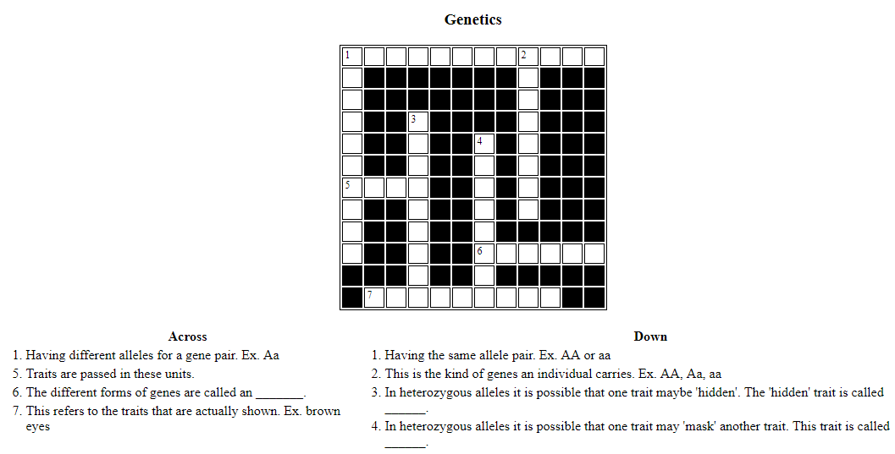

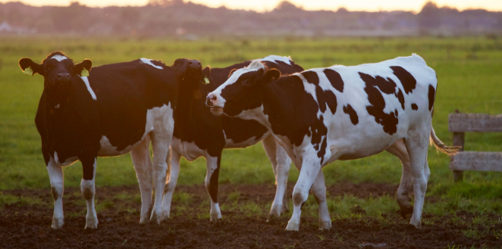
What role do genetics play in our everyday lives?
Using AgExplorer.ffa.org, identify three career focus areas (other than animal science) in which genetics would play a large role.

- ________________________________________________

- ________________________________________________

- ________________________________________________

Part 3
Directions:
Aligned to the following standards:
FFA.PL-A; FFA.PL-E; FFA.PL-F; FFA.PG-J; FFA.CS-M; FFA.CS-N; CCSS.ELA.SL.9-10.1; CCSS.ELA.SL.9-10.2; CCSS.ELA.RST.9-10.4; CCSS.ELA.9-10.7; CCSS.ELA.RST.9-10.9; MP1; MP2; MP5; MP6; CRP.02; CRP.04; CRP.06; CRP.08
In genetics there is a tool called a Punnett Square that can help determine the probable genotypic outcome of offspring. The genotype can then be used to determine the phenotype. Watch the video available at https://youtu.be/d4izVAkhMPQ, or use websites/videos similar to it, and then complete the Punnett square practice below.

- A homozygous purple (RR) flower is being crossed with a heterozygous purple flower (Rr). What color will the potential offspring be? ______________________
Show all work for full credit.

- A heterozygous black bull (Gg) has been crossed with a heterozygous black heifer (Gg). What percentage of the offspring will be black? _______________
What percentage of the offspring will be white? ______________
Show all work for full credit.

- A homozygous black lab (TT) is crossed with a homozygous yellow lab (tt). What percentage of the offspring will be chocolate? _______________________
What percentage of the offspring will be yellow? _________________
Show all work for full credit.

KEY: Dairy Farm
Aligned to the following standards:
FFA.PL-A; FFA.PL-E; FFA.PL-F; FFA.PG-J; FFA.CS-M; FFA.CS-N; CCSS.ELA.SL.9-10.1; CCSS.ELA.SL.9-10.2; CCSS.ELA.RST.9-10.4; CCSS.ELA.9-10.7; CCSS.ELA.RST.9-10.9; MP1; MP2; MP5; MP6; CRP.02; CRP.04; CRP.06; CRP.08
Part 1
Directions:
Read over and answer the questions below while you watch the video “Jared Poldervaart – SAE – Dairy Herd,” available at https://vimeo.com/279310671.

How many cows are on the farm where Jared works?

- 450
- 650
- 850
- 1050

What were the beginning steps Jared took to develop his SAE?

- Getting more involved in the dairy
- Learning the science behind genomic testing and its application to the herd
- Understanding the breeding program

Which of the following was one of Jared’s biggest challenges?

- Transportation to and from the farm
- Understanding herd genomics
- Time management between work and school

What did Jared do in his agriculture class to help him with his SAE?
Agriculture finals – he took his SAE and inserted it into his classroom.
What skills has Jared learned through this SAE?
- Taking samples

- Sending samples to the lab for processing

- Applying results to the herd

What has Jared learned through his SAE?

The science background of the dairy and the application to the herd

Herd genetics are important.

Part 2
Directions:
Aligned to the following standards:
FFA.PL-A; FFA.PL-E; FFA.PL-F; FFA.PG-J; FFA.CS-M; FFA.CS-N; CCSS.ELA.SL.9-10.1; CCSS.ELA.SL.9-10.2; CCSS.ELA.RST.9-10.4; CCSS.ELA.9-10.7; CCSS.ELA.RST.9-10.9; MP1; MP2; MP5; MP6; CRP.02; CRP.04; CRP.06; CRP.08
Productive dairy herds rely heavily on the farmer having a solid understanding of the herd genomics and genetics. Genomics and genetics become important because they help to ensure herd health and productivity. Learn about the impact of genetics through the activities below.
Genomics: Looking at all of the genes of an organism and how they work together in relation to the growth and development of an organism
Genetics: Looking at the individual genes of an organism
Let’s take a look at genetics! Genetics are analyzed in animal systems, such as a dairy herd, to ensure high-producing, healthy animals. Using this Indiana University website, http://www.indiana.edu/~p1013447/dictionary/genterm.htm, complete the crossword below to learn important vocabulary for the next activity.

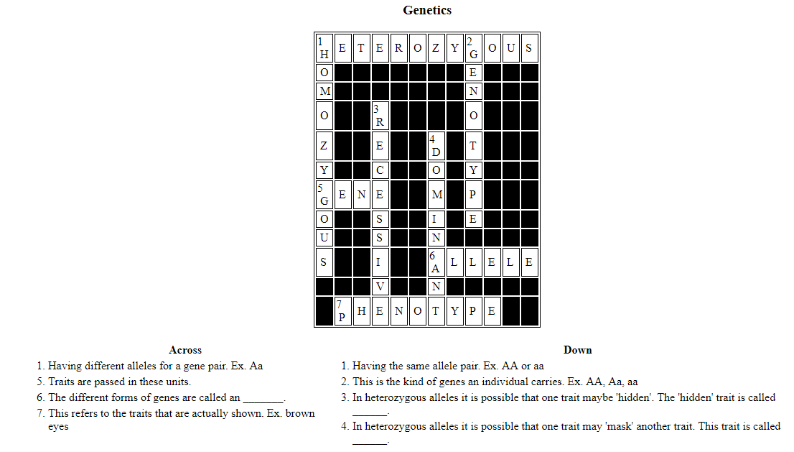
What role do genetics play in our everyday lives? Answers will vary.
Using AgExplorer.ffa.org, identify three career focus areas (other than animal science) in which genetics would play a large role. Answers will vary. Example, plant systems

- ________________________________________________

- ________________________________________________

- ________________________________________________

Part 3
Directions:
Aligned to the following standards:
FFA.PL-A; FFA.PL-E; FFA.PL-F; FFA.PG-J; FFA.CS-M; FFA.CS-N; CCSS.ELA.SL.9-10.1; CCSS.ELA.SL.9-10.2; CCSS.ELA.RST.9-10.4; CCSS.ELA.9-10.7; CCSS.ELA.RST.9-10.9; MP1; .MP2; MP5; MP6; CRP.02; CRP.04; CRP.06; CRP.08
In genetics there is a tool called a Punnett Square that can help determine the probable genotypic outcome of offspring. The genotype can then be used to determine the phenotype. Watch the video available at https://youtu.be/d4izVAkhMPQ, or use websites/videos similar to it, and then complete the Punnett square practice below.

- A homozygous purple (RR) flower is being crossed with a heterozygous purple flower (Rr). What color will the potential offspring be? purple
Show all work for full credit.
R R
r
R
RR | RR
Rr | Rr

- A heterozygous black bull (Gg) has been crossed with a heterozygous black heifer (Gg). What percentage of the offspring will be black? 75%
What percentage of the offspring will be white? 25%
Show all work for full credit.
g
g
G
G  GG | Gg
Gg | gg

- A homozygous black lab (TT) is crossed with a homozygous yellow lab (tt). What percentage of the offspring will be chocolate? 100%
What percentage of the offspring will be yellow? 0%
Show all work for full credit.
t
t
T  Tt | T  Tt
Tt | Tt

