Tractors, Trailers and Trucks ... Oh My!
Directions:
Answer the questions below as you watch the video “Agricultural Mechanics SAE | Jeremiah Hager,” available at https://vimeo.com/377379103.
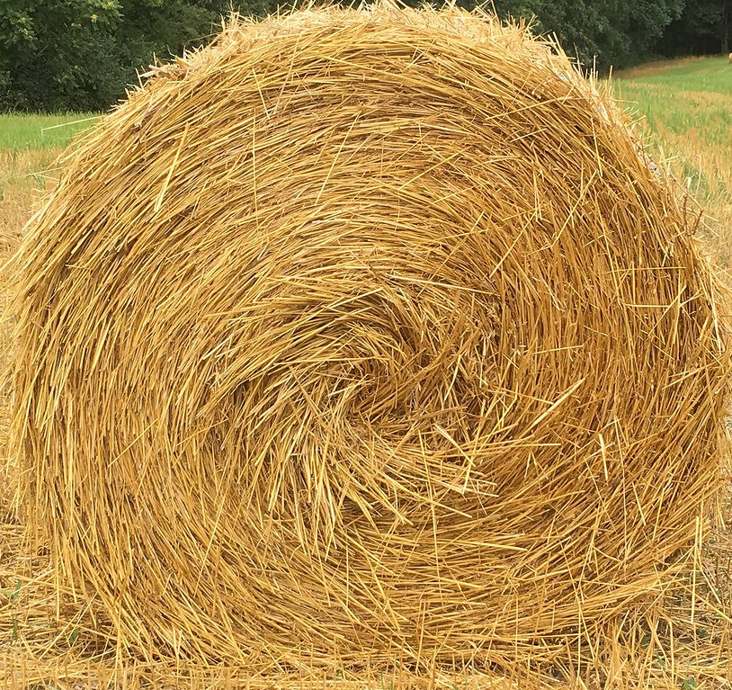
What tools does he use in his business?
How have his family and neighbors helped him with his SAE?

How did Jeremiah’s agriculture background lead him to an SAE in agricultural mechanics?

In his SAE, what types of equipment does Jeremiah work on?


What does he repair on this equipment?


What beginning steps were important for him to be successful in his SAE?

Aligned to the following standards:
PST.04; PL-A.; PG-J.; CCSS.RI.9-10.1; CCSS.SL.9-10.1; CCSS.SL.9-10.4; CCSS.RST.9-10.2; CCSS.RST.9-10.4; CCSS.RST.9-10.9; CRP.02; CRP.04; CRP.07; CRP.08

Engine Breakdown
Aligned to the following standards:
PST.04; PL-A.; PG-J.; CCSS.RI.9-10.1; CCSS.SL.9-10.1; CCSS.SL.9-10.4; CCSS.RST.9-10.2; CCSS.RST.9-10.4; CCSS.RST.9-10.9; CRP.02; CRP.04; CRP.07; CRP.08
Directions:
In his SAE, Jeremiah often has to work on and even rebuild diesel engines. Let’s learn a little more about diesel engines by labeling the parts of an engine and explaining what those components do. The following resources will be helpful as you complete this worksheet:
- “Definition of Terms — Diesel Engines,” https://www.swtc.edu/Ag_Power/diesel_engines/terms.htm
- “Diagram of Diesel Engine,” https://engineeringworkshop.blogspot.com/2009/09/label-diagram-of-diesel-engine.html
- “Diesel Engine,” https://en.wikipedia.org/wiki/Diesel_engine

Complete the table below by explaining the function of each engine part.
Engine Component | Function
Rocker Arm
Pushrod
Cylinder
Fly Wheel
Connecting Rod
Piston
Piston Rings
Crankshaft
Oil Pan
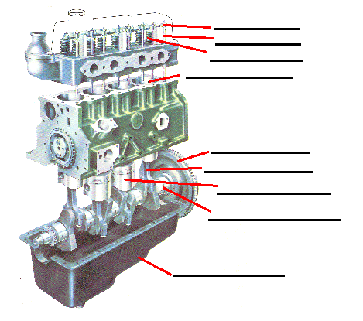

Using the resources listed above, label this diagram of a diesel engine.
How does a diesel engine work?

Careers in Ag Mechanics
Aligned to the following standards:
PST.04; PL-A.; PG-J.; CCSS.RI.9-10.1; CCSS.SL.9-10.1; CCSS.SL.9-10.4; CCSS.RST.9-10.2; CCSS.RST.9-10.4; CCSS.RST.9-10.9; CRP.02; CRP.04; CRP.07; CRP.08
Directions:
Using AgExplorer (AgExplorer.ffa.org), research four careers that are related to agricultural mechanics. (Hint: There are over a dozen careers that will appear when you search for agricultural mechanics.) Compare and contrast the job responsibilities for each of your chosen careers by completing the tasks below.

- Research two careers that are related to agricultural mechanics, and then answer the questions in the boxes below to compare and contrast the job responsibilities of the two careers.

Career 1 ________________________________

and

Career 2 ________________________________
What are similarities that EVERYONE would recognize?

What are similarities that NO ONE would recognize?

Similarities
What are differences that EVERYONE would recognize?

What are differences that NO ONE would recognize?

Differences

- Research two different careers that are related to agricultural mechanics, and then answer the questions in the boxes below to compare and contrast the job responsibilities of the two careers.

Career 3 ________________________________

and

Career 4 ________________________________
What are similarities that EVERYONE would recognize?

What are similarities that NO ONE would recognize?

Similarities
What are differences that EVERYONE would recognize?

What are differences that NO ONE would recognize?

Differences

- Using specific examples from what you learned about the job descriptions of the four careers, write one paragraph explaining which career appeals most to you. Do this on a separate piece of paper.

