Agricultural Mechanics
Created: 07/2020 by the National FFA Organization

Jeremiah Hager’s supervised agricultural experience (SAE) program is in agricultural mechanics, and he works on tractors, skid steers, trucks, trailers and other equipment. Discover how he developed his interests into an SAE that allows him to do what he truly enjoys.

Student Learning Objectives:
After completing these activities, students will …
- Label the most important parts of a diesel engine.
- Describe the function of the main parts of a diesel engine.
- Explain how a diesel engine works.

Time Required: 90 minutes
Resources/References:
- Video: “Agricultural Mechanics SAE | Jeremiah Hager,” https://vimeo.com/377379103
- Glossary: “Definition of Terms — Diesel Engines,” https://www.swtc.edu/Ag_Power/diesel_engines/terms.htm
- Image: “Diagram of Diesel Engine,” https://engineeringworkshop.blogspot.com/2009/09/label-diagram-of-diesel-engine.html
- Website: “Diesel Engine,” https://en.wikipedia.org/wiki/Diesel_engine

Equipment and Supplies Needed:
- A copy of the “Tractors, Trailers and Trucks ... Oh My!” worksheet for each student
- A copy of the “Engine Breakdown” worksheet for each student
- Internet access to play the video in real time or embed it in a PowerPoint ahead of time

Student activity sheets:
Direct access to student activity sheets without lesson plan or answer key for easy upload to learning management system or printing for classwork.
https://ffa.box.com/s/upl2hgezeh0p7ceecnqdlyr22bivcfqi (Word)
https://ffa.box.com/s/j1dftxw469cc5lfu8we9e0bz3lw7up1v (PDF)

Cross-Curricular Connections:
Engineering
Describe the function of the main parts of a diesel engine.

Explain how a diesel engine works.

These activities are aligned to the following standards:

AFNR Performance Element
- PST.04. Plan, build and maintain AFNR structures.
FFA Precept
- FFA.PL-A.Action: Assume responsibility and take the necessary steps to achieve the desired results, no matter what the goal or task at hand.
- FFA.PG-J.Mental Growth: Embrace cognitive and intellectual development relative to reasoning, thinking and coping.
Common Career Technical Core
- AG-PST4 Plan, build, and maintain AFNR structures.
Common Core – Reading: Informational Text
- CCSS.ELA-Literacy.RI.9-10.1 Cite strong and thorough textual evidence to support analysis of what the text says explicitly as well as inferences drawn from the text.
Common Core – Speaking and Listening
- CCSS.ELA-Literacy.SL.9-10.1 Initiate and participate effectively in a range of collaborative discussions (one-on-one, in groups, and teacher-led) with diverse partners on grades 9-10 topics, texts, and issues, building on others' ideas and expressing their own clearly and persuasively.
- CCSS.ELA-Literacy.SL.9-10.4 Present information, findings, and supporting evidence clearly, concisely, and logically such that listeners can follow the line of reasoning and the organization, development, substance, and style are appropriate to purpose, audience, and task.
Common Core – Science & Technical Subjects
- CCSS.ELA-Literacy.RST.9-10.2 Determine the central ideas or conclusions of a text; trace the text's explanation or depiction of a complex process, phenomenon, or concept; provide an accurate summary of the text.
- CCSS.ELA-Literacy.RST.9-10.4 Determine the meaning of symbols, key terms, and other domain-specific words and phrases as they are used in a specific scientific or technical context relevant to grades 9-10 texts and topics.
- CCSS.ELA-Literacy.RST.9-10.9 Compare and contrast findings presented in a text to those from other sources (including their own experiments), noting when the findings support or contradict previous explanations or accounts.
AFNR Career Ready Practices
- CRP.02. Apply appropriate academic and technical skills. Career-ready individuals readily access and use the knowledge and skills acquired through experience and education to be more productive.
- CRP.04. Communicate clearly, effectively, and with reason. Career-ready individuals communicate thoughts, ideas and action plans with clarity, whether using written, verbal and/or visual methods.
- CRP.07. Employ valid and reliable research strategies. Career-ready individuals are discerning in accepting and using new information to make decisions, change practices or inform strategies.
- CRP.08. Utilize critical thinking to make sense of problems and persevere in solving them. Career-ready individuals readily recognize problems in the workplace, understand the nature of the problem, and devise effective plans to solve the problem.
Partnership for 21st Century Skills
- Information Literacy
- Initiative and Self-Direction
- Productivity and Accountability

Lesson Plan:
- Bell Ringer: What do you think an SAE in agricultural mechanics would involve?

- Introduction: Agricultural mechanics covers a broad range of agriculture tasks and industries. Today, we will learn about an FFA member who took his background in agriculture and working alongside his father hauling livestock and turned it into a job where he works on a variety of machinery while continuing to grow his knowledge and skill set.

- Activity: Each student needs a copy of the worksheet “Tractors, Trailers and Trucks ... Oh My!” Students will complete the worksheet as they watch the video “Agricultural Mechanics SAE | Jeremiah Hager,” available at https://vimeo.com/377379103. When students have finished with the video, give each student a copy of the worksheet “Engine Breakdown.” Students will learn some basic information about diesel engines. They will label the main components, describe the function of those components and explain how a diesel engine works.

- Follow-up: Have students share what they found most interesting about Jeremiah’s SAE. Find out which students have experience in agricultural mechanics or know someone who works in that area. Discuss the impact it would have on the agriculture industry if there was suddenly no one skilled in the area of power, structural and technical systems.

- Optional — Extended Learning Opportunities (Not factored into time requirement):
  - Using AgExplorer (AgExplorer.ffa.org), have students research four careers that are related to agricultural mechanics. There are over a dozen careers that will appear when you search for agricultural mechanics. Have students compare and contrast the job responsibilities for each of their chosen careers using the “Careers in Ag Mechanics” worksheet.

- Exit Ticket: List two things you learned about diesel engines today.

Tractors, Trailers and Trucks ... Oh My!
Directions:
Answer the questions below as you watch the video “Agricultural Mechanics SAE | Jeremiah Hager,” available at https://vimeo.com/377379103.
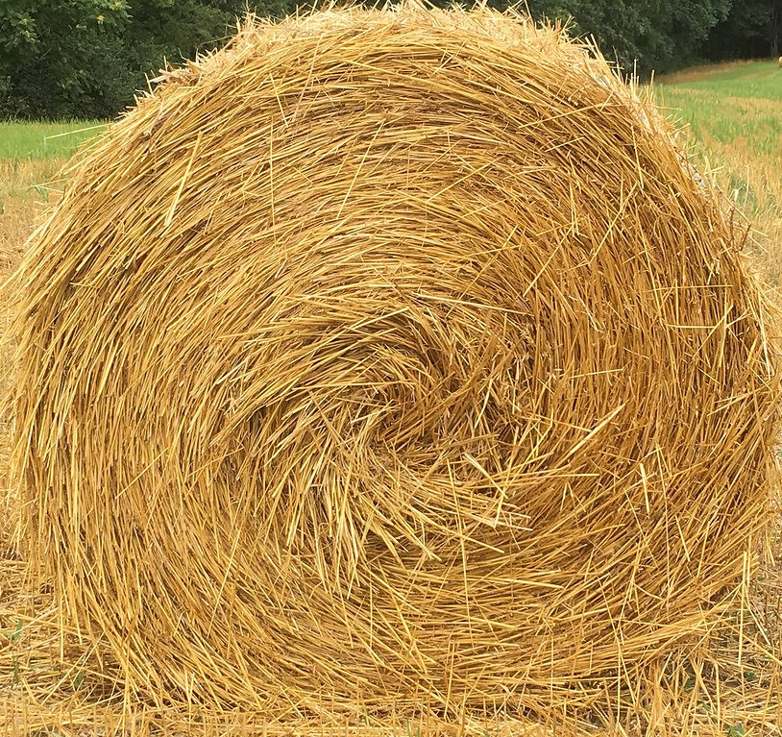
What tools does he use in his business?
How have his family and neighbors helped him with his SAE?

How did Jeremiah’s agriculture background lead him to an SAE in agricultural mechanics?

In his SAE, what types of equipment does Jeremiah work on?


What does he repair on this equipment?


What beginning steps were important for him to be successful in his SAE?

Aligned to the following standards:
PST.04; PL-A.; PG-J.; CCSS.RI.9-10.1; CCSS.SL.9-10.1; CCSS.SL.9-10.4; CCSS.RST.9-10.2; CCSS.RST.9-10.4; CCSS.RST.9-10.9; CRP.02; CRP.04; CRP.07; CRP.08

Engine Breakdown
Aligned to the following standards:
PST.04; PL-A.; PG-J.; CCSS.RI.9-10.1; CCSS.SL.9-10.1; CCSS.SL.9-10.4; CCSS.RST.9-10.2; CCSS.RST.9-10.4; CCSS.RST.9-10.9; CRP.02; CRP.04; CRP.07; CRP.08
Directions:
In his SAE, Jeremiah often has to work on and even rebuild diesel engines. Let’s learn a little more about diesel engines by labeling the parts of an engine and explaining what those components do. The following resources will be helpful as you complete this worksheet:
- “Definition of Terms — Diesel Engines,” https://www.swtc.edu/Ag_Power/diesel_engines/terms.htm
- “Diagram of Diesel Engine,” https://engineeringworkshop.blogspot.com/2009/09/label-diagram-of-diesel-engine.html
- “Diesel Engine,” https://en.wikipedia.org/wiki/Diesel_engine

Complete the table below by explaining the function of each engine part.
Engine Component | Function
Rocker Arm
Pushrod
Cylinder
Fly Wheel
Connecting Rod
Piston
Piston Rings
Crankshaft
Oil Pan
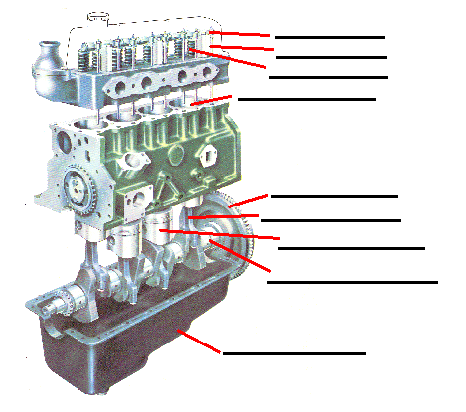

Using the resources listed above, label this diagram of a diesel engine.
How does a diesel engine work?

Careers in Ag Mechanics
Aligned to the following standards:
PST.04; PL-A.; PG-J.; CCSS.RI.9-10.1; CCSS.SL.9-10.1; CCSS.SL.9-10.4; CCSS.RST.9-10.2; CCSS.RST.9-10.4; CCSS.RST.9-10.9; CRP.02; CRP.04; CRP.07; CRP.08
Directions:
Using AgExplorer (AgExplorer.ffa.org), research four careers that are related to agricultural mechanics. (Hint: There are over a dozen careers that will appear when you search for agricultural mechanics.) Compare and contrast the job responsibilities for each of your chosen careers by completing the tasks below.

- Research two careers that are related to agricultural mechanics, and then answer the questions in the boxes below to compare and contrast the job responsibilities of the two careers.

Career 1 ________________________________

and

Career 2 ________________________________
What are similarities that EVERYONE would recognize?

What are similarities that NO ONE would recognize?

Similarities
What are differences that EVERYONE would recognize?

What are differences that NO ONE would recognize?

Differences

- Research two different careers that are related to agricultural mechanics, and then answer the questions in the boxes below to compare and contrast the job responsibilities of the two careers.

Career 3 ________________________________

and

Career 4 ________________________________
What are similarities that EVERYONE would recognize?

What are similarities that NO ONE would recognize?

Similarities
What are differences that EVERYONE would recognize?

What are differences that NO ONE would recognize?

Differences

- Using specific examples from what you learned about the job descriptions of the four careers, write one paragraph explaining which career appeals most to you. Do this on a separate piece of paper.

KEY: Tractors, Trailers and Trucks ... Oh My!
Directions:
Answer the questions below as you watch the video “Agricultural Mechanics SAE | Jeremiah Hager,” available at https://vimeo.com/377379103.
What tools does he use in his business?

Welder

Cutting torch to bend or move steel or fix steel to make a new fender or brush guard
How have his family and neighbors helped him with his SAE?

They have given him resources, including helping him develop his knowledge and skills, providing him with shop space when he needs it and giving him hand-me-down tools.
How did Jeremiah’s agriculture background lead him to an SAE in agricultural mechanics?

He got involved with baling and raking hay when he was little. His family would also haul livestock, so they had to do a lot of truck maintenance. He loved doing that, so he continued to develop his skills. He went from trucks to trailers and tractors, then moved on to engine rebuilds and hydraulic systems.

What beginning steps were important for him to be successful in his SAE?

Gaining knowledge and skill and earning people’s trust
In his SAE, what types of equipment does Jeremiah work on?
skid steers trucks
bush hogs trailers
discs

What does he repair on this equipment?
seals and fuel pumps
hydraulic systems
hoses
rebuilds engines

Aligned to the following standards:
PST.04; PL-A.; PG-J.; CCSS.RI.9-10.1; CCSS.SL.9-10.1; CCSS.SL.9-10.4; CCSS.RST.9-10.2; CCSS.RST.9-10.4; CCSS.RST.9-10.9; CRP.02; CRP.04; CRP.07; CRP.08

KEY: Engine Breakdown
Aligned to the following standards:
PST.04; PL-A.; PG-J.; CCSS.RI.9-10.1; CCSS.SL.9-10.1; CCSS.SL.9-10.4; CCSS.RST.9-10.2; CCSS.RST.9-10.4; CCSS.RST.9-10.9; CRP.02; CRP.04; CRP.07; CRP.08
Directions:
In his SAE, Jeremiah often has to work on and even rebuild diesel engines. Let’s learn a little more about diesel engines by labeling the parts of an engine and explaining what those components do. The following resources will be helpful as you complete this worksheet:
- “Definition of Terms — Diesel Engines,” https://www.swtc.edu/Ag_Power/diesel_engines/terms.htm
- “Diagram of Diesel Engine,” https://engineeringworkshop.blogspot.com/2009/09/label-diagram-of-diesel-engine.html
- “Diesel Engine,” https://en.wikipedia.org/wiki/Diesel_engine

Complete the table below by explaining the function of each engine part.
Engine Component | Function
Rocker Arm | A lever that transmits pushrod motion to valve stem motion
Pushrod | The linkage between the cam and the shorter side of the rocker arm
Cylinder | The piston chamber of an engine
Fly Wheel | An engine component for maintaining rotational inertia of the crankshaft
Connecting Rod | The rod joining the piston with the crankshaft
Piston | A cylindrical plug that slides up and down in the cylinder and is connected to the connecting rod
Piston Rings | Metal rings that form the seal between the piston and cylinder wall
Crankshaft | A rotating shaft for converting rotary motion into linear motion
Oil Pan | The lower section of the crankcase used as a lubricating-oil reservoir on an internal combustion engine.

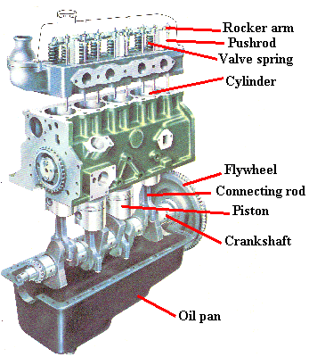
Using the resources listed above, label this diagram of a diesel engine.
How does a diesel engine work?
Diesel engines work by compressing only the air. This increases the air temperature inside the cylinder to such a high degree that atomised diesel fuel injected into the combustion chamber ignites spontaneously. With the fuel being injected into the air just before combustion, the dispersion of the fuel is uneven; this is called a heterogeneous air-fuel mixture. The torque a diesel engine produces is controlled by manipulating the air-fuel ratio; instead of throttling the intake air, the diesel engine relies on altering the amount of fuel that is injected, and the air-fuel ratio is usually high.

