Gone Fishing
Created: 04/2024 by the National FFA Organization
Description of Lesson: Follow Joe Lindberg as he explains his minnow trapping SAE. Then dive deep into the various aspects of the aquaculture and fishery industries and careers within those industries.
Student Learning Objectives:
After completing these activities, students will …
- Examine the components of a minnow trapping SAE.
- Investigate different sectors of the aquaculture and fisheries industry.
- Explore careers related to the aquaculture and fisheries industry.

Suggested Grade Level:
Grades 9 and 10 (This lesson is written so instructors can scale up or down based on class needs.)

Suggested Time: 55-65 minutes (*Time requirements may vary based upon student understanding and class schedule.)
Resources/References:
- Video: “Minnow Trapping SAE | Joe Lindberg,” https://vimeo.com/901201858
- Website: AgExplorer, AgExplorer.FFA.org/
- Website: Florida Department of Agriculture, Sharks Aquaculture Life Training, Ornamental Fish Culture, https://shellfish.ifas.ufl.edu/wp-content/uploads/SALT_FDACS_Ornamental_Fish_Powerpoint-1.pdf
- Website: National Oceanic and Atmospheric Administration, https://www.fisheries.noaa.gov/
- Website: National Geographic Magazine, “How to Farm a Better Fish,” https://www.nationalgeographic.com/foodfeatures/aquaculture/
- Video: “PETRA-AQUA tropical fish wholesale - ABOUT US,” https://youtu.be/cc2fB0aVEJU?feature=shared
- Website: United States Department of Agriculture, “Aquaculture,” https://www.usda.gov/topics/farming/aquaculture
- Video: “What Is Aquaculture and Why Do We Need It?” https://youtu.be/k6U3IgT1lVQ?feature=shared
Equipment and Supplies Needed:
- A copy of the “Gone Fishing” worksheet for each student
- A copy of the “Fish are Friends … AND Food” worksheet for each student
- A copy of the “How Is It All Connected?” worksheet for each student
- A set of Appendices 1-4 for the whole class
- Internet access to play the video in real time or embed it in a PowerPoint ahead of time
- Students devices to access content at each station

Vocabulary:
- Aquaculture
- Biomass
- Feed Conversion Ratio
- Fishery
- Freshwater
- Marine
- Minnow
- Ornamental
- Sustainable

Cross-Curricular Connections:
Science | English/Language Arts | Mathematics
Observe various videos, images, graphs and charts to extract key information. | - Read various texts and summarize key points through various questions.  - Design a concept map connecting different industries, careers and products together. | Find the feed efficiency quotients and percentages for various animals compared to fish.

Virtual Instruction Ideas:
Instructor may post the student activity sheets to an LMS. Students may access the SAE video on their own devices to complete.

Student Activity Sheets:
Direct access to student activity sheets without lesson plan or answer key for easy upload to a learning management system or printing for classwork.

https://ffa.box.com/s/kc0homd47tab3d5ohptf1js7gwo26qkf (Word)
https://ffa.box.com/s/aztr34qa8j67m5o8ofdmoryzop7rnpxu (Non-Designed Word)
https://ffa.box.com/s/odur70ihoinpw7cbdxfmeph6r2quchib (PDF)
https://docs.google.com/document/d/1i_irWdawtYpbtpgJSx0QRw7ttcCKt2TjLBE4emW3BV0/copy (Google)

These Activities Are Aligned to the Following Standards:
AFNR Performance Element
- CS.05: Describe career opportunities and means to achieve those opportunities in each of the Agriculture, Food & Natural Resources career pathways.
FFA Precept
- FFA.PL-A.Action: Assume responsibility and take the necessary steps to achieve the desired results, no matter what the goal or task at hand.
- FFA.PL-C.Vision: Visualize the future and how to get there.
- FFA.PG-I.Professional Growth: Assume responsibility for attaining and improving upon the skills needed for career success.
- FFA.PG-J.Mental Growth: Embrace cognitive and intellectual development relative to reasoning, thinking and coping.
Common Career Technical Core
- AG5: Describe career opportunities and means to achieve those opportunities in each of the Agriculture, Food & Natural Resources career pathways.
AFNR Cluster Skills
- CS.05: Describe career opportunities and means to achieve those opportunities in each of the Agriculture, Food & Natural Resources career pathways.
Common Core – Reading: Informational Text
- CCSS.ELA-Literacy.RI.9-10.2 Determine a central idea of a text and analyze its development over the course of the text, including how it emerges and is shaped and refined by specific details; provide an objective summary of the text.
- CCSS.ELA-Literacy.RI.9-10.4: Determine the meaning of words and phrases as they are used in a text, including figurative, connotative, and technical meanings; analyze the cumulative impact of specific word choices on meaning and tone (e.g., how the language of a court opinion differs from that of a newspaper).
Common Core –Writing
- CCSS.ELA-Literacy.W.9-10.2: Write informative/explanatory texts to examine and convey complex ideas, concepts, and information clearly and accurately through the effective selection, organization, and analysis of content.
Common Core – Speaking and Listening
- CCSS.ELA-Literacy.SL.9-10.2 Integrate multiple sources of information presented in diverse media or formats (e.g., visually, quantitatively, orally) evaluating the credibility and accuracy of each source.
Common Core – Science & Technical Subjects
- CCSS.ELA-Literacy.RST.9.10.4 Determine the meaning of symbols, key terms, and other domain-specific words and phrases as they are used in a specific scientific or technical context relevant to grades 9-10 texts and topics.
Common Core – Math Practices
- CCSS.Math.Practice.MP1: Make sense of problems and persevere in solving them.
- CCSS.Math.Practice.MP2: Reason abstractly and quantitatively.
- CCSS.Math.Practice.MP4: Model with mathematics
- CCSS.Math.Practice.MP6: Attend to precision.
AFNR Career Ready Practices
- CRP.02: Apply appropriate academic and technical skills. Career-ready individuals readily access and use the knowledge and skills acquired through experience and education to be more productive.
- CRP.04: Communicate clearly, effectively, and with reason. Career-ready individuals communicate thoughts, ideas and action plans with clarity, whether using written, verbal and/or visual methods.
- CRP.08: Utilize critical thinking to make sense of problems and persevere in solving them. Career-ready individuals readily recognize problems in the workplace, understand the nature of the problem, and devise effective plans to solve the problem.
- CRP.11. Use technology to enhance productivity. Career-ready individuals find and maximize the productive value of existing and new technology to accomplish workplace tasks and solve workplace problems.
Partnership for 21st Century Skills
- Communication
- Critical Thinking and Problem Solving
- Environmental Literacy
- Global Awareness
- Information, Communications, and Technology Literacy
- Think Creatively

Lesson Plan:
- Bell Ringer: Have you ever wondered where the fish you eat at restaurants or buy at the grocery store come from? How do you think they are raised or caught?

- Introduction: Have you ever been fishing? Fish are a growing sector of protein in people’s diets, and fishing is an increasingly popular recreational activity. It’s a great place to start an SAE and a great career to go into. In the SAE video we’re about to watch, we’ll see a student who is taking advantage of that opportunity and trapping live bait for fishermen in his community.

- Activity 1: Each student needs a copy of the worksheet “Gone Fishing.”
  - Play the video “Minnow Trapping SAE | Joe Lindberg,” available at https://vimeo.com/901201858. Students will watch the video and answer the questions on the student worksheet as they follow along.
- Activity 2: Each student needs a copy of the worksheet “Fish Are Friends … AND Food.”
  - Transition into this activity by saying: In his SAE, Joe used his local lakes and ponds to harvest fish for bait. Did you know there are many uses for fish? Did you also know there are whole industries surrounding the breeding, raising, stocking and catching of fish? The aquaculture industry focuses on breeding and raising fish for many different purposes including food, fishing, medicine, aquariums and more. The fishing industry also focuses on catching primarily marine animals for food. Let’s explore each of those industries a bit more.
  - Split students up into groups and have them visit all four stations below. Allow for seven to 10 minutes per station, depending on your students. They will follow the directions and fill out the appropriate portion of the worksheet at each station.
    - Station 1: What Is Aquaculture? (Appendix 1)
      - Students will watch a video, read over the facts in Appendix 1 and answer the related questions on their worksheets.
    - Station 2: The Fishing Industry (Appendix 2)
      - Students will read over information from the National Oceanic and Atmospheric Administration regarding sustainable fishing and answer the related questions.
    - Station 3: Ornamental Fish and Aquariums (Appendix 3)
      - Students will review the infographic and video provided and answer the related questions.
    - Station 4: Fishy Careers (Appendix 4)
      - Using AgExplorer, students will explore four different careers related to aquaculture and the fishing industry and answer the related questions.

- Follow-up: Each student needs a copy of the worksheet “How Is It All Connected?” Have students draw a concept map illustrating how the different industries and products related to fish and aquatic animals are connected.

- Exit Ticket: Have each student give a one-sentence explanation of one of the connections they made on their concept maps before they leave.

Aligned to the following standards:
CS.05; FFA.PL-A; FFA.PL-C; FFA.PG-I; FFA.PG-J; CCSS.ELA-RI.9-10.2; CCSS.ELA-RI.9-10.4; CCSS.ELA.W.9-10.2; CCSS.ELA.SL.9-10.2; CCSS.ELA.RST.9.10.4; CCSS. MP1; CCSS. MP2; CCSS. MP4; CCSS. MP6; CRP.02; CRP.04; CRP.08; CRP.11
Gone Fishing
Directions:
Answer the questions below as you watch the video “Minnow Trapping SAE | Joe Lindberg,” available at https://vimeo.com/901201858.

- What is Joe’s SAE, and which career pathway is it in?

- What are the steps Joe describes for his SAE?

- How did Joe find his minnow trapping SAE? Who helped him get started?

- How did Joe have to prepare to start his SAE?

- What did Joe say he has learned from his SAE?

- What is Joe’s favorite part of his SAE?

Fish Are Friends … AND Food
Aligned to the following standards:
CS.05; FFA.PL-A; FFA.PL-C; FFA.PG-I; FFA.PG-J; CCSS.ELA-RI.9-10.2; CCSS.ELA-RI.9-10.4; CCSS.ELA.W.9-10.2; CCSS.ELA.SL.9-10.2; CCSS.ELA.RST.9.10.4; CCSS. MP1; CCSS. MP2; CCSS. MP4; CCSS. MP6; CRP.02; CRP.04; CRP.08; CRP.11

Directions:
Visit each of the stations according to your teacher’s directions. As you visit each station, complete the associated activities on this worksheet.

Station 1: What Is Aquaculture?
Directions:
Watch the video at the station and read over the fact sheet. Answer the following questions as you do.

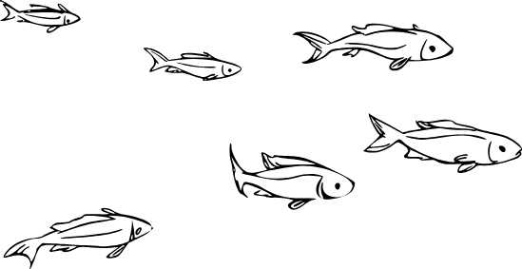
- How is aquaculture described in the video?

- In your own words, summarize why the speaker in the video believes that aquaculture is incredibly important for humanity’s future.

- Explain the two major differences between freshwater aquaculture and marine aquaculture.

- Efficiency can be calculated by taking the output and dividing it by the input. You can calculate the percentage of efficiency by multiplying that quotient by 100.

Output/Input x 100 = Efficiency

Using the values on the fact sheet, calculate the feed conversion efficiency percentage for each of the following species and fill in the table below. Fish is done for you.

Species | Cattle | Pigs | Broiler Chickens | Fish
Output |  |  |  | 1 lb. biomass
Input |  |  |  | 1.1 lbs. feed
Feed Efficiency Quotient |  |  |  | .909
Feed Efficiency Percentage |  |  |  | 90.9%

- What species is the most efficient? Why do you think that is?

Station 2: The Fishing Industry
Directions:
Read over the information sheet at this station and visit the website by scanning the QR code or navigating to the link. Then answer the following questions based on the information you’ve viewed.

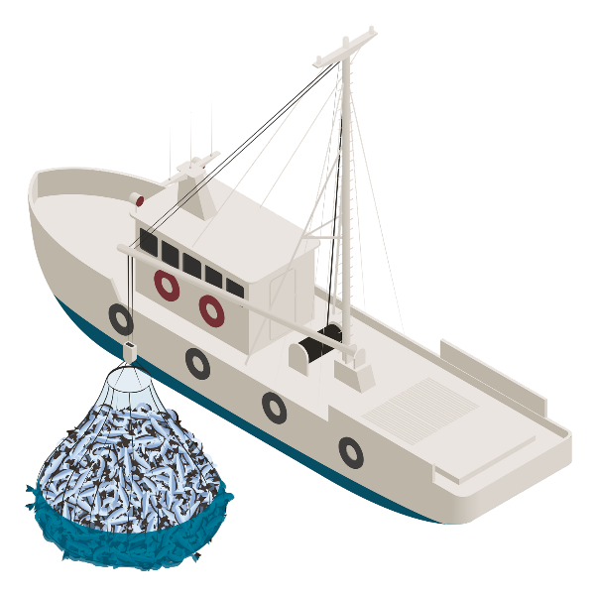
- List the five standards of sustainable seafood in the United States.

- What are the top five species groups by value?

- What was the combined value of all those species in 2020?

- What is the top port for seafood?
  - By pounds?
  - By value?
- Why is it important that the seafood industry be sustainably managed?

Station 3: Ornamental Fish and Aquariums
Directions:
Explore the information on the infographic and watch the video that is linked in order to answer the questions below.

- What do you notice about the percentages of freshwater and saltwater fish that are raised in aquaculture versus wild caught?

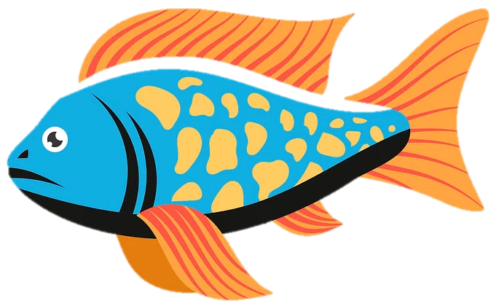

  - Why do you think the percentages are this way?

- Where do most of the imported ornamental fish come from?

  - Why do you think this is?

- List three observations you had about the ornamental aquaculture farm in the video.

Station 4: Fishy Careers
Directions:
Use the QR codes or links at the station to learn about four careers within the aquaculture and fisheries industry. Use the information from AgExplorer (AgExplorer.FFA.org/) to answer the questions below.
- Record the following information about each career.
  - One-sentence summary/description of the career
  - Salary
  - Two typical daily responsibilities
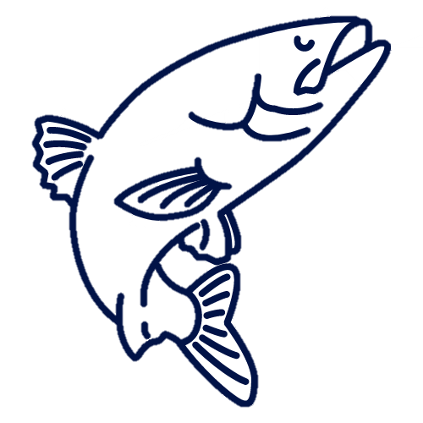
  - Education level or training required
Aquaculturist: | Salary:
One-Sentence Summary:
Typical Daily Responsibilities: | Education/Training Required:
Aquaculture Hatchery Manager: | Salary:
One-Sentence Summary:
Typical Daily Responsibilities: | Education/Training Required:
Fisheries Technician: | Salary:
One-Sentence Summary:
Typical Daily Responsibilities: | Education/Training Required:
Saltwater Husbandry Technician: | Salary:
One-Sentence Summary:
Typical Daily Responsibilities: | Education/Training Required:
How Is It All Connected?
Aligned to the following standards:
CS.05; FFA.PL-A; FFA.PL-C; FFA.PG-I; FFA.PG-J; CCSS.ELA-RI.9-10.2; CCSS.ELA-RI.9-10.4; CCSS.ELA.W.9-10.2; CCSS.ELA.SL.9-10.2; CCSS.ELA.RST.9.10.4; CCSS. MP1; CCSS. MP2; CCSS. MP4; CCSS. MP6; CRP.02; CRP.04; CRP.08; CRP.11

Directions:
Concept maps illustrate relationships between items, ideas or concepts. See below for a brief example.
Ocean

Boats/Ships
Living Things

Harvest from ocean
Coral
Animals
Plants

Military
Amphibians
Mammals

Transportation
Provides home for
Fish

Draw a concept map illustrating how the different industries and products related to fish and aquatic animals are connected to each other. Be sure to include at least two items or ideas from each station.

Aligned to the following standards:
CS.05; FFA.PL-A; FFA.PL-C; FFA.PG-I; FFA.PG-J; CCSS.ELA-RI.9-10.2; CCSS.ELA-RI.9-10.4; CCSS.ELA.W.9-10.2; CCSS.ELA.SL.9-10.2; CCSS.ELA.RST.9.10.4; CCSS. MP1; CCSS. MP2; CCSS. MP4; CCSS. MP6; CRP.02; CRP.04; CRP.08; CRP.11
KEY: Gone Fishing
Directions:
Answer the questions below as you watch the video “Minnow Trapping SAE | Joe Lindberg,” available at https://vimeo.com/901201858.

- What is Joe’s SAE, and which career pathway is it in?

Joe’s SAE is minnow trapping, and it is in the Natural Resources Systems pathway.

- What are the steps Joe describes for his SAE?

- Load up his equipment in his truck.
- Drive to the lake.
- Take the traps out of the water.
- Measure out the minnows.
- Load them into the tanks and transport to the bait shop.

- How did Joe find his minnow trapping SAE? Who helped him get started?

He was in the bait shop and the owner approached him to trap for her. She loaned him some traps and tanks and helped him to get the trapping rights for a few local lakes and ponds.

- How did Joe have to prepare to start his SAE?

He had to begin by researching the game and fish and other wildlife regulations.

- What did Joe say he has learned from his SAE?
- Where the minnows are and where to best set the traps
- How to be intuitive
- Manufacturing specialized tools to help him trap minnows

- What is Joe’s favorite part of his SAE?

He enjoys the interpersonal part of bringing the minnows into the bait shop and getting to interact with the owner and talk with her.
KEY: Fish Are Friends … AND Food
Aligned to the following standards:
CS.05; FFA.PL-A; FFA.PL-C; FFA.PG-I; FFA.PG-J; CCSS.ELA-RI.9-10.2; CCSS.ELA-RI.9-10.4; CCSS.ELA.W.9-10.2; CCSS.ELA.SL.9-10.2; CCSS.ELA.RST.9.10.4; CCSS. MP1; CCSS. MP2; CCSS. MP4; CCSS. MP6; CRP.02; CRP.04; CRP.08; CRP.11
Directions:
Visit each of the stations according to your teacher’s directions. As you visit each station, complete the associated activities on this worksheet.

Station 1: What Is Aquaculture?
Directions:
Watch the video at the station and read over the fact sheet. Answer the following questions as you do.

- How is aquaculture described in the video?

Farming food in the marine environment and freshwater

- In your own words, summarize why the speaker in the video believes that aquaculture is incredibly important for humanity’s future.

Answers will vary.

- Explain the two major differences between freshwater aquaculture and marine aquaculture.
  - Freshwater aquaculture takes place in lakes, ponds and man-made systems; marine aquaculture takes place in oceanic systems.
  - Freshwater aquaculture produces species like catfish, tilapia and trout; marine aquaculture produces species such as oysters, clams, mussels, shrimp and marine fish.
- Efficiency can be calculated by taking the output and dividing it by the input. You can calculate the percentage of efficiency by multiplying that quotient by 100.

Output/Input x 100 = Efficiency

Using the values on the fact sheet, calculate the feed conversion efficiency percentage for each of the following species and fill in the table below. Fish is done for you.

Species | Cattle | Pigs | Broiler Chickens | Fish
Output | 1 lb. biomass | 1 lb. biomass | 1 lb. biomass | 1 lb. biomass
Input | 6.8 lbs. feed | 2.9 lbs. feed | 1.7 lbs. feed | 1.1 lbs. feed
Feed Efficiency Quotient | .147 | .345 | .588 | .909
Feed Efficiency Percentage | 14.7% | 34.5% | 58.8% | 90.9%

- What species is the most efficient? Why do you think that is?

Fish are the most efficient; they require less resources to raise.

Station 2: The Fishing Industry
Directions:
Read over the information sheet at this station and visit the website by scanning the QR code or navigating to the link. Then answer the following questions based on the information you’ve viewed.
- List the five standards of sustainable seafood in the United States:
  - Consider social and economic factors for fishing communities.
  - Prevent overfishing.
  - Rebuild depleted stocks.
  - Minimize bycatch and interactions with protected species.
  - Identify and conserve essential fish habitats.
- What are the top five species groups by value?
  - Crabs; $584 million
  - Lobsters; $563 million
  - Scallops; $488 million
  - Salmon; $478 million
  - Shrimp; $435 million
- What was the combined value of all those species in 2020?
$2.548 billion

- What are the top ports for seafood?
  - By pounds? Dutch Harbor, AK; 763 million pounds
  - By value? New Bedford, MA; $451 million
- Why is it important that the seafood industry be sustainably managed?
It is important to make sure that we are not overfishing and depleting resources so that we can continue to have seafood for future generations and to ensure that species do not go extinct.
Station 3: Ornamental Fish and Aquariums
Directions:
Explore the information on the infographic and watch the video that is linked in order to answer the questions below.

- What do you notice about the percentages of freshwater and saltwater fish that are raised in aquaculture versus wild caught?

Most freshwater ornamentals are farm-raised as opposed to wild caught.
Most saltwater ornamentals are wild caught versus farm-raised.

  - Why do you think the percentages are this way?

Answers will vary but could include that saltwater fish are more difficult
to raise and care for.

- Where do most of the imported ornamental fish come from?
Southeast Asia

  - Why do you think this is?
Answers will vary but could include that that region is the native home to many desirable fish species and that it is less expensive to operate a business in that area of the world.

- List three observations you had about the ornamental aquaculture farm in the video.
  - Answers will vary.
  - Answers will vary.
  - Answers will vary.
Station 4: Fishy Careers
Directions:
Use the QR codes or links at the station to learn about four careers within the aquaculture and fisheries industry. Use the information from AgExplorer (AgExplorer.FFA.org/) to answer the questions below.
- Record the following information about each career.
  - One-sentence summary/description of the career
  - Salary
  - Two typical daily responsibilities
  - Education level or training required
Aquaculturist: | Salary: $57,000
One-Sentence Summary: Answers will vary.
Typical Daily Responsibilities:  - Answers will vary.  - Answers will vary. | Education/Training Required:  A bachelor’s or master’s degree in fisheries science, biological sciences, aquaculture, natural resource management or a related field of study is needed.
Aquaculture Hatchery Manager: | Salary: $60,000
One-Sentence Summary: Answers will vary.
Typical Daily Responsibilities:  - Answers will vary.  - Answers will vary. | Education/Training Required:  Hatchery managers typically have a bachelor’s degree in natural resource management, fisheries science, aquaculture, hatchery management, hatchery maintenance or a related field.
Fisheries Technician: | Salary: $39,000
One-Sentence Summary: Answers will vary.
Typical Daily Responsibilities:  - Answers will vary.  - Answers will vary. | Education/Training Required:  An associate degree in aquaculture, biology, chemistry, natural resource management or agriculture is usually needed.
Saltwater Husbandry Technician: | Salary: $47,000
One-Sentence Summary: Answers will vary.
Typical Daily Responsibilities:  - Answers will vary.  - Answers will vary. | Education/Training Required:  To be a saltwater husbandry technician, a bachelor’s degree or higher is required in ecology, marine biology, animal science, zoology, natural resource management, aquaculture, fisheries science or a related field.

How Is It All Connected?
Aligned to the following standards:
CS.05; FFA.PL-A; FFA.PL-C; FFA.PG-I; FFA.PG-J; CCSS.ELA-RI.9-10.2; CCSS.ELA-RI.9-10.4; CCSS.ELA.W.9-10.2; CCSS.ELA.SL.9-10.2; CCSS.ELA.RST.9.10.4; CCSS. MP1; CCSS. MP2; CCSS. MP4; CCSS. MP6; CRP.02; CRP.04; CRP.08; CRP.11
Directions:
Concept maps illustrate relationships between items, ideas or concepts. See below for a brief example.
Ocean

Boats/Ships
Living Things

Harvest from ocean
Coral
Animals
Plants

Military
Amphibians
Mammals

Transportation
Provides home for
Fish

Draw a concept map illustrating how the different industries and products related to fish and aquatic animals are connected to each other. Be sure to include at least two items or ideas from each station.

Answers will vary.

Appendix 1: What Is Aquaculture?
Directions:
Watch the video “What Is Aquaculture and Why Do We Need It?” either by visiting the link below or scanning the QR code, then answer the related questions.
https://youtu.be/k6U3IgT1lVQ?feature=shared
Next, read over the aquaculture facts on this sheet and answer the related questions.

Aquaculture Facts:

Aquaculture is the production of aquatic organisms under controlled conditions throughout part or all of their life cycle.

There are primarily two types of aquaculture: freshwater aquaculture and marine aquaculture.



Marine aquaculture refers to farming (primarily saltwater-dwelling) species that live in the ocean and estuaries. Species included are oysters, clams, mussels, shrimp and fish like salmon, seas bass, yellowtail and more.
Freshwater aquaculture primarily takes place in lakes, ponds, or man-made systems and tanks and produces species such as catfish, tilapia and trout.

Why Aquaculture? Pounds for Pound:
Different sources of animal protein have different demands on natural resources. One measure of this is the
“feed conversion ratio”: an estimate of the feed required to gain one pound of body mass (biomass).
By this measure, farming salmon is about six times more efficient than raising beef.

 | 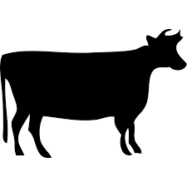  Beef Cattle  (Hereford) | 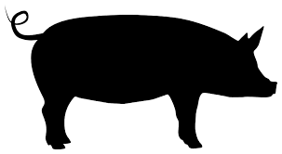  Pigs/Pork | 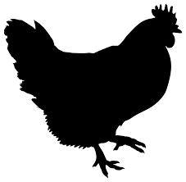  Broiler Chickens | 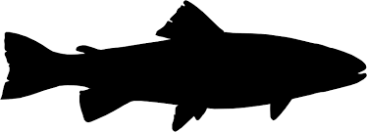  Fish  (Salmon, other species vary)
Pounds of feed needed to produce one pound of body mass for various animals: | 6.8 pounds of feed  per 1 pound of  biomass gain | 2.9 pounds of feed  per 1 pound of  biomass gain | 1.7 pounds of feed  per 1 pound of  biomass gain | 1.1 pounds of feed  per 1 pound of  biomass gain

References:
National Oceanic and Atmospheric Administration, National Ocean Service, “What is Aquaculture,” https://oceanservice.noaa.gov/facts/aquaculture.html#:~:text=Aquaculture%20is%20breeding%2C%20raising%2C%20and,of%20threatened%20or%20endangered%20species
National Geographic Magazine, “How to Farm a Better Fish,” https://www.nationalgeographic.com/foodfeatures/aquaculture/
United States Department of Agriculture, “Aquaculture,” https://www.usda.gov/topics/farming/aquaculture
Appendix 2: The Fishing Industry
Directions:
Read over the information below and visit the website by scanning the QR code or navigating to the link. Then answer the questions on your worksheet based on the information you’ve viewed.
Sustainable Seafood:
The United States is really good at making sure the seafood we catch and farm is sustainable. That means our fishermen follow very intentional and strict rules to protect the environment and the marine populations we are fishing.
We keep a close eye on our oceans to see if we're catching too many fish. If we notice overfishing, we take action fast to fix it. By doing this, we’re able to responsibly manage our fishing industry. Right now, over 90% of the fish stocks we watch are not being overfished.
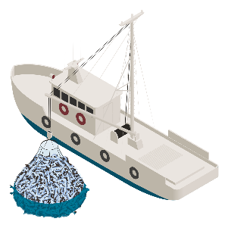
Some of the standards that all U.S. seafood must adhere to are as follows:

Prevent Overfishing:
Steps are being taken to monitor fish populations and regulate fishing endeavors to ensure that we are not depleting the ocean of fish and giving ample time to reproduce and repopulate.
Consider Social and Economic Factors for Fishing Communities:
Considering how the fishing industry will benefit or otherwise affect the local economy, the workforce and community institutions

Rebuild Depleted Stocks:
The fishing industry is also working to help populations replenish by different means such as pausing fishing, decreasing the amount of fishing, and breeding and raising fish to restock
wild populations and more.
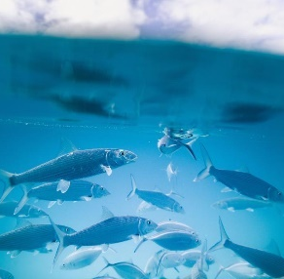
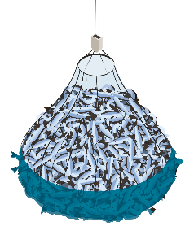
Minimize Bycatch and Interactions with Protected Species:
Bycatch is the unintended catching of fish or other aquatic creatures in the process of catching the target species while fishing. Fishermen are consistently working on doing their best to only catch the species they are targeting and to leave other species alone.


Identify and Conserve Essential Fish Habitats:
The fishing industry is also working to responsibly interact with fish habitats. Different fishing methods are used to help mitigate the destruction of habitats and efforts are being made to protect and revitalize fish habitats.

References:
National Oceanic and Atmospheric Administration, Sustainable Seafood: Understanding Sustainable Seafood, https://www.fisheries.noaa.gov/topic/sustainable-seafood/understanding-sustainable-seafood

Fisheries of the United States Infographics:
Scan the QR code or visit the link below to view a couple of infographics from the National Oceanic and Atmospheric Administration about the commercial fishing and seafood industry in the United States.
https://www.fisheries.noaa.gov/national/sustainable-fisheries/fisheries-united-states
Appendix 3: Ornamental Fish and Aquariums
Directions:
Explore the information on the infographic below and watch the video that is linked in order to answer the questions on your worksheet.

Where do ornamental aquarium fish come from?

Saltwater Fish
Freshwater Fish

5% Aquacultured
95% Wild Capture
10% Wild Capture
90% Aquacultured



Ornamental Aquaculture Farm:
Watch this video to virtually visit ornamental aquaculture facilities!
https://youtu.be/cc2fB0aVEJU?feature=shared

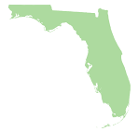
References:
Florida Department of Agriculture, Sharks Aquaculture Life Training, Ornamental Fish Culture,
https://shellfish.ifas.ufl.edu/wp-content/uploads/SALT_FDACS_Ornamental_Fish_Powerpoint-1.pdf
Florida is the top producer of ornamental aquaculture products in the United States with 95% of ornamentals produced in the U.S. coming from there.
Appendix 4: Fishy Jobs
Directions:

Use the QR codes or links below to learn about four careers within the aquaculture and fisheries industry. Use the information from AgExplorer to answer the questions on your worksheet.
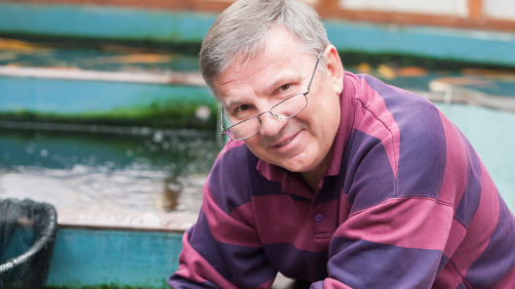
Aquaculturist
Overview: Aquaculturists understand the growth, development and production of aquatic animals. Aquaculturists work to bring a variety of healthy fish, lobsters, crabs and more from aquatic environments to our dinner tables. Additionally, they collect and record growth, production and environmental data and perform routine maintenance of equipment.
AgExplorer.FFA.org/career/aquaculturist/
Salary: $57,000

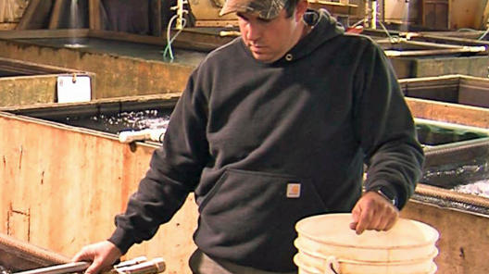
Aquaculture Hatchery Manager
Overview: Hatchery managers oversee all aspects of an aquaculture hatchery, including the management of personnel, fish, infrastructure and equipment. Additionally, they meet with federal and state officials to establish priorities for fish production and coordinate research projects. A hatchery manager’s main roles include supervision and training of farm and ground
staff to ensure all maintenance, health, and safety
AgExplorer.FFA.org/career/aquaculture-hatchery-manager/
and service standards are maintained and
financial objectives are achieved.


Salary: $60,000

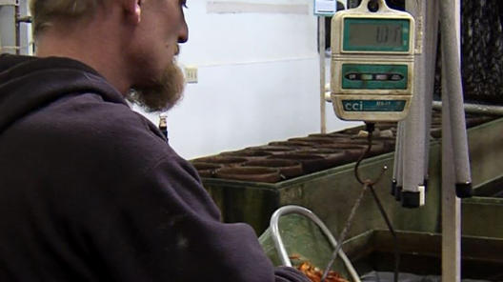
Fisheries Technician
Overview: Fisheries technicians oversee and assist in the daily work completed at a fishery. They ensure fish are healthy, properly housed and fed and are responsible for general maintenance around the facility. Additionally, they assist biologists and technicians in various natural resource management practices or research activities.
AgExplorer.FFA.org/
career/fisheries-technician/


Salary: $39,000

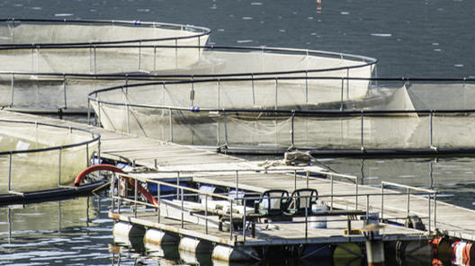
Saltwater Husbandry Technician
Overview: Saltwater husbandry technicians are responsible for general farm operations including the feeding and care of fish grown in a saltwater habitat. Their duties require them to test and maintain saltwater levels and feeding techniques to promote optimal growth of saltwater fish.

Salary: $47,000
AgExplorer.FFA.org/
career/saltwater-husbandry-technician/

