John Deere Dealership Career Exploration
Created: 06/2025 by the National FFA Organization
Description of Lesson: This multi-activity lesson introduces students to a variety of careers within John Deere dealerships, emphasizing customer and product support roles. Through interactive exploration, students will deepen their understanding of dealership operations and reflect on potential career pathways.
Student Learning Objectives:
After completing these activities, students will …
- Explore dealership careers using AgExplorer.
- Identify personal strengths and align them with specific customer and product support roles.
- Create a realistic representation of a career through a “Day in the Life” vlog.
- Advocate for a chosen career.
- Reflect on which career path fits best and plan next steps.

Suggested Grade Level:
Grades 9 and 10 (This lesson is written so instructors can scale up or down based on class needs.)

Suggested Time: 90 minutes (*Time requirements may vary based upon student understanding and class schedule.)
Resources/References:
- Website, John Deere Dealership Careers, https://www.deere.com/en/our-company/john-deere-careers/dealership-jobs/

Related Resources:
- Careers in Power, Structural and Technical Systems, https://FFA.box.com/v/careersinPSTsystems

Equipment and Supplies Needed:
- A copy of the “Green Collar Careers” worksheet for each student
- Internet access
- Phone or camera
Vocabulary:
- Dealership career
- Power, Structural and Technical Systems
- Vlog
Cross-Curricular Connections:
English/Language Arts | Technology
- Research careers and complete a career profile. | - Explore the different roles within Power, Structural and Technical Systems.  - Create a “day in the life” vlog.
SAE and FFA Connections
- Agricultural Technology and Mechanical Systems CDE, FFA.org/participate/cdes/agricultural-technology/
- SAE Idea Cards, https://FFA.box.com/s/0j0438zo941eymcncgpqabh5iqzzlrpg
Student Activity Sheets:
Direct access to student activity sheets without lesson plan or answer key for easy upload to a learning management system or printing for classwork.

https://ffa.box.com/s/dkpk3pn51bpbqly5f9b0l1s18wwbxb1q (Word)
https://ffa.box.com/s/0a74ww4goaiztnuhkiji9cvzwgdaxy7e (PDF)
https://docs.google.com/document/d/1w0EQCtoLz_ByfaZyucIaNTc_hyrx8G_yqNr-RPRI-vo/copy (Google)

These Activities Are Aligned to the Following Standards:
FFA Precept
- FFA.PL-A.Action: Assume responsibility and take the necessary steps to achieve the desired results, no matter what the goal or task at hand.
- FFA.PL-C.Vision: Visualize the future and how to get there.
- FFA.PL-E.Awareness: Understand personal vision, mission and goals.
- FFA.PL-F.Continuous Improvement: Accept responsibility for learning and personal growth.
- FFA.PG-I.Professional Growth: Assume responsibility for attaining and improving upon the skills needed for career success.
- FFA.PG-J.Mental Growth: Embrace cognitive and intellectual development relative to reasoning, thinking and coping.
- FFA.CS-M.Communication: Effectively interact with others in personal and professional settings.
- FFA.CS-N.Decision Making: Analyze a situation and execute an appropriate course of action.
Common Career Technical Core
- AG5 Describe career opportunities and means to achieve those opportunities in each of the Agriculture, Food & Natural Resources Career Pathways.
NASDCTEc
- AGC09.02 Select, research and examine critical aspects of career opportunities in one or more AFNR career pathways in order to gain an understanding of the breadth of occupations within this cluster.
AFNR Cluster Skills
- CS.05. Describe career opportunities and means to achieve those opportunities in each of the Agriculture, Food & Natural Resources career pathways.
Common Core – Speaking and Listening
- CCSS.ELA-Literacy.SL.9-10.1 Initiate and participate effectively in a range of collaborative discussions (one-on-one, in groups, and teacher-led) with diverse partners on grades 9-10 topics, texts, and issues, building on others' ideas and expressing their own clearly and persuasively.
- CCSS.ELA-Literacy.SL.9-10.2 Integrate multiple sources of information presented in diverse media or formats (e.g., visually, quantitatively, orally) evaluating the credibility and accuracy of each source.
AFNR Career Ready Practices
- CRP.04. Communicate clearly, effectively, and with reason. Career-ready individuals communicate thoughts, ideas and action plans with clarity, whether using written, verbal and/or visual methods.
- CRP.07. Employ valid and reliable research strategies. Career-ready individuals are discerning in accepting and using new information to make decisions, change practices or inform strategies.
- CRP.08. Utilize critical thinking to make sense of problems and persevere in solving them. Career-ready individuals readily recognize problems in the workplace, understand the nature of the problem, and devise effective plans to solve the problem.
- CRP.10. Plan education and career path aligned to personal goals. Career-ready individuals take personal ownership of their own educational and career goals, and they are regularly act on a plan to attain these goals.
Partnership for 21st Century Skills
- Communication
- Critical Thinking and Problem Solving
- Initiative and Self-direction
- Leadership and Responsibility

Lesson Plan:
- Bell Ringer: What do you think it’s like to work in a John Deere dealership?

- Introduction: In this lesson, we’ll explore the wide range of customer and product support careers available in John Deere dealerships. Whether you're interested in fixing machines, solving tech issues or helping customers get back in the field, there’s a dealership role that matches a variety of interests and skills. By the end of this lesson, you will have a better understanding of how each career contributes to dealership success and which one might be right for you. Let’s dig into the green collar world of John Deere dealerships!

- Activity: Each student needs a copy of the worksheet “Green Collar Careers.”
  - Part 1:
    - Students will go to John Deere’s website, https://about.deere.com/en-us/careers/dealership-careers.
    - Once there, they will click on “start your career search.”
    - Students should choose five careers connected with John Deere dealerships that interest them.
    - They will then complete the chart on their student activity sheets for each career and answer the reflection questions.

  - Part 2: Students will select one career and utilize the rubric to create a “Day in the Life” vlog. They’ll plan their script and simulate the following:
- Their morning routine and job start.
- Four key daily tasks and tools used.
- End-of-day wrap-up and reflection.
Presentations can be shared via video, TikTok, Instagram reels, done live in class, etc.

  - Part 3:
    - Students will enter their selected career into a Career Bracket Battle.
    - In each round, two careers face off with students delivering one- to two-minute persuasive pitches defending why their role is essential to a successful dealership.
    - After each round, the class votes on which role advances.
    - The battle continues until the “Most Essential Dealership Career” is crowned.
    - When done, students will answer the reflection questions.
    - *Note: If you have more than 12 students in your class, you will have to expand the bracket or have careers face off to make it into the bracket of 12 careers.

- Optional – Extended Learning Opportunities (Not factored into time requirement):
  - Invite a guest speaker from a local John Deere dealership (service manager, technician, precision ag support, etc.) to speak about their career path and daily responsibilities. Or, organize a field trip to a local dealership so students can see customer and product support careers in action.

- Exit Ticket: Which dealership career did you connect with most today, and what’s one thing you can do this year to learn more about it?

Green Collar Careers
Aligned to the following standards:
NRS.01; AGPE01.01; CCSS.RI.9-10.3; CCSS.SL.9-10.1; RST.9.10.1; RST.9.10.2; RST.9.10.4; RST.9.10.5; RST.9.10.9; RST.9.10.10; WHST.9.10.7; WHST.9.10.9; MP3; MP6; AG-NR2; HS-LS2-6; HS-LS2-7
Part 1
Directions:
- Go to John Deere’s website, https://about.deere.com/en-us/careers/dealership-careers.
- Click on the “start your career search.”
- Choose five careers connected with John Deere dealerships that interest you.
- Complete the chart below for each career.

Career | Location | Job Responsibilities | Compensation | Why This Career Interests Me | What Role Does This Career Play in the Company?

Reflection Questions:

- Which career did you find most interesting and why?

- What three skills do you already have that would help you in one of these careers?

Part 2
Directions:
Choose one of the five careers from Part 1 and plan a video that showcases a day on the job. Use the prompts and rubric below to outline your content.
Career Selected: ______________________________________

Scene/Description | What You’ll Say/Show | Props or Actions
Morning Routine
Arriving to Work and Setup
Task 1:
Task 2:
Task 3:
Task 4:
Wrap-up and Reflection

“Day in the Life” Video Rubric
Area | 4 Points | 3 Points | 2 Points | 1 Point
Content | All content is accurate. There are no factual errors. | Most of the content is accurate, but there is one piece of information that seems inaccurate. | The content is generally accurate, but one piece of information is clearly inaccurate. | Content is confusing or contains more than one factual error.
Clarity and Creativity | The video is easy to understand, and all elements are clearly written or spoken. Creativity was used. | The video is easy to understand, and most elements are clearly written or spoken. Some creativity was used. | The video is hard to understand with very quiet speaking or very hard to read writing. Little creativity was used. | The video is hard to understand, and one cannot follow the thought process. No creativity was used.
Narration and Preparedness | The video is clearly rehearsed and presented with no mistakes.  Student spoke slowly and clearly. | One mistake is heard in the video. | Two mistakes are heard in the video. | Three or more mistakes are heard in the video.  Student spoke very fast and was unclear.
Time | Student stayed in the two- to three-minute time frame. |  |  | Student was either under or over the allotted time frame.
Total: _____________
Comments:

___________________________________________________________________________________________________

___________________________________________________________________________________________________

___________________________________________________________________________________________________

___________________________________________________________________________________________________

___________________________________________________________________________________________________

___________________________________________________________________________________________________

___________________________________________________________________________________________________

___________________________________________________________________________________________________

Part 3
Directions:
Prepare a one- to two-minute speech to persuade your classmates that your chosen career is the most essential dealership role. Fill in the bracket below as your classmates debate until you find the most essential dealership role.
Career: ______________________
Speech Planning:
- Opening Hook:
How will you grab attention?

- Main Argument 1:
What makes this role vital to dealership success?

- Main Argument 2:
How does this role support customers or the team?

- Closing Statement:
Why should this role win the bracket?

ROUND 2
ROUND 3

ROUND 4

ROUND 1

Reflection Questions:

- Which career won the bracket? Do you agree with the class’s final choice? Why or why not?

- Whose pitch (besides your own) stood out the most to you? What made it persuasive or memorable?

- What did you learn about dealership careers that surprised you?

- If you had to pick a dealership career to shadow for one day, which would you choose and what would you hope to learn or experience during that day?

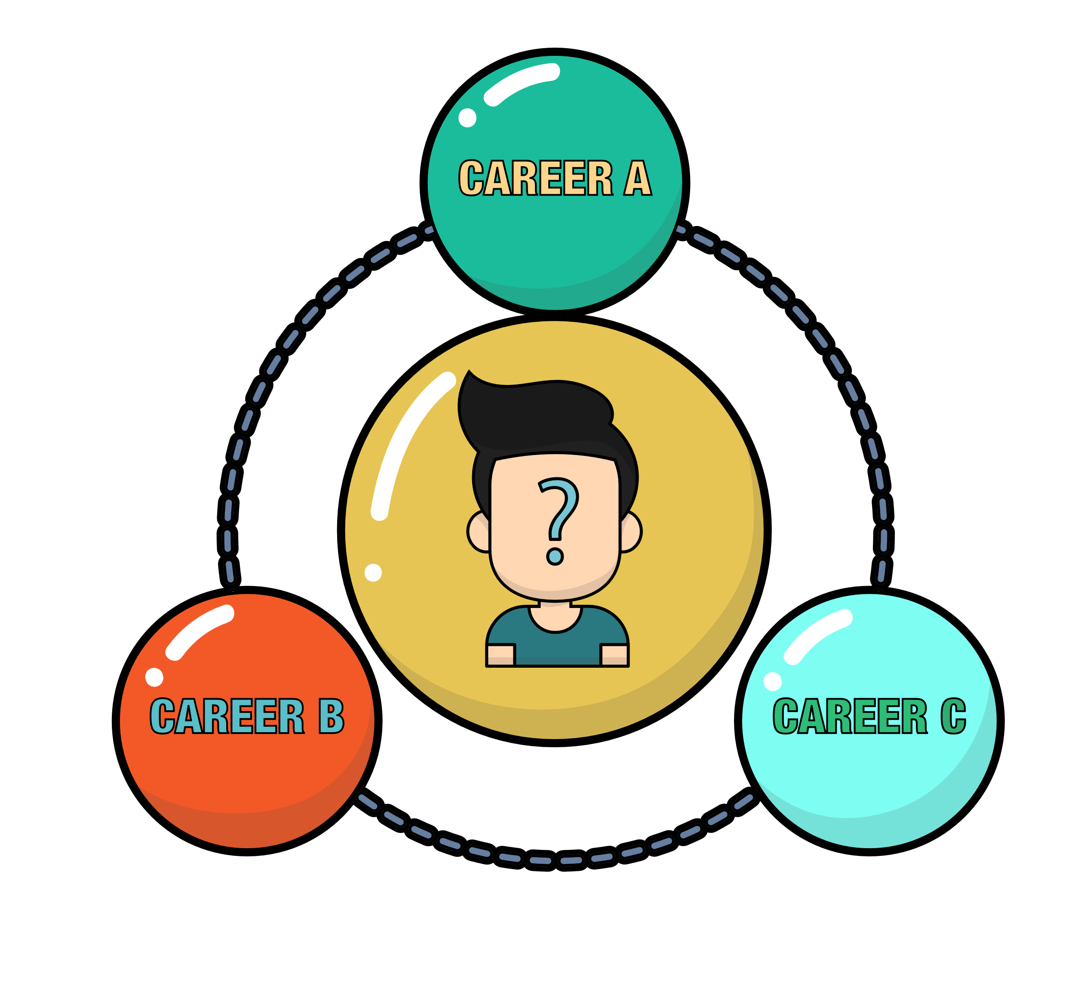
- What is your next step to prepare for a future career?

KEY: Green Collar Careers
Part 1
Directions:
- Go to John Deere’s website, https://about.deere.com/en-us/careers/dealership-careers.
- Click on the “start your career search.”
- Choose five careers connected with John Deere dealerships that interest you.
- Complete the chart below for each career.

Career | Location | Job Responsibilities | Compensation | Why This Career Interests Me
Answers will vary. | Answers will vary. | Answers will vary. | Answers will vary. | Answers will vary.
Answers will vary. | Answers will vary. | Answers will vary. | Answers will vary. | Answers will vary.
Answers will vary. | Answers will vary. | Answers will vary. | Answers will vary. | Answers will vary.
Answers will vary. | Answers will vary. | Answers will vary. | Answers will vary. | Answers will vary.
Answers will vary. | Answers will vary. | Answers will vary. | Answers will vary. | Answers will vary.

Reflection Questions:

- Which career did you find most interesting and why?
Answers will vary.
- What three skills do you already have that would help you in one of these careers?
Answers will vary.
Part 2
Directions:
Choose one of the five careers from Part 1 and plan a video that showcases a day on the job. Use the prompts and rubric below to outline your content.
Career Selected: _____ Answers will vary. _________________________________

Scene/Description | What You’ll Say/Show | Props or Actions
Morning Routine | Answers will vary. | Answers will vary.
Arriving to Work and Setup | Answers will vary. | Answers will vary.
Task 1: Answers will vary. | Answers will vary. | Answers will vary.
Task 2: Answers will vary. | Answers will vary. | Answers will vary.
Task 3: Answers will vary. | Answers will vary. | Answers will vary.
Task 4: Answers will vary. | Answers will vary. | Answers will vary.
Wrap-up and Reflection | Answers will vary. | Answers will vary.

“Day in the Life” Video Rubric
Area | 4 Points | 3 Points | 2 Points | 1 Point
Content | All content is accurate. There are no factual errors. | Most of the content is accurate, but there is one piece of information that seems inaccurate. | The content is generally accurate, but one piece of information is clearly inaccurate. | Content is confusing or contains more than one factual error.
Clarity and Creativity | The video is easy to understand, and all elements are clearly written or spoken. Creativity was used. | The video is easy to understand, and most elements are clearly written or spoken. Some creativity was used. | The video is hard to understand with very quiet speaking or very hard to read writing. Little creativity was used. | The video is hard to understand, and one cannot follow the thought process. No creativity was used.
Narration and Preparedness | The video is clearly rehearsed and presented with no mistakes.  Student spoke slowly and clearly. | One mistake is heard in the video. | Two mistakes are heard in the video. | Three or more mistakes are heard in the video.  Student spoke very fast and was unclear.
Time | Student stayed in the two- to three-minute time frame. |  |  | Student was either under or over the allotted time frame.
Total: _____________
Comments:

___________________________________________________________________________________________________

___________________________________________________________________________________________________

___________________________________________________________________________________________________

___________________________________________________________________________________________________

___________________________________________________________________________________________________

___________________________________________________________________________________________________

___________________________________________________________________________________________________

___________________________________________________________________________________________________

Part 3
Directions:
Prepare a one- to two-minute speech to persuade your classmates that your chosen career is the most essential dealership role. Fill in the bracket below as your classmates debate until you find the most essential dealership role.

Career: ____ Answers will vary. __________________
Speech Planning:
- Opening Hook:
How will you grab attention?

Answers will vary.

- Main Argument 1:
What makes this role vital to dealership success?

Answers will vary.

- Main Argument 2:
How does this role support customers or the team?

Answers will vary.

- Closing Statement:
Why should this role win the bracket?

Answers will vary.

ROUND 2
ROUND 3

ROUND 4

ROUND 1

Reflection Questions:

- Which career won the bracket? Do you agree with the class’s final choice? Why or why not?

Answers will vary.

- Whose pitch (besides your own) stood out the most to you? What made it persuasive or memorable?

Answers will vary.

- What did you learn about dealership careers that surprised you?

Answers will vary.

- If you had to pick a dealership career to shadow for one day, which would you choose and what would you hope to learn or experience during that day?

Answers will vary.

- What is your next step to prepare for a future career?

Answers will vary.

