Prunes
Aligned to the following standards:
CS.01; FFA.PL-A; FFA.PL-E; FFA.PG-J; FFA.CS-N; AG1; AGC02.02; CCSS.ELA.RI.9-10.2; CCSS.ELA.RI.9-10.4; CCSS.ELA.SL.9-10.2; CCSS.ELA.WHST.9.10.4; MP1; MP5; MP6; CRP.02; CRP.04; CRP.05; CRP.06; CRP.08
Directions:
Read over and answer the questions below while you watch the video “John Zuppan – SAE – Prune Orchard,” available at https://vimeo.com/289989630.


Identify three tasks John needs to complete for his SAE. Record one item on each of the lines of this task list.
Which of the following was John’s biggest challenge?

- Learning to complete the necessary tasks needed to maintain the orchard
- Deciding what variety of trees to plant
- Time management
- Communication skills

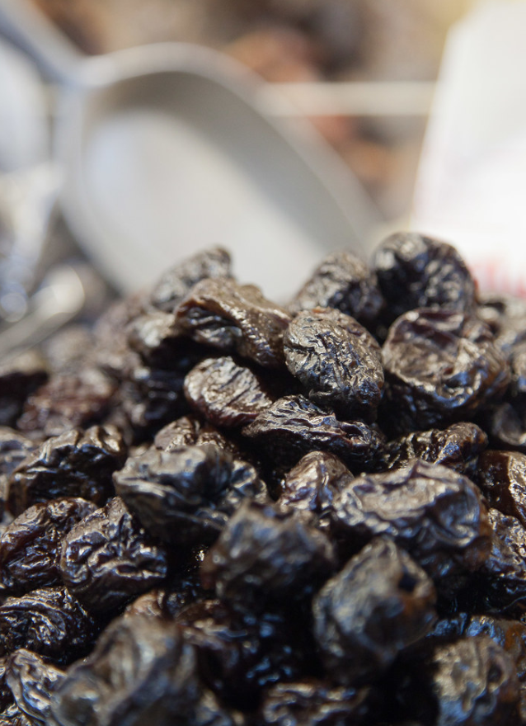

What did John participate in through class and FFA that has helped to better equip him to be successful in his chosen SAE?

___________________________________________

Directions:
Using the California Dried Plums website, https://www.californiadriedplums.org/about-prunes-and-dried-plums/history, develop a timeline with pictures to represent the dried plum’s development. (Hint: There should be a minimum of 9 points.) Include a picture for each moment on your timeline.

Trivia!
Aligned to the following standards:
CS.01; FFA.PL-A; FFA.PL-E; FFA.PG-J; FFA.CS-N; AG1; AGC02.02; CCSS.ELA.RI.9-10.2; CCSS.ELA.RI.9-10.4; CCSS.ELA.SL.9-10.2; CCSS.ELA.WHST.9.10.4; MP1; MP5; MP6; CRP.02; CRP.04; CRP.05; CRP.06; CRP.08
Directions:
Using the California Dried Prunes FAQs, https://www.californiadriedplums.org/about-prunes-and-dried-plums/faq, complete the following crossword puzzle.
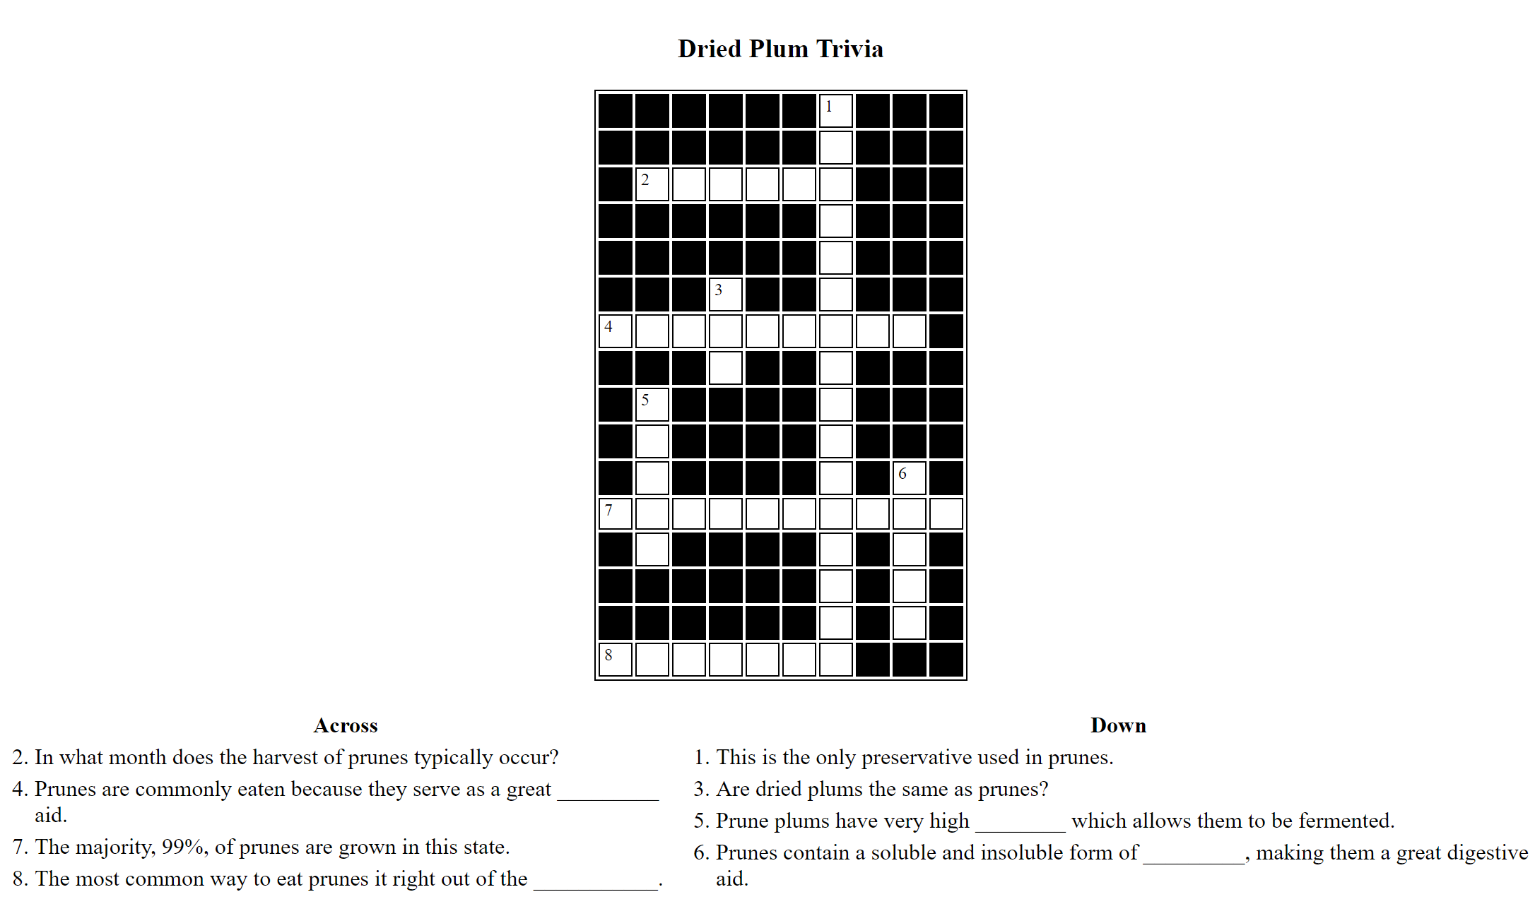
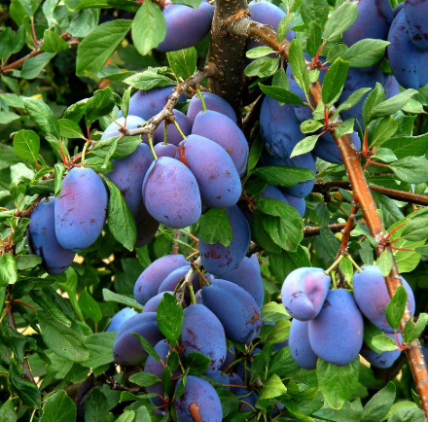
Why do you think many consumers are unfamiliar with prunes and their production?
What would be a way to help consumers have a better understanding of prunes?
Production
Aligned to the following standards:
CS.01; FFA.PL-A; FFA.PL-E; FFA.PG-J; FFA.CS-N; AG1; AGC02.02; CCSS.ELA.RI.9-10.2; CCSS.ELA.RI.9-10.4; CCSS.ELA.SL.9-10.2; CCSS.ELA.WHST.9.10.4; MP1; MP5; MP6; CRP.02; CRP.04; CRP.05; CRP.06; CRP.08
Directions:
Using the information available at https://www.californiadriedplums.org/about-prunes-and-dried-plums/growing-and-harvesting, develop a flow chart using pictures and minimal words that depicts the prune production process. See the example below of what a flow chart can look like.
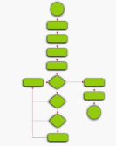

Prunes and Nutrition
Aligned to the following standards:
CS.01; FFA.PL-A; FFA.PL-E; FFA.PG-J; FFA.CS-N; AG1; AGC02.02; CCSS.ELA.RI.9-10.2; CCSS.ELA.RI.9-10.4; CCSS.ELA.SL.9-10.2; CCSS.ELA.WHST.9.10.4; MP1; MP5; MP6; CRP.02; CRP.04; CRP.05; CRP.06; CRP.08
Directions:
Now that we have a better understanding of prunes and their production, let’s look at the benefits to you as a consumer. Complete the following activities below to learn about how prunes can fit into your diet each day to make a healthier you. Use the following website to assist you in completing the activities: https://www.californiadriedplums.org/nutrition.
What would a dietitian say about the health benefits of prune consumption?



What would your family say about the health benefits of prune consumption?

Now that better understand the nutrition and health benefits, what would you tell someone about the health benefits of prunes?

Using AgExplorer.ffa.org, determine two career focus areas in which a person in the prune production industry could have a career. Write them on the lines below and include a short description of why you selected that focus area.

- ______________________ -

- ______________________ -
Prunes Every Day
Aligned to the following standards:
CS.01; FFA.PL-A; FFA.PL-E; FFA.PG-J; FFA.CS-N; AG1; AGC02.02; CCSS.ELA.RI.9-10.2; CCSS.ELA.RI.9-10.4; CCSS.ELA.SL.9-10.2; CCSS.ELA.WHST.9.10.4; MP1; MP5; MP6; CRP.02; CRP.04; CRP.05; CRP.06; CRP.08
Directions:
Using what you now know about prunes, let’s take a look at how we can incorporate prunes into our daily diet. Utilizing the two infographics provided, take a recipe you currently love and rewrite the recipe to incorporate prunes.

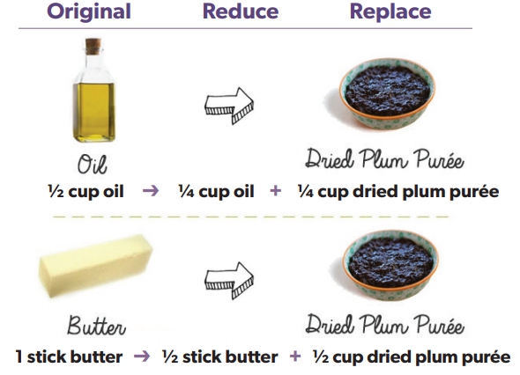
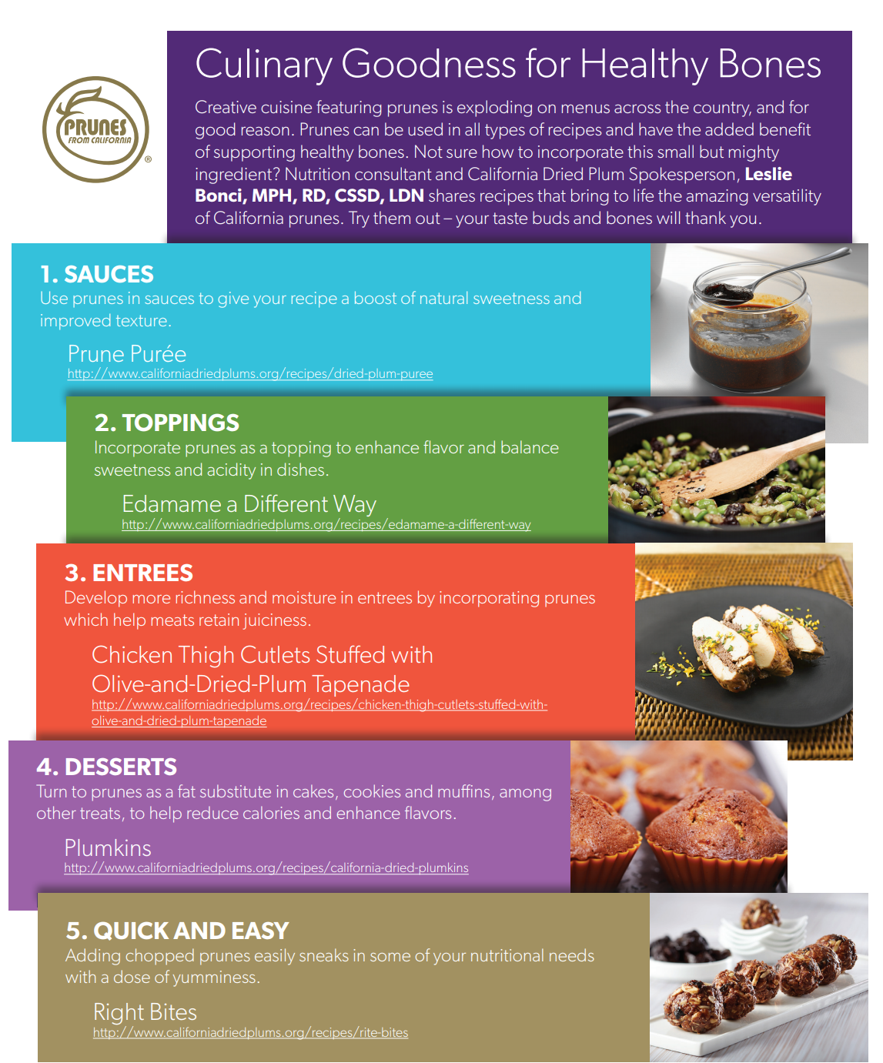
What other types of substitutions can be made in common recipes to make them healthier?
Redesigned Recipe Incorporating Prunes
Original Recipe

