Prune Orchard SAE
Created: 05/2019 by the National FFA Organization

SAE Video Summary: Follow John as he walks us through his supervised agricultural experience (SAE) program as a prune orchard worker. John works to learn the business so he can one day make this a career.
Student Learning Objectives:
After completing these activities, students will …
- Describe a prune orchard SAE.
- Identify the history behind the dried plum industry.
- Illustrate the prune production process.
- Describe how prunes can be used in the daily diet.
- Identify career focus areas that are involved in the prune production process.

Time Required: 120 minutes
Resources:
- “John Zuppan – SAE – Prune Orchard,” https://vimeo.com/289989630.
- Ag Explorer - https://agexplorer.ffa.org/
- California Dried Plums - https://www.californiadriedplums.org/

Equipment and Supplies Needed:
- A copy of the “Prune” worksheet for each student
- A copy of the “Prunes and Nutrition” worksheet for each student
- A copy of the “Trivia!” worksheet for each student.
- A copy of the “Production” worksheet for each student
- A copy of the “Prunes Every Day” worksheet for each student
- Internet access to play the video in real time or embed it in a PowerPoint ahead of time.

This quick lesson plan would work well as Part Of:
- An SAE lesson/unit.
- A plant science lesson.
- A research lesson/unit.
- A food science lesson.

Student Activity Sheets:
Direct access to student activity sheets without lesson plan or answer key for easy upload to learning management systems or printing for classwork.
https://ffa.box.com/s/wlpk5xm34mpenjfv9taek0cnuyu7b2ob (Word)
https://ffa.box.com/s/1aiiflzjgmmxrxz3duiwrpoyv95f4zxm (PDF)
These activities are aligned to the following standards:

AFNR Performance Element
- CS.01: Analyze how issues, trends, technologies and public policies impact systems in the Agriculture, Food & Natural Resources Career Cluster.
FFA Precept
- FFA.PL-A.Action: Assume responsibility and take the necessary steps to achieve the desired results, no matter what the goal or task at hand.
- FFA.PL-E.Awareness: Understand personal vision, mission and goals.
- FFA.PG-J.Mental Growth: Embrace cognitive and intellectual development relative to reasoning, thinking and coping.
- FFA.CS-N.Decision Making: Analyze a situation and execute an appropriate course of action.
Common Career Technical Core
- AG1: Analyze how issues, trends, technologies and public policies impact systems in the Agriculture, Food & Natural Resources Career Cluster.
NASDCTEc
- AGC02.02: Employ the use of technical information effectively to maintain and communicate records and reporting procedures commonly used in the AFNR cluster.
Common Core – Reading: Informational Text
- CCSS.ELA-Literacy.RI.9-10.2: Determine a central idea of a text and analyze its development over the course of the text, including how it emerges and is shaped and refined by specific details; provide an objective summary of the text.
- CCSS.ELA-Literacy.RI.9-10.4: Determine the meaning of words and phrases as they are used in a text, including figurative, connotative, and technical meanings; analyze the cumulative impact of specific word choices on meaning and tone (e.g., how the language of a court opinion differs from that of a newspaper).
Common Core – Speaking and Listening
- CCSS.ELA-Literacy.SL.9-10.2: Integrate multiple sources of information presented in diverse media or formats (e.g., visually, quantitatively, orally) evaluating the credibility and accuracy of each source.
Common Core – Literacy in Science & Technical Subjects: Writing
- CCSS.ELA-Literacy.WHST.9.10.4: Produce clear and coherent writing in which the development, organization, and style are appropriate to task, purpose, and audience.
Common Core – Math Practices
- CCSS.MP1: Make sense of problems and persevere in solving them.
- CCSS.MP5: Use appropriate tools strategically.
- CCSS.MP6: Attend to precision.
AFNR Career Ready Practices
- CRP.02: Apply appropriate academic and technical skills. Career-ready individuals readily access and use the knowledge and skills acquired through experience and education to be more productive.
- CRP.04: Communicate clearly, effectively, and with reason. Career-ready individuals communicate thoughts, ideas and action plans with clarity, whether using written, verbal and/or visual methods.
- CRP.05: Consider the environmental, social and economic impact of decisions. Career-ready individuals understand the interrelated nature of their actions and regularly make decisions that positively impact and/or mitigate negative impact on other people, organizations and the environment.
- CRP.06: Demonstrate creativity and innovation. Career-ready individuals regularly think of ideas that solve problems in new and different ways, and they contribute those ideas in a useful and productive manner to improve their organization.
- CRP.08: Utilize critical thinking to make sense of problems and persevere in solving them. Career-ready individuals readily recognize problems in the workplace, understand the nature of the problem, and devise effective plans to solve the problem.
Partnership for 21st Century Skills
- Critical Thinking and Problem Solving
- Flexibility and Adaptability
- Initiative and Self-Direction
- Leadership and Responsibility
- Think Creatively

Lesson Plan:
- Bell Ringer: On your own paper, create a list of all the words that come to mind when you hear the word “prune.” Have students think-pair-share their lists. Then, have students share their thoughts with the class. Ask students why they came up with the words that they did.

- Introduction: Having a supervised agricultural experience (SAE) program is an integral part agricultural education. Today, we are going to watch a short video depicting one student’s prune orchard SAE. After the video, we will discover more about the history, production and consumption of prunes in the U.S.

- Activity 1: Each student needs a copy of the worksheet “Prunes.” Students will begin by answering the provided questions while watching the video “John Zuppan – SAE – Prune Orchard,” https://vimeo.com/289989630. Next, students will learn about the history behind the prune industry. Students will use the California Dried Plums website, https://www.californiadriedplums.org/about-prunes-and-dried-plums/history, and develop a timeline with pictures to represent the dried plum’s development. There should be a minimum of nine points on the timeline. Students should also include a picture for each moment on their timeline.

Activity 2: After students complete their timelines, they will explore some fun facts about prunes and their production. Each student needs a copy of the worksheet “Trivia!” Using the California Dried Prunes FAQs, https://www.californiadriedplums.org/about-prunes-and-dried-plums/faq, students will complete a crossword about the FAQs provided. Lastly, students will answer the question “Why do you think many consumers are unfamiliar with prunes and their production?” and “What would be a way to help consumers have a better understanding of prunes?” Have students share their answers with the class and discuss why this unfamiliarity may exist.

Activity 3: Each student needs a copy of the worksheet “Production.” Using the information available at https://www.californiadriedplums.org/about-prunes-and-dried-plums/growing-and-harvesting, have students develop a flow chart using pictures and minimal words that depicts the prune production process. When all students have completed their charts, have them compare and share with other students.

Activity 4: Each student needs a copy of the worksheet “Prunes and Nutrition.” Now that students have a better understanding of prunes and their production, have them look at the benefits to them as a consumer. Students should complete the activities to learn about how prunes can fit into their diet each day to make them healthier. Students should use the following website to learn about nutrition: https://www.californiadriedplums.org/nutrition.
Have student begin by reading through the nutritional aspects of prune consumption. Then, have students complete the three prompts and share what they now know about prunes. Students will then use AgExplorer to determine two career focus areas in which people can be employed in the prune production industry. Students will need to explain why they chose the career focus areas that they did. Have students share and compare with their classmates.

Activity 5: Hand out a “Prunes Every Day” worksheet to each student. Students will use what they now know about prunes to look at how they can incorporate prunes into their daily diets. Utilizing the two infographics provided, students will take a recipe they currently love and rewrite the recipe to incorporate prunes.

- Follow-up: Create a recipe “book” to share with the class so that all students have access to the different recipes developed in class.

- Leveling Up: Have students create their new recipes in a food lab. Students should then perform a sensory evaluation of the different products to determine the best product.

- Exit Ticket: What role do prunes play in the agriculture industry?

Prunes
Aligned to the following standards:
CS.01; FFA.PL-A; FFA.PL-E; FFA.PG-J; FFA.CS-N; AG1; AGC02.02; CCSS.ELA.RI.9-10.2; CCSS.ELA.RI.9-10.4; CCSS.ELA.SL.9-10.2; CCSS.ELA.WHST.9.10.4; MP1; MP5; MP6; CRP.02; CRP.04; CRP.05; CRP.06; CRP.08
Directions:
Read over and answer the questions below while you watch the video “John Zuppan – SAE – Prune Orchard,” available at https://vimeo.com/289989630.


Identify three tasks John needs to complete for his SAE. Record one item on each of the lines of this task list.
Which of the following was John’s biggest challenge?

- Learning to complete the necessary tasks needed to maintain the orchard
- Deciding what variety of trees to plant
- Time management
- Communication skills

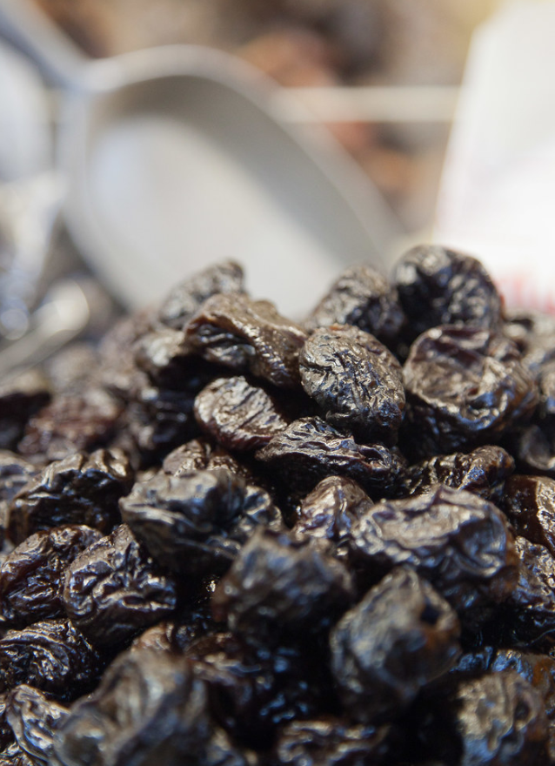

What did John participate in through class and FFA that has helped to better equip him to be successful in his chosen SAE?

___________________________________________

Directions:
Using the California Dried Plums website, https://www.californiadriedplums.org/about-prunes-and-dried-plums/history, develop a timeline with pictures to represent the dried plum’s development. (Hint: There should be a minimum of 9 points.) Include a picture for each moment on your timeline.

Trivia!
Aligned to the following standards:
CS.01; FFA.PL-A; FFA.PL-E; FFA.PG-J; FFA.CS-N; AG1; AGC02.02; CCSS.ELA.RI.9-10.2; CCSS.ELA.RI.9-10.4; CCSS.ELA.SL.9-10.2; CCSS.ELA.WHST.9.10.4; MP1; MP5; MP6; CRP.02; CRP.04; CRP.05; CRP.06; CRP.08
Directions:
Using the California Dried Prunes FAQs, https://www.californiadriedplums.org/about-prunes-and-dried-plums/faq, complete the following crossword puzzle.
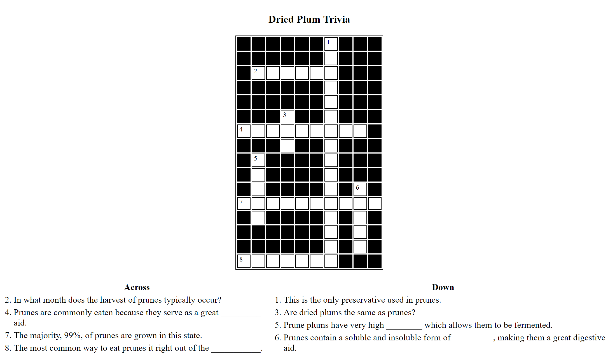
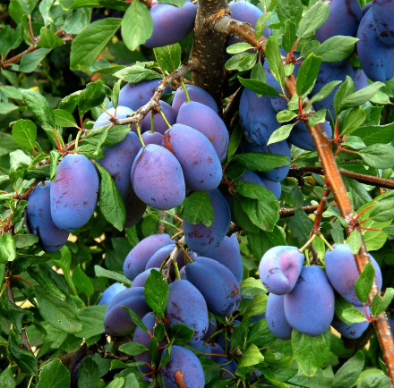
Why do you think many consumers are unfamiliar with prunes and their production?
What would be a way to help consumers have a better understanding of prunes?
Production
Aligned to the following standards:
CS.01; FFA.PL-A; FFA.PL-E; FFA.PG-J; FFA.CS-N; AG1; AGC02.02; CCSS.ELA.RI.9-10.2; CCSS.ELA.RI.9-10.4; CCSS.ELA.SL.9-10.2; CCSS.ELA.WHST.9.10.4; MP1; MP5; MP6; CRP.02; CRP.04; CRP.05; CRP.06; CRP.08
Directions:
Using the information available at https://www.californiadriedplums.org/about-prunes-and-dried-plums/growing-and-harvesting, develop a flow chart using pictures and minimal words that depicts the prune production process. See the example below of what a flow chart can look like.
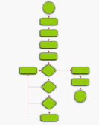

Prunes and Nutrition
Aligned to the following standards:
CS.01; FFA.PL-A; FFA.PL-E; FFA.PG-J; FFA.CS-N; AG1; AGC02.02; CCSS.ELA.RI.9-10.2; CCSS.ELA.RI.9-10.4; CCSS.ELA.SL.9-10.2; CCSS.ELA.WHST.9.10.4; MP1; MP5; MP6; CRP.02; CRP.04; CRP.05; CRP.06; CRP.08
Directions:
Now that we have a better understanding of prunes and their production, let’s look at the benefits to you as a consumer. Complete the following activities below to learn about how prunes can fit into your diet each day to make a healthier you. Use the following website to assist you in completing the activities: https://www.californiadriedplums.org/nutrition.
What would a dietitian say about the health benefits of prune consumption?



What would your family say about the health benefits of prune consumption?

Now that better understand the nutrition and health benefits, what would you tell someone about the health benefits of prunes?

Using AgExplorer.ffa.org, determine two career focus areas in which a person in the prune production industry could have a career. Write them on the lines below and include a short description of why you selected that focus area.

- ______________________ -

- ______________________ -
Prunes Every Day
Aligned to the following standards:
CS.01; FFA.PL-A; FFA.PL-E; FFA.PG-J; FFA.CS-N; AG1; AGC02.02; CCSS.ELA.RI.9-10.2; CCSS.ELA.RI.9-10.4; CCSS.ELA.SL.9-10.2; CCSS.ELA.WHST.9.10.4; MP1; MP5; MP6; CRP.02; CRP.04; CRP.05; CRP.06; CRP.08
Directions:
Using what you now know about prunes, let’s take a look at how we can incorporate prunes into our daily diet. Utilizing the two infographics provided, take a recipe you currently love and rewrite the recipe to incorporate prunes.
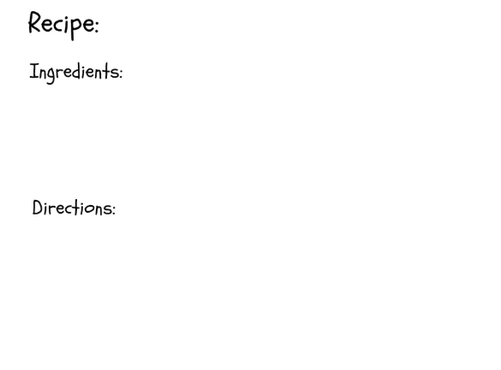
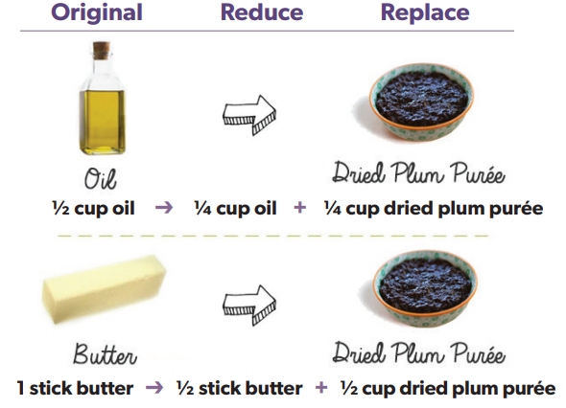
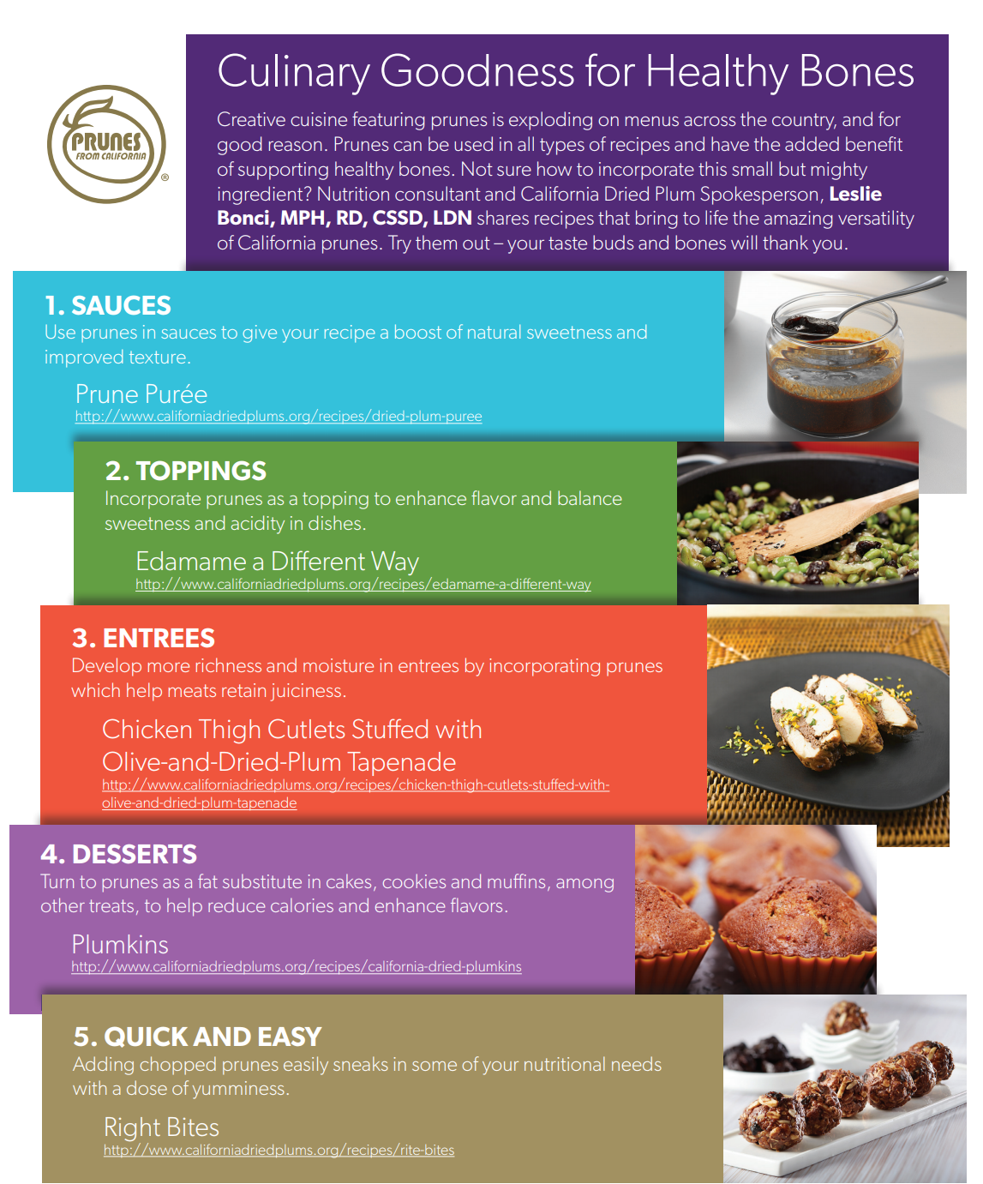
What other types of substitutions can be made in common recipes to make them healthier?
Redesigned Recipe Incorporating Prunes
Original Recipe
KEY: Prune Production
Aligned to the following standards:
CS.01; FFA.PL-A; FFA.PL-E; FFA.PG-J; FFA.CS-N; AG1; AGC02.02; CCSS.ELA.RI.9-10.2; CCSS.ELA.RI.9-10.4; CCSS.ELA.SL.9-10.2; CCSS.ELA.WHST.9.10.4; MP1; MP5; MP6; CRP.02; CRP.04; CRP.05; CRP.06; CRP.08
Directions:
Read over and answer the questions below while you watch the video “John Zuppan – SAE – Prune Orchard,” available at https://vimeo.com/289989630.

Identify three tasks John needs to complete for his SAE. Record one item on each of the lines of this task list.
What did John participate in through class and FFA that has helped to better equip him to be successful in his chosen SAE?

Fruit tree judging
Which of the following was John’s biggest challenge?

- Learning to complete the necessary tasks needed to maintain the orchard
- Deciding what variety of trees to plant
- Time management
- Communication skills

Pruning, painting

Mowing, Spraying

Roto-tilling

Directions:
Using the California Dried Plums website, https://www.californiadriedplums.org/about-prunes-and-dried-plums/history, develop a timeline with pictures to represent the dried plum’s development. (Hint: There should be a minimum of 9 points.) Include a picture for each moment on your timeline.
1890–1920

An oversupply and the costs of labor caused issues in the prune production industry. Quality standards were also a struggle with ensuring consistent high-quality product.
1850–1870

When gold seekers were unable to find gold, many turned to farming. Louis Pellier focused on the production of dried plums.
1870–1890

After a realization of the number of plums the country was consuming, a focus began to shift to increase production in the U.S. The railroad played an integral part in making transportation easier for production, processing and sales.
1920–1940

The organization of the Dried Fruit Association of California led to improvements and quality control across production. Prune juice was also brought to market.
1940–1946

Trading policies changed, leading other countries to import from places other than the U.S. Domestic campaigns were started to market the dried fruit.
1947–1960

Post war, there was a large supply of fruit. Adoption of the Federal Marketing Agreement and Order began developing volume and quality controls. A change in harvesting techniques developed.
1960–1970

Due to high-tech companies entering the valley (now known as Silicon Valley), growers began to work in other regions.
1970–1990

More marketing was needed to increase sales that were previously declining. “High Fiber Fruit Campaign” was developed to aid in efforts.
1990–present

Industry learned about alternative uses in cooking for prunes. The FDA gave approval to move from the name “prunes” to “dried plums.”

Prunes and Nutrition
Aligned to the following standards:
CS.01; FFA.PL-A; FFA.PL-E; FFA.PG-J; FFA.CS-N; AG1; AGC02.02; CCSS.ELA.RI.9-10.2; CCSS.ELA.RI.9-10.4; CCSS.ELA.SL.9-10.2; CCSS.ELA.WHST.9.10.4; MP1; MP5; MP6; CRP.02; CRP.04; CRP.05; CRP.06; CRP.08
Directions:
Now that we have a better understanding of prunes and their production, let’s look at the benefits to you as a consumer. Complete the following activities below to learn about how prunes can fit into your diet each day to make a healthier you. Use the following website to assist you in completing the activities: https://www.californiadriedplums.org/nutrition.
What would a dietitian say about the health benefits of prune consumption? Plums are very nutritious because they contain many beneficial nutrients for daily health. Prunes can provide nutrition for digestive health, bones, heart and much more. Also, substituting prunes into your everyday meals can, in turn, make them healthier and more nutritious.

What would your family say about the health benefits of prune consumption? Answers will vary.

Now that you better understand the nutrition and health benefits, what would you tell someone about the health benefits of prunes? Answers will vary.
Using AgExplorer.com, determine two career focus areas in which a person in the prune production industry could have a career. Write them on the lines below and include a short description of why you selected that focus area. Answers will vary. Examples include plant systems, food products and processing systems, agricultural education, etc. A description about why they selected the career focus area must be included.
- ______________________ -

- ______________________ -
Directions:
Using the California Dried Prunes FAQs, https://www.californiadriedplums.org/about-prunes-and-dried-plums/faq, complete the following crossword puzzle.
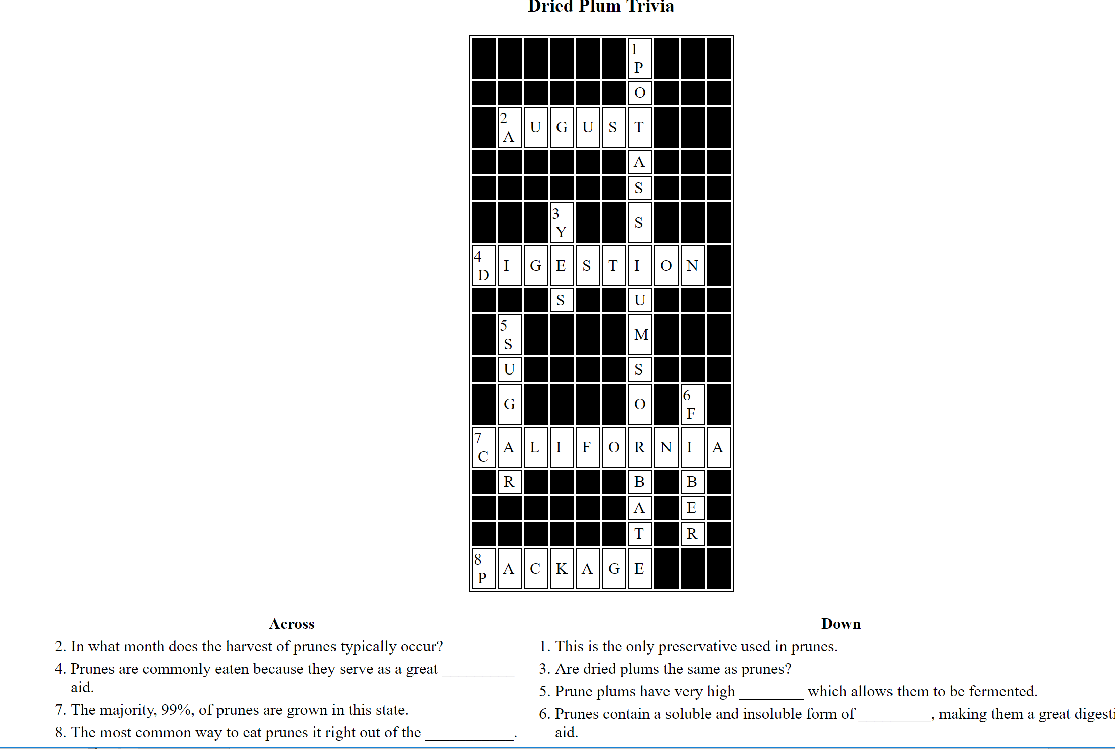

Why do you think many consumers are unfamiliar with prunes and their production? Answers will vary.
What would be a way to help consumers have a better understanding of prunes?
Answers will vary.

Production
Aligned to the following standards:
CS.01; FFA.PL-A; FFA.PL-E; FFA.PG-J; FFA.CS-N; AG1; AGC02.02; CCSS.ELA.RI.9-10.2; CCSS.ELA.RI.9-10.4; CCSS.ELA.SL.9-10.2; CCSS.ELA.WHST.9.10.4; MP1; MP5; MP6;CRP.02; CRP.04; CRP.05; CRP.06; CRP.08
Directions:
Using the information available at https://www.californiadriedplums.org/about-prunes-and-dried-plums/growing-and-harvesting, develop a flow chart using pictures and minimal words that depicts the prune production process. See the example below of what a flow chart can look like.

Charts may vary. The directions said there should be more pictures than words, so keep that in mind while evaluating students’ work.

Example chart:

Plant trees prune trees irrigation during the summer Check fruit readiness harvest in August through shaking of the tree dryer washing placement placed on large wooden trays dehydration travel to packaging plants inspection grade for size storage packed in order for further processing.

Prunes Every Day
Aligned to the following standards:
CS.01; FFA.PL-A; FFA.PL-E; FFA.PG-J; FFA.CS-N; AG1; AGC02.02; CCSS.ELA.RI.9-10.2; CCSS.ELA.RI.9-10.4; CCSS.ELA.SL.9-10.2; CCSS.ELA.WHST.9.10.4; MP1; MP5; MP6;CRP.02; CRP.04; CRP.05; CRP.06; CRP.08
Directions:
Using what you now know about prunes, let’s take a look at how we can incorporate prunes into our daily diet. Utilizing the two infographics provided, take a recipe you currently love and rewrite the recipe to incorporate prunes.
What other types of substitutions can be made in common recipes to make them healthier? Answers will vary. An example would be applesauce.
Redesigned Recipe Incorporating Prunes Answers will vary.
Original Recipe Answers will vary.

