Asking Questions
Aligned to the following standards:
CS.01; FFA.PL-A; FFA.PG-J; FFA.CS-N; AG1; AGC10.04; CCSS.RI.9-10.4; CCSS.RI.9-10.8; CCSS.RST.9-10.7; CCSS.RST.9-10.9; MP2; MP3; MP5; MP6; CRP.02; CRP.04; CRP.05; CRP.06; CRP.07; CRP.08; CRP.11
Directions:
Answer the questions below as you watch the video “Research-Composting SAE | Jordan Butler and Amari Manago,” available at https://vimeo.com/349686476.
What motivated them to do this research SAE?

- What is Jordan and Amari’s SAE?

- What is the topic of their research project?

- What steps did they take to get started?

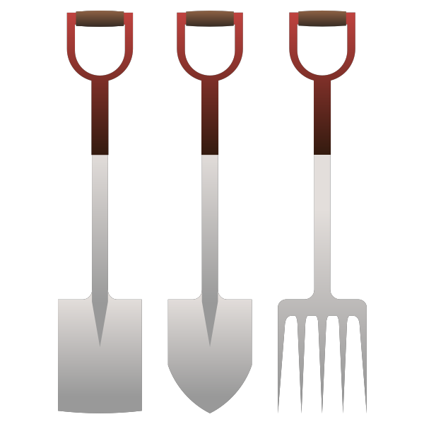
Step 1

Step 2

Step 3

- Who helped them to complete their project?
How did this person help Amari and Jordan?

Person 1:

How did this person help them?

Person 2:

How did this person help them?

Person 3:

- Jordan and Amari had to write survey questions to find out what people knew about composting. In the space below, create two multiple choice survey questions to find out what people know about composting in your community. (Tip: Make the questions specific, and make sure there is an option for everyone, such as “other.”)

Research It!
Aligned to the following standards:
CS.01; FFA.PL-A; FFA.PG-J; FFA.CS-N; AG1; AGC10.04; CCSS.RI.9-10.4; CCSS.RI.9-10.8; CCSS.RST.9-10.7; CCSS.RST.9-10.9; MP2; MP3; MP5; MP6; CRP.02; CRP.04; CRP.05; CRP.06; CRP.07; CRP.08; CRP.11
Part 1
Directions:
Jordan and Amari encouraged us to look beyond the typical SAEs and find a topic we wanted to know more about. Complete the following activities to discover four areas of research/research topics that appeal to you.

Go to the United States Department of Agriculture (USDA) Agricultural Research Service (ARS) website (https://www.ars.usda.gov/).

Explore the website. You can use any of the following options to explore USDA ARS research and complete the chart.
- Search the site by using key words in the standard search tool
- Search through the “I Want To” tool
- Search through the “Trending Topics” tool
- Search through the “ARS in Your State” tool

Research Topics of Interest  (one per row) | Two Facts You Learned About This Topic | Two Questions You Would Ask the Person Doing the Research
 | 1.  2. | 1.  2.
 | 1.  2. | 1.  2.
 | 1.  2. | 1.  2.
 | 1.  2. | 1.  2.

Part 2
Directions:
Now that you’ve identified some areas you would like to explore, choose two. Complete the table below to brainstorm questions you want to investigate and how you might carry out that research.

Research Topic | Question About This Topic You Want to Answer Through Research | Process to Answer the _____Question_____  What would you need to do to answer this question? (conduct an experiment, survey the community, etc.) | What do you need to know before you can begin the process of answering this question?

Aligned to the following standards:
CS.01; FFA.PL-A; FFA.PG-J; FFA.CS-N; AG1; AGC10.04; CCSS.RI.9-10.4; CCSS.RI.9-10.8; CCSS.RST.9-10.7; CCSS.RST.9-10.9; MP2; MP3; MP5; MP6; CRP.02; CRP.04; CRP.05; CRP.06; CRP.07; CRP.08; CRP.11

