Baa, Baa, Sheep
Aligned to the following standards:
AS.06; PL-A.; PG-J.; AG-ANI6; AGPC01.01; CCSS.RI.9-10.1; CCSS.SL.9-10.4; CRP.02; CPR.07; CRP.08
Directions:
Answer the questions below as you watch the video “Sheep SAE | Kami Harmon,” available at https://vimeo.com/377222025.
How has her lamb operation grown?

What is Kami’s SAE?

What are her daily tasks?
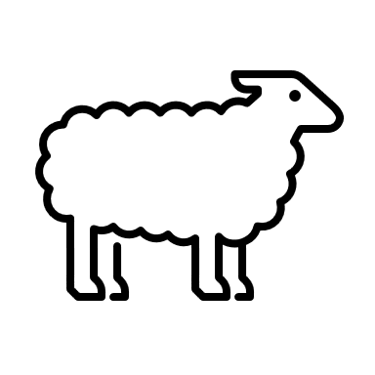

What does “working the lambs” consist of?

What does Kami mean when she says she runs her sheep?

What specific activities does Kami do with her lambs to prepare them for the show ring?

What was Kami’s SAE her freshmen year?

What advice does she give other students based on what she learned from that experience?

Have You Any Wool (or Meat)?
Aligned to the following standards:
AS.06; PL-A.; PG-J.; AG-ANI6; AGPC01.01; CCSS.RI.9-10.1; CCSS.SL.9-10.4; CRP.02; CPR.07; CRP.08
Directions:
To learn more about sheep wool and meat, complete the activities below.

- There are dozens of sheep breeds, but we are going to learn more about some of the most popular breeds in the United States. There are sheep that are raised specifically for their meat and others that are raised specifically for their wool, although there are also many dual-purpose breeds. Complete the chart below. (Suggested Resource: Sheep Breeds A–Z, http://www.sheep101.info/sheepbreedsa-z.html)

Sheep Breed | Description | Used Mostly for Its Meat or Its Wool?
Border Leicester: (insert/paste image)

Hampshire: (insert/paste image)
Katahdin: (insert/paste image)

Merino: (insert/paste image)
Rambouillet: (insert/paste image)

Suffolk: (insert/paste image)

- Lamb and mutton have always been popular around the world, but in the United States, they have only become popular among the general public in recent years. Identify the primal cuts of lamb on the diagram below. Then, name one or two retail cuts of meat from those primal cuts, describe them and give an example of how best to cook it. (Suggested Resource: The Only Lamb Cuts Guide You’ll Ever Need, https://medium.com/farmdrop/the-only-lamb-cuts-guide-youll-ever-need-how-to-choose-and-cook-your-cuts-29419edf875b)
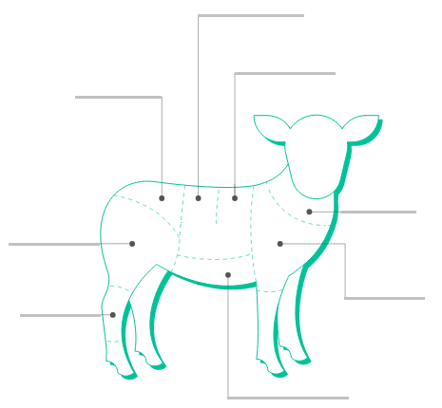

Primal Cut | Primal Cut Description | Best Way to Cook | Retail Cuts
Shank |  |  | 1.
Leg |  |  | 1.  2.
Rump |  |  | 1.  2.
Loin |  |  | 1.  2.
Rack |  |  | 1.  2.
Breast |  |  | 1.  2.
Shoulder |  |  | 1.  2.
Neck |  |  | 1.

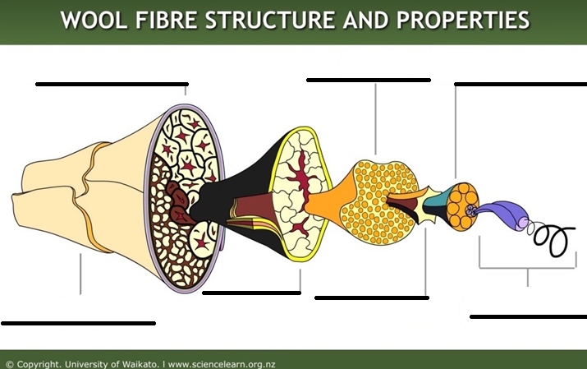
- Sheep wool has been used for thousands of years in clothes, blankets and other materials. Let’s learn more about the properties that make it so useful in material. Label the different parts of a wool fiber and describe each component. (Suggested Resource: Wool Fibre Properties, https://www.sciencelearn.org.nz/resources/875-wool-fibre-properties)
Description:
Description:

Description:

Description:

Description:

Description:

Description:

