Sheep
Created: 07/2020 by the National FFA Organization

Kami Harmon’s supervised agricultural experience (SAE) program is caring for and showing her lambs. Discover how lambs are trained for showing and all the work that entails.

Student Learning Objectives:
After completing these activities, students will …
- Discover how to care for show sheep.
- Research popular breeds of meat sheep and wool sheep.
- Identify and describe the primal cuts of lamb.
- Explain how the different components of a wool fiber work together to give wool its unique properties.

Time Required: 180 minutes
Resources/References:
- Video: “Sheep SAE | Kami Harmon,” https://vimeo.com/377222025
- Website: Sheep Breeds A–Z, http://www.sheep101.info/sheepbreedsa-z.html
- Article: “The Only Lamb Cuts Guide You’ll Ever Need,” https://medium.com/farmdrop/the-only-lamb-cuts-guide-youll-ever-need-how-to-choose-and-cook-your-cuts-29419edf875b
- Website: Wool Fibre Properties, https://www.sciencelearn.org.nz/resources/875-wool-fibre-properties

Equipment and Supplies Needed:
- A copy of the “Baa, Baa Sheep” worksheet for each student
- A copy of the “Have You Any Wool (or Meat)?” worksheet for each student
- Internet access to play the video in real time or embed it in a PowerPoint ahead of time

Student activity sheets:
Direct access to student activity sheets without lesson plan or answer key for easy upload to learning management system or printing for classwork.
https://ffa.box.com/s/646yh0mxufkbpqjd7krbxwky0sxy4vu3 (Word)
https://ffa.box.com/s/ugb8jid3hxasosx14fjdtb6021tw1jso (PDF)

Cross-Curricular Connections:
Science
Examine the different components of wool fiber and explain how they work together to give wool its unique properties.

These activities are aligned to the following standards:

AFNR Performance Element
- AS.06. Classify, evaluate, and select animals based on anatomical and physiological characteristics.
FFA Precept
- FFA.PL-A.Action: Assume responsibility and take the necessary steps to achieve the desired results, no matter what the goal or task at hand.
- FFA.PG-J.Mental Growth: Embrace cognitive and intellectual development relative to reasoning, thinking and coping.
Common Career Technical Core
- AG-ANI6 Classify, evaluate, and select animals based on anatomical and physiological characteristics.
NASDCTEc
- AGPC01.01 Produce and/or manage animals in domesticated and/or natural environments using an application of knowledge regarding anatomy and physiology to enhance animal production.
Common Core – Reading: Informational Text
- CCSS.ELA-Literacy.RI.9-10.1 Cite strong and thorough textual evidence to support analysis of what the text says explicitly as well as inferences drawn from the text.
Common Core – Speaking and Listening
- CCSS.ELA-Literacy.SL.9-10.4 Present information, findings, and supporting evidence clearly, concisely, and logically such that listeners can follow the line of reasoning and the organization, development, substance, and style are appropriate to purpose, audience, and task.
AFNR Career Ready Practices
- CRP.02. Apply appropriate academic and technical skills. Career-ready individuals readily access and use the knowledge and skills acquired through experience and education to be more productive.
- CRP.07. Employ valid and reliable research strategies. Career-ready individuals are discerning in accepting and using new information to make decisions, change practices or inform strategies.
- CRP.08. Utilize critical thinking to make sense of problems and persevere in solving them. Career-ready individuals readily recognize problems in the workplace, understand the nature of the problem, and devise effective plans to solve the problem.
Partnership for 21st Century Skills
- Critical Thinking and Problem Solving
- Information Literacy

Lesson Plan:
- Bell Ringer: When you hear the word “sheep,” what do you think of? Why?

- Introduction: While it has always had a place in American livestock production, especially in the western states, raising sheep has become even more popular over the last several years. Lamb and mutton (meat from adult sheep) are not as well known in the U.S. as beef, pork and chicken, but in other parts of the world, they are among the most popular meats. Today, we will learn more about sheep, including how one FFA member prepares her sheep for shows, the most popular meat and wool breeds, the different cuts of lamb and the structure of wool fibers.

- Activity: Each student needs a copy of the worksheet “Baa, Baa, Sheep.” They will complete this worksheet as they watch the video “Sheep SAE | Kami Harmon,” available at https://vimeo.com/377222025. After students have watched the video, they will need a copy of the worksheet “Have You Any Wool (or Meat)?” This worksheet includes three activities. Students will research six breeds of sheep (three meat and three wool species), although some are considered dual-purpose. Then, students will learn about the primal cuts of lamb by identifying the cuts, describing them and indicating what cooking method is best. Finally, students will label the components of a wool fiber and explain how each of those components works together to give wool its unique properties.

- Follow-up: After students have completed both worksheets, have a class discussion about eating lamb and mutton. Have students share their experiences (if any) with eating lamb. If very few in your class have eaten lamb or mutton, discuss the differences in meat popularities around the world and why it might not be common in your area. (Ex. The very high temperatures in your area limit the variety of sheep breeds that can thrive, so producers do not consider raising sheep to be worthwhile.) If it is common in your area, discuss why that might be and have students imagine what it might be like in areas where the meat is rarely consumed.

- Optional — Extended Learning Opportunities (Not factored into time requirement):
  - If very few students have ever eaten lamb or mutton, introducing students to a variety of lamb and mutton dishes would be an enriching experience. Be sure to follow all school policies regarding food and students.
  - If sheep are common in your area or most of your students have sheep, conduct a small “class sheep show” so students can show off their sheep and their showmanship. If most students don’t have sheep, but they are readily available in your area, then take a field trip to one of the local producers and have students learn firsthand how to handle sheep. Be sure to follow all school policies regarding field trips.

- Exit Ticket: What was the most interesting fact you learned today about sheep?

Baa, Baa, Sheep
Aligned to the following standards:
AS.06; PL-A.; PG-J.; AG-ANI6; AGPC01.01; CCSS.RI.9-10.1; CCSS.SL.9-10.4; CRP.02; CPR.07; CRP.08
Directions:
Answer the questions below as you watch the video “Sheep SAE | Kami Harmon,” available at https://vimeo.com/377222025.
How has her lamb operation grown?

What is Kami’s SAE?

What are her daily tasks?
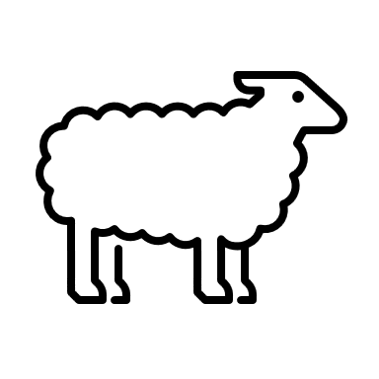

What does “working the lambs” consist of?

What does Kami mean when she says she runs her sheep?

What specific activities does Kami do with her lambs to prepare them for the show ring?

What was Kami’s SAE her freshmen year?

What advice does she give other students based on what she learned from that experience?

Have You Any Wool (or Meat)?
Aligned to the following standards:
AS.06; PL-A.; PG-J.; AG-ANI6; AGPC01.01; CCSS.RI.9-10.1; CCSS.SL.9-10.4; CRP.02; CPR.07; CRP.08
Directions:
To learn more about sheep wool and meat, complete the activities below.

- There are dozens of sheep breeds, but we are going to learn more about some of the most popular breeds in the United States. There are sheep that are raised specifically for their meat and others that are raised specifically for their wool, although there are also many dual-purpose breeds. Complete the chart below. (Suggested Resource: Sheep Breeds A–Z, http://www.sheep101.info/sheepbreedsa-z.html)

Sheep Breed | Description | Used Mostly for Its Meat or Its Wool?
Border Leicester: (insert/paste image)

Hampshire: (insert/paste image)
Katahdin: (insert/paste image)

Merino: (insert/paste image)
Rambouillet: (insert/paste image)

Suffolk: (insert/paste image)

- Lamb and mutton have always been popular around the world, but in the United States, they have only become popular among the general public in recent years. Identify the primal cuts of lamb on the diagram below. Then, name one or two retail cuts of meat from those primal cuts, describe them and give an example of how best to cook it. (Suggested Resource: The Only Lamb Cuts Guide You’ll Ever Need, https://medium.com/farmdrop/the-only-lamb-cuts-guide-youll-ever-need-how-to-choose-and-cook-your-cuts-29419edf875b)
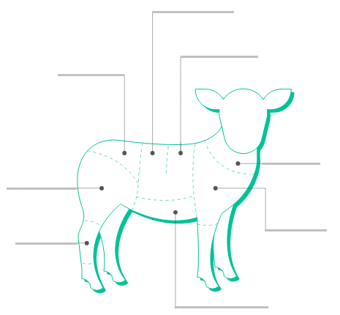

Primal Cut | Primal Cut Description | Best Way to Cook | Retail Cuts
Shank |  |  | 1.
Leg |  |  | 1.  2.
Rump |  |  | 1.  2.
Loin |  |  | 1.  2.
Rack |  |  | 1.  2.
Breast |  |  | 1.  2.
Shoulder |  |  | 1.  2.
Neck |  |  | 1.

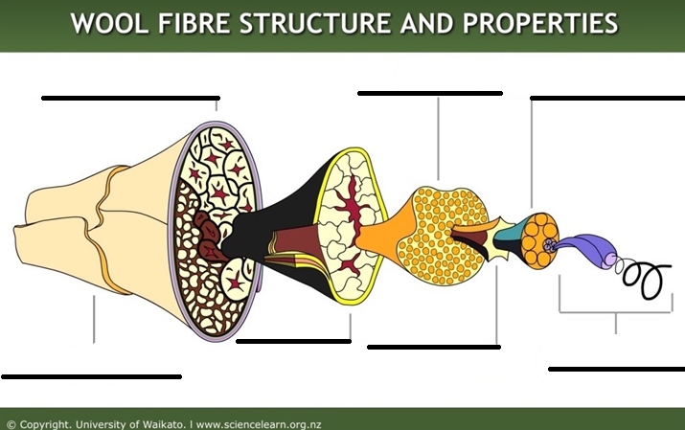
- Sheep wool has been used for thousands of years in clothes, blankets and other materials. Let’s learn more about the properties that make it so useful in material. Label the different parts of a wool fiber and describe each component. (Suggested Resource: Wool Fibre Properties, https://www.sciencelearn.org.nz/resources/875-wool-fibre-properties)
Description:
Description:

Description:

Description:

Description:

Description:

Description:

KEY: Baa, Baa, Sheep
Aligned to the following standards:
AS.06; PL-A.; PG-J.; AG-ANI6; AGPC01.01; CCSS.RI.9-10.1; CCSS.SL.9-10.4; CRP.02; CPR.07; CRP.08
Directions:
Answer the questions below as you watch the video “Sheep SAE | Kami Harmon,” available at https://vimeo.com/377222025.
How has her lamb operation grown?

She started out showing one lamb, but that has now grown to five lambs and her knowledge has increased as well.
What is Kami’s SAE?
Showing and caring for lambs

What are her daily tasks?

Feeds the lambs every morning no later than 8:30 to keep them on the same schedule

Lambs have entire day to rest

Works the lambs when the temperature cools down

Feeds them again
What does “working the lambs” consist of?

Running and walking them, setting them up, washing and brushing them
What does Kami mean when she says she runs her sheep?

Running the sheep is making them do sprints so they are not over-conditioned (fat). She wants them to look athletic.
What specific activities does Kami do with her lambs to prepare them for the show ring?

Walking them to prepare them for walking in a show ring

Setting them up, which is placing their legs so they are in the correct position and show their attributes to their best advantage

What was Kami’s SAE her freshmen year?

She had a plant SAE, but she was not a plant person. She didn’t enjoy it and was not motivated.
What advice does she give other students based on what she learned from that experience?

She says to pick something you love and want to do every day.

KEY: Have You Any Wool (or Meat)?
Aligned to the following standards:
AS.06; PL-A.; PG-J.; AG-ANI6; AGPC01.01; CCSS.RI.9-10.1; CCSS.SL.9-10.4; CRP.02; CPR.07; CRP.08
Directions:
To learn more about sheep wool and meat, complete the activities below.

- There are dozens of sheep breeds, but we are going to learn more about some of the most popular breeds in the United States. There are sheep that are raised specifically for their meat and others that are raised specifically for their wool, although there are also many dual-purpose breeds. Complete the chart below. (Suggested Resource: Sheep Breeds A- Z, http://www.sheep101.info/sheepbreedsa-z.html)

Sheep Breed | Description | Used Mostly for Its Meat or Its Wool?
Border Leicester: (insert/paste image)  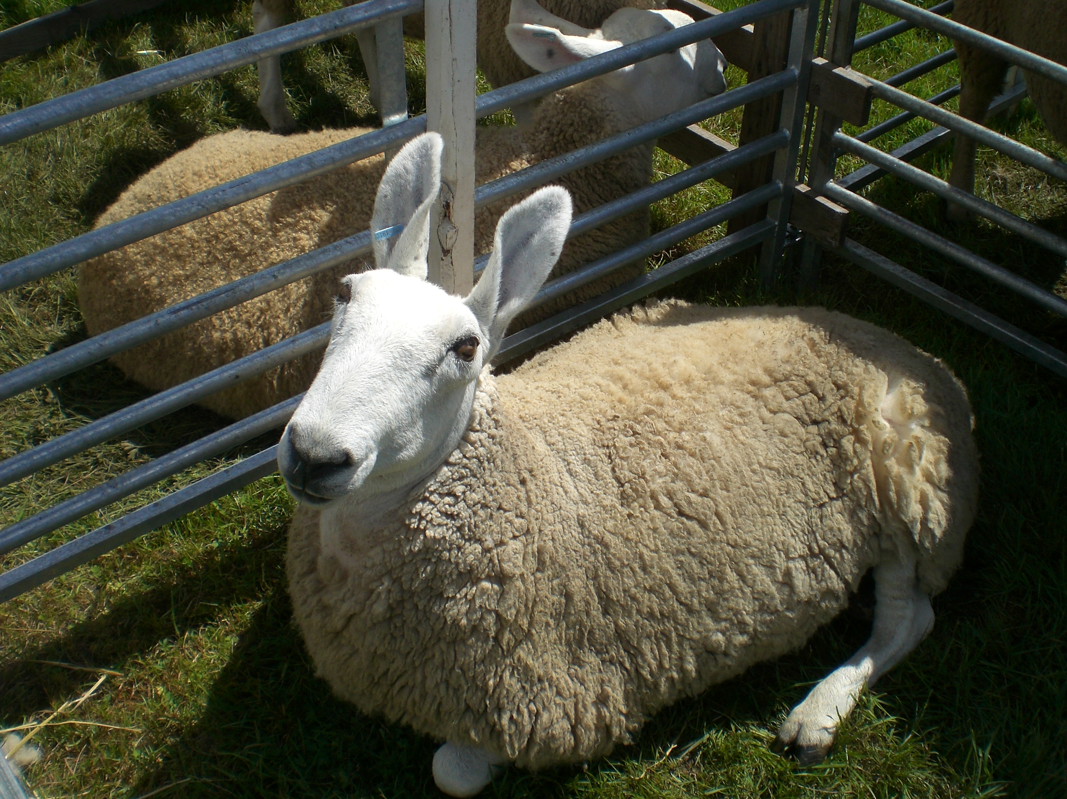 | Founded in 1767 by George and Matthew Culley of Fenton, Northumberland, England. They are moderately prolific, good milkers and mothers. They have been used throughout the world to sire crossbred females. They yield a long-stapled, lustrous, coarse wool that is much in demand by hand spinners. | Technically dual-purpose, but mostly wool
Hampshire: (insert/paste image)  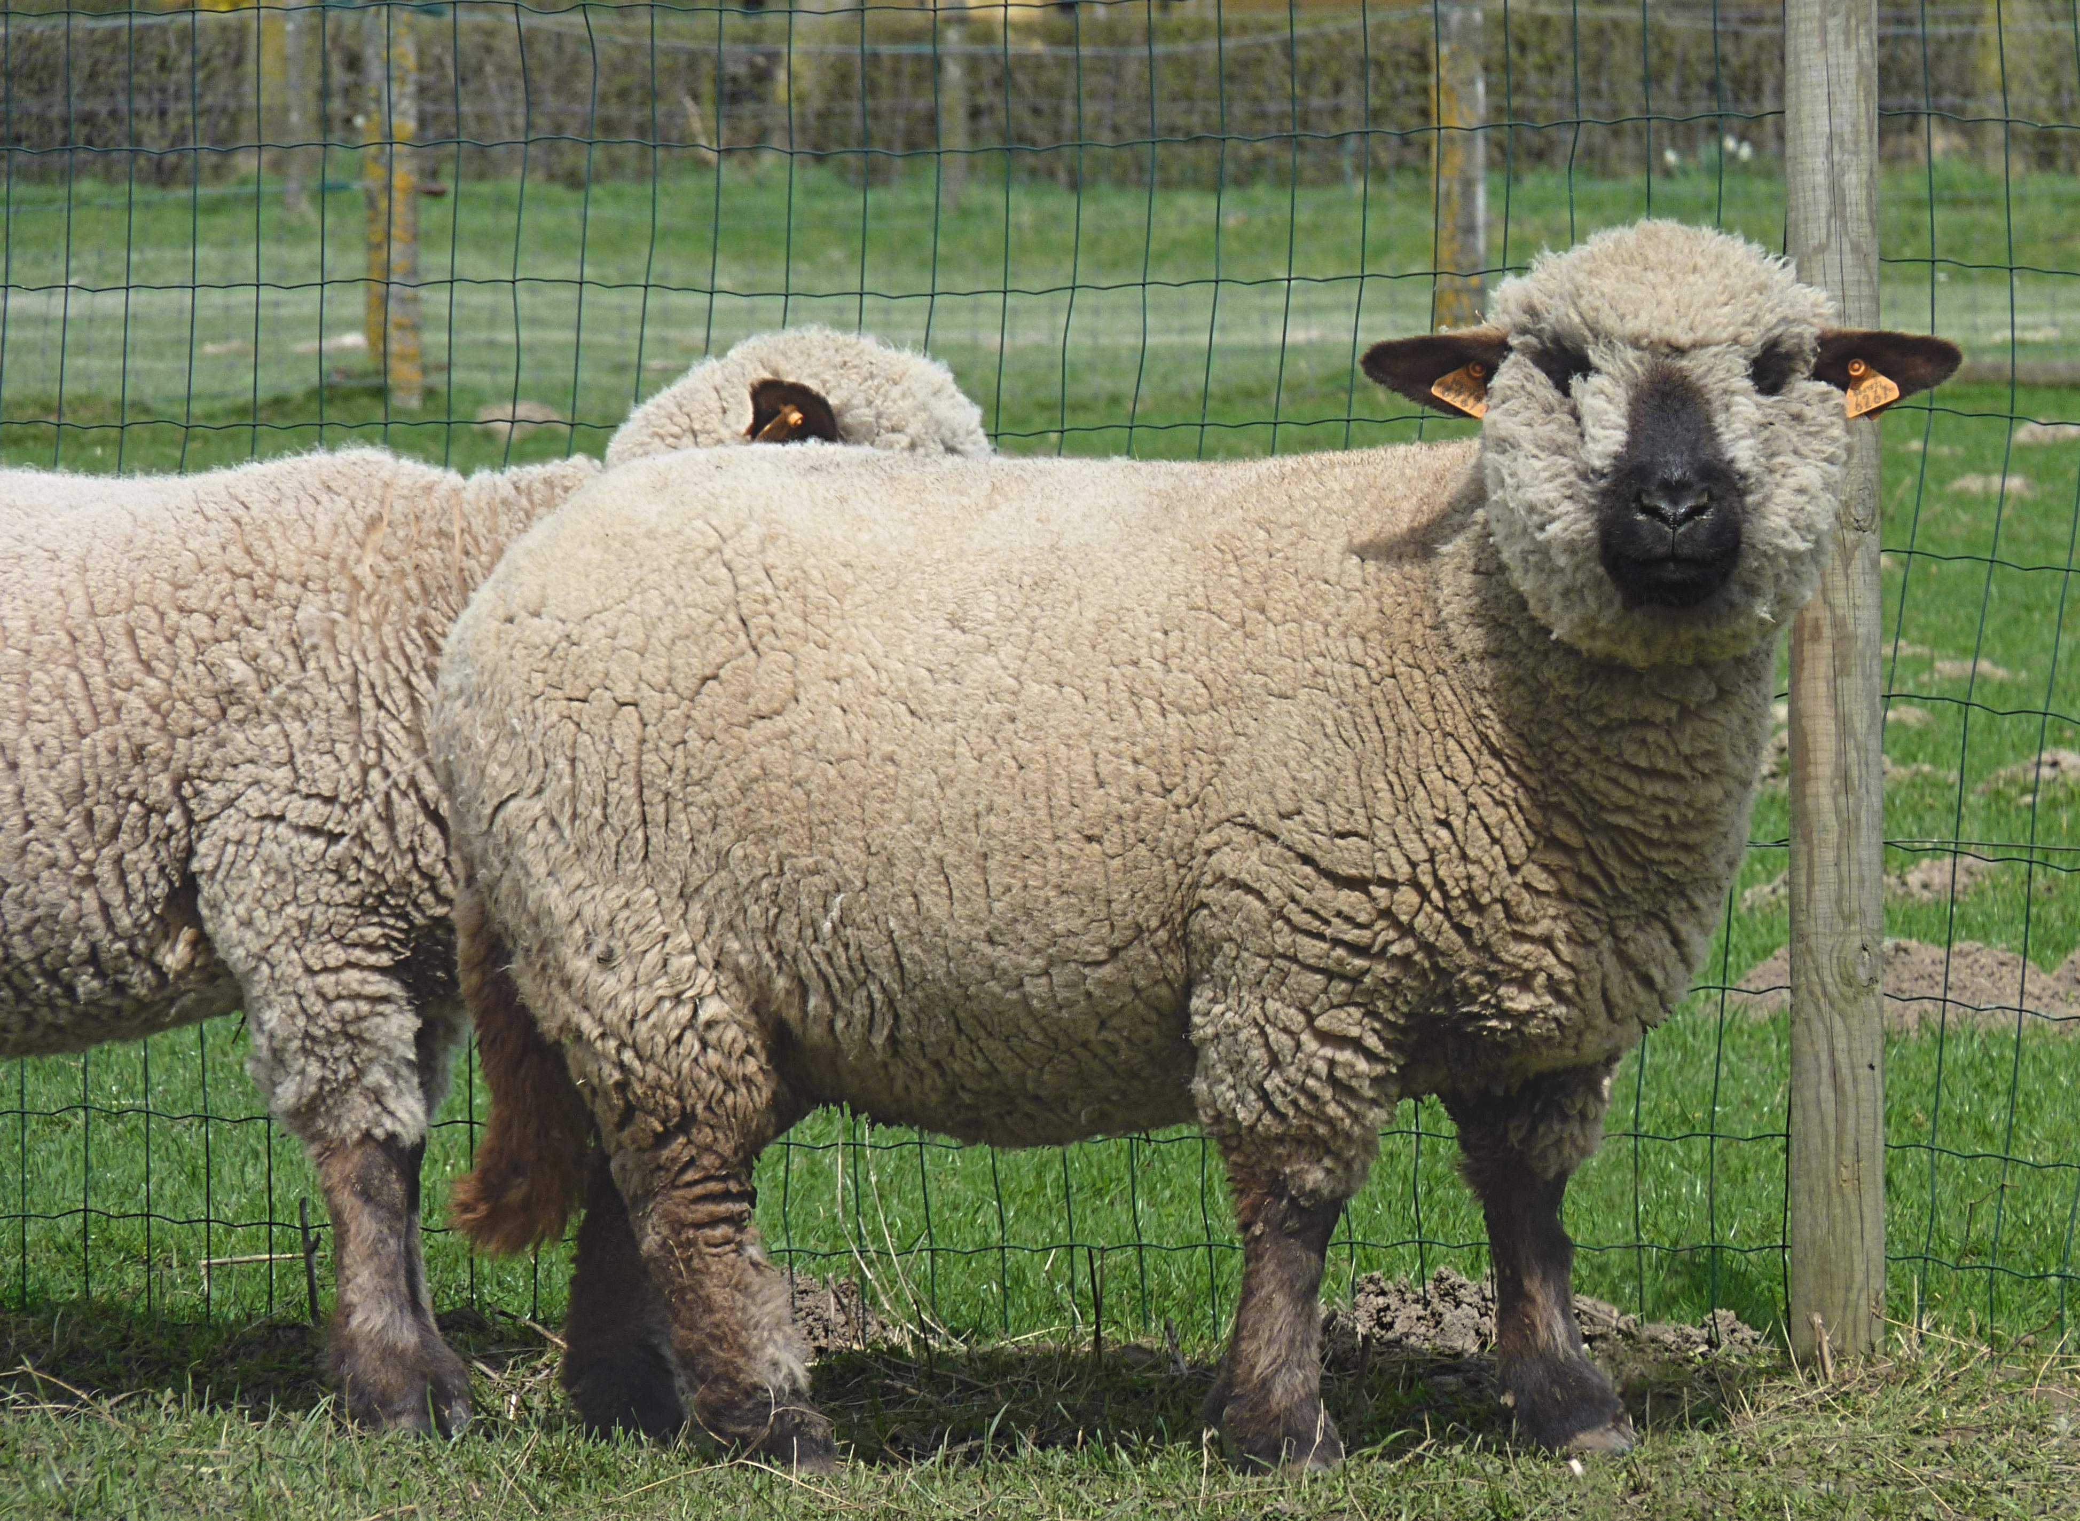 | Hampshires are a large breed, with black faces and legs and wool on the legs and head. Their fast growth rate and superior carcass merit make them a popular choice to sire crossbred market lambs. | Meat
Katahdin: (insert/paste image)  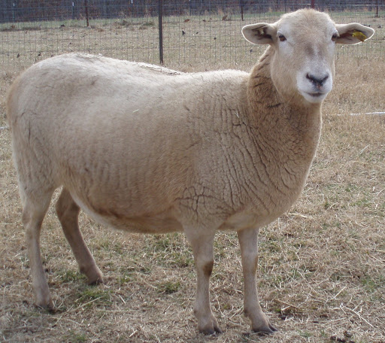 | The Katahdin is a hair sheep developed in the 1950s by amateur geneticist Michael Piel. It is an easy-care, low-maintenance meat-type sheep that is naturally tolerant of climatic extremes and capable of high performance in a variety of environments. Has a natural resistance to internal parasites. | Meat
Delaine Merino: (insert/paste image)  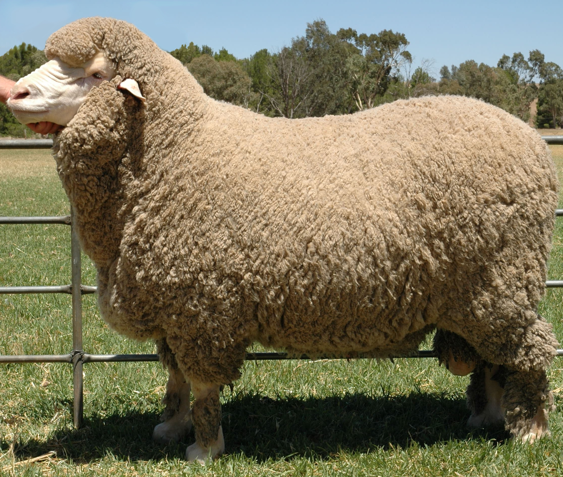 | Delaine Merino is the most practical Merino and is especially adapted to range sheep production in the western and southwestern parts of the U.S. It is of medium size with a smooth body and is free of wrinkles. In the U.S., over 95 percent of Merinos are smooth or nearly smooth. | Fine wool
Rambouillet: (insert/paste image)  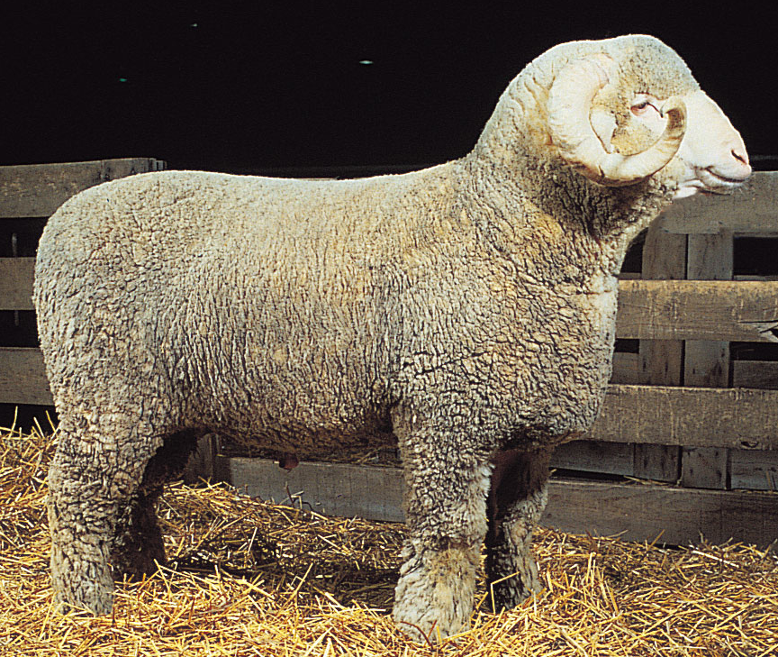 | It is the foundation of most western range flocks and raised throughout the United States. The Rambouillet descends entirely from the Spanish Merino. It is a dual-purpose sheep, producing a desirable carcass and good fine wool. They are large sized, rugged and long-lived with a strong flocking instinct. | Fine wool, some consider it dual-purpose
Suffolk: (insert/paste image)  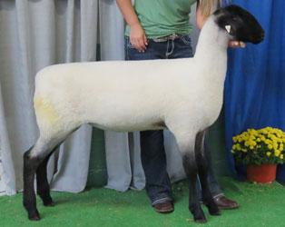 | The most popular pure breed of sheep in U.S. They are a large breed with a distinctive all-black head and legs that are free of wool. Suffolk lambs grow faster than any other breed and yield heavy, high-cutability carcasses of the type demanded by today's health conscience consumers. | Meat
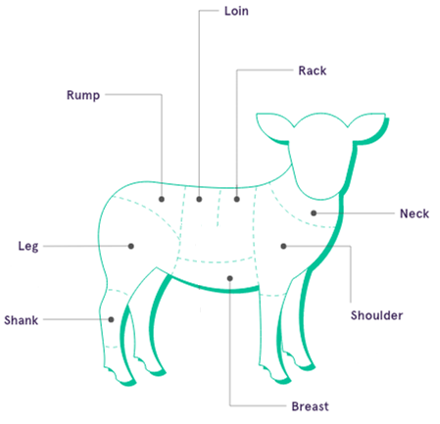
- Lamb and mutton have always been popular around the world, but in the United States, they have only become popular among the general public in recent years. Identify the primal cuts of lamb on the diagram below. Then, name one or two retail cuts of meat from those primal cuts, describe them and give an example of how best to cook it. (Suggested Resource: The Only Lamb Cuts Guide You’ll Ever Need, https://medium.com/farmdrop/the-only-lamb-cuts-guide-youll-ever-need-how-to-choose-and-cook-your-cuts-29419edf875b)

Primal Cut | Primal Cut Description | Best Way to Cook | Retail Cuts
Shank | A meaty cut from the lower end of the lamb leg. The bone running through the center provides a lot of the flavor, releasing collagen as the joint cooks and tenderizing the flesh. | Slow cooking | 1. Lamb shank
Leg | Lamb leg is popular due to its dark, melt-in-the-mouth meat and meat-to-bone ratio, making this one easy to carve at the dinner table. | Roasting | 1. Leg of lamb  2. Leg steaks
Rump | Rump comes from the back side of the lamb where the top of the leg meets the loin. It is a plump yet lean cut, with a generous layer of fat to keep the meat juicy. | Quick roast | 1. Rump  2.Chump chop
Loin | Taken from the top of the back, the loin is a prized cut of lamb due to the super tender meat. Doesn’t have a layer of fat for protection, so care must be taken not to overcook. | Loin best for roasting; chops best for quick frying or grilling | 1. Loin Chop  2. Noisettes
Rack | The rack is very popular. It is easy to achieve perfectly crisp skin and tender, melt-in-the-mouth flesh. Cutlets are individual rib steaks taken from the rack. | Quick roasting or grilling | 1. Rack of lamb  2. Cutlets
Breast | A value cut that is often underused as it has quite a lot of fat and can be tough if cooked incorrectly. The layer of fat brings flavor and tenderizes the meat. | Slow roasting | 1. Breast  2. Rolled lamb breast
Shoulder | This large cut from the top front leg of the lamb has lots of lean juicy meat. The bone and generous marbling keep the meat juicy and the flavor intense. | Slow roasting | 1. Whole shoulder  2. Mince/ground lamb
Neck | The neck fillet is often underrated and inexpensive as it takes a little longer cooking than other popular cuts, but the marbling through the cut gives all the flavors. | Slow cooking | 1. Neck fillet

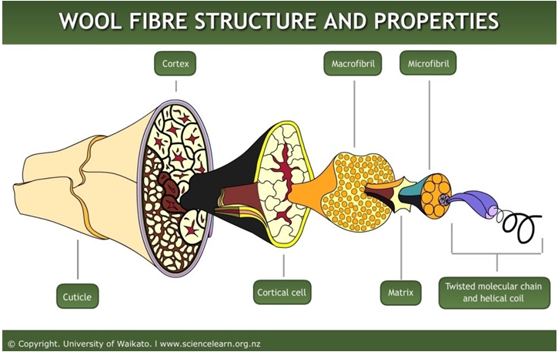
- Sheep wool has been used for thousands of years in clothes, blankets and other materials. Let’s learn more about the properties that make it so useful in material. Label the different parts of a wool fiber and describe each component. (Suggested Resource: Wool Fibre Properties, https://www.sciencelearn.org.nz/resources/875-wool-fibre-properties)
Description:
Within the twisted molecular chains are protein chains that are coiled in a helical shape much like a spring. This structure is stiffened by hydrogen bonds and disulphide bonds within the protein chain. They link each coil of the helix, helping to prevent it stretching. The helical coil — the smallest part of the fiber — gives wool its flexibility, elasticity and resilience, which helps wool fabric keep its shape and remain wrinkle-free in use.
Description:
Within the matrix area, there are embedded smaller units called microfibrils. The microfibrils in the matrix are rather like the steel rods embedded in reinforced concrete to give strength and flexibility. The microfibrils contain pairs of twisted molecular chains.
Description:
The cortex — the internal cells — make up 90 percent of the fiber. There are two main types of cortical cells — ortho-cortical and para-cortical. Each has a different chemical composition. In finer fibers, these two types of cells form in two distinct halves. The cells expand differently when they absorb moisture, making the fiber bend. This creates the crimp in wool. In coarser fibers, the para-cortical and ortho-cortical cells form more randomly so there is less crimp.

Fiber crimp makes wool feel springy and provides insulation by trapping air.
Description:
Inside the cortical cells are long filaments called macrofibrils. These are made up of bundles of even finer filaments called microfibrils, which are surrounded by a matrix region.
Description:
The cortical cells are surrounded and held together by a cell membrane complex, acting similarly to mortar holding bricks together in a wall.

The cell membrane complex contains proteins and waxy lipids and runs through the whole fiber. The molecules in this region have fairly weak intermolecular bonds, which can break down when exposed to continued abrasion and strong chemicals.

The cell membrane complex allows easy uptake of dye molecules.
Description:
On the outside of the wool fiber is a protective layer of scales called cuticle cells. They overlap like tiles on a roof. The exposed edges of the cells face away from the root end so there is more friction when you rub the fiber in one direction than the other. This helps wool expel dirt and gives it the ability to felt. Wool felts when fibers are aligned in opposite directions and they become entangled.

The scales have a waxy coating chemically bound to the surface. This stops water penetrating the fiber but allows absorption of water vapor. This makes wool water-repellent and resistant to water-based stains.
Description:
The matrix consists of high sulfur proteins. This makes wool absorbent because sulfur atoms attract water molecules. Wool can absorb up to 30 percent of its weight in water and can also absorb and retain large amounts of dye. This region is also responsible for wool’s fire-resistance and anti-static properties.

