Count Joy
Created: 02/2024 by the National FFA Organization
Description of Lesson: Life on the farm teaches resilience and joy in simple blessings. In her retiring address, 2022-23 National FFA Central Region Vice President Karstyn Cantrell shares how ordinary tasks foster skills related to the FFA mission.
Student Learning Objectives:
After completing these activities, students will …
- Understand the importance of joy.
- Define perseverance.

Suggested Grade Level:
Grades 9 and 10 (This lesson is written so instructors can scale up or down based on class needs.)

Suggested Time: 60 minutes (*Time requirements may vary based upon student understanding and class schedule.)

Resources/References:
- Video: “Count Joy” | Karstyn Cantrell 2023 Retiring Adress, https://vimeo.com/showcase/10781759/video/883072933

Related Resources:
- Retiring Addresses and Keynote Speeches, FFA.org/ffa-video-center/convention-keynotes-and-retiring-addresses/

Equipment and Supplies Needed:
- A copy of the “Count Joy” worksheet for each student
- Internet access to play the video in real-time or embed it in a PowerPoint ahead of time

Vocabulary:
- Joy
- Perseverance
Cross-Curricular Connections:
English/Language Arts
- Write and create a scrapbook page centered around items students count as joy.

Virtual Instruction Ideas:
Have students download and watch the video on a device of their choice and complete the worksheet.

Student Activity Sheets:
Direct access to student activity sheets without lesson plan or answer key for easy upload to a learning management system or printing for classwork.
Word: https://ffa.box.com/s/hesneczjzp164g426n9tasej7vqovt3b
PDF: https://ffa.box.com/s/n0pzy8ojqv3gxthrxgas2adacbasxqxc
Google Doc: https://docs.google.com/document/d/1A1jRRo2RwYMZg1JvH1aoZ1yrKTN4S8cjAJPhHrjAvyU/copy
Undesigned: https://ffa.box.com/s/atqvyna45ybgiohnw3suaiow8g07grs5

These Activities Are Aligned to the Following Standards:
FFA Precept
- FFA.PL-A.Action: Assume responsibility and take the necessary steps to achieve the desired results, no matter what the goal or task at hand.
- FFA.PL-D.Character: Conduct oneself appropriately in relation to others regardless of the situation.
- FFA.PG-J.Mental Growth: Embrace cognitive and intellectual development relative to reasoning, thinking and coping
Common Core – Writing
- CCSS.ELA-Literacy.W.9-10.4: Produce clear and coherent writing in which the development, organization, and style are appropriate to task, purpose, and audience.
AFNR Career Ready Practices
- CRP.02: Apply appropriate academic and technical skills. Career-ready individuals readily access and use the knowledge and skills acquired through experience and education to be more productive.
- CRP.04. Communicate clearly, effectively, and with reason. Career-ready individuals communicate thoughts, ideas and action plans with clarity, whether using written, verbal and/or visual methods.
Partnership for 21st Century Skills
- Collaboration
- Communicate Clearly
- Initiative and Self-direction
- Productivity and Accountability
- Think Creativity

Lesson Plan:
- Bell Ringer: Name two things in your life that make you happy.

- Introduction: Give each student the “Count Joy" worksheet. Today, we are going to watch a retiring address from the 96th National FFA Convention & Expo. This retiring address was given by 2022-23 National FFA Central Region Vice President Karstyn Cantrell. In her speech, we will learn how ordinary farm tasks foster personal growth and leadership as well as inspire positive change, keeping in line with the FFA mission. As we are watching the video, look over the questions on the worksheet “Count Joy” and be ready for the answers.

- Activity: Each student needs a copy of the worksheet “Count Joy.”
  - Part 1: Have students watch the retiring address of 2022-23 National FFA Central Region Vice President Karstyn Cantrell. The video is available at https://vimeo.com/883072933. While students watch the video, have them complete the questions.
  - Part 2: Students will develop their own scrapbook, which should include some of their joys. They should include detailed instances, pictures and other items that have brought them joy. Once completed, they should answer the question asking them to explain the importance of counting joy.

- Follow-up: Have students share their joys with a partner, a small group or the class.

- Exit Ticket: In your own words, define perseverance. Why is it important?

Count Joy
Aligned to the following standards:
FFA.PL-A; FFA.PL-D; FFA.PG-J; CCSS.ELA-Literacy.W.9-10.4; CRP.02; CRP.04
Part 1
Directions:
Answer the following questions while watching the retiring address of 2022-23 National FFA Central Region Vice President Karstyn Cantrell, “Count Joy.” The video is available at https://vimeo.com/883072933.

- Karstyn shared four jobs she had around her family farm. What were they?
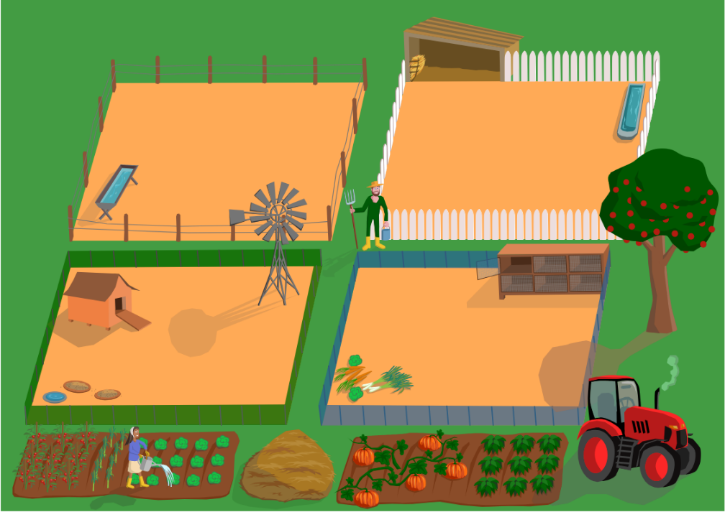

2.
1.

4.
3.

- What was one of Karstyn’s least favorite jobs around the farm?

- How do you count joy in the simple things?

- Karstyn shared the names of nine FFA members who not only count joy but share joy as well. List the names and stories of three members.

- Who in your life has shared joy with you? What did they do?

- How do you share joy with those around you?

- Ryan Best, one of Karstyn’s trusted mentors, once told her that “nothing comes in or out of a closed fist.” What does this mean?

- What does actively living “palms up” mean to you?

Part 2
Directions:
Karstyn Cantrell, 2022-23 National FFA Central Region Vice President, challenged us to count our joys. She shares in her retiring address that she keeps a journal to count her joys. In the space provided, reflect on this past year and create a scrapbook page centered around items you counted as joy. Please provide specific instances and pictures.


- Why is finding, counting and sharing joy important?

KEY: Count Joy
Aligned to the following standards:
FFA.PL-A; FFA.PL-D; FFA.PG-J; CCSS.ELA-Literacy.W.9-10.4; CRP.02; CRP.04
Part 1
Directions:
Answer the following questions while watching the retiring address of 2022-23 National FFA Central Region Vice President Karstyn Cantrell, “Count Joy.” The video is available at https://vimeo.com/883072933.

- Karstyn shared four jobs she had around her family farm. What were they?

2. Filling syringes with meds
- Opening gates

4. Herding cows
3. Filling water troughs

- What was one of Karstyn’s least favorite jobs around the farm?
Herding cows

- How do you count joy in the simple things?
Answers will vary.

- Karstyn shared the names of nine FFA members who not only count joy but share joy as well. List the names and stories of three members.
Answers will vary but should include three of the following: Ellie (10:53), Carly, Ester, Lexi, Brooke, Chloe, Ella, Gracie, Lucy.

- Who in your life has shared joy with you? What did they do?
Answers will vary.

- How do you share joy with those around you?
Answers will vary.

- Ryan Best, one of Karstyn’s trusted mentors, once told her that “nothing comes in or out of a closed fist.” What does this mean?
It means we cannot receive joy if we close ourselves off to it, and we can’t share joy if we never try to give it away.

- What does actively living “palms up” mean to you?
Answers will vary.

Part 2
Directions:
Karstyn Cantrell, 2022-23 National FFA Central Region Vice President, challenged us to count our joys. She shares in her retiring address that she keeps a journal to count her joys. In the space provided, reflect on this past year and create a scrapbook page centered around items you counted as joy. Please provide specific instances and pictures.
Answers will vary.

- Why is finding, counting and sharing joy important?
Answers will vary.

