Composting
Created: 07/2020 by the National FFA Organization

Kayley Pennington and Cheyenne Bolender’s supervised agricultural experience (SAE) program is composting food waste from their school cafeteria. Discover how they got the entire school involved in their composting efforts and how they use the compost in their agricultural education program.

Student Learning Objectives:
After completing these activities, students will …
- Explain how composting works.
- Identify and describe the five areas that must be controlled for composting to be successful.
- Examine the phases of composting and the bacteria involved in the process.

Time Required: 60 minutes
Resources/References:
- Video: “Composting SAE | Kayley Pennington and Cheyenne Bolender,” https://vimeo.com/368429355
- Article: “The Science Behind Composting,” https://www.livescience.com/63559-composting.html
- Website: Understanding the Process, https://www.epa.gov/sustainable-management-food/types-composting-and-understanding-process
- Article: “Compost Microorganisms,” http://compost.css.cornell.edu/microorg.html

Equipment and Supplies Needed:
- A copy of the “No Food Waste” worksheet for each student
- A copy of the “Heat It Up!” worksheet for each student
- Internet access to play the video in real time or embed it in a PowerPoint ahead of time

Student activity sheets:
Direct access to student activity sheets without lesson plan or answer key for easy upload to learning management system or printing for classwork.
https://ffa.box.com/s/zs31q73navdlzaj7cy1ikag22pu9o0d9 (Word)
https://ffa.box.com/s/xted4rqron2rpf05kq4hdj5uy5wej1ie (PDF)

Cross-Curricular Connections:
Science
Examine the phases of composting and the bacteria involved in the process.

These activities are aligned to the following standards:

AFNR Performance Element
- ESS.04. Demonstrate the operation of environmental service systems (e.g., pollution control, water treatment, wastewater treatment, solid waste management and energy conservation).
FFA Precept
- FFA.PL-A.Action: Assume responsibility and take the necessary steps to achieve the desired results, no matter what the goal or task at hand.
- FFA.PG-J.Mental Growth: Embrace cognitive and intellectual development relative to reasoning, thinking and coping.
- FFA-CS-M.Communication: Effectively interact with others in personal and professional settings.
Common Career Technical Core
- AG-ENV4 Demonstrate the operation of environmental service systems (e.g., pollution control, water treatment, wastewater treatment, solid waste management and energy conservation).
NASDCTEc
- AGPF01.04 Operate environmental service systems (e.g., pollution control, water treatment, wastewater treatment, solid waste treatment, and energy) to manage a facility environment.
AFNR Cluster Skills
- CS.02. Evaluate the nature and scope of the Agriculture, Food, and Natural Resources Career Cluster and the role of agriculture, food, and natural resources (AFNR) in society and the economy.
- CS.04. Demonstrate stewardship of natural resources in AFNR activities.
- CS.06. Analyze the interaction among AFNR system in the production, processing and management of food, fiber and fuel and the sustainable use of natural resources.
Common Core – Science & Technical Subjects
- CCSS.ELA-Literacy.RST.9.10.2 Determine the central ideas or conclusions of a text; trace the text's explanation or depiction of a complex process, phenomenon, or concept; provide an accurate summary of the text.
- CCSS.ELA-Literacy.RST.9.10.4 Determine the meaning of symbols, key terms, and other domain-specific words and phrases as they are used in a specific scientific or technical context relevant to grades 9-10 texts and topics.
- CCSS.ELA-Literacy.RST.9.10.8 Assess the extent to which the reasoning and evidence in a text support the author's claim or a recommendation for solving a scientific or technical problem.
- CCSS.ELA-Literacy.RST.9-10.10 By the end of grade 10, read and comprehend science/technical texts in grades 9-10 text complexity band independently and proficiently.
- CCSS.ELA-Literacy.RST.11-12.2 Determine the central ideas or conclusions of a text; summarize complex concepts, processes, or information presented in a text by paraphrasing them in simpler but still accurate terms.
Common Core – Literacy in Science & Technical Subjects: Writing
- CCSS.ELA-Literacy.WHST.9-10.4 Produce clear and coherent writing in which the development, organization, and style are appropriate to task, purpose, and audience.
- CCSS.ELA-Literacy.WHST.9-10.7 Conduct short as well as more sustained research projects to answer a question (including a self-generated question) or solve a problem; narrow or broaden the inquiry when appropriate; synthesize multiple sources on the subject, demonstrating understanding of the subject under investigation.
- CCSS.ELA-Literacy.WHST.9-10.8 Gather relevant information from multiple authoritative print and digital sources, using advanced searches effectively; assess the usefulness of each source in answering the research question; integrate information into the text selectively to maintain the flow of ideas, avoiding plagiarism and following a standard format for citation.
- CCSS.ELA-Literacy.WHST.9-10.9 Draw evidence from informational texts to support analysis, reflection, and research.
- CCSS.ELA-Literacy.WHST.11-12.9 Draw evidence from informational texts to support analysis, reflection, and research.
Next Generation Science
- HS-ETS1-3 Evaluate a solution to a complex real-world problem based on prioritized criteria and trade-offs that account for a range of constraints, including cost, safety, reliability, and aesthetics as well as possible social, cultural, and environmental impacts.
AFNR Career Ready Practices
- CRP.02. Apply appropriate academic and technical skills. Career-ready individuals readily access and use the knowledge and skills acquired through experience and education to be more productive.
- CRP.04. Communicate clearly, effectively, and with reason. Career-ready individuals communicate thoughts, ideas and action plans with clarity, whether using written, verbal and/or visual methods.
- CRP.07. Employ valid and reliable research strategies. Career-ready individuals are discerning in accepting and using new information to make decisions, change practices or inform strategies.
- CRP.08. Utilize critical thinking to make sense of problems and persevere in solving them. Career-ready individuals readily recognize problems in the workplace, understand the nature of the problem, and devise effective plans to solve the problem.
Partnership for 21st Century Skills
- Critical Thinking and Problem Solving
- Environmental Literacy
- Information Literacy
- Productivity and Accountability

Lesson Plan:
- Bell Ringer: What do you do with food waste and scraps at your home? How much food do you think is thrown away in your home every day?

- Introduction: The United States Department of Agriculture (USDA) says that in the U.S. we waste 30 to 40 percent of the food supply. Where does all this food waste go? Can we put it to better use? Today, we’ll learn how two FFA members used their SAE to turn cafeteria food waste into something useful.

- Activity: Each student needs a copy of the worksheet “No Food Waste.” Show the video “Composting SAE | Kayley Pennington and Cheyenne Bolender,” available at https://vimeo.com/368429355, and have students complete the worksheet as they watch. Once students are finished with the video, give students a copy of the worksheet “Heat It Up!” Students will learn about the basics of composting: how it works, what elements need to be controlled and how bacteria work in phases to speed decomposition.

- Follow-up: Have a class discussion on the feasibility of creating a similar composting program at your school. Would the entire student body and the administration be receptive to the idea? How might their concerns be overcome? If you already have a similar program at your school, discuss ways the program could be improved.

- Optional — Extended Learning Opportunities (Not factored into time requirement):
  - Divide students into groups and have them develop a detailed plan for creating and implementing a composting program at your school. If you school already has a program, have students develop a plan to either expand the program into nearby schools or improve the program already in place.

- Exit Ticket: Would it be possible for you to compost at your home? Why or why not? If you can’t, what are other ways you could reduce your family’s food waste?

No Food Waste
Aligned to the following standards:
ESS.04; PL-A.; PG-J; CS-M; AG-ENV4; AGPF01.04; CS.02; CS.04; CS.06; CCSS.RST.9-10.2; CCSS.RST.9-10.4; CCSS.RST.9-10.8; CCSS.RST.9-10.10; CCSS.RST.11-12.2; CCSS.WHST.9-10.4; CCSS.WHST.9-10.7; CCSS.WHST.9-10.8; CCSS.WHST.9-10.9; CCSS.WHST.11-12.9; HS-ETS1-3; CRP.02; CRP.04; CRP.07; CRP.08
Directions:
Answer the questions below as you watch the video “Composting SAE | Kayley Pennington and Cheyenne Bolender,” available at https://vimeo.com/368429355.

What is Kayley and Cheyenne’s SAE?

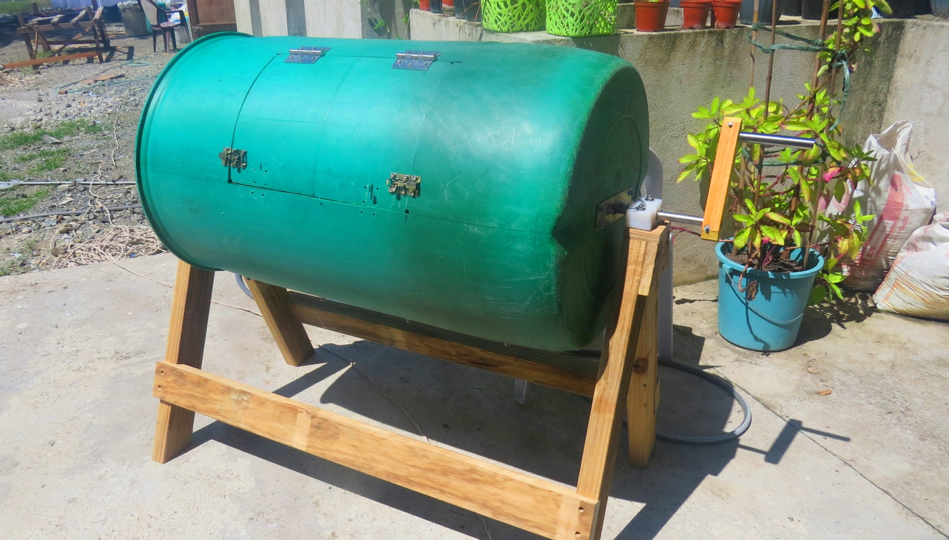
Where did they get the get the idea for their compost bin design?

How did they build their compost bin?

What tasks do they do on Friday afternoons?



How did they introduce the composting project to the entire school and get them on board?

What is Kayley and Cheyenne’s favorite part of their SAE?

Who has helped them the most with their SAE?

Heat It Up!
Aligned to the following standards:
ESS.04; PL-A.; PG-J; CS-M; AG-ENV4; AGPF01.04; CS.02; CS.04; CS.06; CCSS.RST.9-10.2; CCSS.RST.9-10.4; CCSS.RST.9-10.8; CCSS.RST.9-10.10; CCSS.RST.11-12.2; CCSS.WHST.9-10.4; CCSS.WHST.9-10.7; CCSS.WHST.9-10.8; CCSS.WHST.9-10.9; CCSS.WHST.11-12.9; HS-ETS1-3; CRP.02; CRP.04; CRP.07; CRP.08
Directions:
Learn more about how composting works by completing the following activities.

- What is composting? (Suggested Resource: “The Science Behind Composting,” https://www.livescience.com/63559-composting.html)

- In the table below, list the five areas that need to be monitored and controlled during composting. Then, explain how those five areas are controlled. (Suggested Resource: Understanding the Process, https://www.epa.gov/sustainable-management-food/types-composting-and-understanding-process)

Area | Description

- Research the phases of composting and discover how the different types of bacteria work together to break down organic matter. Use the information you gather to complete the following chart. (Suggested Resource: “Compost Microorganisms,” http://compost.css.cornell.edu/microorg.html)

Phase | Bacteria Involved | Temperature | What Is Happening in This Phase?

KEY: No Food Waste
Aligned to the following standards:
ESS.04; PL-A.; PG-J; CS-M; AG-ENV4; AGPF01.04; CS.02; CS.04; CS.06; CCSS.RST.9-10.2; CCSS.RST.9-10.4; CCSS.RST.9-10.8; CCSS.RST.9-10.10; CCSS.RST.11-12.2; CCSS.WHST.9-10.4; CCSS.WHST.9-10.7; CCSS.WHST.9-10.8; CCSS.WHST.9-10.9; CCSS.WHST.11-12.9; HS-ETS1-3; CRP.02; CRP.04; CRP.07; CRP.08
Directions:
Answer the questions below as you watch the video “Composting SAE | Kayley Pennington and Cheyenne Bolender,” available at https://vimeo.com/368429355.

What is Kayley and Cheyenne’s SAE?
Taking food scraps, which are given to them by other students, from the cafeteria and composting it to create healthy soil for the agriculture department

Where did they get the get the idea for their compost bin design?

They researched what methods of composting were best with the least smell that could break down large amounts of food. They learned that a tumbler bin met all their requirements.
How did they build their compost bin?

They bought a recycled barrel, rebar and wooden planks to put it all together.

What tasks do they do on Friday afternoons?

They collect the food waste bins from the cafeteria and move them to the compost bin.

They add the waste to the compost bin and then spin the compost bin to mix everything and eventually create the soil.
How did they introduce the composting project to the entire school and get them on board?

To introduce the composting project, they talked to all the students during their lunches to discuss what composting was, what the bins in the lunchroom were for, and what could and could not go into the bins.
What is Kayley and Cheyenne’s favorite part of their SAE?

Seeing students taking part in changing the environment by putting food scraps into the bins
Who has helped them the most with their SAE?

Their agriculture teacher, principal and the student body
KEY: Heat It Up!
Aligned to the following standards:
ESS.04; PL-A.; PG-J; CS-M; AG-ENV4; AGPF01.04; CS.02; CS.04; CS.06; CCSS.RST.9-10.2; CCSS.RST.9-10.4; CCSS.RST.9-10.8; CCSS.RST.9-10.10; CCSS.RST.11-12.2; CCSS.WHST.9-10.4; CCSS.WHST.9-10.7; CCSS.WHST.9-10.8; CCSS.WHST.9-10.9; CCSS.WHST.11-12.9; HS-ETS1-3; CRP.02; CRP.04; CRP.07; CRP.08
Directions:
Learn more about how composting works by completing the following activities.

- What is composting? (Suggested Resource: “The Science Behind Composting,” https://www.livescience.com/63559-composting.html)

Composting is a process that works to speed up the natural decay of organic material by providing the ideal conditions for detritus-eating organisms to thrive, according to the United States Department of Agriculture (USDA). The end-product of this concentrated decomposition process is nutrient-rich soil that can help crops, garden plants and trees to grow.

- In the table below, list the five areas that need to be monitored and controlled during composting. Then, explain how those five areas are controlled. (Suggested Resource: Understanding the Process, https://www.epa.gov/sustainable-management-food/types-composting-and-understanding-process)

Area | Description
Feedstock and Nutrient Balance | Composting, or controlled decomposition, requires a proper balance of “green” organic materials and “brown” organic materials. “Green” organic material includes grass clippings, food scraps and manure, which contain large amounts of nitrogen. “Brown” organic materials include dry leaves, wood chips and branches, which contain large amounts of carbon but little nitrogen. Obtaining the right nutrient mix requires experimentation and patience. It is part of the art and science of composting.
Particle Size | Grinding, chipping and shredding materials increases the surface area on which microorganisms can feed. Smaller particles also produce a more homogeneous compost mixture and improve pile insulation to help maintain optimum temperatures. If the particles are too small, however, they might prevent air from flowing freely through the pile.
Moisture Content | Microorganisms living in a compost pile need enough moisture to survive. Water is the key element that helps transports substances within the compost pile and makes the nutrients in organic material accessible to the microbes. Organic material contains some moisture in varying amounts, but moisture also might come in the form of rainfall or intentional watering.
Oxygen Flow | Turning the pile, placing the pile on a series of pipes or including bulking agents such as wood chips and shredded newspaper all help aerate the pile. Aerating the pile allows decomposition to occur at a faster rate than anaerobic conditions. Care must be taken, however, not to provide too much oxygen, which can dry out the pile and impede the composting process.
Temperature | Microorganisms require a certain temperature range for optimal activity. Certain temperatures promote rapid composting and destroy pathogens and weed seeds. Microbial activity can raise the temperature of the pile’s core to at least 140° F. If the temperature does not increase, anaerobic conditions (i.e., rotting) occur. Controlling the previous four factors can bring about the proper temperature.

- Research the phases of composting and discover how the different types of bacteria work together to break down organic matter. Use the information you gather to complete the following chart. (Suggest Resource: “Compost Microorganisms,” http://compost.css.cornell.edu/microorg.html)

Phase | Microorganisms Involved | Temperature | What Is Happening in This Phase? | Length of Phase
Mesophilic (moderate-temperature) | Mesophilic bacteria  Fungi | Less than 40°C | Initial decomposition is carried out by mesophilic microorganisms, which rapidly break down the soluble, readily degradable compounds. The heat they produce causes the compost temperature to rapidly rise. | A couple of days
Thermophilic (high-temperature) | Thermophilic bacteria (early part of phase is genus Bacillus and later part is genus Thermus)  Actinomycetes  Fungi | 40°C to 55°C must be kept less than 65°C because kills microbes and limits the decomposition | During the thermophilic phase, high temperatures accelerate the breakdown of proteins, fats and complex carbohydrates like cellulose and hemicellulose, the major structural molecules in plants. | A few days to several months
Cooling and Maturation | Mesophilic bacteria  Actinomycetes | Cools from 55°C to less than 40°C | As the supply of the high-energy compounds from the thermophilic phase becomes exhausted, the compost temperature gradually decreases, and mesophilic microorganisms once again take over for the final phase of "curing" or maturation of the remaining organic matter. | Several months

