Keep Clam
Aligned to the following standards:
AS.06; FFA.PL-A; FFA.PG-J; AG-ANI6; CCSS.RI.9-10.1; CCSS.SL.9-10.4; MP6; CRP.02; CRP.07
Directions:
Read over this worksheet and answer the questions as you watch “Specialty Animal Production – Seafood SAE | Kent Sloan,” available at https://vimeo.com/368426767.

What are Kent’s responsibilities?

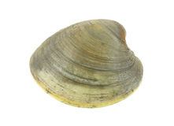

Explain the purpose of the tumbler.

How does the clam grader work?
Why is it important to grade clams?
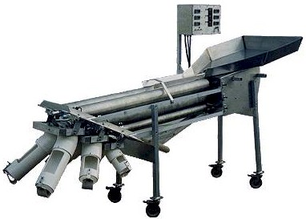
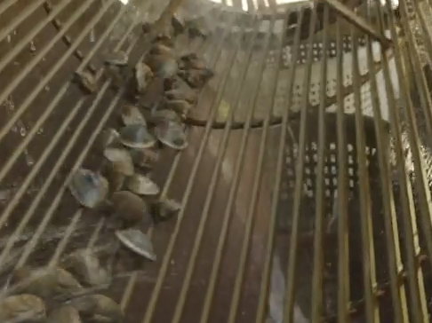

Why is Kent’s job important?
What is Kent’s favorite thing about his SAE?



Dig Into Clams
Aligned to the following standards:
AS.06; FFA.PL-A; FFA.PG-J; AG-ANI6; CCSS.RI.9-10.1; CCSS.SL.9-10.4; MP6; CRP.02; CRP.07
Directions:
Using the website “Basic Bivalve Biology: Taxonomy, Anatomy and Life History” from the Food and Agriculture Organization (http://www.fao.org/3/y5720e/y5720e07.htm#bm07.1), complete the following activities to learn more about the anatomy of clams and the life cycle of scallops.

Part 1

Label the external anatomy of a clam.

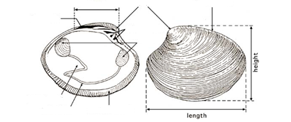
Adapted from “Hatchery Culture of Bivalves,” 2004, http://www.fao.org/3/y5720e/y5720e00.htm

Label the internal anatomy of a clam, and then answer the related questions.
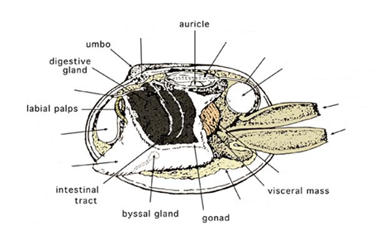
Adapted from “Hatchery Culture of Bivalves,” 2004, http://www.fao.org/3/y5720e/y5720e00.htm
How do the adductor muscles work?
What is the purpose of the gills?
Why is the foot so well-developed in clams?

Part 2
Aligned to the following standards:
AS.06; FFA.PL-A; FFA.PG-J; AG-ANI6; CCSS.RI.9-10.1; CCSS.SL.9-10.4; MP6; CRP.02; CRP.07

Label the parts of the developmental stages of a scallop (another type of bivalve, like a clam). Explain what happens during each stage in the boxes below the image.
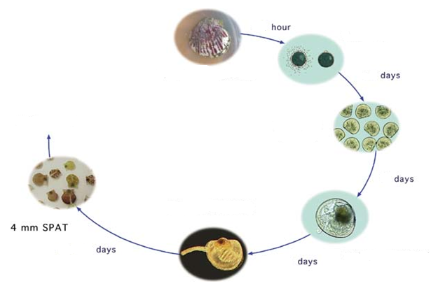
Adapted from “Hatchery Culture of Bivalves,” 2004, http://www.fao.org/3/y5720e/y5720e00.htm

Fertilization

D-Larva
Mature Larvae

Metamorphosis/
Early Juvenile
How might an in-depth understanding of the developmental stages of a scallop be beneficial in the agriculture industry? In what career areas would this information be most helpful?

