Clams
Created: 03/2019 by the National FFA Organization

Kent’s supervised agricultural experience (SAE) program involves working in his family’s seafood business. Follow along as he shares details about clam production from harvesting to processing.
Student Learning Objectives:
After completing these activities, students will …
- Explain the purpose of clam processing equipment.
- Label the external and internal anatomy of a clam.
- Summarize the development stages of a bivalve.

Time Required: 90 minutes
Resources/References:
- Video: “Specialty Animal Production – Seafood SAE | Kent Sloan,” https://vimeo.com/368426767
- Website: “Basic Bivalve Biology: Taxonomy, Anatomy and Life History,” http://www.fao.org/3/y5720e/y5720e07.htm#bm07.1

Equipment and Supplies Needed:
- A copy of the “Keep Clam” worksheet for each student
- A copy of the “Dig Into Clams” worksheet for each student
- Internet access to play the video in real time or embed it in a PowerPoint ahead of time
- Technology access for students to find information about bivalves (clams)

student activity sheets:
Direct access to student activity sheets without lesson plan or answer key for easy upload to learning management systems or printing for classwork.
https://ffa.box.com/s/ltubts6rkb39oipe00jscjfon8jjao6o (Word)
https://ffa.box.com/s/67ip9c9p3uy7p88ye5rbvkvg6qyfhmcf (PDF)

Cross-Curricular Connections:
Science
Label and explain the anatomy and development stages of a bivalve

These activities are aligned to the following standards:
AFNR Performance Element
- AS.06. Classify, evaluate, and select animals based on anatomical and physiological characteristics.
FFA Precept
- FFA.PL-A.Action: Assume responsibility and take the necessary steps to achieve the desired results, no matter what the goal or task at hand.
- FFA.PG-J.Mental Growth: Embrace cognitive and intellectual development relative to reasoning, thinking and coping.
Common Career Technical Core
- AG-ANI6 Classify, evaluate, and select animals based on anatomical and physiological characteristics.
Common Core – Reading: Informational Text
- CCSS.ELA-Literacy.RI.9-10.1 Cite strong and thorough textual evidence to support analysis of what the text says explicitly as well as inferences drawn from the text.
Common Core – Speaking and Listening
- CCSS.ELA-Literacy.SL.9-10.4 Present information, findings, and supporting evidence clearly, concisely, and logically such that listeners can follow the line of reasoning and the organization, development, substance, and style are appropriate to purpose, audience, and task.
AFNR Career Ready Practices
- CRP.02. Apply appropriate academic and technical skills. Career-ready individuals readily access and use the knowledge and skills acquired through experience and education to be more productive.
- CRP.07. Employ valid and reliable research strategies. Career-ready individuals are discerning in accepting and using new information to make decisions, change practices or inform strategies.
Partnership for 21st Century Skills
- Information Literacy
Lesson Plan:
- Bell Ringer: On their own paper, have students respond to this question: Do you like seafood? Why or why not?

- Introduction: For students who live in coastal areas, supervised agricultural experience (SAE) programs involving seafood can be common. Today, we will learn about one student’s SAE working at his family’s seafood company. Then, we’ll dig a little deeper into information about a specific type of seafood known as bivalves, which includes clams and scallops.

- Activity:
  - Each student needs a copy of the worksheet “Keep Clam.” As students watch “Specialty Animal Production – Seafood SAE | Kent Sloan” (https://vimeo.com/368426767), they should complete the worksheet.
  - After the video is finished, give each student a copy of the “Dig Into Clams” worksheet. They will use the website “Basic Bivalve Biology: Taxonomy, Anatomy and Life History” from the Food and Agriculture Organization (http://www.fao.org/3/y5720e/y5720e07.htm#bm07.1) to learn about bivalves and complete the worksheet. Before students complete the worksheet, ask students why it is important to learn about the anatomy and physiology of different living things. Through the discussion, help students arrive at the concept that by learning about the differences and similarities among diverse creatures (humans, horses, cattle, clams, snails, worms, etc.), we can have a better understanding of how our ecosystem works as a whole and learn to classify animals by their differences and similarities.
    - The worksheet has two parts. In the first part, students will label the internal and external anatomy of a clam. In the second part of the worksheet, they will label and explain the developmental stages of a scallop.

- Follow-up: Have a class discussion about the unique anatomical features of clams that allow them to move and eat.
  - Alternative: If you live in an area where fresh seafood is not readily available or if you are in a landlocked state, have a class discussion about what it would be like to live and work in and near the ocean every day.

- Optional — Extended Learning Opportunities (Not factored into time requirement):
  - This should take 30 minutes.
  - If you live in an area where fresh seafood is not readily available, have students find a clam recipe online that appeals to them and then share it with the class.
  - If you live in an area where fresh seafood is common, have students bring in their family’s favorite seafood recipe and compile a class seafood cookbook.

- Exit Ticket: Have students respond to this prompt: In the video, Kent said that good work ethic and paying attention were important because it could save someone’s life. Have you ever considered that working hard could have that big of an affect? Do you agree or disagree with Kent? Why or why not?

Keep Clam
Aligned to the following standards:
AS.06; FFA.PL-A; FFA.PG-J; AG-ANI6; CCSS.RI.9-10.1; CCSS.SL.9-10.4; MP6; CRP.02; CRP.07
Directions:
Read over this worksheet and answer the questions as you watch “Specialty Animal Production – Seafood SAE | Kent Sloan,” available at https://vimeo.com/368426767.

What are Kent’s responsibilities?

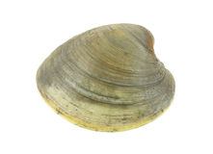

Explain the purpose of the tumbler.

How does the clam grader work?
Why is it important to grade clams?
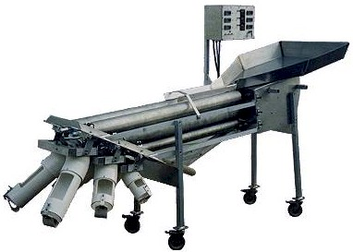
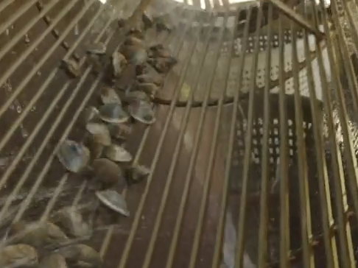

Why is Kent’s job important?
What is Kent’s favorite thing about his SAE?



Dig Into Clams
Aligned to the following standards:
AS.06; FFA.PL-A; FFA.PG-J; AG-ANI6; CCSS.RI.9-10.1; CCSS.SL.9-10.4; MP6; CRP.02; CRP.07
Directions:
Using the website “Basic Bivalve Biology: Taxonomy, Anatomy and Life History” from the Food and Agriculture Organization (http://www.fao.org/3/y5720e/y5720e07.htm#bm07.1), complete the following activities to learn more about the anatomy of clams and the life cycle of scallops.

Part 1

Label the external anatomy of a clam.

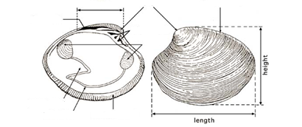
Adapted from “Hatchery Culture of Bivalves,” 2004, http://www.fao.org/3/y5720e/y5720e00.htm

Label the internal anatomy of a clam, and then answer the related questions.
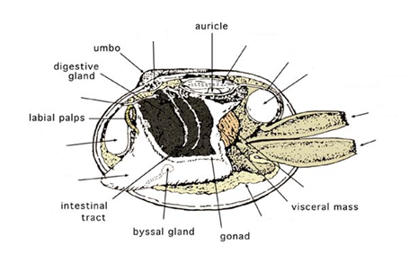
Adapted from “Hatchery Culture of Bivalves,” 2004, http://www.fao.org/3/y5720e/y5720e00.htm
How do the adductor muscles work?
What is the purpose of the gills?
Why is the foot so well-developed in clams?

Part 2
Aligned to the following standards:
AS.06; FFA.PL-A; FFA.PG-J; AG-ANI6; CCSS.RI.9-10.1; CCSS.SL.9-10.4; MP6; CRP.02; CRP.07

Label the parts of the developmental stages of a scallop (another type of bivalve, like a clam). Explain what happens during each stage in the boxes below the image.
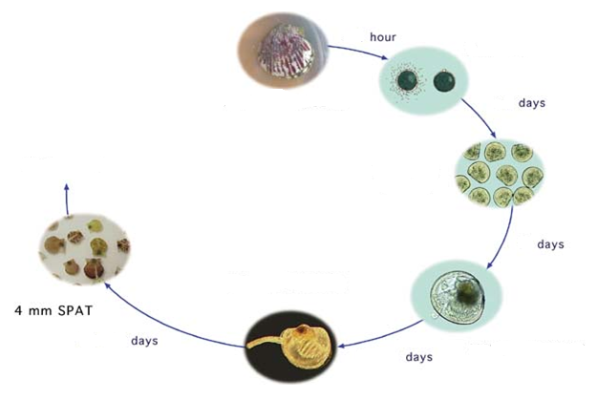
Adapted from “Hatchery Culture of Bivalves,” 2004, http://www.fao.org/3/y5720e/y5720e00.htm

Fertilization

D-Larva
Mature Larvae

Metamorphosis/
Early Juvenile
How might an in-depth understanding of the developmental stages of a scallop be beneficial in the agriculture industry? In what career areas would this information be most helpful?
KEY: Keep Clam
Aligned to the following standards:
AS.06; FFA.PL-A; FFA.PG-J; AG-ANI6; CCSS.RI.9-10.1; CCSS.SL.9-10.4; MP6; CRP.02; CRP.07
Directions:
Read over this worksheet and answer the questions as you watch “Specialty Animal Production – Seafood SAE | Kent Sloan,” available at https://vimeo.com/368426767.

What are Kent’s responsibilities?

Set up the tumbler for processing Grade and sort clams

Harvest clams Repair nets and bags

Explain the purpose of the tumbler.

The tumbler separates the live clams from the dead clams and empty shells. It removes everything that doesn’t need to be there.

How does the clam grader work?
The grader sorts clams by size, 1 inch and 7/8 inches.
Why is it important to grade clams?
Different sizes have different market value and use.

Why is Kent’s job important?

In the seafood industry, if you don’t do things right, people can get sick.
What is Kent’s favorite thing about his SAE?

Working in his family’s business, being with family and being on the water

KEY: Dig Into Clams
Aligned to the following standards:
AS.06; FFA.PL-A; FFA.PG-J; AG-ANI6; CCSS.RI.9-10.1; CCSS.SL.9-10.4; MP6; CRP.02; CRP.07
Directions:
Using the website “Basic Bivalve Biology: Taxonomy, Anatomy and Life History” from the Food and Agriculture Organization (http://www.fao.org/3/y5720e/y5720e07.htm#bm07.1), complete the following activities to learn more about the anatomy of clams and the life cycle of scallops.

Part 1

Label the external anatomy of a clam.
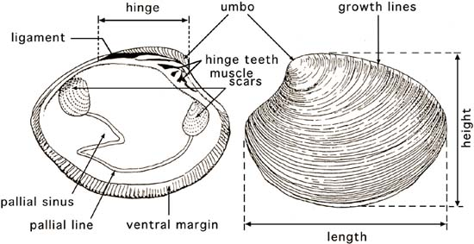
From “Hatchery Culture of Bivalves,” 2004, http://www.fao.org/3/y5720e/y5720e00.htm

Label the internal anatomy of a clam, and then answer the related questions.
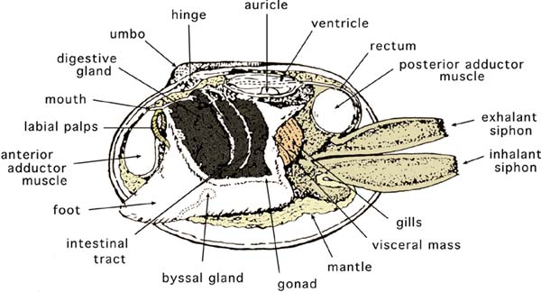
From “Hatchery Culture of Bivalves,” 2004, http://www.fao.org/3/y5720e/y5720e00.htm
How do the adductor muscles work?
The muscles close the valves and spring the valves open when the muscles relax. The large, anterior muscle is the "quick muscle" and contracts to close the valves shut; the smaller, smooth part, the "catch muscle," holds the valves in position when they have been closed or partially closed.

What is the purpose of the gills?
They are large leaf-like organs that are used partly for respiration and partly for filtering food from the water. Two pairs of gills are located on each side of the body. At the anterior end, two pairs of flaps, termed labial palps, surround the mouth and direct food into the mouth.

Why is the foot so well-developed in clams?
The organ is used to burrow into the substrate and anchor the animal in position.

Part 2
Aligned to the following standards:
AS.06; FFA.PL-A; FFA.PG-J; AG-ANI6; CCSS.RI.9-10.1; CCSS.SL.9-10.4; MP6; CRP.02; CRP.07
Label the parts of the developmental stages of a scallop (another type of bivalve, like a clam). Explain what happens during each stage in the boxes below the image.
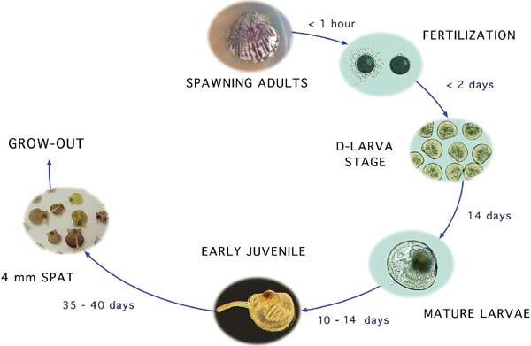
From “Hatchery Culture of Bivalves,” 2004, http://www.fao.org/3/y5720e/y5720e00.htm
Fertilization
Cell division begins and within thirty minutes after fertilization the egg divides into the two-celled stage. The eggs are heavier than water and sink to the bottom of the tank where cell division continues.

D-Larva
The larva has two valves, a complete digestive system and an organ called the velum that is peculiar to bivalve larvae. When the larva swims through the water column the velum collects phytoplankton upon which the larva feeds.

Mature Larvae
When larvae approach maturity, a foot develops and gill rudiments become evident. Small dark circular dots, the eye-spots, develop near the center of each valve of some species. Between periods of swimming activity, larvae settle and use the foot to crawl on a substrate. When a suitable substrate is found the larva is ready to metamorphose.

Metamorphosis/
Early Juvenile
Metamorphosis is a critical time in the development of bivalves, during which the animal changes from a swimming, planktonic to a sedentary benthic existence. After metamorphosis they enter the early juvenile stage and begin to grow. Growth rate is greatly affected by climate, location in the subtidal or intertidal zones and genetic makeup. Growth can also vary greatly from year to year and in temperate areas there are seasonal patterns in growth.

How might an in-depth understanding of the developmental stages of a scallop be beneficial in the agriculture industry? In what career areas would this information be most helpful?
Answers will vary.

