Humbly Known
Created: 11/2020 by the National FFA Organization

Retiring Address Video Summary: Humility is a skill that each person needs to be able to recognize and acknowledge. In this retiring address, 2019-20 National FFA President Kolesen McCoy shares how humility will help lead each of us to recognize our strengths and act upon them.
Student Learning Objectives:
After completing these activities, students will …
- Describe humility.
- Describe how they can meet people where they are.
- Identify their strengths.
- Create a list of strengths and the impact of those strengths.

Time Required: 45 minutes
Resources/References:
- Video: “Humbly Known | Kolesen McCoy Retiring Address,” https://vimeo.com/showcase/7865594/video/477811062

Equipment and Supplies Needed:
- A copy of the “Humbly Known” worksheet for each student
- Internet access to play the video in real time or embed it in a PowerPoint ahead of time

Cross-Curricular Connections:
English/Language Arts
Students develop acts of kindness based on their strengths.

Student Activity Sheets:
Direct access to student activity sheets without lesson plan or answer key for easy upload to a learning management system or printing for classwork.

https://ffa.box.com/s/je6kbu6q2jzs4l9rbysku28ujhflw69y (Word)
https://ffa.box.com/s/tpy2r3z0rf1vgn7dm92lketh28v1b0hc (Non-Designed)
https://ffa.box.com/s/s3gnslnrdyoqc1b1mv0bqikgvhbeoznz (PDF)

These activities are aligned to the following standards:

FFA Precept
- FFA.PL-A.Action: Assume responsibility and take the necessary steps to achieve the desired results, no matter what the goal or task at hand.
- FFA.PL-C.Vision: Visualize the future and how to get there.
- FFA.PL-E.Awareness: Understand personal vision, mission and goals.
- FFA.PG-J.Mental Growth: Embrace cognitive and intellectual development relative to reasoning, thinking and coping.
- FFA.CS-N.Decision Making: Analyze a situation and execute an appropriate course of action.

Common Core – Writing
- CCSS.ELA-Literacy.W.9-10.4: Produce clear and coherent writing in which the development, organization, and style are appropriate to task, purpose, and audience.

AFNR Career Ready Practices
- CRP.02: Apply appropriate academic and technical skills. Career-ready individuals readily access and use the knowledge and skills acquired through experience and education to be more productive.
- CRP.04: Communicate clearly, effectively, and with reason. Career-ready individuals communicate thoughts, ideas and action plans with clarity, whether using written, verbal and/or visual methods.
- CRP.06: Demonstrate creativity and innovation. Career-ready individuals regularly think of ideas that solve problems in new and different ways, and they contribute those ideas in a useful and productive manner to improve their organization.
- CRP.08: Utilize critical thinking to make sense of problems and persevere in solving them. Career-ready individuals readily recognize problems in the workplace, understand the nature of the problem, and devise effective plans to solve the problem.

Partnership for 21st Century Skills
- Critical Thinking and Problem Solving
- Flexibility and Adaptability
- Initiative and Self-Direction
- Leadership and Responsibility

Lesson Plan:
- Bell Ringer: What does humility mean?

- Introduction: Today, we are going to watch a retiring address from the 93rd National Convention & Expo. This retiring address was given by the 2019-20 National FFA President Kolesen McCoy. In his speech, we learn how we need to have humility and use our strengths to meet people where they are.

Hand out the worksheet “Humbly Known.” Before watching the video, look over the questions on the “Humbly Known” worksheet, and be ready to listen for the answers as you view the video.

- Activity:
  - Part 1: Each student needs a copy of the worksheet “Humbly Known.” Students will then watch the retiring address of 2019-20 National FFA President Kolesen McCoy and complete the activities. The video “Humbly Known | Kolesen McCoy Retiring Address” is available at https://vimeo.com/showcase/7865594/video/477811062.
  - Part 2: As we heard from Kolesen, we need to recognize our strengths and act upon them. Have students identify four personal strengths and then determine how they can use them to benefit others and the impact of their strengths. Examples of strengths: creative thinker, good artist or musician, positive attitude, etc.

- Follow-up: Have student share one strength of their choice and how they are going to use that strength to help others and the impact it will have.

- Optional — Extended Learning Opportunities (Not factored into time requirement):
  - Have students perform the acts of kindness they brainstormed in their strengths chart and journal their thoughts and results.

- Exit Ticket: What is humility, and how does it apply to your life?

Humbly Known
Aligned to the following standards:
FFA.PL-A; FFA.PL-C; FFA.PL-E; FFA.PG-J; FFA.CS-N; CCSS.ELA.W.9-10.4; CRP.02; CRP.04; CRP.06; CRP.08
Part 1
Directions:
Fill in the blanks and answer the questions while watching “Humbly Known,” retiring address of 2019-20 National FFA President Kolesen McCoy. The video is available at https://vimeo.com/showcase/7865594/video/477811062.





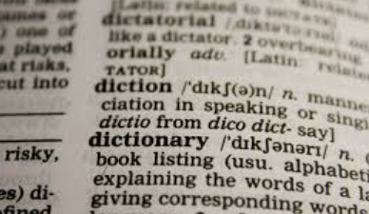

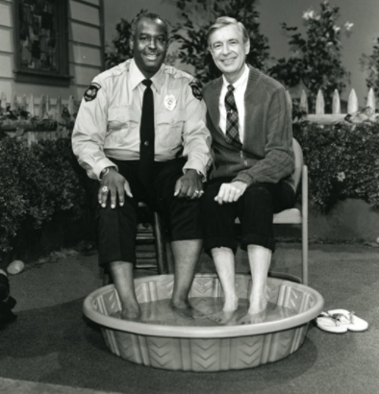
What is humility according to Kolesen?
Our _______________ would be to our _________________, and we would look for ways to ___________________ serve the people around us.
Our ______________ would be to our _______________ and to our ____________, and we would be able to _______________ the ________________________ and ______________________ we make upon those every day.
Is there someone who has set everything aside to be there for you? Explain your answer.
What does humility mean according to the dictionary?
Why does Kolesen love hotels?

- You get your own space
- People clean up after you
- You can build forts
- The floor is always lava
- All of the above
How does Russell show people who he is?
________________ has to be something that we ______________.
How can you meet someone where they are?
Emily recognizes her strengths and acts upon them. Where is Emily from?

- Indiana
- Alabama
- California
- Texas
- Michigan
“It’s our job to encourage each other to discover our uniqueness and provide ways of developing its expression.” —Fred Rogers

What is your uniqueness?

Part 2
Aligned to the following standards:
FFA.PL-A; FFA.PL-C; FFA.PL-E; FFA.PG-J; FFA.CS-N; CCSS.ELA.W.9-10.4; CRP.02; CRP.04; CRP.06; CRP.08
Directions:
As we heard from Kolesen, we need to recognize our strengths and act upon them. Identify four personal strengths and identify how you can use them to benefit others. Examples of some strengths are creative thinker, good artist or musician, positive attitude, etc.

Strength | Description | Plan to Benefit Others | Impact

Why should we use our strengths to help others?

KEY: Humbly Known
Aligned to the following standards:
FFA.PL-A; FFA.PL-C; FFA.PL-E; FFA.PG-J; FFA.CS-N; CCSS.ELA.W.9-10.4; CRP.02; CRP.04; CRP.06; CRP.08
Part 1
Directions:
Fill in the blanks and answer the questions while watching “Humbly Known,” retiring address of 2019-20 National FFA President Kolesen McCoy. The video is available at https://vimeo.com/showcase/7865594/video/477811062.
What is humility according to Kolesen? Willingness to be known for who we really are
Our heart would be to our hands, and we would look for ways to
humbly serve the people around us.
Our heart would be to our eyes and to our mind, and we would be able
to humble the perceptions and judgments we make upon those
every day.
Is there someone who has set everything aside to be there for you? Explain your answer.
Answers will vary.
What does humility mean according to the dictionary? A modest or low view of one’s own importance; humbleness
Why does Kolesen love hotels?

- You get your own space
- People clean up after you
- You can build forts
- The floor is always lava
- All of the above
How does Russell show people who he is? By meeting people where they are
Humility has to be something that we live.
How can you meet someone where they are? Answers will vary.
Emily recognizes her strengths and acts upon them. Where is Emily from?

- Indiana
- Alabama
- California
- Texas
- Michigan
“It’s our job to encourage each other to discover our uniqueness and provide ways of developing its expression.” —Fred Rogers

What is your uniqueness? Answers will vary.

