Selling Your Way into the Future
Aligned to the following standards:
FFA.PL-A; FFA.PL-E; FFA.PG-J; FFA.CS-M; FFA.CS-N; CCSS.ELA.SL.9-10.2; CCSS.ELA.SL.9-10.4; CCSS.ELA.WHST.9.10.4; MP1; MP3; MP5; MP6; CRP.02; CRP.04; CRP.08
Part 1
Directions:
Selling and sales is an important component to every industry. Watch the video “Kristina Budris – SAE – Broadhead Arrowheads” to discover how one FFA member is learning firsthand about the sales industry. The video link is https://vimeo.com/300298569. As you watch, complete the activity below.

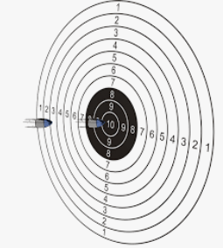

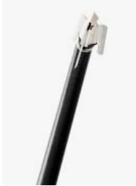
What was Kristina’s biggest challenge?
How did she overcome this challenge?
Identify three ways in which this SAE has benefited Kristina.

What is a broadhead arrow tip?
What was the progression of responsibility for Kristina? How did she gain more responsibility?

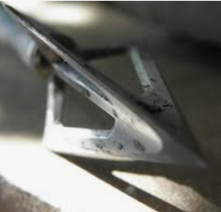

Aligned to the following standards:
FFA.PL-A; FFA.PL-E; FFA.PG-J; FFA.CS-M; FFA.CS-N; CCSS.ELA.SL.9-10.2; CCSS.ELA.SL.9-10.4; CCSS.ELA.WHST.9.10.4; MP1; MP3; MP5; MP6; CRP.02; CRP.04; CRP.08
Part 2
Directions:
Now, we will learn how the sales process works. There is more to the sales process than just talking people into purchasing a product. There is research, planning and follow up to consider, in addition to the sales conversation. There are 7 steps in the sales process. At each step, follow the prompt to prepare your sale!

Select a product you would like to sell. It can be anything from a pencil to livestock to Air Jordan shoes. Be sure to select a product you know something about. What is your product?

__________________________________
Draw a picture of your product:
Step 1: Find Customers and Determine Their Needs
Who is your customer?

What motivates this customer to purchase certain products? (Ex. They like to be ahead of popular trends.)
Step 2: Make Initial Contact
It is important to make the first meeting comfortable. It can be helpful to use relevant facts or humor to ease any tension. However, taking an interest in the person you are selling to and getting to the point quickly are important.

Write two statements that you could use for making initial contact with your customer.

Step 3: Identify Specific Customer Needs
It is important to know your customer and their needs. It is important to ask relevant questions of your customer (Ex. What do you like about your car? What features do you require your vehicle to have?). Questions that are open ended are best.

Construct four questions you could ask your customer to identify their needs.

Aligned to the following standards:
NRS.01; AGPE01.01; CCSS.RI.9-10.3; CCSS.SL.9-10.1; RST.9.10.1; RST.9.10.2; RST.9.10.4; RST.9.10.5; RST.9.10.6; RST.9.10.8; RST.9.10.9; WHST.9.10.7; WHST.9.10.9; MP3; MP6; AG-NR2; HS-LS2-6; HS-LS2-7


Step 4: Make the Sales Presentation
This is when you get to talk about your product and how it will meet your customer’s needs.

What are the product features?

What are the product benefits?

What success has this product had?

What makes your product different from others?
Step 5: Handle Objections
Objections are points in the conversation when the customer shows hesitation or lack of interest in potentially purchasing. (Ex. I don’t want a pickup truck.)

Identify two objections your customer may have and how you would respond.
Step 6: Close the Sale
This is the point in which you ask for the purchase and clear up any questions. How would you ask for the sale?
Step 7: Follow Up
At this point, it is always important to check in to make sure that your customer is satisfied with the purchase and remedy any issues. Write a statement you would say to follow up with your customer after the purchase of your product.
What was most challenging about this process? Why?

What are 2 skills you have learned from this process that you could apply in your life?

